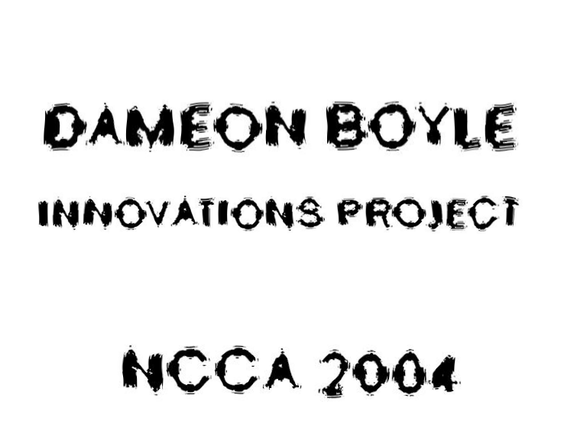

CONTENTS

- ABSTRACT Pg3

- INTRODUCTION

- HOW CAN ANIMATION IMPROVE UNDERSTANDING? Pg4

3.1) EDUCATION AND LEARNING
3.2) VISUAL LEARNERS
3.3) AUDITORY LEARNERS Pg5
3.4) KINAESTHETIC LEARNERS Pg6
3.5) 3D-DIAGRAMS Pg9
3.6) LEVELS OF ABSTRACTION
3.7) A FOURTH DIMENSION: ~ TIME
3.8) PRODUCING A 3D ANIMATION TO AID UNDERSTANDING: THE HUMAN HEART Pg11

- HOW CAN ANIMATION IMPROVE MEMORY? Pg13

4.1) HUMAN MEMORY Pg15
4.2) LAWS OF MEMORY Pg16
4.3) MEMORY TECHNIQUES: ~ ‘MNEMONICS’ Pg17
4.4) ASSOCIATION Pg18
4.5) EMPHASIZING ASSOCIATIONS Pg19
4.6) IMAGINATION
4.7) LOCATION
4.8) LEARNING STYLES AND MEMORY TECHNIQUES Pg21
4.9) THE JOURNEY SYSTEM
4.10) LONG AND SHORT TERM MEMORY Pg23
4.11) USING THE OUTLINED MEMORY TECHNIQUES TO CREATE VISUALS FOR REMEMBERING ‘GLYCOLYSIS’. Pg24

- DISADVANTAGES AND LIMITATIONS OF ANIMATION IN EDUCATIONAL PRODUCTIONS Pg32

5.1) EDUCATIONAL ANIMATION REQUIRES FURTHER EXPERIMENTATION
5.2) ANIMATION IS EXPENSIVE Pg33
5.3) IS ANIMATION NECESSARY?
5.4) FLAWS WITH ASSOCIATIONS: MORPHING IN MAYA® Pg34

- CONCLUSIONS Pg35

- BIBLIOGRAPHY Pg36

- APPENDICES Pg37

1) ABSTRACT

This report discusses the role of animation in education. It looks at how the human mind learns, subdividing learning into two major components: ~ UNDERSTANDING and MEMORY. It addresses the issue as to whether animation can improve both components for individuals of all learning categories: visual, auditory and kinaesthetic.
A short film has been produced to illustrate the advantages and possible disadvantages of animation in teaching, scientific material in particular.
Memory techniques, mnemonics have been researched and an initial story-board developed to demonstrate such techniques visually.
Other areas investigated include: Abstraction of data, Possible further experimentation and Morphing in Maya.

2) INTRODUCTION

One of the questions I asked myself when the task of producing innovative research was presented to me was, what uses other than entertainment does animation provide? Surprisingly I answered myself rather quickly.
Whilst studying for four academic a-levels I had used many methods of learning material and just as importantly remembering it. I realised that, at the end of the day it is the exams which test just how well the student has learned the given material in the given time. Only one exam could decide a year’s work on each subject. I therefore decided not only to learn the subject matter but how to do well on exams.
After understanding material I would convert them into miniature movies in my ‘minds-eye’ akin to animations. When remembering material I would use my imagination to produce, loud, exciting, often funny or rude images. I discovered that most topics contained information that flowed into the next topic, links it seemed were also very important. However in the two years I studied for my a-levels I seen possibly one 2D animation as part of a biological documentary. It seemed to me that small movies explaining the a-level syllabus criteria, similar to the movies I had created in my imagination, would have been invaluable. I therefore decided to research the human mind, how we learn and attempt to answer if animation should have a greater role in education.

3) HOW CAN ANIMATION IMPROVE UNDERSTANDING?

To answer this question ironically I needed to learn how humans learn.

3.1) EDUCATION AND LEARNING
Psychologists have determined that there are three main ways in which people learn.
- VISUAL
- AUDITORY
- KINAESTHETIC
No-one uses one of the styles exclusively, and there is usually significant overlap in learning styles.
3.2) VISUAL LEARNERS

Visual learners make up around 65% of the population*. They relate most effectively to written information, notes, diagrams and pictures. Typically they will be unhappy with a presentation where they are unable to take detailed notes - to an extent information does not exist for a visual learner unless it has been written down. This is why some visual learners will take notes even when they have printed course notes on the desk in front of them. Visual learners will tend to be most effective in written communication, symbol manipulation etc.

Since almost two-thirds of people learn visually its importance in teaching is paramount. However when teaching subjects of a scientific nature it is often difficult to produce images which fully demonstrate the process that is occurring. This is because the majority of scientific concepts simply cannot be seen e.g. gravity. Many of the processes are visible but are limited by current technology e.g. the electron microscope has the greatest magnification ability currently available. No-one has yet seen an atom, its nuclear components or further still the electrons that encompass it.

The connection between visual learners and animation is an obvious one. Since such students learn most effectively from written communication and imagery, the scope for learning from a detailed, visually pleasing animation is very promising. Such students have an affinity for understanding and remembering illustrations or photographs. Animation can take such illustrations and ‘bring them to life’.

3.3) AUDITORY LEARNERS
Auditory learners make up about 30% of the population * and relate most effectively to the spoken word. They will tend to listen to a lecture, and then take notes afterwards, or rely on printed notes. Often information written down will have little meaning until it has been heard - it may help auditory learners to read written information out loud. Auditory learners may be sophisticated speakers, and may specialise effectively in subjects like law or politics.

A large component of animation is sound. Its importance is often overlooked. In an educational production this importance would be greatly heightened. Up to a third of students may find a solely visual production non-useful. Here the benefits of animation again over written data are very evident. Music can be used much like the exciting images that attract visual learners. Sound effects can be used in conjunction with important processes to create associations. A narrator may also be used to deliver the material in a clear, understandable manner.

3.4) KINAESTHETIC LEARNERS
Kinaesthetic learners make up around 5% of the population* and learn effectively through touch, movement and space. They learn many of their skills by imitation and practice. Predominantly kinaesthetic learners can appear slow, in that information is normally not presented in a style that suits their learning methods.
It is much more difficult to predict the benefits of animation for this learning category by comparison to the former categories. The spatial element of 3D animation may improve their learning. Touch also plays an important role, textures, particularly those with bump maps, may help by indicating the surface composition to the student possibly aiding understanding.
However the greatest advantage animation is likely to offer such learners is movement. Take for instance the dynamic nature of scientific bodies e.g. beating of a heart, nature of colliding bodies, osmosis of particles can be clearly shown in an animation. Infact, with this group’s fondness and affinity for dynamics this learning category may respond the greatest to educational animation.

3.5) 3D-DIAGRAMS

A huge advantage of 3D animation is it’s third dimension, a z-axis giving volume to whatever lies within its three-dimensional matrix. Visual learners may well get an enhanced sense of what they are learning. For example compare the following:

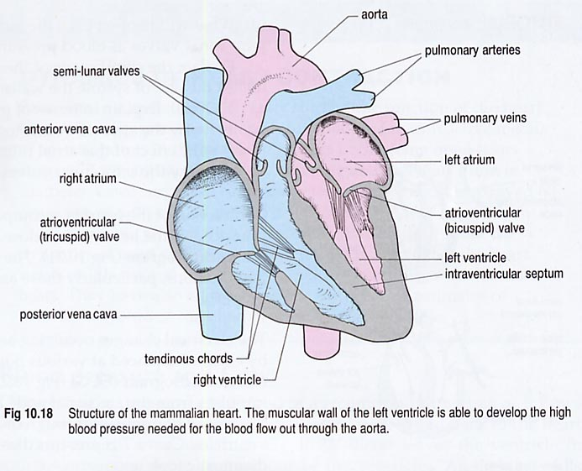

(fig1) 2D-image from book.
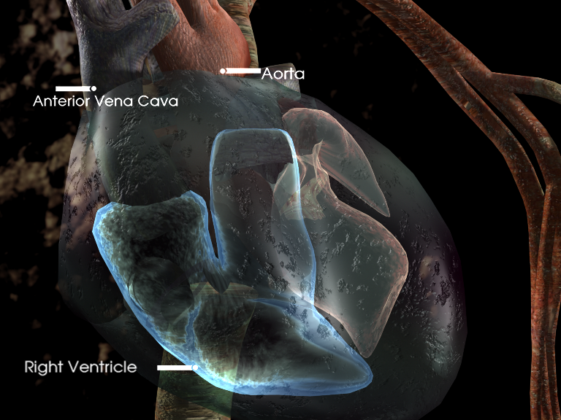

( fig2) 3D tiff from animation.

Students may not fully grasp the location of the posterior vena cava at the back of the heart for example. Or they may not know that when the blood leaves the right atrium it moves forward as well as upwards. Fig 2 is a still from the animation I have produced where the camera rotates 180 degrees about the heart showing the front of the heart, its sides and what arteries and veins enter it from above or behind. The student’s sense of the heart’s gross structure is greatly heightened.

3.6) LEVELS OF ABSTRACTION
When teaching any subject there are various levels of abstraction:-
TEXT → DIAGRAMS → ILLUSTRATIONS → ANIMATION
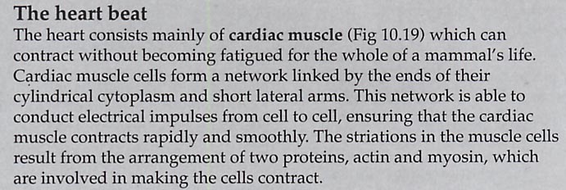
(fig3) text, lowest level of information.
Each level contains more and more information. Not in a subject matter viewpoint but from a sensory information view-point. Animation can provide the most concentrated form of information, a 3D interface, the dimension of time, as well as movement i.e. dynamic imagery and an auditory component. From an educational stand-point it aims to maximise the chances of a student understanding the material, covering all of the learning categories. But could all of this information prove to be a disadvantage?

3.7) A FOURTH DIMENSION: ~ TIME

Animation offers a fourth dimension in teaching – TIME. Many processes particularly science involve time. It is a huge advantage to be able to illustrate what is happening relative to everything else. Take the heartbeat again for example. Here there are two processes occurring at once, blood entering the right side of the heart is destined for the lungs to be oxygenated. Blood entering the left side of the heart, at the same time as that of the right, is oxygenated and destined for the remainder of the body. Traditional images when explaining this must show diagrams in a sequential form, first illustrations show how blood enters the right side and then the left. With animation the entire process can be shown occurring together. The lower ventricles beat in sync as do the atria. The valves in each of the chambers, open and close at specific times. If ones semi-lunar valve in the upper right ventricle where to open at the wrong time, blood would leak back into the heart and the oxygenation of the blood would be greatly reduced. An animation showing a full 3-dimensional heart beating with all of its components moving in time is much clearer, is easier to understand and instills a strong image much more likely to be imprinted in the mind’s eye of the student.

3.8) PRODUCING A 3D-ANIMATION TO AID UNDERSTANDING: THE HUMAN HEART

The only way I could investigate the usefulness of animation in teaching was to attempt a small production of my own. I selected biology as my subject of choice and to keep my investigation authentic I looked at a syllabus currently teaching biology AQA ^{(1).} I decided to present an animation suitable to teach all but again to keep the investigation legitimate I chose advanced-level criteria.
The next stage was to decide what topic to produce an animation for? I eventually decided on the heart-beat for several reasons:

- The heart is very dynamic taking advantage of animation’s locomotive values.
- It has many operations occurring simultaneously. Four valves and four chambers beat in a particular order. This is very difficult to teach diagrammatically yet animation is very well suited to the task.
- Animation can be shown in real-time and slowed down or sped up to grasp time-related processes more easily. The average heart, beats seventy times per minute therefore many components are involved in one second. It is useful to see how they work in real-time but to understand the order of events they need to be slowed down. Animation is ideal for this.
- The heart has a complicated structure with blood vessels i.e. arteries and veins entering it from all directions. Having a 3D diagram is very beneficial.

My aims were to produce an animation that would last between thirty seconds and one minute and would demonstrate the abilities of animation to teach, using the heart as a case study. The film would not be produced to teach students about the heart, this is much too large a task considering time commitments and that I am a one-man team. It would merely show the advantages of animation in teaching the heart as discussed above.
I decided on what capabilities of animation I would present:

- An engaging introduction to intrigue students \ capture their attentions.
- Show the 3-Dimensional qualities. A 180º rotation around the heart would illustrate this.
- Show the dynamic qualities particularly related to time. Both the sequence of events that occur and the ability to speed up or slow down the teaching of the material.
- Make the imagery striking so that it may be more memorable for the student. Detailed textures, engaging effects, interesting background without drowning out the heart visuals.
- Demonstrate the auditory component of animation since thirty percent of individuals learn aurally*.
- Show text capabilities to help with ones capacity to remember names. Those components that are more difficult to remember should have their names shown for longer. (See ‘laws of memory’- ‘law of frequency’).

(The animation when produced lasted forty seconds and attempted to exhibit above.)

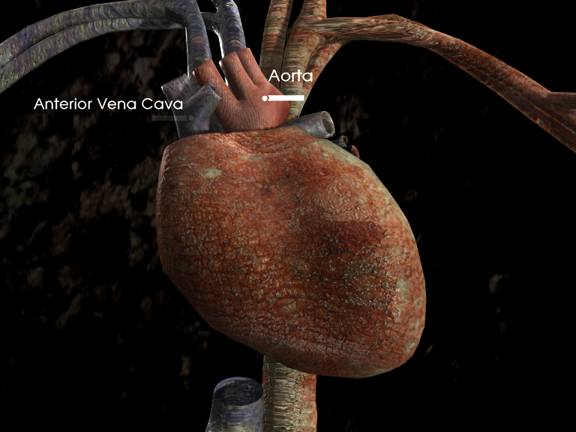

(fig4) scene from animation.

4) HOW CAN ANIMATION IMPROVE MEMORY?

When remembering events, people or places, most individuals ‘play’ through their memories akin to that of an animation. The question arises how do our memories work and what aspects of animation will enhance it?

To investigate the usefulness of animation in memorising large complex processes I used the biological process of ‘GLYCOLYSIS AND THE KREBS CYCLE’ as my case study.

Glycolysis is the lengthy and complicated chain reaction that occurs in the cells of all organisms when they respire. It involves the breakdown of the six-carbon glucose molecule many times to release ATP (Adenosine TriPhosphate) the universal ‘currency’ of energy in cells.

After consulting the AQA syllabus⁽¹⁾ to see what students are required to know of this reaction reveals:

14.8) Respiration produces ATP, which is the immediate form of energy for many cell activities

The biochemistry of respiration: The release of energy from glucose by aerobic respiration. Process of glycolysis should be considered in such detail so that students can recall:
- The names of biochemical compounds at each stage
- The number of carbon molecules associated with each compound.
- The stages where ATP is released.

The reaction looks like this: ~

6C GLUCOSE
2 X 3C PHOSPHORYLATED SUGAR
3C PYRUVIC ACID
2C ACETYL CO-ENZYME A (8 ATP)
6C CITRATE
5C ALPHA-KETO-GLUTERATE
4C SUCCINATE
4C FUMERATE
4C MALATE
4C OXALOACETATE (30ATP)
6C CITRATE
So how can one more easily remember this lengthy and complex reaction, meeting all the requirements outlined by the AQA syllabus⁽¹⁾? To answer this, one needs to understand how the human memory works.

4.1) HUMAN MEMORY

We remember things by association. Every piece of information in our memory is connected to other pieces in some way or another. For example, if you come across the words "Bournemouth University", what do you think of? Perhaps something like this:
- Bournemouth University: ~ (Poole house, the logo, the entrance, PG10, your office, ‘Dylans’, graduation, Maya®)⁽²⁾
But it's unlikely that we might see " Bournemouth University " and think of "horse" (unless one remembers a funny incident involving a horse in the university). And what if one were asked what the 7th letter of the alphabet was? Chances are, they wouldn't know that "G = 7," but they could easily think , "A B C D E F G," and then realize its "G". Association has been used to get to the letter G, A is the first letter, then one keeps choosing the next letter in the sequence until they get to the right one ⁽³⁾.
Sometimes an association comes very easily. For example, meeting a Mr. green who lives on green road. The association is immediate. Or for example the room number of a lecture theatre is the same as one’s house. Another natural association is made and is less likely to be forgotten.
When pieces of information are not obviously related in any way, however, creativity is necessary to make associations. Acronyms for example are one method of remembering information: ~
- i before e except after c, or when sounded like a as in neighbor and weigh (rule for remembering ei or ie)
- Richard of York gave battle in vain (colors of the rainbow)
- All cows eat grass; Every good boy deserves fun (notes of musical scale)

4.2) LAWS OF MEMORY
There are three main laws governing memory: ~
Law of Recency:

One is more likely to remember events that happened recently than events that happened a long time ago. For example remembering yesterday’s dinner is easier than remembering dinner one week ago.

Law of Vividness:

One tends to remember the most spectacular or striking impressions rather than those that are more ordinary. For example remembering where you where when Princess Diana died, your 18th birthday party or Computer animation interview.

Law of Frequency:

One tends to remember events experienced the most often, rather than those experienced infrequently. One is much more likely to remember their name or phone number rather than pi squared.

4.3) MEMORY TECHNIQUES: ~ ‘ MNEMONICS’

Mnemonic [nim-on-ik] n., adj. : technique intended to help the memory⁽⁵⁾ .

Suppose one needs to remember a shopping list: ~ butter, bread, sausages, orange juice, mouthwash, washing-up-liquid, tea-bags.

The easiest way to remember such a list is to convert the list into a mental animation with striking imagery.
Here is an example for the above list.

“A huge tub of ‘kerry-gold’® butter is sitting in a field. It is a swimming-pool. There are characters made out of bread some white, some brown and they are sunbathing, turning into toast under the hot sun by the butter pool. They are smoking sausages. They get too hot so they start squeezing oranges into glasses and rubbing it onto themselves like suntan lotion. It starts too burn them and they look at their glasses in horror to see that they are infact bottles of glowing mouthwash. The weather reflects this change of mood and huge, green clouds rush in and start raining washing-up liquid. The bread people grab the giant tea-bag pillows they were lying on and put them over their heads so that they don’t get wet.” ⁽⁶⁾

The more extreme and bolder the images one produces, the better. It helps if the images are objects, events or locations from the individual’s everyday life. It is also very important to make links so that the entire story can be remembered. For example above, ‘the bread person was in pain and the big green clouds came in because he/she was unhappy and rained washing-up liquid, so they grabbed tea-bag pillows to cover their heads’. Now all that needs to be remembered is the butter and the entire list should be more easily memorized.

This entire mental animation may seem like it is a lot just to remember seven objects but in one’s imagination the animation is only a matter of seconds. ‘Images speak a thousand words.’ In the same way to memorize a set of complex reactions the same method of association can be applied. When teaching subject material this technique could be incredibly useful for memorising data particularly for those students who are less creative and would struggle in creating their own memory-animations.

The three fundamental principles underlying the use of mnemonics are:
- Association
- Imagination
- Location
Working together, these principles can be used to generate powerful mnemonic systems. ⁽⁷⁾
4.4) ASSOCIATION
Association is the method by which you link anything to be remembered to a method of remembering it. The example earlier being Mr.Green from Green Rd. There are many ways of creating such associations the key is to be creative and produce vivid impressions. The more striking the more memorable and this can often lead to creating funny or rude images. Here are some possible associations particularly suited to animation:
- being placed on top of the associated object
- crashing or penetrating into each other
- merging together
- wrapping around each other
- rotating around each other or dancing together
- engulfing or eating the other
- unraveling or unzipping from the other
- one being an extension of the other
Being the same colour, smell, shape, or feeling. Whatever can be used to link the thing being remembered with the image used to recall it is the association image.

4.5) EMPHASIZING ASSOCIATIONS
When one is creating a mnemonic, e.g. an image or story to remember a telephone number, the following pointers can be used to make the mnemonic more memorable:
- Use positive, pleasant images. The brain often blocks out unpleasant ones.
- Exaggerate the size of important parts of the image
- Use humour (perhaps linked with point 2)! Funny or peculiar things are easier to remember than normal ones.
- Similarly rude or sexual rhymes are very difficult to forget.
- Symbols (e.g. red traffic lights, pointing fingers, etc.) can be used in mnemonics.
- Vivid, colourful images are easier to remember than drab ones.
- Use all the senses to code information or dress up an image. Remember that the mnemonic can contain sounds, smells, tastes, touch, movements and feelings as well as pictures.
- Bringing three dimensions and movement to an image makes it more vivid. Movement can be used either to maintain the flow of association, or can help to remember actions.
- Locate similar mnemonics in different places with backgrounds of those places. This will help to keep similar images distinct and unconfused.
The important thing is that the mnemonic should clearly relate to the thing being remembered, and that it should be vivid enough to be clearly remembered. ⁽⁷⁾

4.6) IMAGINATION

Imagination is used to create the links and associations needed to create effective memory techniques - put simple, imagination is the way in which one uses their mind to create the links that have the most meaning for them. A problem can arise here in that one’s associations may not be prominent to another person, it is encouraged therefore to make personal associations.
The more dramatic one imagines and visualises a situation, the more effective it will be in sticking in their minds for later recall.

4.7) LOCATION
Location provides one with two things: a coherent context into which information can be placed so that it hangs together, and a way of separating one mnemonic from another: e.g. by setting one mnemonic in say PG10, I can separate it from a similar mnemonic located in ‘Allesbrooke’ lecture theatre.
Location provides context and texture to your mnemonics, and prevents them from being confused with similar mnemonics. For example, by setting one mnemonic with visualisations in Winton and another similar mnemonic with images of Co.Derry –N.Ireland, allows myself to separate them with no danger of confusion.
So using the three fundamentals of Association, Imagination and Location one can design images that strongly link things with the links between themselves and other things, in a context that allows the to recall those images in a way that does not conflict with other images and associations.

4.8) LEARNING STYLES AND MEMORY TECHNIQUES
Mnemonics like the association technique demonstrated above are not exclusive to visual individuals. Mnemonics assume the visual approach to learning styles - mnemonics are recommended to be as visually appealing and memorable as possible. If one is an auditory or kinaesthetic learner they may find that this emphasis on imagery leads to ineffective recall. In this case, they should adjust the mnemonics to suit their learning style: if one is an auditory learner, they should use auditory cues to create their mnemonics. The entire sequence could be converted into sounds/music etc. providing the links between one sound and the next are clear, the entire list could again be remembered. For example for bread and butter the individual might hear in a Devon-accent “Bread and butter pudding” , a favourite English pudding from this area (‘bread and bu-{_}-err pu-dd-in’).If you are a kinaesthetic learner, imagine performing actions such as eating the pudding or using tools as the basis of memory techniques.

4.9) THE JOURNEY SYSTEM
The journey method is a powerful, flexible and effective mnemonic based around the idea of remembering landmarks on a well-known journey. It is very useful in that it can be used in conjunction with the association method to give it structure and clarity.
Because the journey method uses routes the individual knows well, the information can be coded into a large number of easily visualised or remembered landmarks along the routes. Because the individual knows what these landmarks look like, they don’t have to translate visualisations for them.

USING THE JOURNEY METHOD
The journey could, for example, be the journey one takes to work or university in the morning, the route they use to get to the front door when they get up in the morning, the route to visit their parents, or a tour around a holiday destination. It could even be a journey around the levels of a computer game. Once one is familiar with the technique they may be able to create imaginary journeys that fix in their mind, and apply these. Creative thinking is critical.
To maximise this technique most effectively, i prepare the journey beforehand so that the landmarks are clear in my mind before i try to commit information to them. This allows me to fix these landmarks as the significant stops to be used in my mnemonic, separating them from others that i may notice as i get to know the route even better.
To remember a list of items, whether these are people, experiments, events or objects, all i need do is associate these objects or representations with the stops on my journey.
As an example I will take the shopping list I created earlier to demonstrate using the assocation method and apply this method to it. The list was: butter, bread, sausages, orange juice, mouthwash, washing-up-liquid and tea-bags.

My journey is the journey I take from getting up in the morning to working at my computer at university.

- End of my bed: ~ A huge heap of Butter smudged all over my duvet, I quickly jump out of bed.
- In the shower: ~ Standing on a big soggy slice of bread, feels terrible.
- On the b-fast table: ~ A plate full of sausages, I eat till I’m going to burst.
- Outside front door: ~The entire driveway is flooded with orange-juice, I start wading through it.
- Top of hill I regularly climb: ~ A table with a lady promoting mouthwash I take a sample to get rid of the taste of sausages, she stares at me because I‘m soaking wet from orange-juice.
- The half circle steps: ~ Big sign saying “danger slippy” and the entire area is coated in green washing up liquid, I can smell it everywhere.
- On my desk next to my computer: ~ I finally make it to computer, notice that my monitor is smashed and has been filled up with tea-bags. ⁽⁶⁾

This would create a very imaginative animation.

EXTENDING THE TECHNIQUE
This is an extremely effective method of remembering long strings of information: with a sufficiently long journey you could, for example, remember elements on the periodic table, lists of Kings and Presidents, geographical information, or the order of cards in a shuffled pack of cards.
The system is extremely flexible also: all one needs to remember even more items, is to memorise a longer journey with more landmarks. To remember a short list, only use part of the route!

4.10) LONG AND SHORT TERM MEMORY
One can use the journey technique to remember information both in the short term memory and long term memory. Where they need to use information only for a short time, keep a specific route (or routes) in the mind specifically for this purpose. To use the route again, overwrite the previous images with the new images that needed to remember. To symbolise that the list is complete, imagine that the route is blocked with cones, a 'road closed/road out' sign for example.
To retain information in long term memory, reserve a journey for that specific information only. The great advantage of this technique is that one can use it to work both backwards and forwards, and start anywhere within the route to retrieve information. Association relies on sequential remembering, if you forget the beginning you forget everything after it. This techniques doesn’t.

4.11) USING THE OUTLINED MEMORY TECHNIQUES TO CREATE VISUALS FOR REMEMBERING ‘GLYCOLYSIS’.
Initially when I first began the project it was my intention to produce an animation that would illustrate the effectiveness of the memory techniques I had researched. The first step was to create a story board with initial images showing how my visual interpretation of the chained reaction worked. Following the production of a thumbnail story-board I was surprised to see that fellow students could actually remember the entire reaction from the storyboards. As a result I realized an animation would not be necessary in this instance however strong visuals were still of huge benefit.
I was presented with three problems outlined by the syllabus: ~ the biochemical names, the number of carbons and when ATP is released. Here is my personal interpretation.
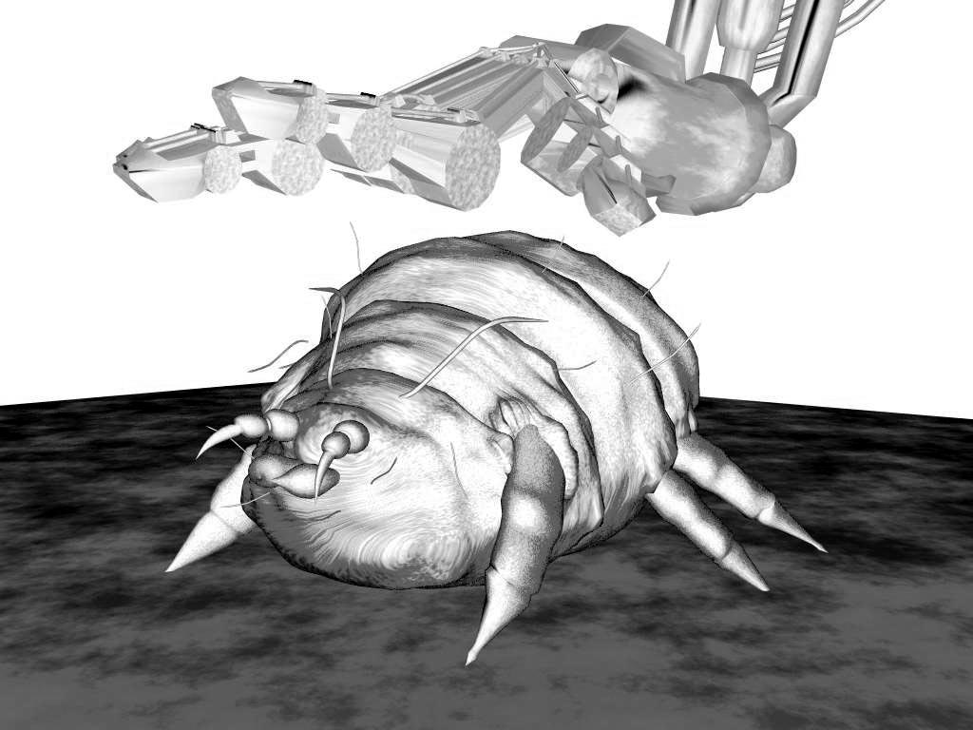
- Glucose :- the vast majority of students at an A-level stage will have come across the molecule glucose, remembering the name therefore is not an issue. Rather than presenting the viewer with a cliché large cube of sugar or a diagrammatical image of chemical structure of glucose I characterized it in the form of a bug. I visualized glucose in the similar form of a dust-mite. The association techniques were perfect for this reaction since they both are sequential in nature. At each stage in the reaction the glucose ‘bug’ would morph into various other objects. Each object related to the name of the compound thereby aiding the student in remembering the compounds’ name.
- To remember the number of carbon molecules each compound contained, I represented the number of carbons as the number of legs the bug had at each stage. The legs would have to be distinctly different so as not to mix one set of legs up with another.
- There are two main areas where ATP are released. Eight by the time the reaction has reached Acetyl Co-Enzyme A. Thirty by the time the Kreb’s cycle reaches Citrate again. I used an intermediate morph into the numbers eight and thirty at each of these two stages to grab attention to the fact that ATP was being released and of the frequency indicated by the number.
- There are only two distinct regions where the reactions take place the cytoplasm and the mitochondria. Although not a distinct part of the syllabus I thought it still might be useful to know which reaction occurs where. So, I included an introduction to the setting of the reaction with a cell morphing into a city and zooming in to the cytoplasm. After the pyruvic acid the subsequent reactions occur in the mitochondria and so I included a change of setting.
- To further remember the reaction I used the journey method but in an unusual way. I used it in conjunction with an acronym. Richard Of York Gave Battle In Vain. These are the colours of the rainbow: Red, Orange, Yellow, Green, Blue, Indigo and Violet. By using these colours as the background colours to my reactions I hoped it would aid memory. Each colour represented a ‘stop’ in the journey.
- I paid particular attention to the morphing or associations between one form of the bug and the next. I tried to make the associations clear and varied from each other.

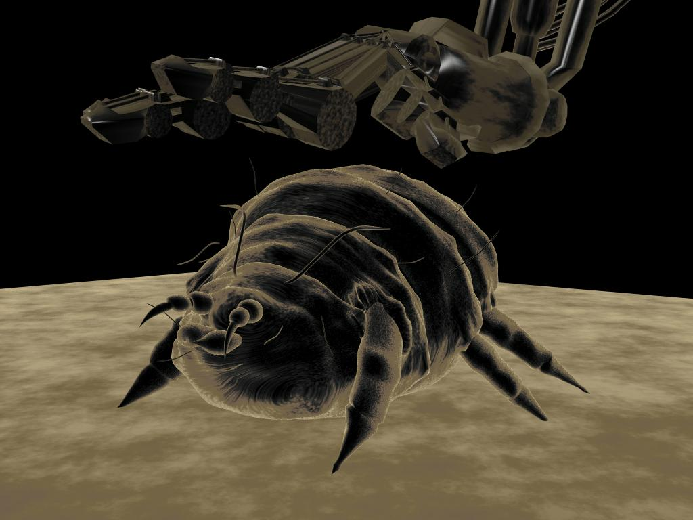
(fig 6)The beginning of the proposed animation. Models created in Maya.

The following shows the early storyboards sufficient it seems for remembering the process. Here is the chain-reaction again:-
6C GLUCOSE
2 X 3C PHOSPHORYLATED SUGAR
3C PYRUVIC ACID
2C ACETYL CO-ENZYME A (8 ATP)
6C CITRATE
5C ALPHA-KETO-GLUTERATE
4C SUCCINATE
4C FUMERATE
4C MALATE
4C OXALOACETATE (30ATP)
6C CITRATE

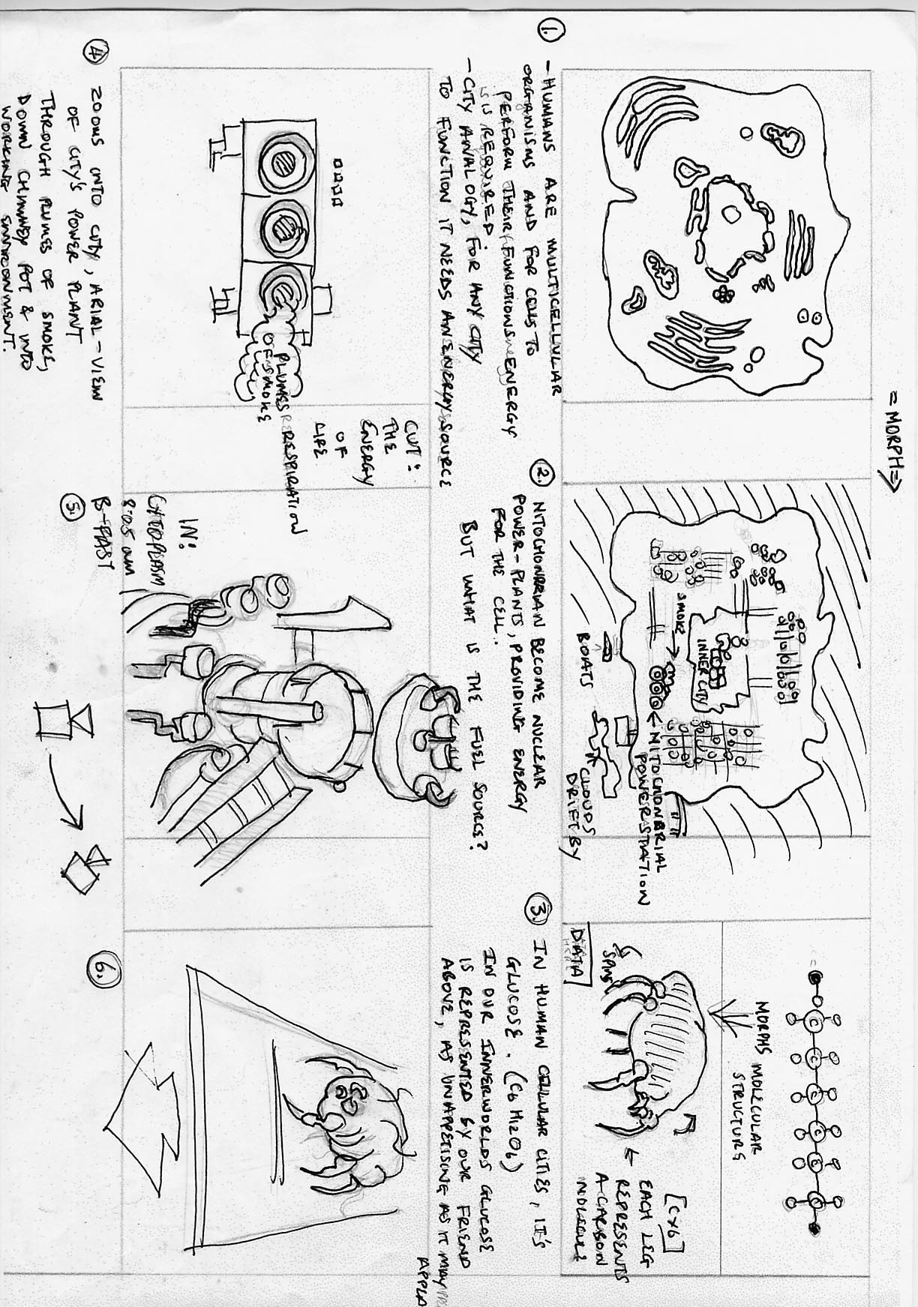
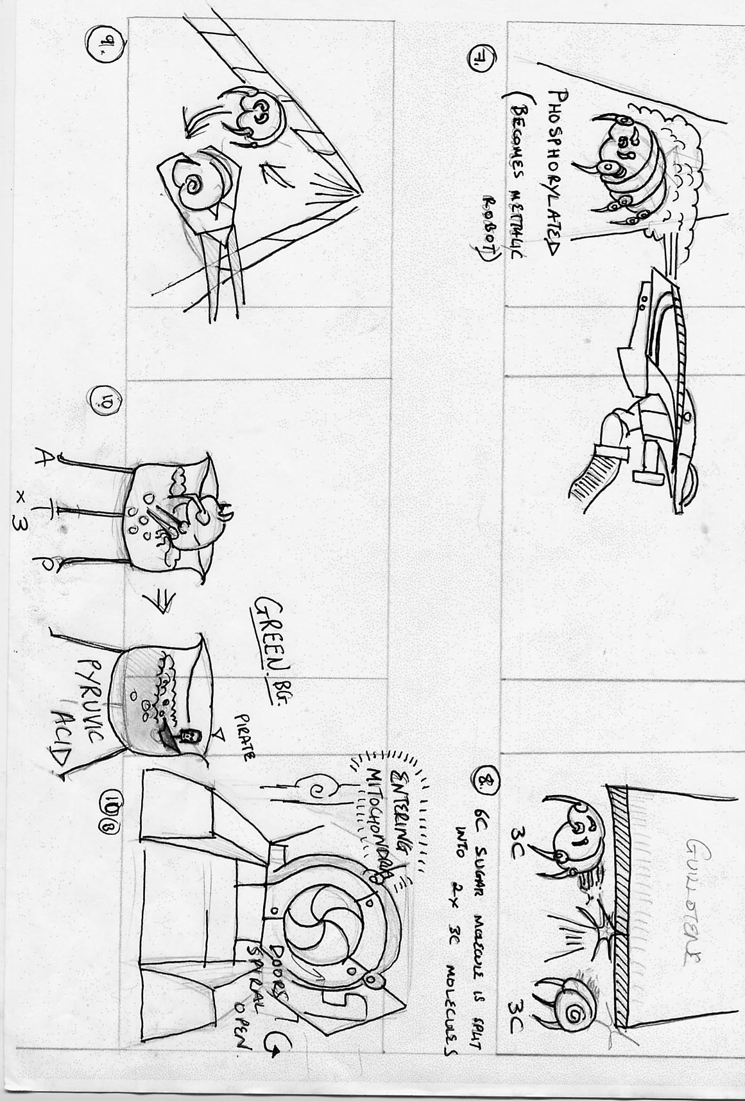
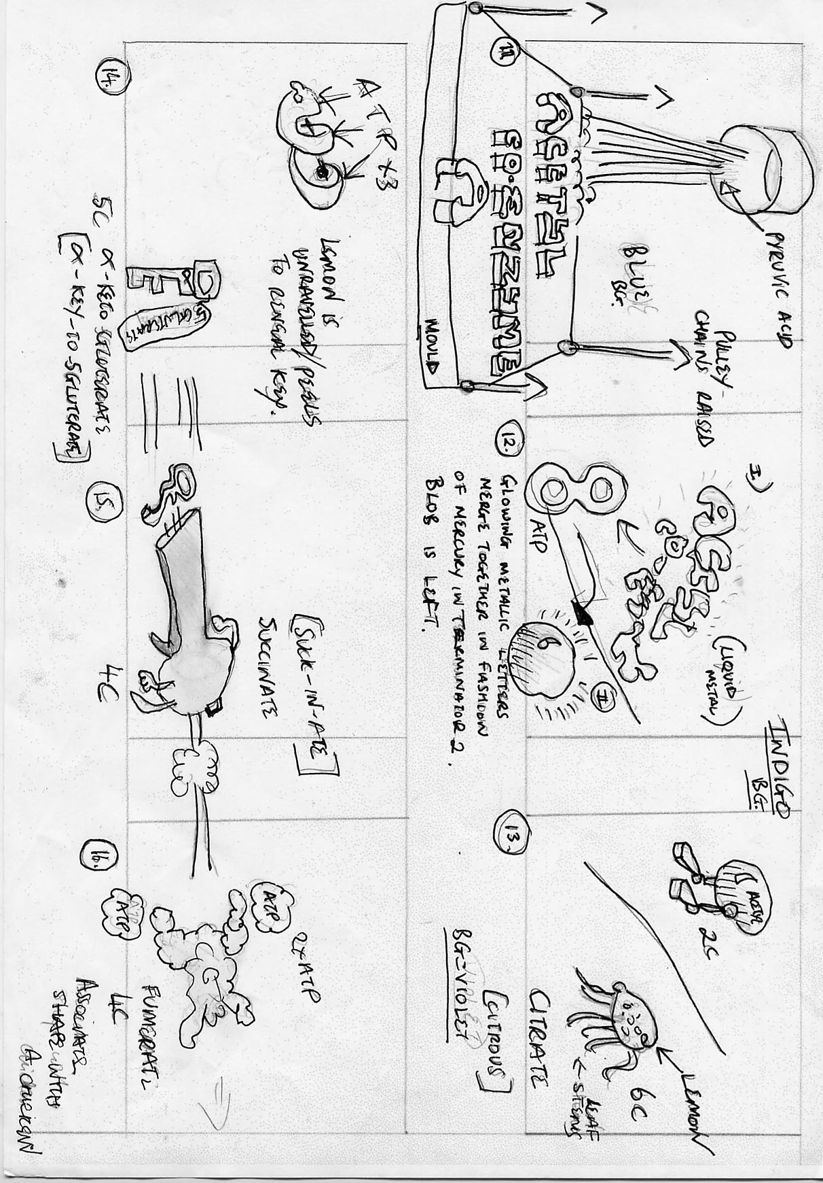
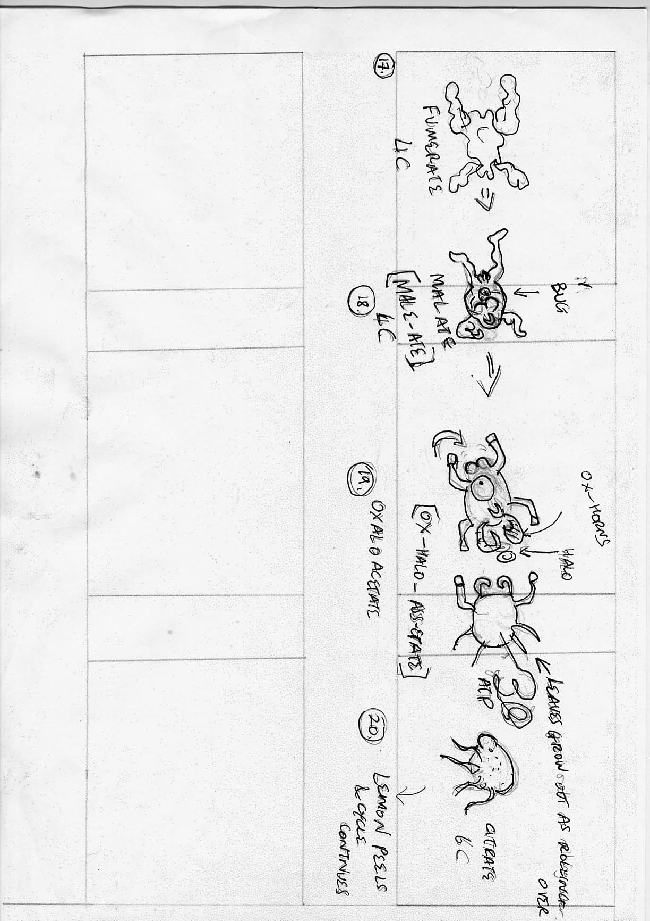
5) DISADVANTAGES AND LIMITATIONS OF ANIMATION IN EDUCATIONAL PRODUCTIONS
Animation can deliver material in the most concentrated form. All senses are targeted and information is delivered in a fashion that is dynamic and more likely to teach all learning types the material. However is a delivery of simultaneous information necessarily a positive thing? Too much sound may distract visual learners from the visuals. Images that are too bold may distract the auditory learner. The lack of ‘hands-on’ interactivity may make the film un-interesting to the kinaesthetic learner.
5.1) EDUCATIONAL ANIMATION REQUIRES FURTHER EXPERIMENTATION
Had I sufficient, time resources and candidates willing to participate I would have liked to have set up the following experimentation.
The only way to investigate if animation actually is a better educator would be through quantative measurement by making students of each category learn several different topics. Each topic would contain information of a similar level of academics and would be equal in the quantity of content. The independent variable i.e. that variable which is free to change would be how the material is delivered. Possibly three subjects could be looked at, one teaching via an animation, one teaching via visuals only e.g. text and diagrams and one teaching via sound only for example. The time allowed for delivery would be set and a test designed for each subject would be given to see which method was more productive.
To further verify the experiment one would then need to get three sets of students of all abilities and learning categories, all would also be learning the subject matter for the first time. They would be given numbers and then a computer could randomise the numbers to ensure the abilities of the students is sufficiently randomn .One group would watch the subject being taught via animation. One would learn via text and diagrams and one would learn via sound only. They would then all be tested. It is in my opinion that if animation was used to full advantage and in conjunction with the memory techniques discussed students of this category would score highest. Due to probability I would then expect those who learnt visually to have second highest scores followed b those who learnt only eith sound since 30 percent of humans learn in this way.
5.2) ANIMATION IS EXPENSIVE
In producing my animation it became apparent just how much time is required to deliver the material in both an entertaining fashion and with clarity. Although the rewards may be great so too is the cost in animator-hours.
The financial costs are also likely to be high particularly since an entire syllabus would ideally need to be catered for. This could involve the work of a very large team for a very long time. Like so much in our society the high cost of such a production is likely to be the deciding factor.
5.3) IS ANIMATION NECESSARY?
Following the production of my story-boards outlining the uses of mnemonics it became apparent that animation wasn’t required. Story-boards which had taken a matter of hours to produce were sufficient for teaching my colleagues the material, material I should say they had never come across before. An animated version of this story-board would have taken weeks to produce. One must therefore look very carefully at how complex the material is and decide if animation really is required, will images and sound suffice? Possibly animation isn’t required for the vast majority of subjects however it may just be the case that it will improve how much the student remembers and put the information in a form understandable to more learning categories.

5.4) FLAWS WITH ASSOCIATION: MORPHING IN MAYA®
The biggest problem with association is if one forgets a link in the middle of the chain all subsequent data and their links are forgotten. For example if you have 20 pieces of data and you forget the link between 15 and 16, data items 16 to 20 are lost. The journey method used in conjunction with this helps eliminate this problem.
A further problem with association is creating the links in software such as maya ®. The most commonly used method of one piece of geometry morphing into another is to use ‘blendshapes’ or their equivalent. Blendshapes however require that the two pieces of geometry have the same number of vertices. The problem arises if an object of complicated geometry is to morph into another complicated model, since it is very difficult to remodel an object that is already complicated in structure. There are ways around the problem. A script can be written so that the complicated object is converted into a sphere, this can then be modeled into another complicated model or another sphere can be put in its place to fake the transition. Another method is to take the rendered tiff of the object and apply tweening to it between that tiff and the tiff of the new complex model. Software such as flash® or after-effects® offer such tweening capabilities.

6) CONCLUSIONS
In any research-based work it is always important for one to remain non-biased throughout the entirety of the investigation. This can often be more difficult than expected since one will already have formed hypothesizes and will have an inclination to prove their hypothesis right or wrong as the case may be. With this in mind I hope that this project has brought to light both equally the advantages and disadvantages of animation for educational means and asked some valuable questions. I began this project with a strong belief that animation has a much bigger role in teaching than currently being used and I have an inclination that animation will eventually become a very large part of teaching, particularly with the dawn of real-time rendering, improved technology and faster production. One cleverly designed animation may teach thousands of students for as many years as the material is dated. Since science in particular is built upon prior knowledge this could be a very long time indeed.
This is a huge topic of which I have only scratched the surface. To possibly merit a large investment of money into producing animations for an entire syllabus for example would require much more evidence. An entire team of animators, leading teachers, possibly psychologists and a very large number of students willing to participate would be necessary to fully assess just how big a role animation has in education.
Who is to know what the future holds, animation could possibly eradicate the need for teachers altogether. Teachers may become interactive computers with huge libraries of animations built up over years so that an inquisitive student may always be answered with an appropriate animation. Is this the stuff science-fiction movies are made of or is this the inevitable science-fact ?

7) BIBLIOGRAPHY
- AQA: Assessments and qualifications alliance.
- www.uni-poderborn.de/fachbereich/AG/agdomik
- www.accd.edu (2)
- www.learning-styles-online.com (*)
- http://brain.web_us.com(3)
- www.sfu.ca/hccc/pdfs/Memory(4)
- ‘Maximise your memory’: Jonathan Hancock ISBN:0715311085 (5)
- www.siggraph.org/education/related.htm (7)
- My imagination :0) (6)

APPENDICES

