Innovations Report

In the normal domestic environment, the discovery of foods moulding or in the process of decomposition is for most people an unpleasant find. The pungent smell and variation of look and texture from its optimum state is seen by the majority as repulsive and the item would be labelled as ‘gone off’ and quickly binned. However is there a different context in which rotting fruit ever be seen as beautiful? Could the continuous transformation in colour and texture be viewed not as a decline but instead as a naturally changing aesthetic feature? This project aims to challenge the common perceptions of decay, capture the essence of the metamorphosis of the decaying process in an innovative way, and establish if beauty can be found therein. In addition, the report aims to research the diverse ways in which artists have used decay in their work, and determine whether they have been successful in showing it as beautiful.

The word decay originated from the Latin word ‘decidre’ where de= down and cadere=fall equating to a downfall . A dictionary definition of a downfall is to fail slowly in beauty, quality or any form of excellence. This ties in with the usual perception of decay which is that it is disgusting and something ‘gone bad’. Much of society views death as awful, an event to be mourned, and judges decay to be repulsive and a waste. However the fundamental reality is that death and decay both play an essential part in the evolution of life. Death is the only certainty in life, and the complicated organisms that inhabit the earth today are the natural consequence of this evolution.

Since the big bang, more than twelve billion years ago, nature has been slowly but consistently evolving and transforming from one form to another. Decay has played a fundamental part in this evolution. In the natural environment there is no waste, and everything is recycled in an infinitely continuous cycle of birth, growth, maturity, reproduction, decline, death, decay and back to birth. When a plant or animal dies, it will either directly or, if initially consumed and digested by a specimen higher in the food chain, indirectly be eaten by decomposing microbes that will decay or dissemble the physical body and extract the nutrient remains into the earth. These nutrients provide the conditions for higher and more complex forms of life. This is an important factor in decay. Rather than returning to the level of simple elements, decomposition stops at the stage of relatively complex chemical and biochemical compounds which raise the quality and fertility of the soil. This in turn helps to nourish new plants. We can therefore establish that in the right context decay is not a bad thing, it is fundamental to our evolution and survival of the species. Without decay the Earth would be littered with dead organisms.
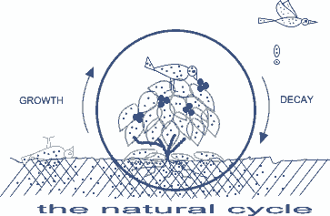
This diagram represents the life cycle. The fallen leaves, dead birds and life wastes of living animals converting into nutrients in the soil illustrates the role of decay.

Prior to analysing beauty in relation to decay I will take a quick detour to discuss the term beauty and its associations to art. Beauty is difficult to define as it is a subjective concept rather than a scientific term. It is highly individual, as the famous saying ‘beauty is in the eye of the beholder,’ accurately describes. In his book ‘the meaning of art’ Herbert Read states that:
any general theory of art must begin with the supposition that man responds to his senses and that certain arrangements of the shape and surface and mass of things results in a pleasurable sensation .
Although I agree that this describes beauty in art on one level in my opinion it is inadequate as a complete theory of beauty. I therefore feel the following statement describes it better:
when looking at art we must consider the different layers of beauty. Art can be appalling to look at, but beautiful in its ability to evoke thoughts and ideas
This in part backs up my opinion that for something to be beautiful it does not have to be aesthetically pleasing as in the traditional sense. One could admire beauty in an ability to transform itself, produce varied, changing colours or even in its capability to suggest thoughts and ideas that challenge our perception. My personal opinion on art is that it can be anything you want it to be whether a unique form of expression or an accurate interpretation of nature.

Frida Kahlo is an artist who expresses herself in her painting with an individual view of the beauty to be found from what might popularly be defined to be the opposite. She paints many self portraits displaying herself with a moustache and thick eyebrows that meet in the middle. These pictures do not fulfil the popular definition of traditional beauty, however the emotion and honesty of her paintings for me make her work beautiful in its own right. As with decay, there is a kind of beauty in imperfection, in forms that are wrinkled or scarred and go against the usual ideals that define what is beautiful and what is ugly. This opinion is also stated, but slightly more intensely by artist Jaymi Zents who describes: “A sense of beauty develops as it connects meaningfully with what is by convention ugly.”

Another aspect to consider is the beauty of change. Decay shows us reality and how nature is constantly altered by the interaction between time and form. The transformations that occur in texture and colour are fascinating to watch. These transformations are dictated by the theory of entropy, described in the dictionary as the “inevitable and steady deteriation of a system or society”. They are very evident in decay, as an organism will be broken down from a rigid structure (low entropy) to a totally disorganised clump of matter (high entropy). The changes occur through random disorder because the new entity materialises as a result of the decay of the old. As the 1st theory of thermodynamics states, nothing can ever be created or destroyed, it is just adapted from one form to another. On a visual level, watching this degeneration and the range of bright colours and textures that are present at different stages could be described as beautiful. It is a fascinating process that only the forces of nature can create.

This project is not endorsing that every aspect of decay is beautiful; it is merely suggesting that beauty can be found in the visual or conceptual aspects of the process. On a rational level, decay should not be deemed to be repulsive. However, in the context of an animal, especially a person, decay is so closely related to death and disease that society has come to see it as such. For this reason, focusing the piece on a decaying animal or human would only serve as shock art and deflect from my intention. We are far too emotionally connected with death to see a rotting corpse as anything but shocking and repulsive. This opinion is backed up by Sam Taylor Wood. In an interview she claimed:
I had the idea for another ‘still life’. I bought a dead hare, hung it, set the camera and filmed for several days. When I got back and watched what I had shot, I realized that it was the most disturbing film I’d ever seen. It was rough decay. It was pure violence
The project aims to represent the beauty of the process in a way which will not disgust the average person. I have chosen fruit as the subject matter to avoid the emotional implications associated with animals.

The process of decay is not something you sit and watch happen; the colour and texture changes occur over such a long duration. Even paint dries faster! If you sat and watched it in real time you would not see any change taking place. To further understand decay and its aesthetic quality, as well as observing the process first hand, research was undertaken into the diverse ways other artists had tackled this subject in their work, ranging from paintings, sculpture ,film and installations.

Anya Gallacio is an artist whose work explores the physical and metaphorical properties of natural materials in a variety of contexts and compositions often juxtaposing with permanent materials. Many of her sculptures depict decay and transformation over time. Her work is described a one critic at the tate to be:
A strategy to develop an aesthetic that proposes an alternative to the museum culture, based on natural rather than man-made systems
In her installation ‘preserve beauty,’ she starts the process from a ripe and mature state and lets the fruit and flowers decay in the gallery, decomposing quickly due to the heat of the room. The apples hang in a bronze cast of a tree. The unpredictable time based qualities in her installations purposely represent the cycles of decomposition and transformation which are a property of the organic materials she uses in her work.

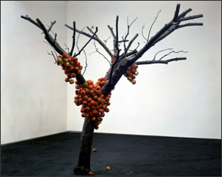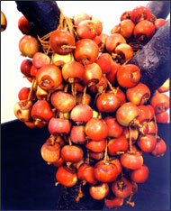
Anya Gallaccio because I could not stop 2000
Installation at Lehmann Maupin, New York
Private Collection/courtesy Lehmann Maupin, New York. 8
The tate Gallery further describes:
the use of living objects, such as in ‘because I could not stop 2002’ which juxtaposes a bronze apple tree with real apples, represents Gallaccio’s ongoing fascination with time, whether presented in its arrested state, or by making visible the inevitable process of natural decay and eventual disappearance.
I find this aspect of her work conceptually very exciting as it contrasts the permanence and traditional durability of the bronze with the naturally morphing aesthetic of real apples left to gradually rot and fall to the gallery floor.

Memento Mori is a term used to describe works of art that remind the viewer of death and its inevitability, presenting an image that provokes thought as to the fleetingness of existence. The term is derived from a Latin phrase meaning “remember you must die” Memento mori type works do not necessarily have to be shocking or morbid; in fact the pieces are often quite beautiful. The reason I mention this genre of art is because decay is very closely related to death, so producing a piece about decay is a relevant example of Memento Mori as it reminds the viewer that they too will decay and die.

Caravaggio was an early baroque artist who is said to have revolutionized art in Europe, rather then conforming to the renaissance ideal of beauty. Caravaggio chose naturalism and embraced human weakness and imperfection. Cunningham described “Caravaggio’s innovative style, even at its most classic was difficult for the public to assimilate and even deliberately rude”. A very relevant example of this is ‘basket of fruit’ 1596, the subject of the painting (a still life with fruit and leaves) is treated in a way that contrasts sharply with similar paintings in renaissance art because rather then painting the fruit to be luscious and in their prime Caravaggio paints it as it is, with imperfections and in a state of decay. In his time there were no refrigerators. A painting of this standard would take a few weeks to complete, during which time nature would have began the process of decay. Caravaggio does not cover up this fact but embraces the beauty of this state. This was innovative at the time because fruit traditionally symbolized fertility and bounty and Caravaggio contradicted this with the appearance of decay (the apple is bruised and the grapes and leaves have began to shrivel up).
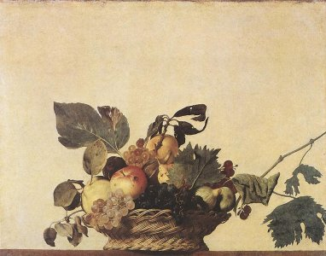
"Still life with a basket of fruit"
oil on canvas, 310mm × 470mm
Pinacoteca Ambrosiana, Milan.

Cited from: http://www.phespirit.info/pictures/caravaggio/p038.htm
Even the composition of the piece contrasted to most still lifes of the time. Instead of centering the fruit on the canvas he paints the basket at eye level, just over the edge of the table and into the viewer’s space. This is a more forceful technique, demanding the observer’s attention. My piece also aims to be ‘in your face’.
17th century cardinal Federico reportedly expressed
I would have hung a similar basket next to it but as no one was able to attain its incomparable beauty and excellence, it remained alone
when talking about Caravaggio’s basket of fruit. The fact that from Federico’s point of view even a bowl of fruit in its ripe, traditionally beautiful state could not compare to the beauty of Caravaggio’s painting of rotting fruit is further evidence that it is possible to find beauty in decay.

One art critic describes the work to “teeter on the moment between full ripeness and decay, managing to seem at once mouth watering and mouldy” I agree that this is the effect of the piece. Just because it is shown at a stage which is not conventionally beautiful does not mean it is not so. The blemishes and wilting make the painting unique, both visually and conceptually more interesting than if we had been presented with another idealistic image of fruit. The piece is an early Baroque example of the memento mori genre because it comments on the inevitability of nature and reminds us that we too will rot.

More than four hundred years later Sam Taylor Wood’s work ‘still life 2001’ adopts in many ways a similar style of composition to Caravaggio, and is even described by Hickling as ‘caravaggesque’. Her piece is a four minute time lapse film showing the changing form of a bowl of fruit from ripe to decomposed liquid mass. The piece is exhibited in the Tate modern on a plasma screen which allows it to be presented on the wall, at first glance appearing to be a painting. Taylor Wood’s style is to “use classical aesthetics recast by modern technology”. She is interested in the relationship between photographs that move and those that don’t, this is as much evident in this piece as many of her other works. The apples, pears, grapes and peach are arranged on a plate in front of a wooden background, the scene beautifully lit in a similar style to that used in a typical seventeenth century Dutch still life. As the piece progresses the fruit starts to shrivel and turn brown. Clouds of mould erupt, at first gradually over chosen members of the arrangement, and then developing to the point where the whole plate is engulfed. The matter continues to shrink and deteriorate further with the clouds fading and liquidation pools begin to develop. Towards the end it becomes apparent that flies have begun to buzz around the fruit. Having watched the piece in the Tate Modern in London several times over I found the piece to be exceptionally engaging and beautiful to watch. The transformations that take place are fascinating; augmented by the fact that this was a completely natural process with very little human interference. This exhibition was very successful. In a room otherwise almost empty, there were always large groups of spectators surrounding it, transfixed by the images. It is an exhibit that once seen would
not be forgotten, which in my opinion adds up to a very successful piece of art.

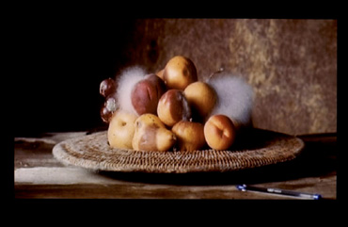
Sam Taylor Wood, still life 2001, cited from: http://fogless.net/artreview/011215_wc2_st/taylor-wood.htm
Toyoko Ito (Toko) copy; 2000-2004

The technique used for ‘still life 2001’ is time lapse. Time lapse is a method of recording events that happen over relatively long periods of time which are too gradual to be seen by the naked eye. This is a very useful technique for documenting the process of decay quickly. If the fruit was filmed and watched it back you would physically be unable to see the changes happening.
Time lapse works by capturing a series of images at consistent time intervals then viewing these images in rapid succession. This makes the changes appear to happen in real time. The concept of Taylor Wood’s piece and what I aim to achieve are similar. The main difference is that Taylor Wood is taking an accurate recording of the process, with very little intervention once the camera has been set, whereas I am not recording the actual process but instead my interpretation of the fruit at different stages of the process. Also, the time intervals between each of her frames would be far shorter than mine, allowing her to play back at a speed closer to, if not exactly 25 frames per second.

Artist and writer Michael Smeitana has used decay in its most natural and honest form as a theme for a recent exhibition named ‘rotten art’. He has used rotten tomatoes, mouldy bread and fully decayed bananas as his main exhibits (shown below).
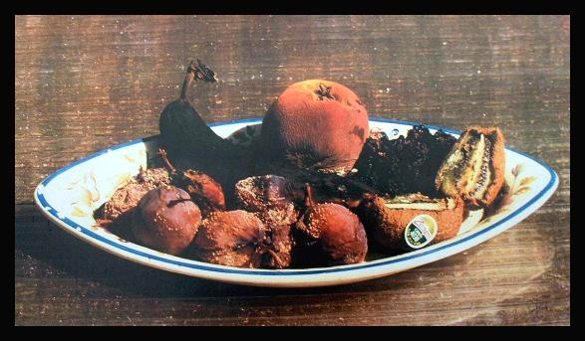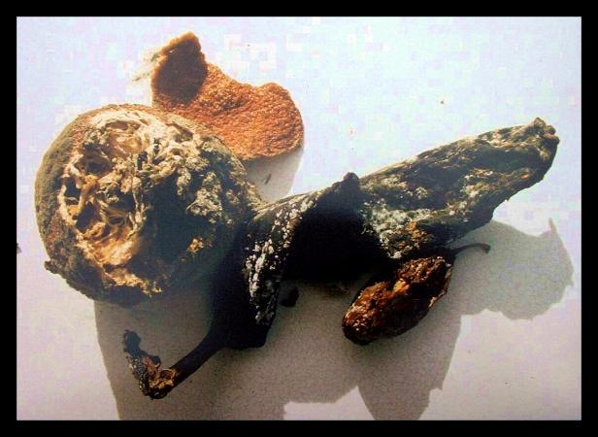
Still life 2 11 x 15 State of the union 8 x 12

The message he is trying to convey is not one of memento mori but his intention to “highlight how mankind wastes a massive amount of food globally.” This is totally different to what I am attempting to convey. The artist states decay as waste. This may be true in the sense that fruit has been bought or grown in order to eat it, and if decayed it does not fulfil its intended function. Also, if food is left to rot in an unnatural place, for example if it is disposed of in a sealed plastic bag and then dumped in a land fill the nutrients are locked away deep underground, too far under to be of any evolutionary use and so are wasted. However, as pointed out earlier, in the wider natural context decay does not necessarily equate to waste. Whatever the artist’s intentions, critics described the exhibits as “surprisingly attractive and tactile, the exhibits have drawn praise for their colour, texture and societal implications” supporting the view that this artist has achieved some success in illustrating that beauty can be found in decay.

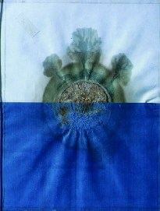
Dieter Roth has explored a completely different use of decay in art by employing organic materials to visualise the process of time. For example, one of his works uses salami to portray a sunset (shown on the left), the inevitable decay of the material being an essential property of the piece. Similarly, sculptor Sonja Alhauser often uses food in her artwork. The visible and biological changes that occur are a large part of the motivation to use food as a medium. It is reported that “she believes art should stimulate all the senses, particularly smell and taste; this sensory interaction between viewer and sculpture is the art”. She has recently been commissioned to create three sculptures made from chocolate. The rationale here is for the sculptor to rouse all senses as well as show impermanence and change. In my opinion this is a great use of food and decay in art. The fact that she creates and thereafter loses control over her works is a fascinating concept in itself, as although she originally puts the piece together, she has no power over the aesthetic once installed.

When considering the final outcome for this project, the aim was to create a piece that represents not just the start and end results of decay but also the actual aesthetics of the process, particularly with reference to the metamorphosis of the visuals. The initial intention was to use time-lapse photography; however this lacked the innovation and creativity that I desired. I wanted something far more experimental in nature, so my concept, partly inspired by Sam Taylor Wood’s piece, progressed to using dynamic fine art with time based elements to produce an adaptation of a still life that is not still, representing decay rather than life. The initial painting was created as my interpretation of the fruit and leaves, using my own style. As the fruit slowly changes the painting was adapted to represent the natural transformation that had occurred, attempting to show the colours and textures at different points. Every time the painting was updated a photograph was taken. The series of photos were then compiled into a short film, dissolving between each image, visually progressing through the process of decay. Although the final painting is a piece of art in its own right, it is capturing the process which is of most importance to me. The thick built up layers of paint in the end product provide a hint of the process. In Herbert Read’s ‘The meaning of art’ he describes
a work of art must be dynamic- it must arrest the attention of the onlooker, move him, infect him’
This was one of the most important aims of the project. The others were to actively communicate the beauty of decay and to produce an innovative and experimental piece of work.

Lerios describes image morphing as the “construction of an image sequence depicting a gradual transition between two images”. This project incorporates image morphing through a combination of painting and animation. I feel the technique I have used is very suitable for my intended effect.

Norman Mclaren was a contemporary ‘genius’ who experimented with the use of several innovative production methods for his animation and sound that differs substantially from methods normally used for animated films. This largely dictates the style of his work, which has earnt him both hundreds of awards and the title of “pioneer of motion picture techniques”. One of his most famous methods is to produce film without a camera by drawing directly onto 35mm blank film; this technique was used for his 1942 film ‘Hen Hop’. This worked by drawing small pictures, each slightly different in sequence onto the small squares of the ‘developed’ film. If a mistake was made it could be wiped clean using a damp cloth and redrawn. This method is useful to depict mobility, but makes static pictures almost impossible. On the video ‘creative process’ Mclaren talked of his pleasure in using drawn lines that could move and described it as “animation at its purest”. He also spoke of his continuing interest in the metamorphosis of light, shade and form.
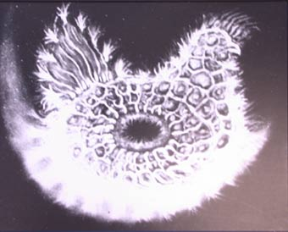
A frame from ‘la Pouette grise (1942), cited from:
http://www.nfb.ca/normanmclaren/expo_en/page10.html
For his film ‘Poulette Grise’ Mclaren aimed to switch the focus point to the process rather than the end result of a painting. He filmed the progress of a still picture, recording its evolution at 15minute intervals, After 3 weeks of this Mclaren had 400feet of film of the picture morphing from one image to another. The movement evolved in a natural sequence but everything had been improvised at the moment of shooting. In this way it differs from my own technique. Mine is not an experimental improvisation and is less fluid in nature. It is more an interpretation of a natural changing aesthetic, a still life that is changing to reflect its subject. Also, my film has only 21 frames and blends between these, whereas Mclaren has hundreds with which he can play back in real time.

I feel my resulting animation is quite interesting both visually and conceptually. It shows the fruit degenerating, decreasing in size and form whereas the painting is building up, having started from a blank canvas, with the layers of paint increasing as the subject grows.

The main aims of my project are to produce an innovative and dynamic piece of work that interprets the process of decomposition and looks for the beauty to be found in decay. I think that this project has been successful in being innovative. When I first came up with the solution of ‘animating my painting’ to represent the changes to the fruit I was unaware that this technique had been used before. From research since I discovered that Norman Mclaren had used a similar technique in his experimental animation ‘Poulette Grise.’ An image from my animation is shown below. To me, the changes in colour and shape visible throughout have a certain beauty. Whether that would be the case for others is a matter of conjecture, so it is up to individuals to decide this for themselves. All the images used in the animation, both before and after manipulation, are shown in Appendix 2.
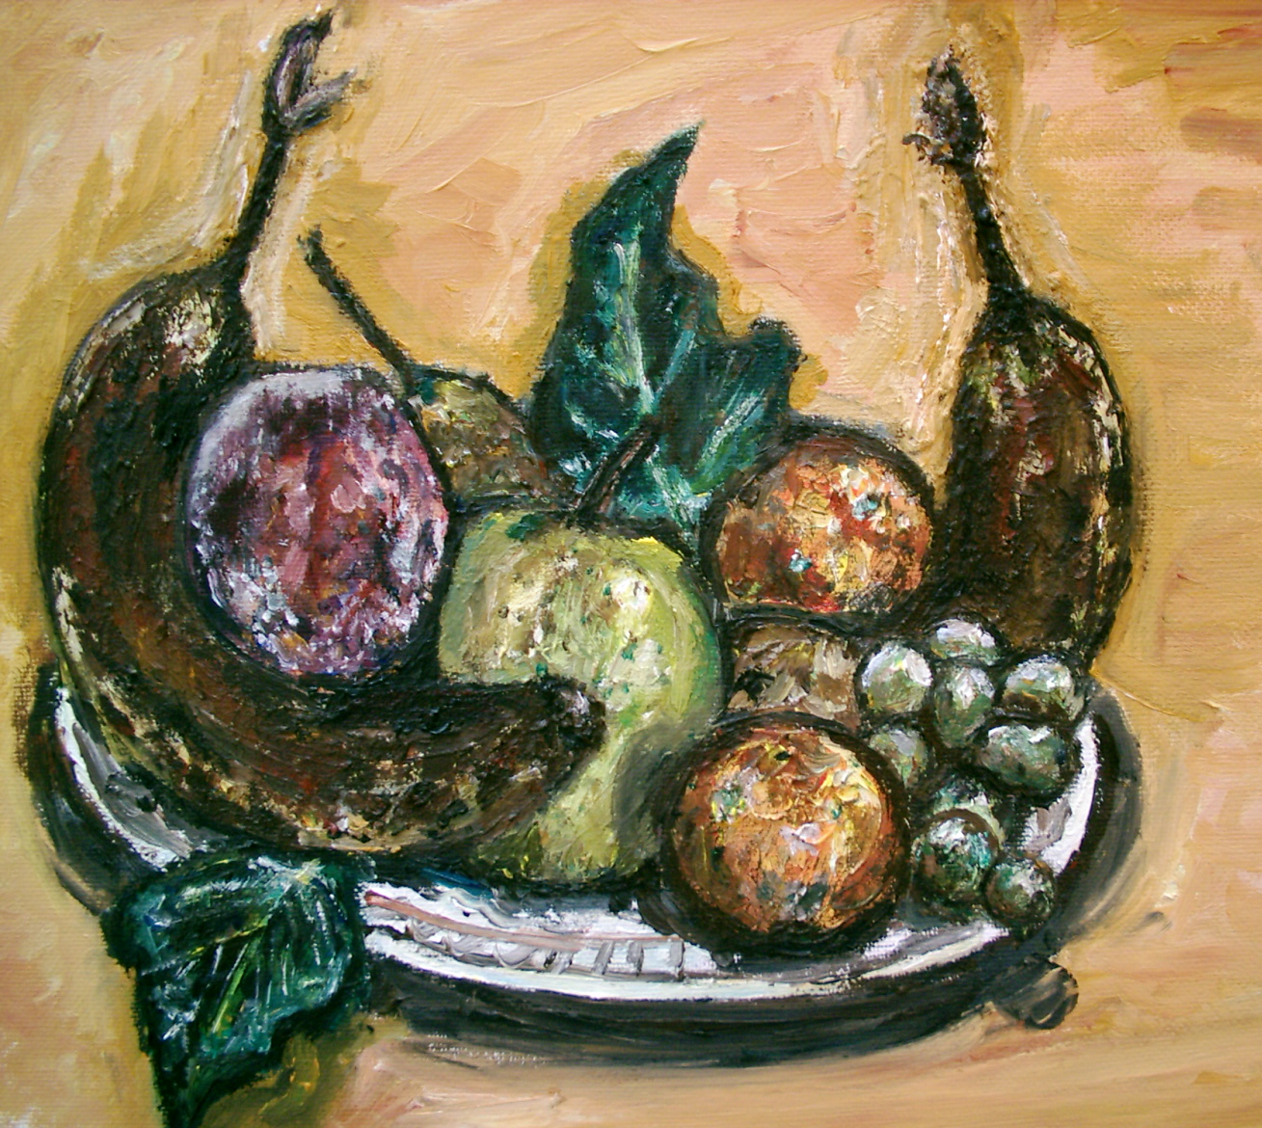

The end quality of the photo sequence is the biggest weakness of the project. The pictures, in some cases, were out of focus and the canvas rotated due to slight alteration of the angle from which the photographs had been taken. ‘Photoshop’ and ‘Shake’ were used to effect corrections to try and resolve the issues. Nevertheless I feel the project was successful because the process was as important as the end result if not more so, and for this purpose the painting technique worked well.

If I could begin this project again I would definitely make use of a tripod and a better quality camera. Although the images went through quite a few adjustments to both improve the quality of the image and to gain continuity between them, it has not proved possible to get this exactly right in my opinion. Some of the pictures were better quality than others, so in some places the continuity has been compromised reflecting the frame quality differences. Initially the pictures were individually cropped and rotated to improve their alignment, however in places they still did not overlap to my satisfaction. This problem was further corrected by using the corner pin tool in ‘Shake’.

To further minimise the movement and focus on the actual transformation of the fruit I decided to modify the images, making them simpler by blocking out the background and then composing back to a uniform painted background. This greatly helped to make the changes in the fruit stand out better as well as clearing up some of the continuity issues. However, after composing the images together it became apparent that cutting the background for the fruit out had an impact on the aesthetic quality. The process for creating the piece seemed to be incomplete and it was obvious the paintings had been extracted, losing the subtleties around their edges. I had become so focussed on making the changes caused by decay visible that I temporarily forgot the importance of the process. I therefore decided to recompose and align the piece using images with their actual background. The pictures with the painted out backgrounds were however used in the credits to demonstrate the changes happening at a faster rate.

The final animation works by slowly fading between images of the same painting, each showing a slight progression of the process of decay. I had to decide the speed with which the images should change, and opted to keep the time period between each relatively slow as the effect aimed for was a smooth process of metamorphosis rather than the dramatic. As mentioned, during the credits the sequence is presented at a faster frame rate so that the changes that occurred could be better understood.

Although frequently paint was added to wet paint already on the canvas, painting over the same picture was not too much of a problem. My personal style of painting is to make big, bold brush strokes, mixing the paint on canvas. I don’t aim to produce photo realistic renditions. However the main challenge came as a consequence of the fruit not just changing in colour and shape but also in size. This meant that in places, space previously filled by the fruit had to be blacked out and the background outline had to be changed continually.

Around day 25 there was an unexpected problem. The fruit was accidentally knocked over. I had major difficulty in trying to reassemble the fruits to their exact, balanced positions at identical rotations. The consequence of this was that the paintings thereafter were not exactly true to the form set at the start.

I found the rate of decay to be disappointingly slow. I had hoped both that a great deal more mould and ‘fur’ would have grown, and also that the fruit would have gone from optimum state to total decomposition to fulfil my aim to capture the entire process. Of necessity, the environment the fruit was kept in was cold and light (a conservatory) so to try and speed things along a heater was introduced. Nevertheless the 52 day period proved not to be long enough for complete degeneration.

The original plan had been to update the painting of the fruit every day. However, because there was minimal change in a 24 hour period, it seemed sensible to extend the time so that actual changes could be a little more clear. Unfortunately, it proved impractical to record the fruit at the same time each day. If this had been possible it could have made a difference to the quality of the piece in terms of continuity between photographs, particularly with reference to the lighting.

For me, the most interesting fruit in the still life was the peach because the changes that occurred were a lot more dramatic and visually interesting than the others. The growth of fur that changed colour from white to green was very beautiful. In appendix 1 there is a detailed account with photographs discussing how decay affected each member of the still life.

In conclusion, from the varied examples of works I examined I think that for many people, beauty in decay can be found at some level, whether this be in the colours, textures, entropy or the interaction between time and form. Even if the reader’s opinion is that there is no beauty in decay, the fundamental role of decay in the cycle of life proves that in nature, although not in food, decay is beneficial and integral to the process of evolution. For me, beauty can be found in decay, and the animation produced attempts to demonstrate so.

The actual technique used for the animation, in my opinion, worked very well and achieved my goals of being innovative and experimental. It was successful in documenting the passage of time. I do however think that the quality would have been enhanced and a lot of work avoided if a tripod and better quality camera had been used. In addition, the end result could have been enhanced if either the fruit had decayed faster or there was a longer period of time in which to complete the experiment, as this would have allowed completion of the decaying process and a more substantial piece. Nontheless, I am pleased with the end product.

Bibliography

Books
- BENEDITTI S (1993)‘Caravaggio, The Master Revealed’ national gallery of Ireland ISBN 0903162687, p148
- BUTTON V. (2003) ‘Turner Prize’ ISBN 1 85437 5121, copyright1997 Tate Gallery, updated edition 1999, 2003. Published by tate publishing Ltd. p194-5
- READ H. (1972) ‘the meaning of art’, new and revised edition. Originally published 1968. LONDON: Faber and Faber Ltd, paper back
- RUSSET R and STARR C (1988) ’Experimental Animation origins of a new art’ Revised edition, Previous ed, New York: Van Nostrand Reinhold 1976. Published by Da Capo press, paper back, ISBN 0 306 80314 3 pp120-124

Video

MCWILLIAMS D (1991)‘creative processes : Norman Mclaren’ Published London: connoisseur. In association with the national film board of canada

Web pages

BECK M (2004) ‘the life cycle and man’ http://www.malcolmbeck.com/articles/the-life-cycle-and-man.htm, cited from the book “the secret life of compost” by Malcolm Beck. Section of a book discussing

Prof BRUYN S T (2002) ‘Art and Aesthetics in Action’ http://www2.bc.edu/~bruyn/Theoretical.html Paper discussing aesthetics

CUNNNIGHAM S ‘Michelangelo Merisi da CARAVAGGIO’ http://www.sparklenet.com/1_Main_Street/Art_Smarts/Master-a-Month/Caravaggio.htm
Webpage discussing Caravaggio

DAVYDORA A (2004) ‘Death becomes her’ http://www.sptimes.ru/archive/times/1026/features/a_14268.htm
Article about Sam Taylor Wood for the st Petersburg times (published 03/12/04)

DUPREE C (2002) ‘Impermanent art’ http://www.harvardmagazine.com/on-line/01027.html . Magazine article for Harvard, published in Jan-Feb 2002 ed, discussing impermanent art

GAYFORD M (2001) ‘Ordinary and sublime’ http://www.telegraph.co.uk/arts/main.jhtml?xml=/arts/2001/11/29/bagay28.xml
Article for the guardian on 28/11/2001, copyright Telegraph Group Limited (2005) discussing the work of Sam Taylor Wood and Mark Wallinger

GREEN C and SMEIATANA M (2000) ‘Spoiled Rotten’ http://artmagic.homestead.com/spoiledrotten.html . Official Website for the ‘spoiled rotten’ exhibition

HAMOU O (2004) ‘Thoughts for June 2004’ http://www.sarskaia.org/news-n-press/news20040601.htm

HANGARTER R P (2000) ‘plants in motion’ http://sunflower.bio.indiana.edu/~rhangart/plantmotion/starthere.html
Created at the Indiana University, Department of Biology. Discusses timelapse in relation to plants

HICKLING A (2002) ‘Marc Quinn’ http://www.guardian.co.uk/reviews/story/0,3604,642834,00.html
review for the Guardian 01/02/2002 briefly comparing Marc Quinn’s work to Cararavaggo

HUNTER K (2003) ‘The beauty of compost piles!’ http://www.svswa.org/recycling/recycling_articles/2002-03.html Discusses the effects of unnaturally disposing of organic matter

KOURNIKAKIS B (2001) ‘Pumpkin Time Lapse Videos’ http://members.memlane.com/bkournikakis/time.htm outlines process of making time lapse film

KREN E and MARX D. ‘Caravaggio’ http://www.wga.hu/frames-e.html?/html/c/caravagg/02/14basket.html Shows painting of ‘basket of fruit’ By Caravaggio for the web gallery of art

LERIOS A (1995) ‘Image Morphing versus 3D Morphing’ http://graphics.stanford.edu/papers/morph/paper/node2.html. Paper discussing image morphing

MEINWAL D ‘memento mori: death and photography in nineteenth century America’ http://cmp1.ucr.edu/terminals/memento_mori/ printed publication CMP Bulletin, vol. 9, No. 4.
POTTER P (2004) “Michelangelo Merisi da Caravaggio (1571–1610). Basket of Fruit (1596)” http://www.cdc.gov/NCIDOD/eid/vol9no12/about_cover.htm, posted November 20, 2003, last reviewed April 13, 2004

WEIS P H (1998-2004), ‘the natural cycle’ http://www.truehealth.org/anatcycl.html Vancouver. Paper discusses health issues relating to decay

‘Turner prize 2003’, http://www.tate.org.uk/contact/forums/turnerprize2003. Discussion forum on the subject ‘Can't decomposing fruit be beautiful?’

‘Turner Prize 2003’, http://www.tate.org.uk/britain/turnerprize/2003/gallaccio.htm. Text outlining Gallaccio’s background and work for the turner prize 2003.

(1997) ‘Entropy’ http://www.geocities.com/Heartland/7547/entropy.html. Web page discussing entropy

Lexico Publishing Group, LLC (2005) http://dictionary.reference.com/search?q=entropy
Dictionary definition of entropy. Referenced from: The American Heritage® Dictionary of the English Language, Fourth Edition
Copyright © 2000 by Houghton Mifflin Company.
Published by Houghton Mifflin Company.

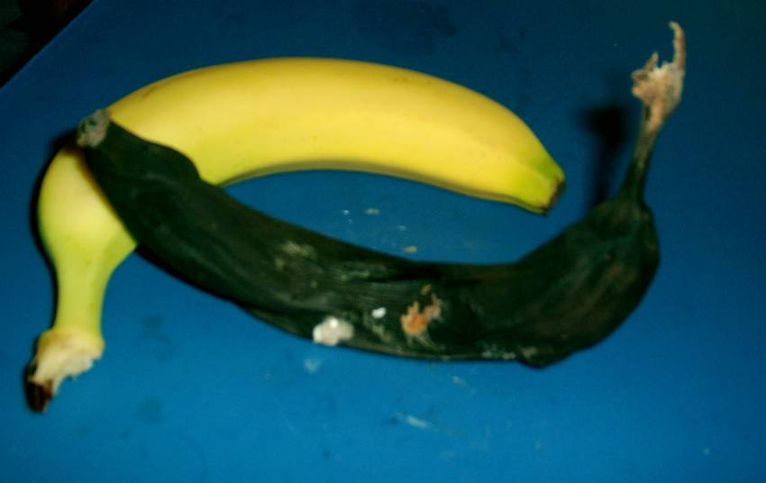
The bananas were the first members of the ‘still life’ to go through significant changes. They began yellow and with areas of lime green around the edges. The texture was smooth and the banana was tough in consistency, holding its shape well. Within a matter of days brown patches had began to appear, at first in small patches, these however spread and grew in frequency. By day 28 no yellow was longer visible and the banana darkened further, simultaneously the stalk turned from green to black and shrunk in diameter to less than a quarter of its original size, seeming in both size and feel almost twig like. The shape had deteriorated where the underside had taken the shape of the plate

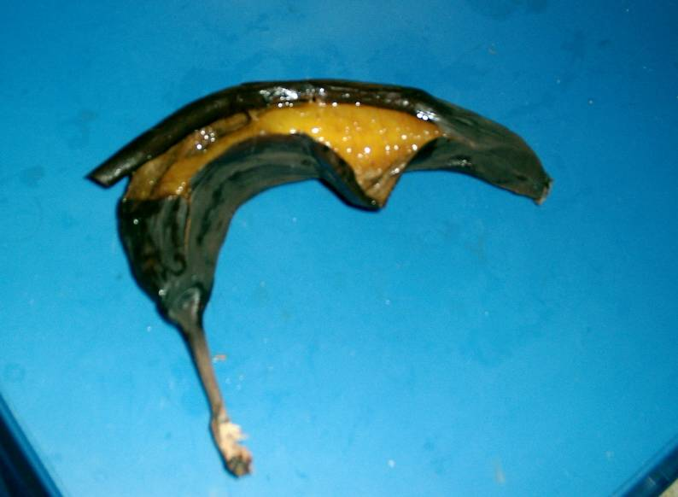The skin had decomposed to be thin and wrinkled, barely strong enough to hold its contents so it was easy to tear open to reveal a brightly orange, marmalade type substance. The flesh was very decomposed and of a viscous nature.
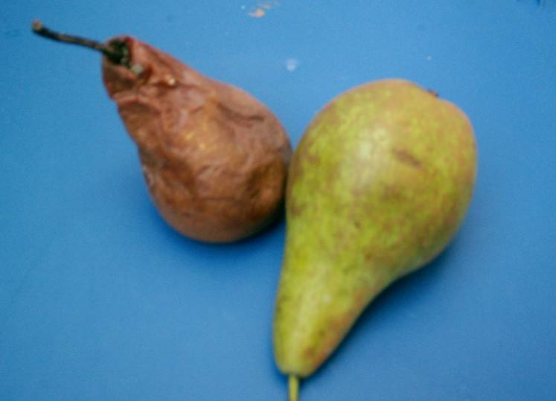
It was unfortunate that the pears were in the most part hidden from the view of the painting because their decomposition became relatively advanced. The colour that had began a ripe green/ green-brown gradually altered to a brick colour. The solid firm shape, became wrinkled and soft, changing shape when moved. At the top the beginnings of mould were visible.
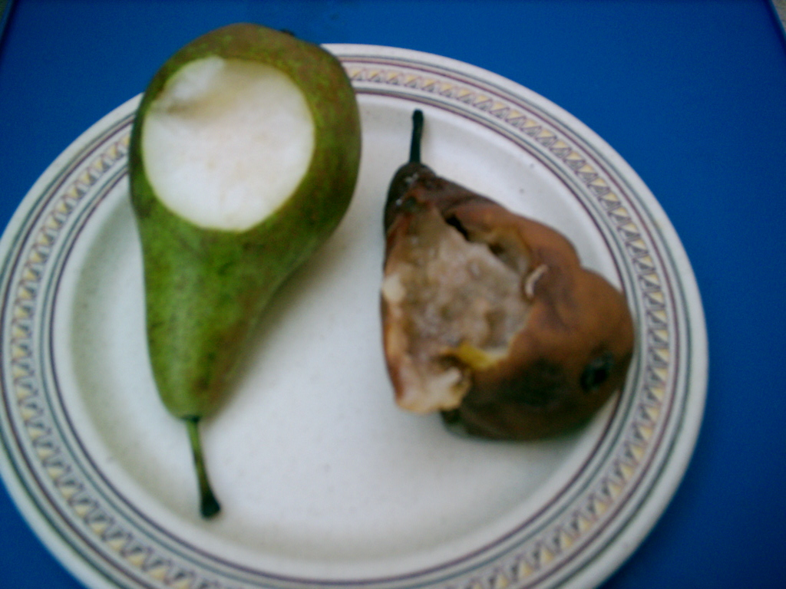
The ripe pear, used as a comparison, was tough to slice open thus a sharp knife having to be used. The skin on the decomposed pear simply tore with little effort to reveal a very sticky broken down state of matter. This showed great contrast to the pale and firm texture of the ripe pear.
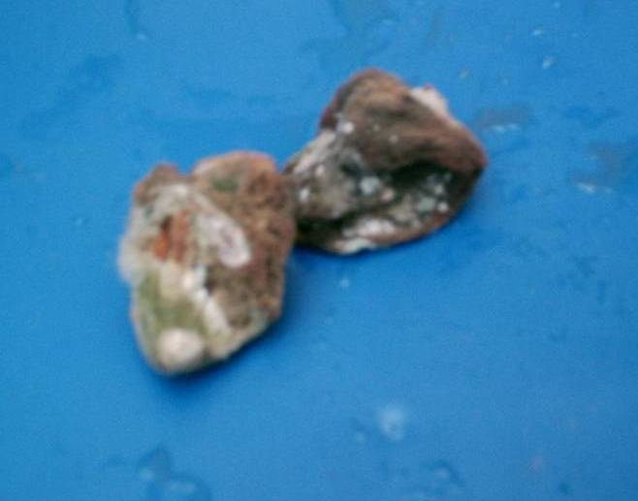
The changes that occurred to the peaches were by far the most drastic. Once the process had really started (around day 22) the fruit shriveled and shrunk at a relatively fast rate, by the end the peaches were less than a quarter of their initial size. It was also the only fruit that had significant growth of ‘fur.’ This was very interesting to watch as it started in small, white patches, then grew and in places turned green or black at the ends.
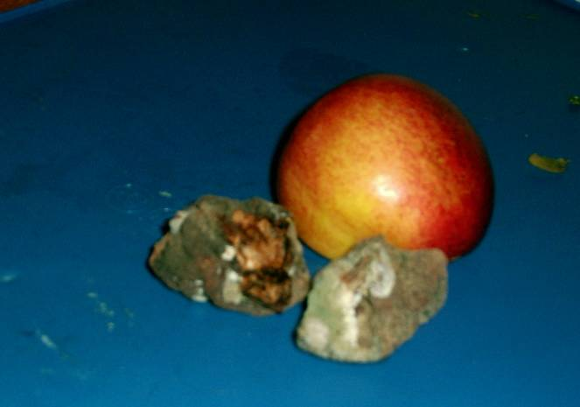
The texture of the original peach had been furry and relatively soft, after 52 days it had become totally shriveled and very tough. Once open it became apparent that the inner flesh had disintegrated to form a tough layer surrounding the seed inside.
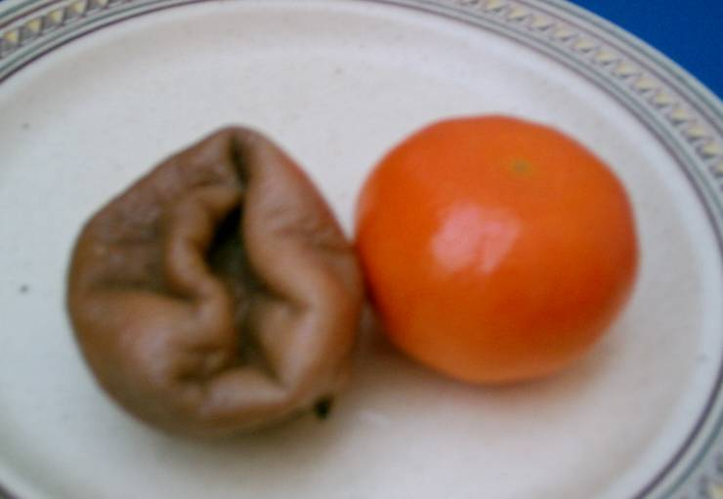
The satsumas were quite disappointing as it had been expected that they would have developed mould. One of them remained relatively unchanged and the other developed a bruise, as the days progressed the bruise grew larger until it progressed to the point where the top section collapsed inwards.

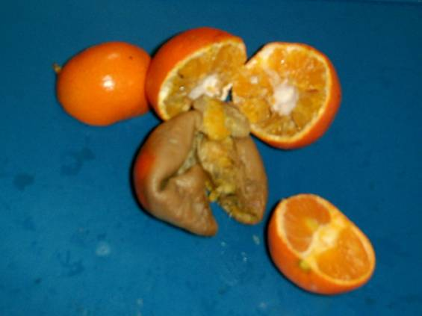

The satsuma’s were broken open to reveal orange/brown ‘mash,’ this contrasted a great deal to the organized segments of the ripe satsuma.

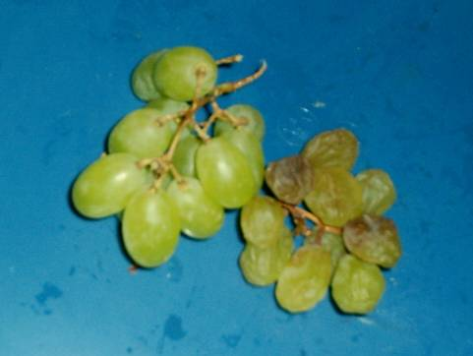
Due to their size and the limited changes in size and colour that occurred the grapes were difficult to document. The shape began firm, smooth and round, by the end this had disintegrated, leaving shriveled, almost empty forms. In addition many of the grapes had browned.

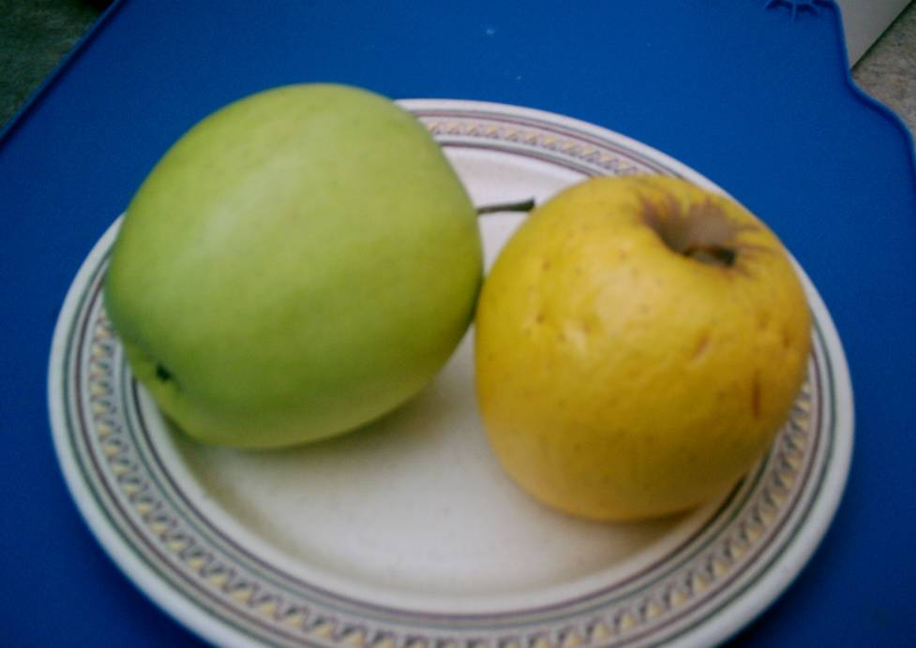
The main changes that occurred to the apple were in relation to colour and texture. Beginning green the apple gradually transformed to be yellow/brown and marked. The texture changed from smooth and firm to very greasy and wrinkled.

Hamou (2004) http://www.sarskaia.org/news-n-press/news20040601.htm ‘Thoughts for June 2004’
Beck http://www.malcolmbeck.com/articles/the_life_cycle_and_man.html, cited from the book “the secret life of compost”
BRUYN (2002) ‘Art and Aesthetics in Action’ http://www2.bc.edu/~bruyn/Theoretical.html
Beck http://www.malcolmbeck.com/articles/the-life-cycle-and-man.htm, cited from the book “the secret life of compost”
Weis (1998-2004), http://www.truehealth.org/anatcycl.html Vancouver
picture cited from Weis P. H. 1998-2004, Vancouver. http://www.truehealth.org/anatcycl.html
H Read ‘the meaning of art’ p18
http://www.tate.org.uk/contact/forums/turnerprize2003
Prof Severyn T BRUYN (2002) http://www2.bc.edu/~bruyn/Theoretical.html ‘Art and Aesthetics in Action’
Oma Hamou (2004) http://www.sarskaia.org/news-n-press/news20040601.htm ‘Thoughts for June 2004’
http://dictionary.reference.com/search?q=entropy
(1997) http://www.geocities.com/Heartland/7547/entropy.html
http://www.sptimes.ru/archive/times/1026/features/a_14268.htm
(2003)‘Turner Prize’ , p194-5
Ibid.
http://www.tate.org.uk/britain/turnerprize/2003/gallaccio.htm
Ibid
Meinwald ‘MEMENTO MORI:DEATH AND PHOTOGRAPHY IN NINETEENTH CENTURY AMERICA’ http://cmp1.ucr.edu/terminals/memento_mori/
http://www.wga.hu/frames-e.html?/html/c/caravagg/02/14basket.html
Scott Cunningham ‘Michelangelo Merisi da CARAVAGGIO’ http://www.sparklenet.com/1_Main_Street/Art_Smarts/Master-a-Month/Caravaggio.htm
Sergio Benedetti ‘Caravaggio The Master Revealed’ p148
Scott Cunningham ‘Michelangelo Merisi da CARAVAGGIO’ http://www.sparklenet.com/1_Main_Street/Art_Smarts/Master-a-Month/Caravaggio.htm
Polyxeni Potter ‘Michelangelo Merisi da Caravaggio (1571–1610). Basket of Fruit (1596)’ (2004) http://www.cdc.gov/NCIDOD/eid/vol9no12/about_cover.htm
Polyxeni Potter “Michelangelo Merisi da Caravaggio (1571–1610). Basket of Fruit (1596)” http://www.cdc.gov/NCIDOD/eid/vol9no12/about_cover.htm
Alfred Hickling (2002) ‘Marc Quinn’ http://www.guardian.co.uk/reviews/story/0,3604,642834,00.html
?Alfred Hickling (2002) ‘Marc Quinn’ http://www.guardian.co.uk/reviews/story/0,3604,642834,00.html
http://www.sptimes.ru/archive/times/1026/features/a_14268.htm
Martin Gayford (2001) ‘Ordinary and sublime’ http://www.telegraph.co.uk/arts/main.jhtml?xml=/arts/2001/11/29/bagay28.xml
Bill Kournikakis ‘Pumpkin Time Lapse Videos’ (2001) http://members.memlane.com/bkournikakis/time.htm
‘plants in motion’ http://sunflower.bio.indiana.edu/~rhangart/plantmotion/starthere.html
Clive Green and Michael Smietana "Spoiled Rotten" http://artmagic.homestead.com/spoiledrotten.html
pictures cited from : Clive Green and Michael Smietana "Spoiled Rotten" http://artmagic.homestead.com/spoiledrotten.html
Ibid
Kurt Hunter ‘The beauty of compost piles!’ http://www.svswa.org/recycling/recycling_articles/2002-03.html
Clive Green and Michael Smietana ‘Spoiled Rotten’ http://artmagic.homestead.com/spoiledrotten.html
picture cited from: Catherine Dupree ‘Impermanent art’(2002) http://www.harvardmagazine.com/on-line/01027.html
http://www.harvardmagazine.com/on-line/01027.html
Catherine Dupree (2002) http://www.harvardmagazine.com/on-line/01027.html
Herbert Read (1972)‘the meaning of art” p19
Apostolos "Toli" Lerios(1995) ‘Image Morphing versus 3D Morphing’ http://graphics.stanford.edu/papers/morph/paper/node2.html
Robert Russet and Cecile Starr (1988) ‘experimental animation origins of a new art’ p122
video reference: Donald McWilliams(1991) ‘creative process: Norman McLaren’
Robert Russet and Cecile Starr (1988)‘experimental animation of new art’ p122
Ibid
Experimental animation p123
Experimental animation p123

