Introduction

In this report, the Renderman texturing/modelling method known as displacement mapping is put under the microscope. What it is, and where and how it is used is covered in varying depth. I set out primarily to learn more about Renderman, then apply my new found knowledge in the creation of a couple of my own displacement shaders. It is hoped that this paper contains sufficient material to educate those who are ignorant to the actual displacement mapping method and its relationship to Renderman. The research section of the text is either based upon, or quoted from previous research and publications, due to the sheer clarity of explanation. Other topics covered are Noise, Antialiasing and Spectral Synthesis.

Displacement Mapping – Previous Work and Research

“Displacement Mapping creates new geometry by first tessellating (dividing) existing triangles into smaller ones and then perturbs the new geometry by displacing the created vertices according to a displacement map.” 1

Before explaining how displacement mapping enhances images, we should look at the work that led up to its development. After the Lambert and Phong lighting models, Ed Catmull developed texture mapping in 1974. Jim Blinn extended the functionality of texture maps by giving us the idea of Bump Maps.2

Up till that point, shaders were used to modify visual attributes of the surface like opacity, colour and specularity. Blinn provided us with a method of altering the normals of the surface. Bump mapping would calculate the normals for a point if it was displaced, so on rendering, this would give the surface a bumpy appearance. However, since it was only the normals being altered, and not the actual geometry, silhouettes of bump mapped shapes would reveal what was really happening, destroying the illusion of reality.

Although detailed, due to optical character recognition faults, the Blinn paper is slightly tedious to translate. As a result, we will be looking at the much simpler explanation from Peachey.3
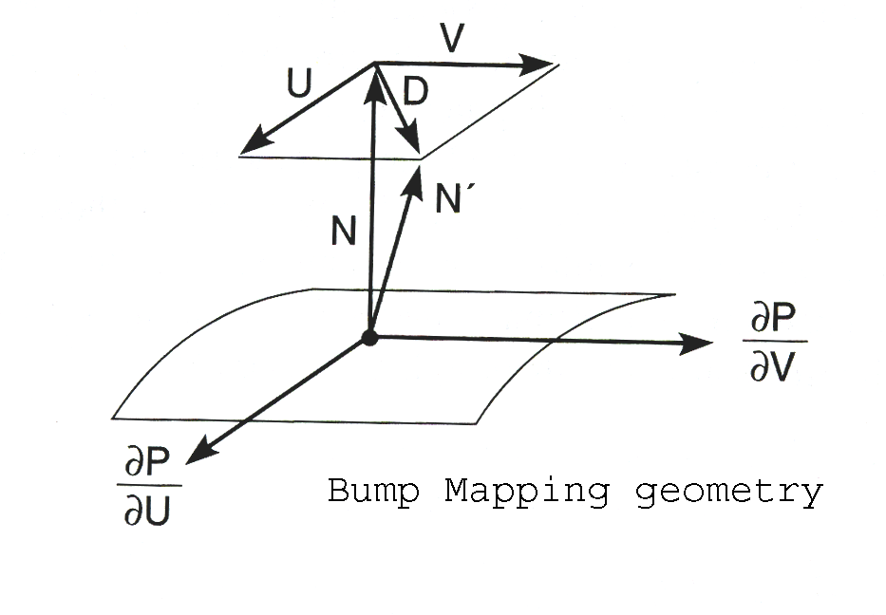
Above we see the simulation of a point being perturbed, along the normal vector N.
The perturbed normal vector N'=N + D.
D, the perturbation vector, lies in the tangent plane of the surface and as a result, is at 90 degrees to N.
D itself is the sum of two seperate perturbation vectors U and V.
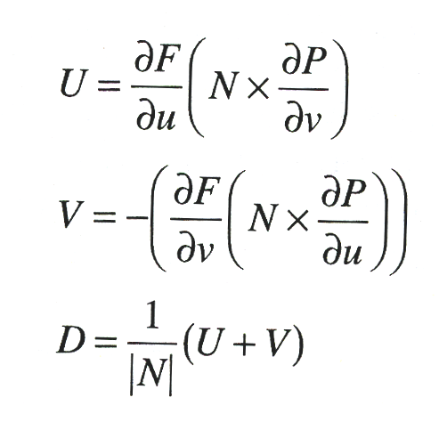
the N x dP/dv cross product is perpendicular to N, and thus also perpendicular to the partial derivative of P, with respect to v. This derivative lies in the tangent plane and indicates the direction that P changes as the v parameter is increased.
If the parametric directions are exactly perpendicular to each other, adding a perturbation to N along the direction of this cross product, would tilt it as if there was an upward slope in the surface, going along the u direction. The dF/du gives us the correct slope of the bump function, with respect to u.

The newly calculated normal is then used in lighting calculations, giving the surface a “textured” appearance.

In pseudo code, this is what takes place:

take point P on surface
calculate normal for point P in a new position
render point P as having this normal

or in Renderman Shading language:

point PP; /*make a point*/
float F=/*some sort of bump function*/
PP=P+F*normalize(N); /*assign the new position to PP*/
N=calculatenormal(PP);

The actual geometry is not being altered at all and as a result, silhouettes of bump mapped objects ruin the illusion of their bumpiness. Here is what displacement mapping does:

take point P on a surface
translate point P by distance along its normal
calculate normal for point P in a new position
render point P

again, in Renderman Shading language:
float F=/*some sort of bump function*/
P=P+F*normalize(N);
N=calculatenormal(P);

The difference in code is marginal, but the results are not.
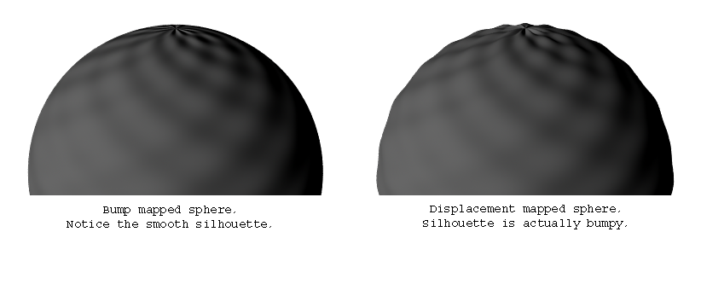

As you might guess Displacement mapping adds a fairly large overhead to the processing, but problems from bump mapping are eliminated – incorrect shadowing, smooth silhouettes.
Now that we have covered the developments leading up to displacement maps, let us see how the tessellation is dealt with. The existing source triangles must be tessellated into smaller ones. There are many algorithms for performing this task. The most common technique of subdividing is shown below.

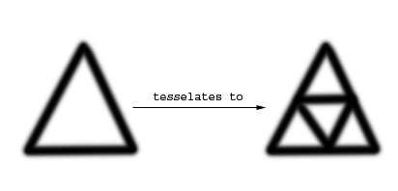
Each edge is split at its midpoint and if need be, the triangles can be iteratively subdivided to produce finer detail. With this tessellation method, the number of triangles resulting for a single source triangle is 4^{n}, where n is the number of iterations performed.

The most straightforward method of tessellating source triangles is to uniformly divide it into a web of smaller triangles throughout the entire mesh. This will produce good-looking results and the new geometry will be easy to generate, regardless of the level of detail in the displacement map. However, creating so much geometry is processor intensive, and usually unnecessary (think about large flat low detail areas).

A method that is used to lessen the overhead of the rendering process is to process the displacement map and examine the level of detail it has, making a height variation map for each texel (the smallest element of a texture map). “This is done by calculating the second derivative of the height variation to the adjacent eight texels of every texel, and storing the result into another map.” This means that you store the rate of the rate of change (if the rate of change was analogised to velocity, then the rate of rate of change would be acceleration). Overleaf are a displacement map and its second derivative.

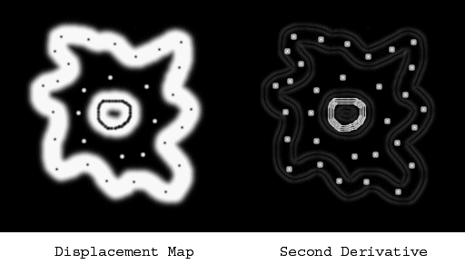
Image taken from 1

The second derivative highlights detailed or “slopey” areas. When tessellating a mesh, the triangles are scan-converted to texture space and the texels inside are examined for detail from the second derivative map. If there is not enough detail, the triangle is left alone and the remaining mesh is processed. The image below shows the 3d mesh in its unsubdivided state and then again after its tessellation. The displacement map in the previous diagram was used.

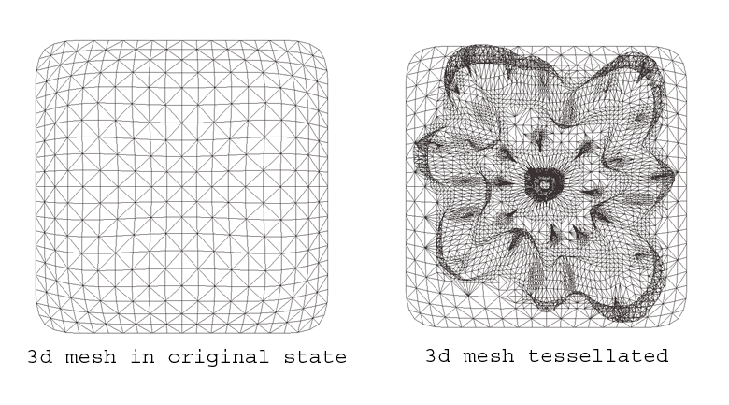
Image also from 1

Note, that in the diagram the vertices of the tessellated mesh have not been displaced yet. It has merely been tessellated. When you tessellate triangles, unevenly split edges can occur. These are called “T-junctions”. What happens is an edge is split on one side, but not on the other. So, on one side, there are two edges and on the other, there is only one. If displacement is applied to a mesh with T-junctions, artifacts such as cracks or jaggedness will occur.

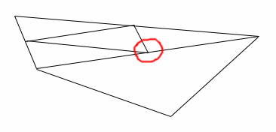
A T-Junction

When the T-junction ladened mesh is displaced, the renderer processes the edge several times differently. This may produce nasty artifacts, especially when the vertex is to be displaced relatively far from its original position. To prevent artifacts from happening, we must eliminate all the T-junctions. Neulander suggests when we tessellate, we must keep a table of all the shared edges, so that they are not split twice. In this table, the edges are uniquely identified by the ordered pair of its original two vertices. The mesh must be searched for T-junctions and when a problematic triangle is located, it must be subdivided so that its edges are not split anymore.

T-Junctions only appear in meshes that are subdivided unequally. If all triangles are equally subdivided, then the edges are split evenly and we will not have to worry about T-Junctions. The cost of this is the vast amount of calculations.

Another problem that Neulander mentions is the preservation of the original mesh's implicit curvature. He suggests that a subdivision scheme, such as Loop's or the Butterfly scheme would guarantee a smooth and consistent surface. However, these schemes are expensive, since they require access to neighbouring edges.

Loop Subdivision1

This process can be split into two sections. The first step is “splitting”, where the triangles are split into 4 smaller triangles (as shown above). After this comes the “averaging” process, where all the vertices are relocated by replacing its position with a weighted average of its neighbours. The corresponding weight masks are shown below.
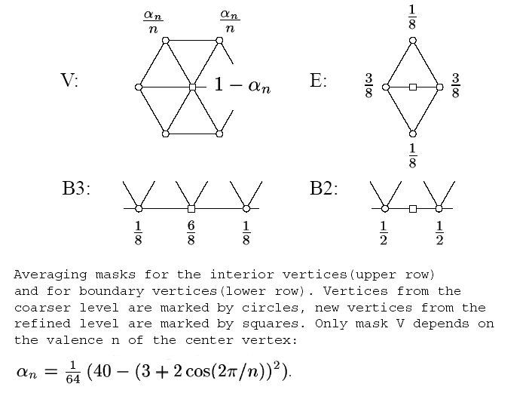
Each vertex is either “regular” or “irregular”. This is determined by the number of neighbouring vertices it has. A regular inner vertex would be valence (“The capacity of something to unite, react of interact with something else” - www.dictionary.com) 6, whilst a regular boundary vertex would only have a valencey of 4.

A problem with the Loop subdivision method is that the averaging process shrinks down the mesh, though it is a very smooth product. This can be resolved by adding an extra strip of triangles around the boundary edge (using the parallelogram rule – see diagram), before the subdivision is applied.
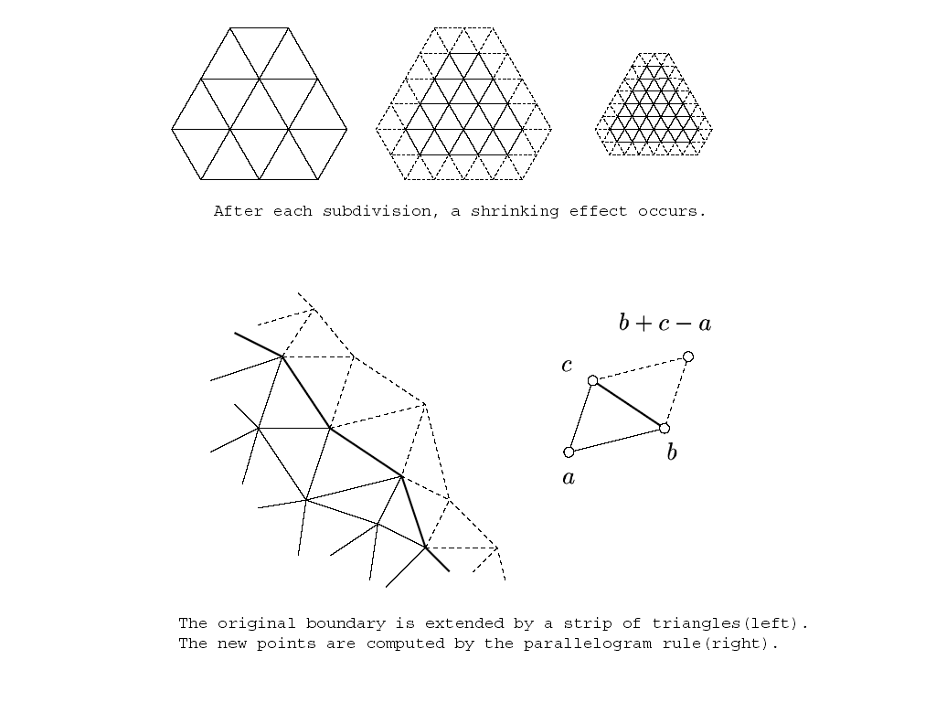

The Renderman Pipeline and how Displacement Mapping fits into it1

Renderman uses a REYES (Renders Everything You Ever Saw) architecture. The first thing it does, after loading the scene description, is to bound all the primitives in boxes. Renderman does not support unbound primitives, such as infinite planes, so this stage is fairly straightforward.

Next, the renderer checks whether the bounding box is on screen at all. Renderman does not do Global Illumination and due to this feature – if something is not on screen, it cannot contribute to the overall image.

If the object is partially visible, it is split into smaller primitives (the off screen elements are discarded).

The next phase is known as “dicing”. The primitives are converted to a common format called a grid. A grid is a tessellation of the primitive into a rectangular array of micro polygons. The vertices of these little facets are to be shaded later, so the facets must be very small so that the renderer can create high quality images.

Next up in the pipeline is the shading process. Firstly Renderman deals with the displacement shaders, moving vertices and recalculating normals. Then it evaluates all the surface shaders, computing all the colour and opacity values for every grid vertex. Finally, the atmosphere shaders are processed. These adjust vertex colour and opacity to simulate any volumetric effects that may have been applied.

After it has been shaded, the grid is sent to the hidden surface evaluation routine. The grid is busted into individual micro polygons then goes through a mini version of the main loop (it is bounded, checked for on screen presence and back face culled if necessary). The bound determines which pixel the micro polygon covers. A stochastic sampling algorithm tests the micro polygon to see if it covers any of the several predetermined point-sample locations of that pixel. For any samples that are covered, the colour and the opacity of the micro polygon are recorded as a visible point. Once all the primitives over a pixel have been processed, the visible point lists for each pixel can be composited together and the final color and opacity are generated.
Unlike other renderers, Renderman performs shading calculations before the hiding algorithm is run. Normal scanline renderers have their polygons depth-sorted, identified as being visible, then have those polygons clipped to create spans which cover portions of the scanline. The end points of those spans are shaded and then painted into pixels.
In Ray tracing renderers, objects are only visible if a ray hits them. Radiosity renderers often resolve colors independently of a specific viewpoint but still compute inter-visibility as a prerequisite to energy transfer.

The significant advantage of shading before hiding, is the involvement of displacement mapping. The final locations of the vertices are not needed by the hiding algorithm till shading is completed. Thus, the shader is free to move points around without the hider ever knowing about it. In other rendering algorithms, if a shader moved vertices after the hider had resolved the surfaces, the hider's results would be invalidated.

The disadvantage of shading before hiding is that the objects are shaded, whether or not they will be eventually hidden from sight. If a scene has large depth complexity, a lot of geometry would be shaded, only to be covered up by objects closer to the camera. This is a huge waste of processor time.

In this pipeline, each stage of processing converts a primitive into a finer and more detailed version. Its representation in memory also increases as it is split, diced,busted and sampled. However, every primitive is processed independently and has no interaction with other primitives in the system. For this reason, the geometric database is streamed through the pipeline. The algorithm uses almost no memory. However, there is one exception: the visible points list.

The visible point list mentioned earlier, cannot be processed until it is known that all the primitives that cover its pixel have been processed. The streaming version of Reyes cannot know that any given pixel is done until the last primitive is rendered, so it must store all the visible point lists for the entire image till the end. These lists contain point sampled representations of the entire geometric database and are very large.(Many gigabytes per frame)

The solution comes in the form of a technique known as Bucketing.
A modified REYES algorithm recognizes that the key to limiting the overall size of the visible point memory is to know that certain pixels are done before having to process the entire database. Those pixels can then be finished and freed early. This is done by dividing the image into rectangular pixel regions, called buckets (hence “bucketing”), which will be processed one by one to completion before significant amounts of work occur on other buckets.

The most important difference to the pipeline is in the bounding step. Now the primitives are sorted based on which buckets they affect (which buckets the bounding box overlaps). If a primitive is not visible in the current bucket of interest, it is put onto a list for the first bucket where it will matter and is thereby held in its most compact form until it is actually needed.

After this, the buckets are processed one at a time. Objects are removed from the list for the current bucket and either split or diced. Split primitives might be added back to the list or might be added to the lists of future buckets, depending on their bounding boxes. Diced primitives go through the normal shading pipeline and are busted. During the busting, micro polygons are bound and similarly bucket sorted. Just like the primitives, micro polygons that are not in the current bucket of interest are not sampled until the appropriate bucket is processed.

Eventually, the current bucket will have no more primitives on its list, either because they have all been sampled, or transferred to future buckets. At this point, the visible point list can be resolved, and the pixels for that bucket displayed. This is why Photo Realistic Renderman creates output pixels in little blocks.

Displacement bounds1

Displacement shaders are able to move vertices of the grids, but there is no formal limit to the extent of their deformation. Shading occurs after the bounding, splitting and dicing processes. Renderman relies heavily on its accurate bounding process to place primitives in the correct bucket. A displacement shader can actually move a vertex outside of its original bounding box, meaning that it is in the wrong bucket. Typically, this results in a rendered hole, which corresponds to the bucket where the grid “should have been considered but wasn't”.

This can be avoided by supplying the renderer with a displacement bound. From the shader's point of view, this is the maximum distance that any vertex might travel. From the renderer's point of view, this number represents the padding that must be given to every bounding box calculation before shading, to stop the vertices from leaving their boxes. The renderer grows the primitive bounding box by this value, which means that the primitive is diced and shaded in a bucket earlier than it would normally be processed. This often leads to micro polygons that are created before their buckets need them – wasting great amounts of memory. As a result, it is important that displacement bounds are as tight as they can be, to minimise damage.

Extreme Displacement

The renderer is sometimes stuck with large displacement bounds. This might be because the object really does do a large displacement, or the camera is looking extremely closely at the object and displacements appear to be large on screen. In extreme cases, the renderer can lose huge amounts of memory to micro polygon lists that contain most of the geometric database. In these cases, there is a better option. The problem with the displacement bound is that it is the worst case (maximum) estimate over the primitive as a whole, whereas the small portion of the primitive represented by a single small grid usually does not contain the worst case displacement and actually could get away with a much smaller (tighter) bound.
The solution to this is to actually run the shader to evaluate the true displacement magnitude for each grid on a grid-by-grid basis, storing the exact displacement bound with each grid. The disadvantage of this technique is that the primitive must be shaded twice, once to determine the actual displacement bound and once to generate the colour when the grid is processed normally in its bucket.

Another problem that is mentioned is the way in which displacement shaders might stretch the micro polygons. This is caused when displacement shaders move the vertices of a micro polygon apart, so that it no longer obeys the constraint that it is approximately the size specified by the shading rate. The stretching of the micro polygons is usually visible in the final image. An individual flat-shaded micro polygon creates a constant coloured region in the image. With a standard shading rate of around a pixel, every pixel gets a different micro polygon and the flat shading is not noticeable. However, large stretched and twisted micro polygons will cover many pixels, making the constant colored region evident.
This can be slightly fixed by using smooth shading interpolation, which blurs the shading discontinuities. However, the geometry is still at fault. If it is possible, reducing the frequency content of the displacement shader so that adjacent micro polygons cannot have hugely varying motion is a good choice of action. Otherwise, a brute force approach to solving this problem is to reduce the shading rate to 0.25 or lower, so that even the micro polygons stay under one pixel in size. This, of course, will have a significant performance impact.

Raytracing of Displacements

The current implementation of PR Renderman does not support true ray tracing of displaced surfaces. Instead it “cheats” by using bump mapping. One solution I came across was the paper entitled “Inverse displacement mapping for the general case” by JR Logie + JW Patterson.

The problem with the REYES architecture is that it "dices" (converts) objects into a very fine grid of micro polygons, before rendering. The surface is diced in isolation from the displacement map, so quality is not always guaranteed. REYES imposes strict size requirements on the size of the diced polygons - the displacement can invalidate these requirements, causing artifacts.
The "key computation involved is the intersection of the ray and the surface". This is where inverse displacement provides an opportunity for this calculation. It is possible to convert the displacement to polygons and then ray trace - but this can prove to be heavy and impractical.

Basically, when rendering normally, we have a known point on the surface and then we displace it to a given height. In this process, we already have the displaced surface and we are trying to find out where it originated. Another description I found was this “Given a primitive and a precomputed displacement map, first compute a mapping that flattens out the original primitive. By applying the inverse of this mapping to a ray, the now (curved) ray can be intersected with the displacement map, which is treated as a heightfield.”(from Geometry Caching for Ray Tracing Displacement Maps, Pharr and Hanrahan)

Overview of technique - The intersection points are first bound on segments of the ray between 2 surfaces.
The surfaces are brought together until a solution is found. A rejection procedure consisting of two parts exists - There is a base case that is searched for first. If this is not met, the case is broken down into smaller instances of the base case.

Some variables/facts to note:

The base surface is denoted by f(u,v)
h= the height of a point above the base surface
D=the distance from the ray to the surface
P=the path of the ray over the surface

The base case has three defining properties:

- Oh(the offset height) is well defined for hmin <= h <= hmax
- D is a monotonically increasing or decreasing function
- P is a monotonically increasing or decreasing function

“The first property ensures that the offset surface can be safely used for all heights between hmin and hmax(The limits denoting the minimum and maximum displacement heights).”

“The second property ensures that the ray segment is either approaching or leaving the surface. The maximum and minimum heights occur at the end of points of the segment.”

“The third property ensures that the path of the ray over the surface will have no local maxima or minima on the segment of the ray. Thus, as in the previous case, the end-points of the segment (when projected into UV space) give the maximum and minimum UV values. This allows an efficient bound on the area of the texture, over which the ray passes, to be calculated. This area will be searched for maximum and minimum height values to decide if the ray segment contains no solutions. This property ensures a tight and quickly calculated bound for the search.”

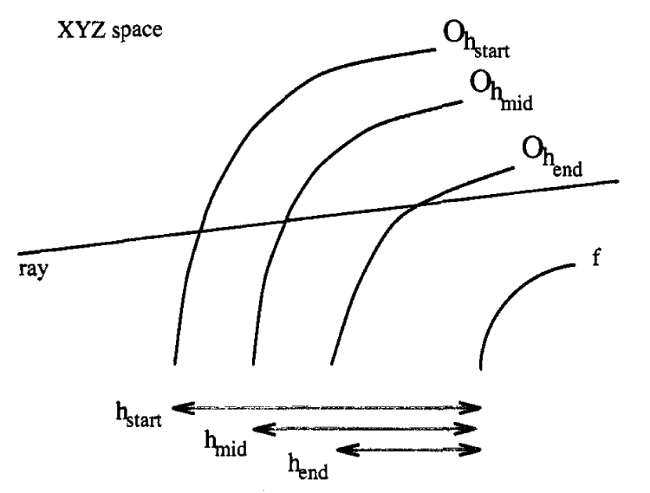
Image from Logie and Patterson paper

“The two inputs to the algorithm are the two height values hstart and hend. These define the heights of the offset surfaces which bound the ray segment under consideration. hstart corresponds to the surface which the ray segment hits first.
Stage one of the algorithm is to intersect the ray with the Oh_{start} and Oh_{end} offset surfaces. This generates two intersection points (u_{start},v_{start}) and (u_{end},v_{end}). These points are tested to see if they are close enough together to find if a solution can be determined. By joining the opposite corners of an individual texel (the single element in texture space), four triangles are formed. If both solution points lie within the same triangle of the texel then the intersection can be determined. When the points are close enough together their values are averaged and the height of this point calculated from the texture function. If this height is greater than the minimum of hstart and hend then the ray misses the surface, otherwise the ray hits the surface. The XYZ space intersection point can be calculated and returned.”

The ray segment is split into two then recursively processed if the intersections with the bounding surfaces are too far apart. The segment is split at h_{mid} (calculated from (h_{start}+h_{end})/2). “The ray is then intersected with the offset surface Oh_{mid} to generate the intersetion point (u_{mid},v_{mid}). This defines two new segments from h_{start} to h_{mid} and h_{mid} to h_{end}.” Both are processed recursively, in this order. By doing this, the algorithm can stop once the first intersection is calculated (this will be the closest one to the required solution).

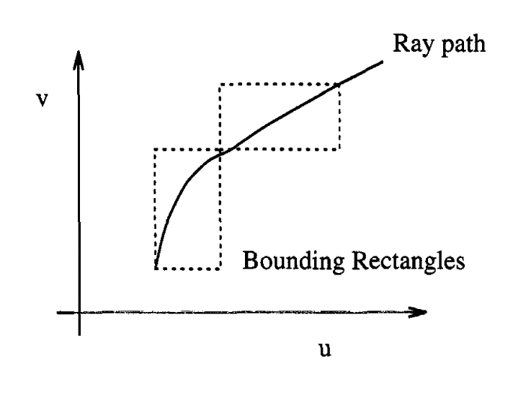
Image from Logie and Patterson paper

The points (u_{start},v_{start}) and (u_{mid},v_{mid}) define a rectangle in UV space which contains the path of the ray over the surface as shown in the diagram above. “This area of the texture is searched to find the maximum and minimum texture heights (h_{max} and h_{min}). These bound the height of the surface under the segment of the ray. If all points on the ray segment are higher than the maximum height of the texture under the ray then the ray must miss the surface.

Overall this technique is not a very good method for the raytracing of displaced surfaces. The two main tasks are searching the texture and calculating the intersection of the ray and the offset surface. The first task can be made efficient according to the authors, using “suitable preprocessing”, so the latter task becomes the most time-consuming task. From the Pharr and Hanrahan paper again, “in practice it has two problems: first finding the intersection of a curved ray with a heightfield is an expensive operation,typically requiring iterative calculations to find an intersection. Second, this technique only handles displacements along the surface normal”.

So, the sheer amount of calculations involve make it ten times slower than the raytracing of bump mapping, which in most cases is a “good enough” alternative.

“Stupid Tricks”

In 2003, Mach Kobayashi presented a very clever way of baking geometry into texture maps then reconstructing the objects out of spheres. Firstly he covers a simpler example – planar displacement. Imagine a jagged surface. If we projected rays from a fixed distance away from the edge, we could obtain the depth information of the rays and store this in some sort of texture map. Now we could reconstruct this edge by applying the depth map to a flat plane as a displacement map – and we have the original object once more.

The next step of progression is to use a sphere as the fixed distance away from the object. With some conversion of rectangular to polar coordinates and unwrapping the depth map calculation is made a sight easier.

Noise1

In the past, computer generated images were notorious for their unrealistic smooth surfaces and shiny specular highlights. In nature, we witness that nothing is perfect and to emulate this in our images, we apply a random factor. True randomness, however, is not the path that we have chosen. If we used a truly random function for a surface texture, it would change every frame. This isn't something desirable. We need a pseudo random generator that can produce identical results for a given set of inputs. As always, control is an important factor in our work.
Perlin listed a few attributes that form perfect noise in his publication entitled “An Image Synthesizer”, published in 1985.

- A narrow bandpass limit in frequency (it has no visible features larger or smaller than within a certain narrow size range)
- Statistical invariance under rotation (no matter how we rotate its domain it has the same statistical character)
- Statistical invariance under translation (no matter how we translate its domain it still has the same statistical character)

Peachey adds “repeatable pseudo random with inputs”

What do the two “statistical invariance” features mean?

If you look at the object from a different view, the input coordinates will differ - so the function will generate a different pattern.

Types of noise

Lattice Noise
As its name suggests, this starts off with a grid of pseudo random numbers(PRN) at every point in the texture space, whose co-ordinates are integers.
Integers are used because floating point numbers are dealt with differently across differing platforms - this would lead to different results based on identical inputs. Smooth interpolation occurs between the lattice points and it is the interpolating function which determines the quality of the noise.

Lattice value noise

"Given a PRN between -1 and 1 at each lattice point, a noise function can be computed by interpolating among these random values." This is the definition that Ebert gives us of value noise. In the implementation of value noise, it is again the interpolation that is a key factor. Linear interpolation is inadequate for smooth-looking noise. The derivatives (gradients) are sharp, so changes are very obvious. Generally cubic interpolants are used, since their immediate derivatives are continuous. We shall see later that being first order continuous might prove not to be enough.

Lattice Gradient Noise

A pseudo random gradient vector is generated at each lattice point, then these gradients are used to generate the function. The value of the noise at all the integer points is zero. An interpolation based on the gradients at the eight corners of a single lattice cube. Perlin's noise was the first implementation of this noise. It uses a different scheme of generating uniformly distributed unit gradients. His method is to generate vectors with components between -1 and 1. Such vectors lie within the cube that bounds the unit sphere. Any vector whose length is greater than 1 lies outside the unit sphere and is discarded. Keeping such vectors would bias the distribution in favor of the directions toward the corners of the cube. The remaining vectors are normalised to unit length. Eight values (from eight corners) from the array are combined using smoothed trilinear interpolation to get the gradient noise value.

Improved Perlin noise1

In a SIGGRAPH 2000 publication Perlin presented to us a way of improving his noise function (especially where displacement is concerned). The noise he presented to us in 1985 is not second order continuous and when it is used to drive displacements, artifacts can appear quite prominently (the surface normal itself is a derivative operator). The other deficiency is that where the pseudo random gradients in the precomputed array are “distributed uniformly over a sphere, the cubic grid itself has directional biases, being shortened along the axes and elongated on the diagonals between opposite cube vertices. This directional asymmetry tends to cause a sporadic clumping effect, where nearby gradients that are almost axis-aligned, and therefore close together, happen to align with each other, causing anomalously high values in those regions.”
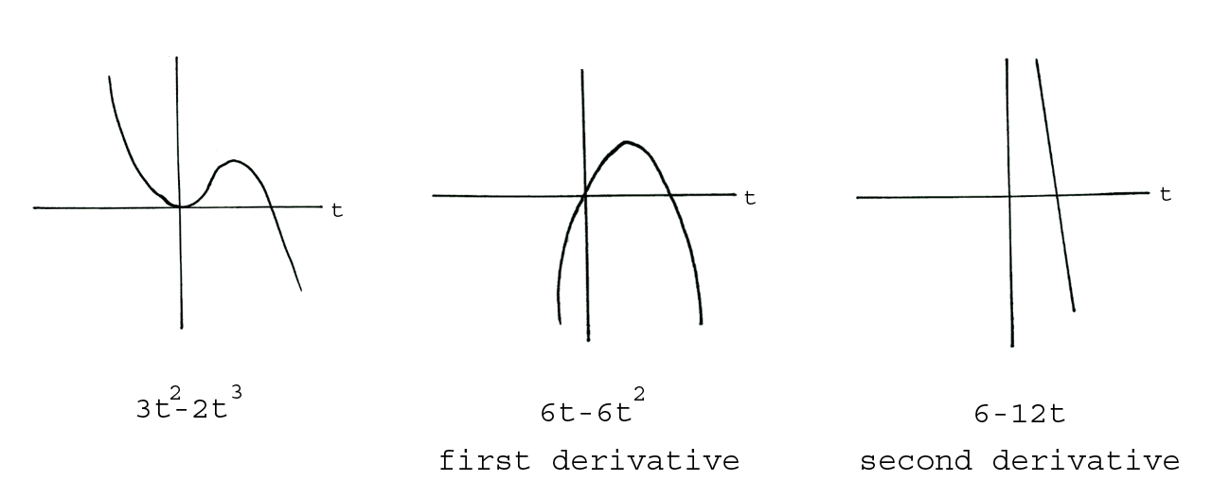
The curves above represent the original cubic noise interpolation function that Perlin originally described. They show us that on the second derivative, the function becomes linear and does not offer continuity at the integer lattice points. To correct this, he proposes that we switch to a quintic interpolation function. The curves for this function are shown in the following diagram.
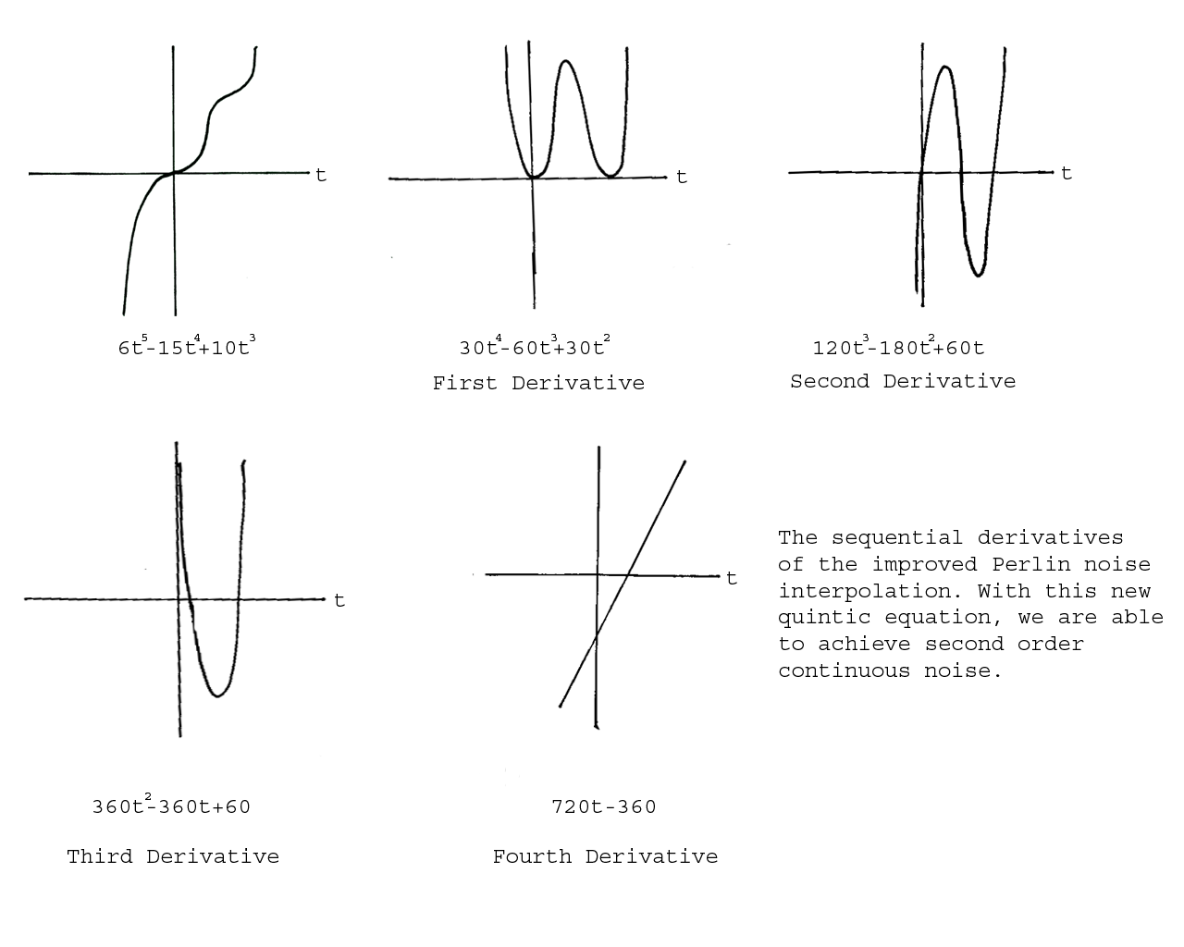
“The key to removing directional bias in the gradients is to skew the set of gradient directions away from the coordinate axes and long diagonals.”
Perlin goes on to state that the pre calculated gradient array need not be random either, since P (the current point on surface) provides “plenty of randomness”. The array is replaced with 12 vectors defined by the directions from the center of a cube to its edges.

(1,1,0),(-1,1,0),(1,-1,0),(-1,-1,0),
(1,0,1),(-1,0,1),(1,0,-1)(-1,0,-1),
(0,1,1),(0,-1,1),(0,1,-1),(0,-1,-1)

“The gradients from this set are chosen by using the result of P, modulo 12.
This set of gradient directions was chosen for two reasons :

1)it avoids the main axis and long diagonal directions, avoiding the possibility of axis clumping
2)it allows the eight inner vectors to be effected without requiring any multiplies (removing 24 multiplies from the computation).
This would provide us with the second order continuity that we desire. Although this could potentially solve our problems, the extra two degrees of power is computationally expensive. Perlin claims otherwise -

”the new algorithm runs approximately ten percent faster than the original”
This is put down to the cost of the extra multiplies (to compute the interpolants), being outweighed by the savings from the multiplies no longer required to compute the eight inner vectors.

Fractional Brownian Motion1
This is where we add together several copies of noise at different frequencies and amplitudes. “The frequency and amplitude of successive additions of noise are related by factors of lacunarity and gain,respectively. Notice that it is “self similar” - in other words, it is summing different copies of itself at different scales.”
Fractional Brownian Motion mimics many thing in nature, such as mountain ranges, and with a little modification, even water.
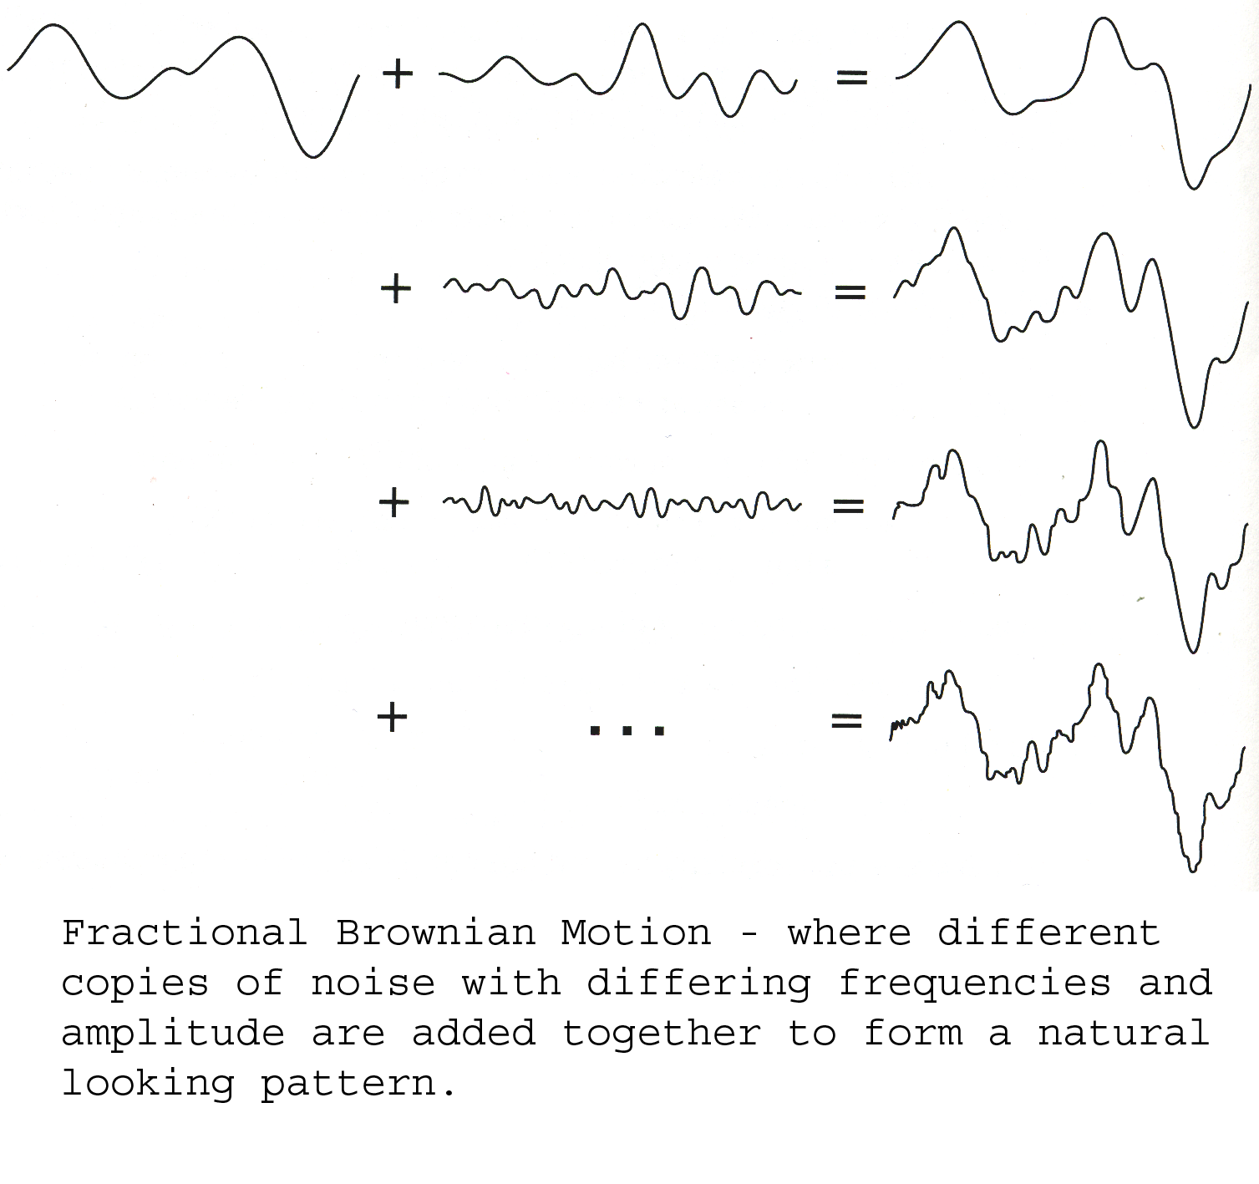
Spectral Synthesis2

Something interesting that was encountered during the research phase of the project was the topic of Spectral Synthesis. The following text is a summary of what Ebert mentions in his Texturing and Modelling book. Fourier analysis tells us that functions can be represented as the sum of many sinusoidal terms. “A Fourier transform takes a function from the temporal or spatial domain, where it is defined, into the frequency domain, where it is represented by the amplitude and phase of a series of sinusoidal waves. When the waves are summed together, it reproduces the original function. This function is called the inverse Fourier transform.”

Spectral synthesis is an “inefficient” implementation of the inverse discrete Fourier transform, which takes afunction from the frequency domain to the spatial domain. If provided with the amplitude and phase for each sinusoidal component, the desired functions can be attained by summing up the waves. The efficient method of doing this would be to use the inverse fast Fourier transform (FFT)algorithm. This however, generates the inverse Fourier transformation for a big group of points all at once. In an implicit procedural texture, we have to generate the inverse Fourier transform for a single point being sampled and it seems that this is best done by summing the sine waves.

Peachy continues, by stating how we do not always have all of the frequency domain information to reconstruct a function exactly. Instead, a function with some known characteristics(usually the power spectrum)will suffice. The power spectrum, “is a plot of the portion of a signal's power (energy per unit time) falling within given frequency bins” (from www.wikipedia.com). Simply put (from my understanding), it shows us how many times a noise frequency occurs in a given function as a whole.

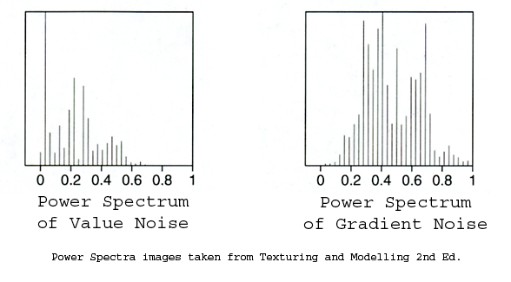
In these graphs(or power spectra) it is the X axis that represents the frequency and the Y axis that deals with the energy. Value noise appears to have a lot of low frequency noise, whereas Gradient noise has most of its energy distributed between 0.3 and 0.7. Having more higher frequency energy is due to the gradient noise using zeros at each lattice point.

Antialiasing of displacement

This is problematic when displacements are small enough to be considered micro detail. The problem stems from the method that we use to sample reflected light hitting the camera.
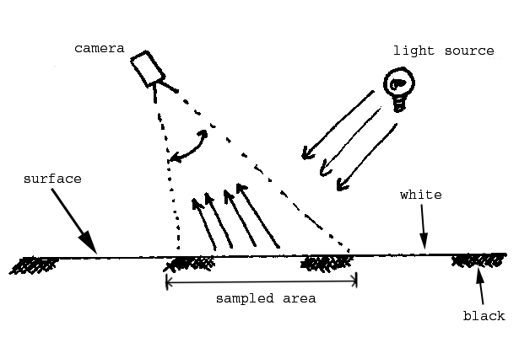
In the above diagram, the camera is looking at a black and white patterned surface. For the purpose of this example, we will say that the sampled area only appears as a single pixel on the screen. Ideally we would want to sample the average light bouncing off the sampled area of the surface and entering the camera. Fundamentally, this would be the mean value of the sum of all the light functions. However, in reality this is quite difficult to calculate and if we were to take the multiple scattering of light into account, we would find the process to be extremely processor intensive.
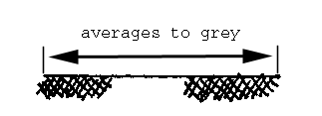

Instead, we usually average the colour of the sampled area and perform the lighting function on it. In this case the black and white averages to grey, the lighting function is performed on the colour and displayed on screen as a grey pixel.
This method is generally fine for flat surfaces without displacement mapping applied. Now we'll take a look at why we encounter problems with displacement mapped geometry.
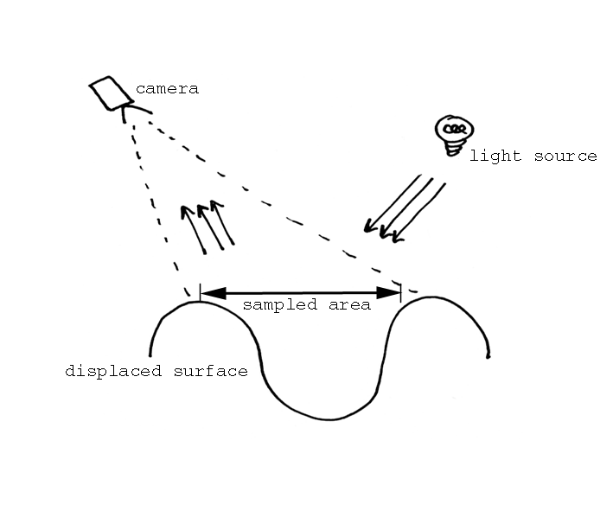
Again, for this example, we shall say that the sampled area appears as a single pixel on the screen. Not all of the light hitting the surface would end up reflected into the field of the camera. As a result, we would experience areas of highlights and shadow. From a distance, this “microdetail” would give the surface an appearance similar to that of rough sandpaper. However, since the area sampled is only spanning one pixel and it is impractical to calculate the average light entering the camera, some form of averaging must be carried out.
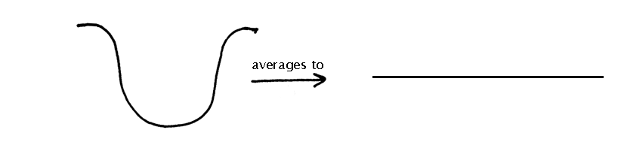
The displacement is averaged out when being sampled, so instead of getting the impression of a rough surface, a flat grey (average) displacement is the result. This is not desirable and it seems that there aren't any immediate techniques cannot solve this dilemma. Although, in the Advanced Renderman book(Anthony Apodora, Larry Gritz) it is stated that “the correct solution” would be to add some surface roughness in the bidirectional reflectance distribution function. This should sufficiently emulate the scattering of light in many directions.

Where has Displacement Mapping been used?

So far we have discussed a lot of theory in this report. Now we shall see where and why displacement mapping has been used in the computer animation industry.

The case we shall investigate, is that of Disney's Dinosaur. This particular example used displacement maps as a means of modelling prominent details in key characters.

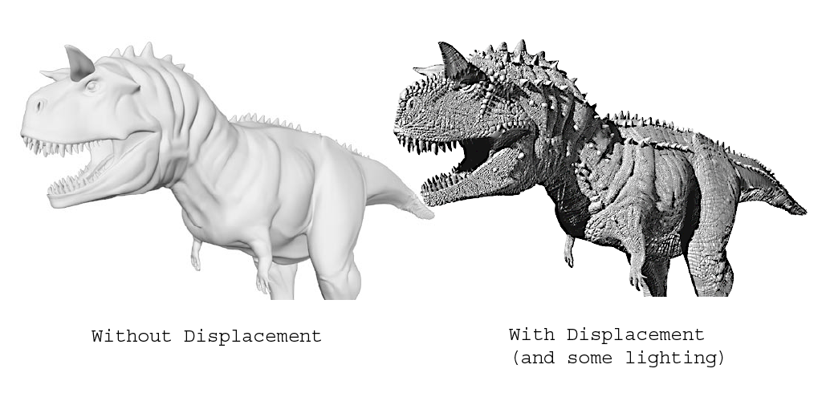
Above, are two images1 of the same model. The one on the left is straight from the modelling department. The one on the right is the very same geometry, but with displacement maps applied. Disney chose to use displacement mapping as a means of modelling all the fine detail because of the sheer number of creatures they had to produce. They had small lemurs alongside gigantic dinosaurs. Since the lemurs were fairly high detailed, the complexity of the dinosaur models really had to hold up.

Instead of defining the details procedurally, Disney used texture painters. The company was unsure about using displacements for a while. They performed tests, modelling denser character heads, containing up to ten times the number of patches that the base heads had – they concluded that the detail from the displacement maps was far greater. Somebody tried converting a model to polygons, based on the data from the displacement maps and found themselves with far too heavy a mesh (a machine with 2 gigabytes of ram was being used) to work with.
Another good point made is that geometric aliasing can occur in dense meshes. With PR Man, the only solution is to drop the shading rate and increase the pixel samples, which would seriously bump up already huge rendering times.

Small changes in displacement maps can effect the surface's reaction to light non linearly. As a result, it is quite commonplace to witness “buzzing” when high frequency maps are used for displacement. The paper mentions that a filter was written to filter this buzzing out, but I was not able to find out what it did exactly.

The displacement maps themselves were split generally into two layers. One would create folds of skin, whilst the other would add the pebbling and scales on the skin. This would prove useful in the tweaking stage. Different displacements could be increased or decreased without affecting the other – also, it was a lot easier than getting a painter to estimate which shade of grey to use.

Another thing to note is that Disney treated middle grey as the zero value. This allowed values less than 0.5 to displace inwards, whilst values greater than 0.5 would displace outward. What seems like a small benefit leads on to having displacement bounds seemingly halved. Effectively you are getting twice the detail for half the displacement bound. So, rendering times are shortened and there is less opportunity for displacement cracking. An artist could also “conceptually” cut in or out of the model. The downside is that there are only 128 levels of painting in a given direction (128 in, 128 out).

Bump mapping was considered, but the old problem of having smooth profiles and the shrinking and growing of detail depending on the orientation of the camera, weighed heavily against its usage.

Disk space was a disadvantage for Disney, whilst working on Dinosaur. The sheer number of maps required (approximately 2000 maps per model) meant that purchasing sufficient storage was essential (fortunately disk space is cheap). Also, rendering times start to increase as the camera moves closely to displacements. A good observation is that displacement maps rarely ever go all the way to pure black or pure white. It would be beneficial to process all the maps to find out what the maximum range really is. This is similar to running the shader twice as mentioned earlier.

Implementation of Displacement Shaders

Following the path of the Disney Dinosaur1 paper, I implemented a simplified version of their displacement technique. A simple scale-like pattern was drawn in Photoshop and with two simple conditional statements, I had the grey values behaving as described in the Disney Dinosaur section.

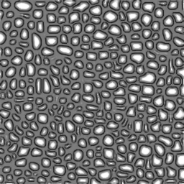
The map used to displace in the shader
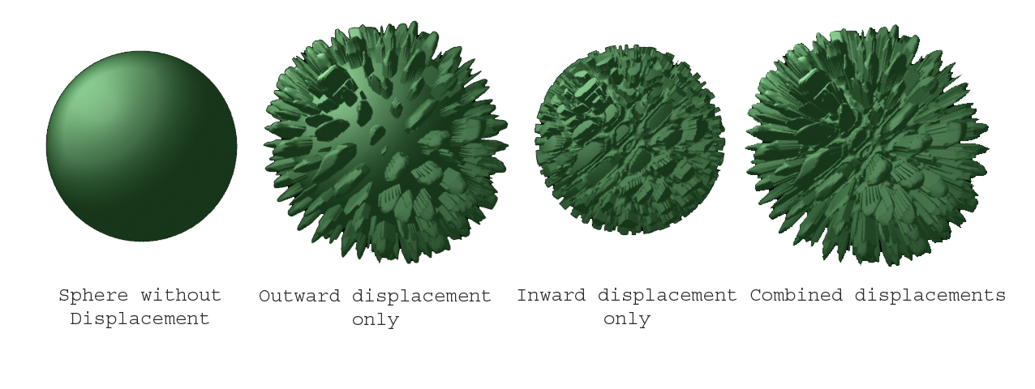
Check the “inout.mpg” file for another example of this shader at work.
The next shader I made was based on Musgrave's 2“windywave” code. It uses Fractional Brownian Motion and turbulence (which is similar to fBm) functions to generate natural looking displacements, as well as adding a “windy” vector to give the water a sense of being blown. By adding a linearly interpolated “t” parameter to the generation of the noise, I was able to animate the effect of the water quite efficiently.
The main problem that was encountered during the creation of this shader was artifact related. The renderer would create what looked like “cuts” in the geometry at regular intervals, which suggested that responsibility might have been given to the grid dicing that Renderman performs in its production pipeline. A solution that was brought up was to increase the grid size so that the regularity of the artifacts were not so noticeable. Increasing the shading rate and pixel samples also should have helped.
However, these suggestions did not solve the problems and it seems that it is the discontinuity of Perlin's original noise that caused them. By filtering the final image with copious amounts of blur, the artifacts are not noticeable, but it is not convenient to rely on blur – what if the user requires a sharp image of the displaced surface?

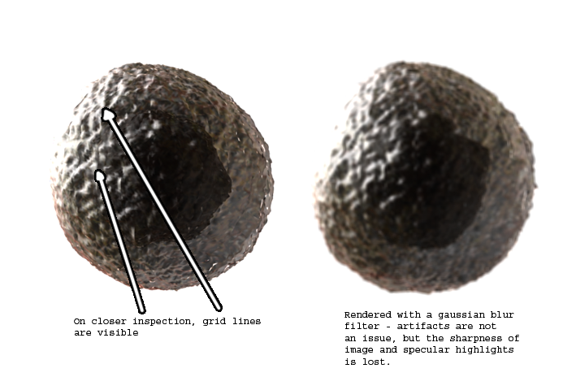
In motion, the problematic “gridding” effect is more apparent (gridding.mpg). It is possible to mask the artifacts with strong reflections and specular effects (see shinywater.mpg), but on closer inspection and prolonged viewing it is still noticeable.

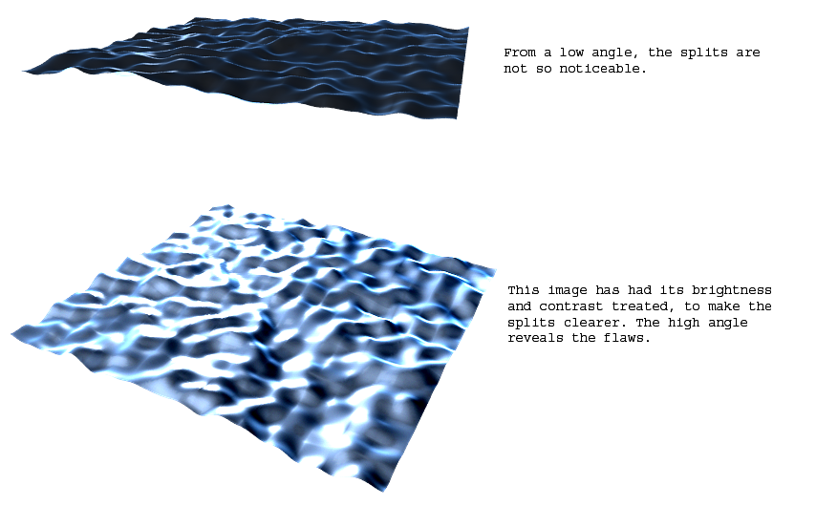
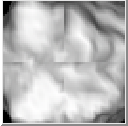

This image is perhaps a better indication of the splitting that occurs. It is a snap shot from the Slim shader preview box.

To combat the issue, I thought about implementing the “improved” noise. Instead of programming it from scratch, I modified some source code that Ian Stephenson donated to me (we shall refer to it as inoise). In Perlin's improved noise, a 5th order interpolation polynomial is utilised to achieve the 2nd order continuity at the integer lattice points. The inoise was a smarter implementation of Perlin's original noise description, integrating the function (thus filtering it in a simple box-filter fashion) in an effort to limit the artifacts.

However, even with the new interpolation polynomial in place, the artifacts were still affecting the renders. Another problem with this new noise is that it used a different set of parameters to the Perlin noise. Previously, I had been passing in the current surface point “P”, along with the interpolating factor “t” into the noise. Inoise however, required me to pass in the separate U and V values, which although was not hard to do – it did not produce the same sort of motion that I had achieved with the original noise implementation. This was partly down to the way in which I interpolated the “t” values. The old noise shader used “t” as a separate parameter (noise(P,t) - forming the two dimensional noise), whereas with inoise, I used the “t” parameter as an offset value (noise((xcomp(P)+t),(ycomp(P)+t))).

I thought about writing a noise function within the shading language, but was advised against doing so, due to C being much better suited to the job.

Given more time and a more definite goal I am certain that I would be able to get the inoise shader to behave more like the Perlin shader.
I would also have attempted to implement the Improved Perlin Noise from scratch.

The other shader which I implemented was based on the Voronoi shader code I took from the Advanced Renderman book1. It uses a cellular basis for the generation of the texture. To explain it simply the surface is divided into a grid and within each cell, a “feature” is made. The shader then calculates the distance between the current sampled point and the nearest feature. The distance can then be used as a value for colour or, as I have used it, a value for displacement. Below are some renders of the shader implementation.
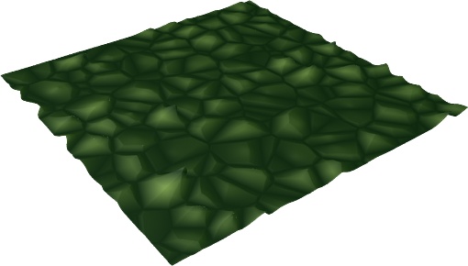
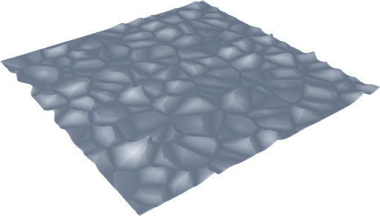

Conclusion

Through the process of this research paper, I learnt a great deal about the pros and cons of displacement mapping in Renderman.
As with all things, there is a time and place for everything.

It would not be appropriate to model an entire scene with displacement shading – the overheads involved would cripple even the most powerful of machines -especially when you get close to surfaces (I experienced my machine dropping into a deep coma, many times when I first started this project, not realising the complexity of displacement maps) The way in which Disney implemented displacement maps as a modeller was innovative, but I still feel that to use it as a main source of detail might have been slightly careless – from personal experience I am convinced that a high resolution polygon model would have rendered a lot faster than the displaced surfaces in the extreme close-up shots. The reasons that they gave for using the displacements were centered around time saving (considering the number of dinosaurs they had to model)– sadly this is something that factors highly in the commercial world that we live in today.

Using displacement maps as a method of modeling, is definitely a technique that will play a part in the future of computer graphics – our ever-increasing computer technology will certainly be able to handle the extra calculations – so it is up to us to use our tools well. Computer games have already started to use techniques similar to displacement mapping. The normals from a high resolution mesh are baked into a normal map, and then applied to a lower polygon model. The next “wave” of games (Doom 3 and Half Life 2 being the flagship titles) utilise this technique to great effect, enhancing the player's experience by immersing them in a deeply detailed world.

This brings me to my next point which is, that techniques should only be used if they will further the viewer/player's experience. If Disney had not used displacement, I must admit, the overall illusion of the dinosaur's existence would have been shattered – so in that respect, they were right to have used the technique.

The knowledge i now possess, has helped me to decide whether to use Renderman or not in my Major Project. Referring back to my argument about enriching a viewer's experience, I would have to admit that Renderman would not actually make much of an extra impact to the style I have chosen to pursue, so I will not be using it.

I would say that in the future, I would probably prefer to work with the implementation of shaders, rather than fixing the problems that occur in them. Although the amount of time i spent researching the problems that I encountered was certainly not a waste of time (I found it to be highly educative), I felt that I neglected the act of creating shaders (in particular, I would have liked to improved the cellular basis texture, giving it more features, making it more flexible).

Further Work

Fixing the problematic gridding effect in the water shader would definitely be on the books for further work. I believe that instead of modifying the inoise, perhaps a completely new DSO shading function would be necessary, even utilizing the new gradients that Perlin mentions (they were not used in the modified inoise, because they are mainly there for efficiency purposes and do not effect the output noticeably). On a “global” scale, the raytracing of displacement mapped surfaces is definitely an issue that needs to be dealt with, as is the anti aliasing of them. Something that would be quite interesting to tackle would be the use of displacement as animation. We have already seen that by interpolating noise parameters we can emulate the motion of water, so why stop there? It would not be difficult to use this same approach to animate a flag blowing in the wind, the movement of hair, grass or fur. Of course, we must not get ahead of ourselves – displacement is probably not the best way to do a lot of these things!

Appendix

What to look at on the accompanying CD :
A “video” directory contains mpeg movies of all the shaders I implemented.
The “code” directory contains all the coding I used to make the shaders
A “sources” directory contains the Adobe Acrobat files I took research from.

Here is the code for the shaders I implemented in the Renderman Shading Language

Simplified Disney Dinosaur Displacement

displacement texture1(float Km = 0.05;

string texname=""; )
{
float texcolor;
normal n = normalize(N);

/* set the displacement to the grayscale
value of the texture map */
if(texname != "")
texcolor = float texture("/home/bacva3/a1477742/innov/scale2.tx", s, t);

if(texcolor<=0.5){

P = P - n * texcolor * Km;/*if less than 0.5 grey, then displace inward*/
}

else{

P=P+n*texcolor*Km; /*if greater than 0.5 grey, then displace outwards*/
}
N = calculatenormal(P);
}

Water Shader(using Perlin noise)

#define MINFILTWIDTH 1.0e-6
#define filterwidthp(p) max (sqrt(area(p)), MINFILTWIDTH)

/*Fractional Brownian Motion*/
float
fBm(point P;float lacunarity; float gain;float octaves;float t)
{
float i;
float mag=0;
float freq=1;

for(i=0;i<6;i+=1)
{
mag+=(float noise((P*freq),t*10));
freq*=2;
}

return mag;
}

/*Turbulence function*/
float turbulence (varying point p; varying float octaves; uniform float lacunarity,gain, t)

{
varying float sum=0,amp=1;
varying point pp=transform("object",p);
uniform float i;
for (i=0; i<octaves;i+=1){
sum+=amp*abs(noise(pp,t*10));
amp*=gain;
pp*=lacunarity;
}
return sum;
}

/*The main shader function*/
displacement
newwindywater(float Km=0.1; float txtscale=1;float windfreq=0.5;float windamp=1;float minwind=0.3;float octaves=2.1; float t=0)
{
float offset;

varying point PP;
float wind;
float turb;
varying float filtwidth=0;
PP=transform("shader",P);
PP*=txtscale*windfreq;
filtwidth=filterwidthp(PP);

offset=Km*fBm(PP,filtwidth,2,octaves,t);
PP*=8;
filtwidth*=8;
turb=turbulence(PP,filtwidth,4,2,t);
wind=minwind+windamp*turb;
P=P+wind*offset*normalize(N);

N=calculatenormal(P);
}

Cellular Basis Texture
/*the function that assigns the features and calculates the distances*/
Void voronoi_f1f2_3d(point PPP;
float jitter;
output float f1; output point pos1;
output float f2; output point pos2;)

{
point testcell;
point thiscell=point (floor(xcomp(PPP))+0.5,floor(ycomp(PPP))+0.5,floor(zcomp(PPP))+0.5);
f1=f2=1000; /*set to a very high value*/
uniform float i,j,k;
for(i=-1;i<=1;i+=1){
for(j=-1;j<=1;j+=1){
for(k=-1;k<=1;k+=1){
point testcell=thiscell+vector(i,j,k);
point pos=testcell+jitter*(vector cellnoise(testcell)-0.5);
vector offset=pos-PPP;
float dist=offset.offset;
if(dist<f1){
f2=f1;pos2=pos1;
f1=dist;pos1=pos;
}
else if(dist<f2){
f2=dist; pos2=pos;
}
}
}
}
f1=sqrt(f1); f2=sqrt(f2);

}
/*the main shader, which uses the distances*/
displacement spikey(float Km=0.1;)
{
point PP=transform("shader",P);
float f1,f2;

point pos1,pos2;

voronoi_f1f2_3d(PP,1,f1,pos1,f2,pos2);

float thing=f2-f1;
P=P+(thing*thing*Km);/*assign P its new value*/
N=calculatenormal(P);

}

Reference Listing

Here is a list of all the documents that helped in the production of this report. A copy of most of them can be found on the accompanying cd.

“Displacement Mapping”, Andrei Räisänen, Helsinki University of Technology, 2002

“Simulation of Wrinkled Surfaces”, James F. Blinn, Caltech/JPL, 1978

“Texturing and Modelling Second Edition”, Ebert, Musgrave, Peachey, Perlin, Worley, 1998

“Displacement Mapping”, Ivan Neulander, http://www.rhythm.com/~ivan/dispMap.html

“An image synthesizer”, Ken Perlin, 1985
”Advanced Renderman 2 To RI_FINITY and Beyond”, Siggraph 2000 Course 40
“Improving Noise”, Ken Perlin, 2002

“Advanced Renderman”, Tony Apodaca and Larry Gritz

”Advanced Renderman 2 To RI_FINITY and Beyond”, Siggraph 2000 Course 40

”Essential Renderman Fast”, Ian Stephenson, 2003

“Towards Hardware Implementation of Loop Subdivision”, Bischoff, Kobbelt, Seidel

“Geometric Caching for Ray Tracing Displacement Maps” Pharr and Hanrahann

“Inverse displacement mapping for the general case” by JR Logie + JW Patterson

1 “Displacement Mapping”, Andrei Räisänen, Helsinki University of Technology, 2002
2 “Simulation of Wrinkled Surfaces”, James F. Blinn, Caltech/JPL, 1978
3“Texturing and Modelling Second Edition”, Ebert, Musgrave, Peachey, Perlin, Worley, 1998 Page 38-40
1 “Displacement Mapping”, Ivan Neulander, http://www.rhythm.com/~ivan/dispMap.html
“Displacement Mapping”, Ivan Neulander, http://www.rhythm.com/~ivan/dispMap.html
1 Towards Hardware Implementation of Loop Subdivision, Bischoff, Kobbelt, Seidel and “Displacement Mapping”, Andrei Räisänen, Helsinki University of Technology, 2002
1 Quoted or adapted from ”Advanced Renderman 2 To RI_FINITY and Beyond”, Siggraph 2000 Course 40 pages 13-28
1 Quoted or adapted from ”Advanced Renderman 2 To RI_FINITY and Beyond”, Siggraph 2000 Course 40
1 “Texturing and Modelling Second Edition”, Ebert, Musgrave, Peachey, Perlin, Worley, 1998 Page 64-78
1 From “Improved Noise” , Perlin, 2000
1 “Advanced Renderman”, Tony Apodaca and Larry Gritz pages 251-253
2“Texturing and Modelling Second Edition”, Ebert, Musgrave, Peachey, Perlin, Worley, 1998 pages 46-48
1Images and Text based upon ”Advanced Renderman 2 To RI_FINITY and Beyond”, Siggraph 2000 Course 40
1 ”Advanced Renderman 2 To RI_FINITY and Beyond”, Siggraph 2000 Course 40 pages 84-90
2“Texturing and Modelling Second Edition”, Ebert, Musgrave, Peachey, Perlin, Worley, 1998 pages 306-308
1 Advanced Rendeman by Tony Apodaca and Larry Gritz

