Jeremy Plant B1464684

BA (Hons) Computer Visualisation and Animation Level 3

NCCA 2004-2005

Innovations Project Report

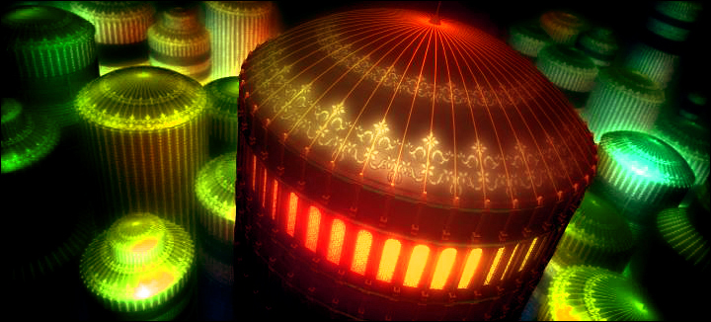

‘The Grand Space Opera’ by Jeremy Plant

Contents

Abstract Page3

Section 1 –

Aims and
Objectives Page 3

Section 2 –

Concept Development &
Production Page 6

Modelling Page 9

Texturing Page 10

Lighting Page 13

Rendering Page 14

PhotoShop Page 14

Section 3 –

Conclusion Page 16

References Page 16

Appendix A – Innovations Project

Proposal Page 17

Abstract

This report provides an illustrated overview and critical analysis of the methods I undertook to produce a 3d still of a futuristic opera house. The initial aim of the project was to research and develop matte painting techniques and produce a finished matte painting using photographic material. However, as you will discover in the following text the project progressed and evolved into a cross between concept art, production art and 3d design.

Technically the project was not wholly successful. It did however prove useful as a ‘what NOT to do’ guide for future reference. This report will discuss the methods I employed and determine whether or not they were appropriate.

It will also document my ideas and introduce my concept in an illustrative and concise format. Where appropriate I will outline what I feel was beneficial to my development and what contributed to the project’s shortcomings.

It would be impractical to include much of the production art I produced for the piece so I have only included a few examples that, I hope, give a good indication of my concept and demonstrate the level of thought that went into project.

Section 1 – Aims and Objectives

My original intention, outlined in Appendix A was to create a matte painting using a blend of photography and 3D. Although I was interested in acquiring these skills, after much consideration I decided to produce a show reel piece that would demonstrate both technical and artistic competence. I drew my inspiration from a CGTalk challenge. The challenge is outlined below.

The Grand Space Opera Challenge -18 October 2004 – 17 January 2005

Think big – REALLY BIG! This is your chance to create an iconic image that captures a pivotal moment in a vast galactic spanning civilisation…. a civilisation so vast that the only thread holding it together is a shared legacy of common legends. Legends of heroes, of heroic battles won against unimaginable odds, of crushing defeats and enemies that swarm through entire galaxies.

Legends of utopian worlds, of vast planetary cities, of whole suns enclosed. Legends of secret sects and empire spanning conspiracies. Legends of oppression and abject poverty. Legends of artists, of scientists, of religious leaders, of political leaders.

The original concept and brief:

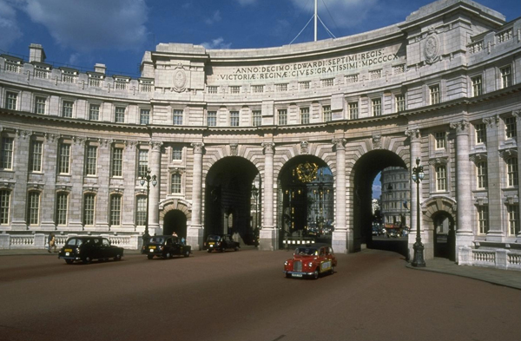

Fig.1 Original Photo

Whilst looking for relevant reference material I found a hi-res image on the internet (Fig1.) that I thought had a lot of possibilities for a 3D matte painting. The intention was to do a ‘Day to Night’ (i.e. turn the image from daylight to a night time image) and turn the image into a ruin that I could make the foreground element of a futuristic city.

This image could then be projected on the surface of simple geometry and incorporated into a moving 3D shot with 3D elements (hover crafts and spotlights) moving through the scene. My original concept sketch is illustrated below in Fig.2.

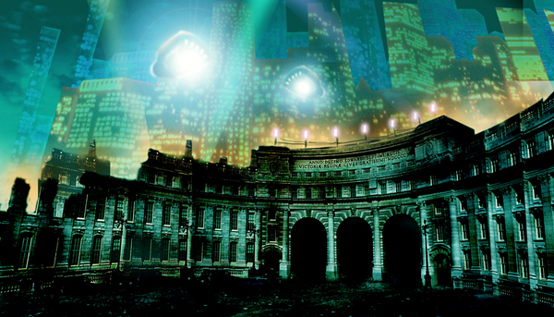

Fig.2 Concept Comp

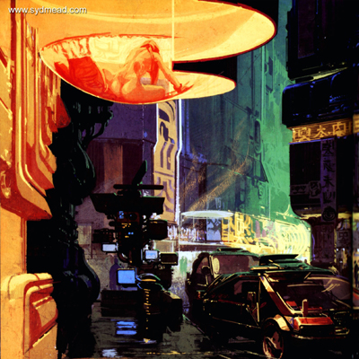

Fig.3 Syd Mead BladeRunner Concept

I was inspired by a Syd Mead concept sketch (Fig 3) for the film BladeRunner. Although I had decided early on not to produce the stereo-typical vision futuristic ‘neo Tokyo’ I was influence by his colour palette and loved the contrast between the warm and cool colours. Full production was put on hold at this stage because I was still considering alternative ideas. However, whilst in the process of deciding on my final idea I began to model a very simple ship that would race through the scene. As the ships would be going so fast they would be barely noticeable so I did not want spend time on the design and modelling of the ships. Having looked at various images of space craft on the internet I decided to use a pre-existing design (the computer game ‘WipeOut’). Figs.4 and 5 show the original and my version.

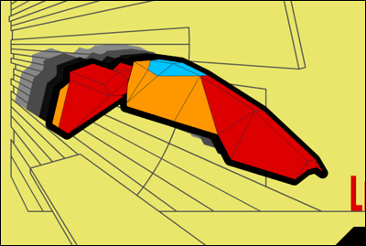

Fig.4 Original Game Design

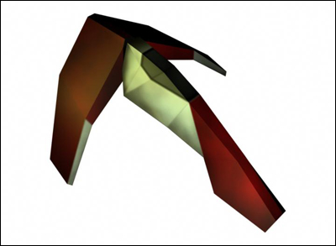

Fig.5 My copy of the ship

With the basic model finished and roughly textured I began to run some quick tests to see the influences the lights on the ships would have on my scene. These test would determine the level of detail that I would have to employ in areas of darkness.

Although I was well underway with the project and keen to use this image for some traditional matte painting practice I felt that the development of the piece would be impeded by the photograph. It was at this time that I made the decision to re-address the project and draw more inspiration from the CGTalk Challenge.

I decided to take the title ‘Grand Space Opera’ quite literately and started to develop concept sketches of a futuristic opera house.

Research:

I looked at various sources for inspiration. The HatchFX.com show reel has a beautiful futuristic city shot which I liked very much. However, I still did not want to produce a stereo-typical vision of the future and began to look further. The websites MattePainting.org, CGTalk.com and Dusso.com were a limitless source of inspiration. Much of the work on these sites explores a much more quirky vision of the future which I was keen to use for my piece.

Mt intention was always set firmly to produce something beautiful but dark. I felt that the Opera House should be a frightening place while at the same time full of life and extravagance. To research this theme I began to look at images of Venice for architectural designs. Whilst Iooking at various online resources I became aware of the Venice Carnival and found the look and concept I was looking for (see Figs.6-8 below).

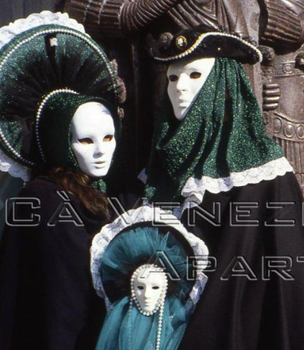

Fig.6 Dark Carnival Family

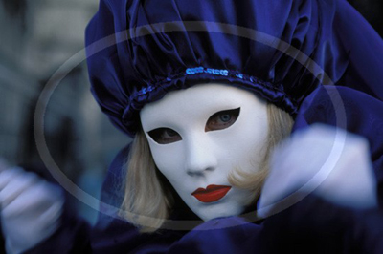

Fig.7 Haunting Costume

My brief was now to produce an image/3D illustration of an futuristic Opera House in a city which was a blend of Venice and China. A huge, opulent city. Rich in design and colour. Dark but quirky. Occupied by a race obsessed with arts and extravagance.

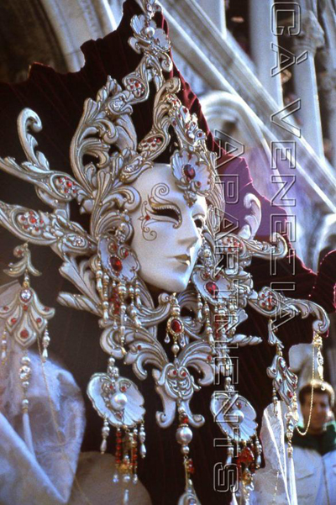

Fig.8 Extravagant Head Dress

It was at this stage that the project became more of a concept piece than a matte painting. Encouraged in a tutorial to produce more production art I became pre-occupied with designing as much background material that I could to gain a better feel for the piece.

My other research consisted of looking at Matte Paintings in the book ‘The Invisible Art’ by Mark Cotta Vaz and Craig Barron, and online resource such as MattPainting.Org and MatteWorldDigital’s website. From these sources I found a huge variety of work to be inspired by.

Matte painters such as Dylon Cole and Dusso are revered amongst the digital art community and provided a huge source of inspiration. However, my objective was now to produce the concept art as well as the final image and this provided me with new challenges:

1. Finding good photo reference material to match my concept was proving difficult.

2. The concept was becoming dulled down due to limited resources to work with (i.e. photo material).

Section 2 – Concept Development & Production

Concept Art:

Having changed my objectives I felt that the incorporation of photographs into my scene would have caused unwanted restraints. I decided to abolish the traditional Matte approach and opted for a completely 3D environment. This allowed me to run ideas freely and develop my vision with complete freedom. Having drawn my inspiration from sources such as the Venice Carnival I began to produce thumb nail production sketches which later formed the basis of my finished piece. These sketches consisted of concept visualisations and character designs.

The concept visualisations:

Using the CGTalk challenge as a starting point I developed my ideas further and decided on a futuristic environment which brought together elements of Venice and ancient China. In this environment wealth is unlimited and elitism is rife. Society exists to appreciate the arts as the most important aspect of life. Opera is viewed as the most important of all the arts and those within the elite who are wealthy enough rise to the towering heights of the Grand Opera House in flying Gondolas.

For this elite sect every corridor is a catwalk and every social event an opportunity to show off their wealth, power and appreciation of the arts.

For my colour palette I decided to use rich reds, oranges and greens. The film ‘City of Lost Children’ used this palette very effectively. This colour range is often associated with wealth and gluttony which suited the inhabitants of this dark world perfectly. Figs.9-18 show the development of the concept and give a quick glimpse behind the scenes at the world portrayed in my final image.

These works couldn’t be developed further due to time restrictions. However, I feel that the sketches, along side my research images (Figs.6-8) convey my ideas quite effectively.

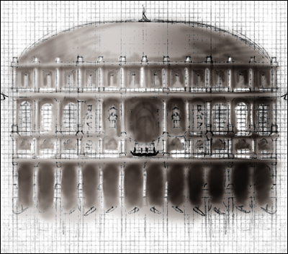

Fig.9 Graph Plan of Opera House

Fig.9. My plans for the front of the Opera House. These changed slightly during production due to time restrictions.

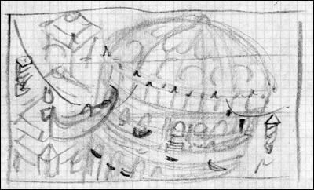

Fig.10 Thumbnail of Final Composition

Fig.10. An early thumbnail sketched approved as the final composition.

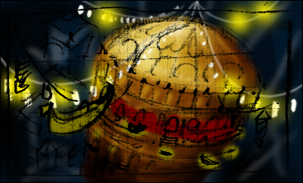

Fig.11 Coloured Thumbnail

Fig.11 illustrates where the lamps and flying Gondolas would be positioned in the scene.

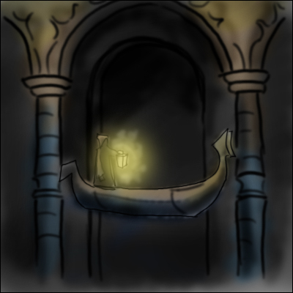

Fig.12 Gondola Boatman

Fig.12. I liked the idea of the flying Gondolas to be like futuristic taxis. The boatmen wait in the darkness below the Opera House to pick up clients. A boatman is considered to be very lucky because they are the only people (other than the super rich) to get anyway near the Opera.

The character designs:

I felt that it would be beneficial to produce a few character designs for the piece. These are illustrated below. I have tried to portray them as being quite extravagant, quirky, dark and greedy. A race preoccupied with indulging themselves in all kinds of sin and revelry.

They are meant to look like they have risen from a futuristic Venetian Carnival. Some in masks, others wearing heavy makeup to disguise the effects of self abuse and wild social events.

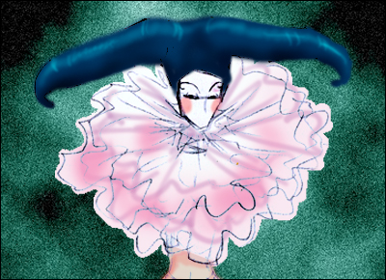

Fig.13 Young Socialite

Fig.13 shows a young socialite in her harlequin outfit. Extravagance is personal expression. Outlandish costume is considered as the height of fashion.

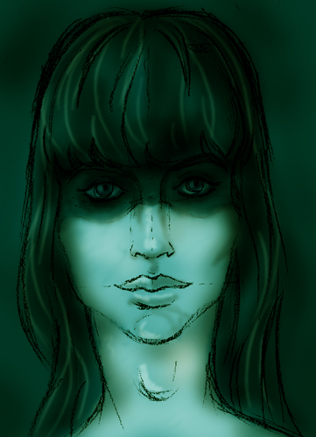

Fig.14 Dark Gothic Makeup

Fig.14 illustrates the use of heavy ‘Heroin Chic’ makeup. Cosmetics are used much in the same way as the French used them in Baroque France.

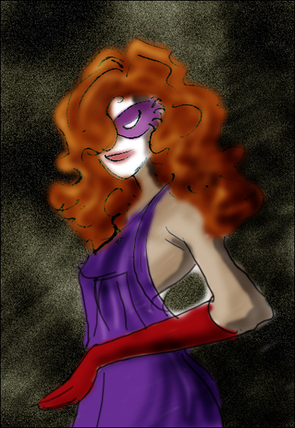

Fig.15 Young Socialite

Fig.15 shows another young socialite with heavy white make up. She would be the equivalent of today’s ‘IT’ girls.

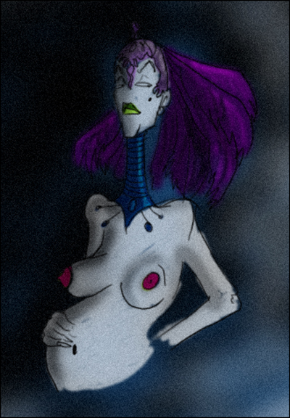

Fig.16 Pregnant Aristocrat

Fig.16. Nothing is obscene in this city. Socialites take every opportunity to draw attention to themselves.

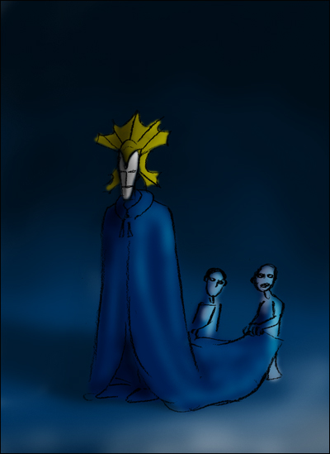

Fig.17 Master assisted by dwarf slaves

My early concept sketches depicted dwarf slaves being maltreated by their masters. Some of them are kept on leashes to like pets. The super rich might have as many as a hundred dwarfs throwing rose petals to the ground to create a red carpet wherever the master goes.

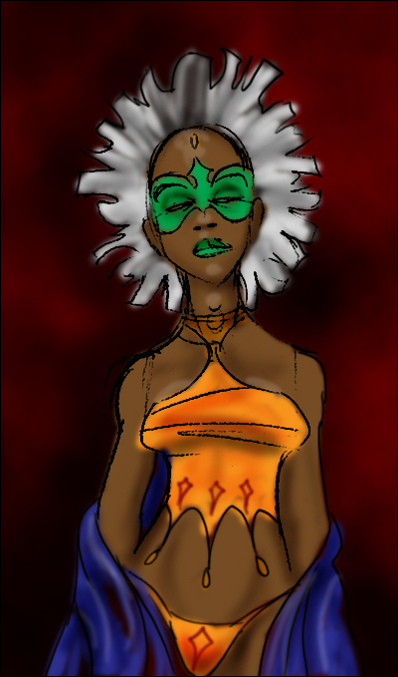

Fig.18 Carnival Queen

Fig.18. A carnival Queen. I like this sketch but think she looks a bit too much like a Super Heroine.

If I had more time I would have loved to develop these designs further and produced some polished production art.

Modelling

My aim was to reduce modelling time by using simple textures on basic models which would then be rendered and projected back onto with matte paintings. With this in mind the modelling was very simple. The opera house had to be a variety of duplicated polygons because it would have been impractical and extremely time consuming to build it as one element. All other elements were built with a ‘Lego’ philosophy in mind. Not knowing how my composition would end up I needed to build a set of objects which could be mixed and matched like building blocks. This saved a great deal of time and gave some degree of flexibility to the back ground buildings.

Because the objects were all built with projection in mind they had to be simple models. With hindsight, had I known that I would have been unable to attempt the projection (more about this later) I would have spent more time on the foreground models.

The Opera House:

I began by modelling the dome opera house. A polygon sphere was used as the basic starting point for the roof. The bottom faces were then deleted to get the correct shape. For the ridges curving up the sphere vertices I used Maya’s ‘create polygon tool’ with Snap To Point selected. This enabled me to draw a poly curve that was exactly the same shape as the basic sphere shape. Once the correct curvature had been achieved this shape was extruded slightly and duplicated around the y axis 47 times to get the 48 ridges.

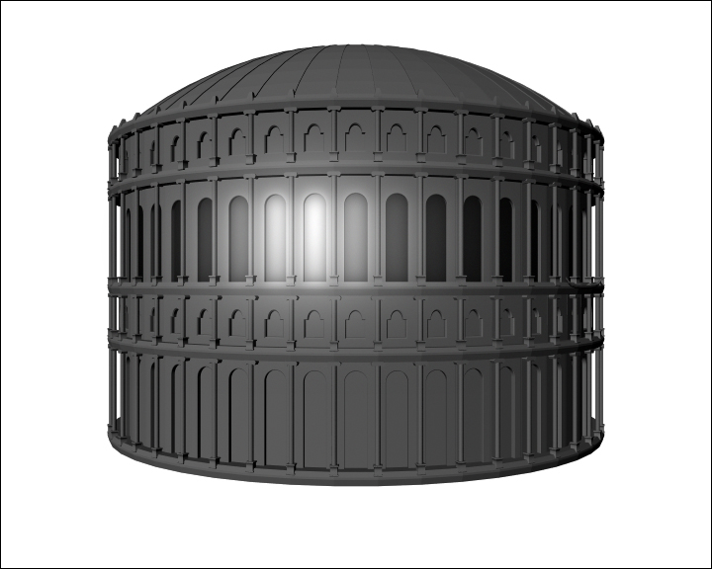

Fig.19 Basic render of the Opera House

Other elements of the opera house had to be built using more sophisticated methods. The window panes and shapes were relatively complicated shapes to construct. These had to be created using the create polygon tool and again, the Snap To Point tool. By putting a sphere partly over a cube one can trace around both objects in an orthographic view to create a window shape. This shape can then be extruded outwards to create the window pane outer edges.

The Background City:

The background elements consist of duplicated dome roofs and cylinders. My intention was to rely on texturing to make them look like different buildings. They were constructed to act as ‘Lego’ bricks which meant it would be easy and quick to build and adjust the background composition.

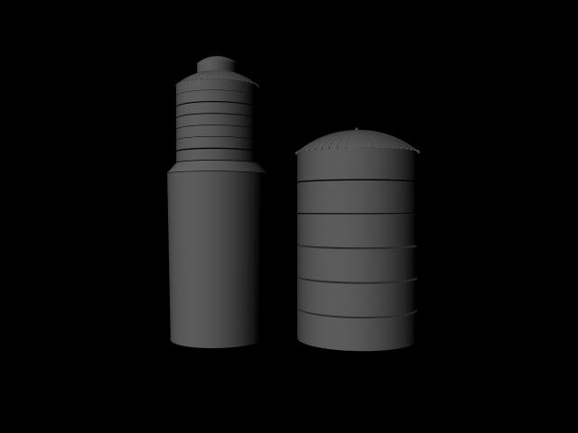

Fig.20 Two generic background elements

The Lamps and Gondolas:

The lamps in the foreground were built using Nurb circles which were then lofted to create the curvaceous structure. These basic objects were then attached to Nurb curves and duplicated along. This had to be done by eye so scalar distance is not completely accurate. These elements were a vital part of the image to give the scene a scene of depth and distance and establish the size of the enormous opera house.

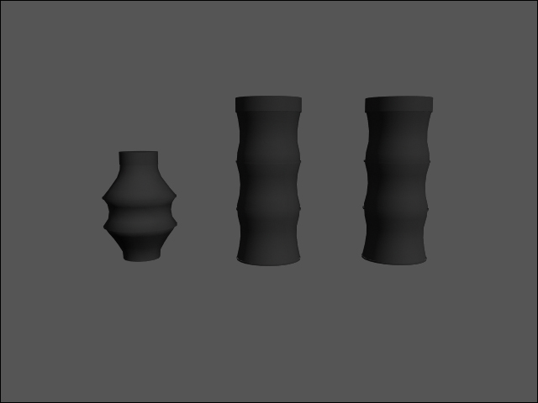

Fig.21 Basic render of Lantern models

Fig.21 is an orthographic view of one of many Gondola models I started. Time did not permit me to finish this model so it was dropped from the composition. These elements will be added when I have more time.

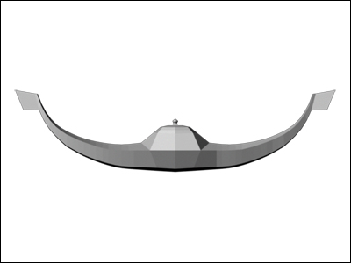

Fig.22 Gondola Side View

Texturing

From the outset I planned to employ the use of textures. Even as a 3d matte painting I would have had to texture the objects to get a basic render to paint onto (to give the scene added realism or less of a CG feel). This ‘painting’ would then be projected back onto the scene to enable a camera move. Because the background elements were so distant and because the opera house was going to be in darkness there was no need to spend too much time creating overly detailed textures as they would not be seen or lit. I wanted the glow of the city and opera house in particular to overpower / dull down everything else.

Researching night lit city images I observed that you do not actually really see much of the building textures at all. In fact the only visible textures are the lights and to some degree, a surrounding colour. As my scene was futuristic and illustrative I set out to achieve the same effect and exaggerate it even further.

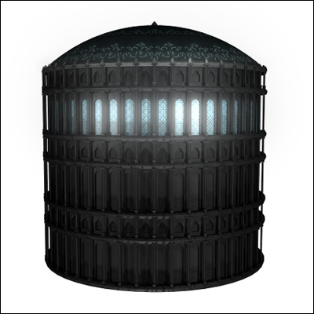

Fig.23 Textured Opera House

However, with this in mind I still needed to give the buildings some relief other wise they would have looked too flat. I decided to use bump maps as the means to achieve this relief and basic textures for slight colour. I utilised layered shaders so I could also apply an alpha map that would define where the material glows (more of this in rendering).

I did not see the need to do any UV mapping so texturing time was cut massively, however, I did need to project the dome texture onto the dome (UV’s based on camera view) as the basic spherical mapping would have given rise to some nasty results.

As I was not using UV maps I decided to experiment with procedural texturing. This proved very successful. Simple Noise gave the Opera House effective relief although it is barely noticeable in the final render.

Below is a quick outline of some of the many textures implemented in the scene:

The ‘Wall Scribe’ Texture:

It was important to give the background elements some kind of texture/relief. Looking at images of dome roofs I discovered an image of a mosque which had writing inscribed into the wall as a pattern (see Fig.24 below).

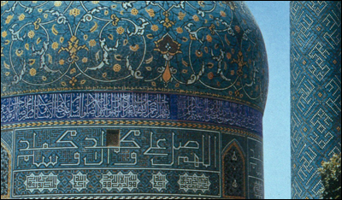

Fig.24 Mosque pattern/Scribe

I decided that this would work within my scene and designed a similar looking text that I could apply to the walls of the background elements. To avoid the look of hand drawn textures I decided to use Photoshop and implement a trick using the default Snap to Settings. I turned on Snap to Grid and painted lines onto the blank layer. Because Snap to Grid was turned on the marks/painted lines were drawn (magnetically) to the straight grid lines which made it easy to create a reasonable scribe effect. Below is a black and white image of one of the textures I used for the background building walls (see Fig.9). This was also used as the bump map.

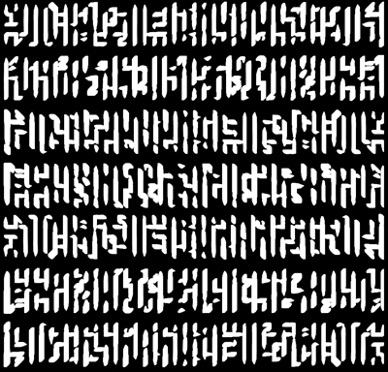

Fig.25 Wall Bump Map

Below you can see the same background models used in Fig.20 with the textures applied. These textures did not prove to be very successful because of the Maya Glow Feature. This will be examined in more detail in later sections.

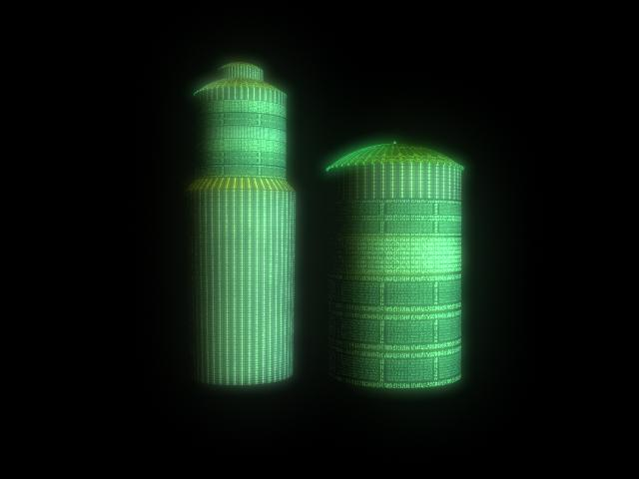

Fig.26 Background Elements with Wall Relief

The Window Texture:

The design of the window texture proved to be quite a challenge. My original designs illustrated in Fig.27 proved ineffective so I decided to use the more basic pattern shown in Fig.28.



Fig.27 Fist Window Design

The window texture did not need to be finely polished as it would be hardly noticeable. The glow would take away most of the detail leaving only an indication of pattern. The bright white parts were used in a layered shader as the source of the glow.

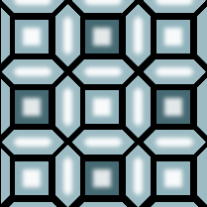

Fig.28 Close up of the Approved Window Texture

I was pleased with the simple results that this texture gave and it was very easy to construct in Photoshop.

The Dome Roof Texture:

For the dome roof I had to design a pattern which took a considerable amount of my time. I had to use a vector graphics program which I was not familiar with and had some trouble arriving at a suitable design. After much experimentation I arrived at the solution you see below (Fig.29). The texture works very nicely when the dome roof glows blue. However, when the colour evolved to an orange it did not prove to be as effective.

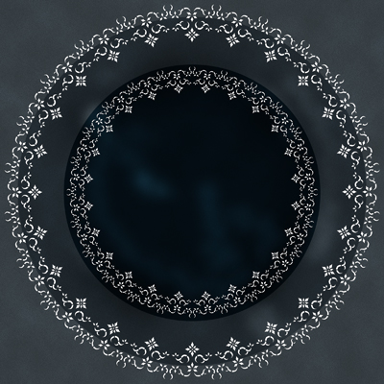

Fig.29 Dome Roof Texture

The Lantern Textures:

I set out to make the lanterns semi transparent and quite ethereal (similar to Japanese paper lanterns). I discovered some Chinese dragon patterns on the internet and decided to use these as the basic pattern on my lanterns. I used Photoshop to retouch them slightly and to duplicate/position them accordingly (see Fig.30 below).

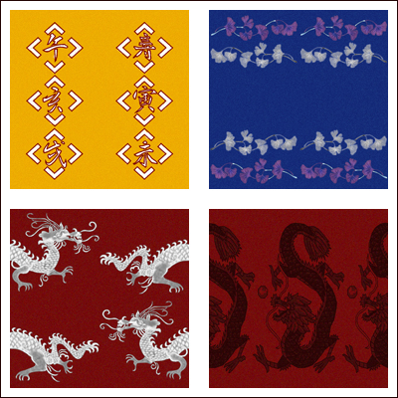

Fig.30 Four of the Lantern Texture Maps

Having made around eight different designs I decided that they were too similar to Christmas tree lights and not what I was aiming for at all. I consequently decided to use just white and red colours to fit in with the scene. The design of the lantern textures bared some importance as
a few of these elements would be relatively close to the camera to give a sense of space and depth to the scene (i.e. scalar relationships established by making large foreground lanterns trail off to tiny dots as they near the opera house roof).

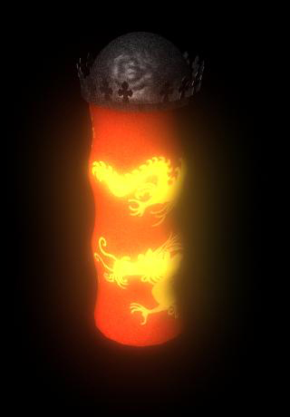

Fig.31 Approved Lantern Texture

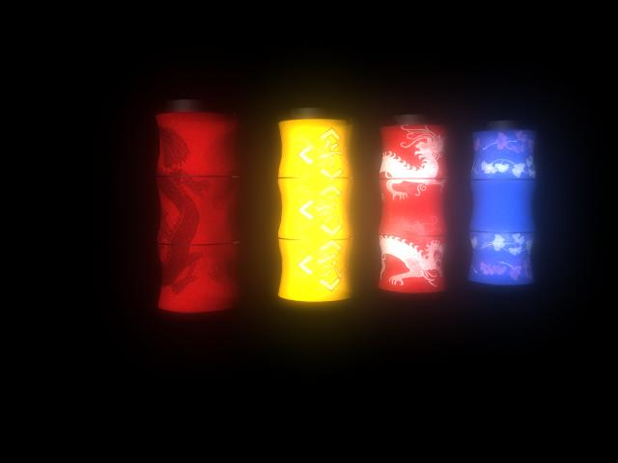

Fig.32 Unused Lanterns

Lighting

Lighting the scene proved to be very time consuming. My methods utilised over 40 lights in the scene which slowed rendering times down drastically. This meant that I had to wait for a considerable amount of time to get feedback on the lighting. Light Linking had to be used extensively to avoid even greater render times which proved to be extremely time consuming as well. I had to regularly keep checking and un-checking the various lights in the Relationship Editor because Maya seemed to consistently alter the links I had previously set up.

The decision to use Maya glow proved to be careless at this stage. Tiny alterations of the lighting would result in highly unpredictable results. This is discussed further in the next section.

I experimented with a method of using dedicated lights to effect only one material in a ‘Layered Shader’ (with Alpha Channel) to give the effect of light gradients running down the walls of the distant buildings. This was achieved by including a glow material/texture which meant that the whole material was not glowing. Fig.33 below illustrates the result of one of these tests.

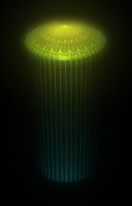

Fig.33 Light Gradient
Rendering

I decided early on use the Maya glow material feature to save on Post Production time. My first tests with glow on the opera house dome roof proved relatively successful so I decided to employ this feature on the background city as well. This gave rise to several problems. It was very difficult to determine the effect that the glow would have on the scene and quite tricky to control. In addition the texture files and bump maps were losing their definition.

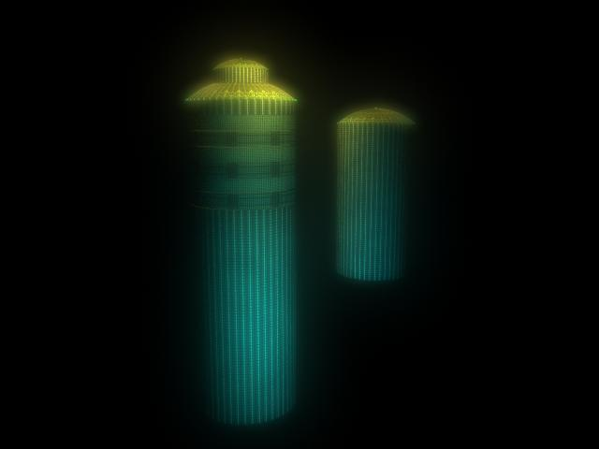

Fig.34 Effects of Maya Glow Feature

On reflection it is apparent that it was a careless mistake to use glow to mimic a source of light. The glow renders look totally unconvincing as a night shot (i.e. the glow sources do not effect surrounding objects/textures). If a glow effect has to be incorporated into a scene it would be far better to do this in Post Production. Where alpha maps could be used to alter the image below. This would give greater flexibility and allow for real time lighting tests.

Another problem that I encountered was that my incorporation of the Glow feature required a large number of lights which gave rise to inflated render times. Even for basic geometry! As the city was built using generic ‘Lego’ type polygons I needed to use different coloured lights to make them stand apart from one another. I tried to render them off as different passes but this did not work as the Maya Renderer would not properly capture the alpha channel of the glow. This meant that when I took each render into Photoshop the glowing buildings had hard lines between each other.

To get around this problem I decided to replace geometry with Camera Image Planes where possible. A render of the distant objects is produced which is then used as the background of the next layer of objects to be rendered and so on. Working forward towards the foreground elements (i.e. the near buildings, opera house and lanterns).

Although this proved successful and enabled me to render off some adequate background plates I found yet another problem. The Maya Renderer seemed to change the intensity of the glow depending on the size of the render. When rendering at a high resolution the glows became far too intense. This prevented me from being able to work on the image in Post at double resolution (the normal resolution for matte work and re-touching).

PhotoShop

The true potential of Photoshop was now limited because it would be hard to get fine adjustments into the final render at PAL resolution (720/576).

I was enabled however to make basic adjustments such as Colour Balance and Levels. This added definition to the scene and greatly improved the contrast and colour relationships between the background and the foreground. I was also able to make subtle adjustment by brush using the brush’s Colour Function which enable colour to be placed onto the image without losing detail.

Final Shot –

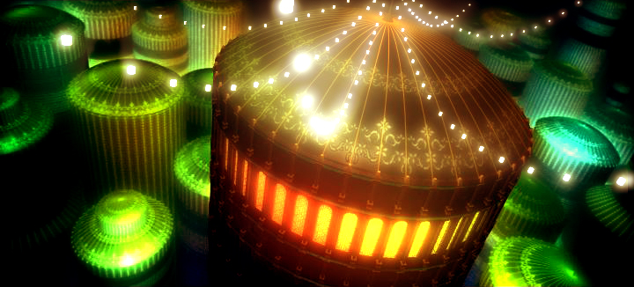

Fig.35 Final Shot ‘The Grand Space Opera’ with stand in Lanterns (glowing cubes).

The approved lanterns are not included in the shot because I ran out of time. However Fig.35 above gives an indication of how the final shot will look.

Fig.36 Final Shot ‘The Grand Space Opera’ without Lanterns.

Section 3 - Conclusion

In conclusion the project did not prove very beneficial to my development as a 3d artist or as a matte painter. It did however give me more experience with regard to setting up and handling scene files of this nature.

Given time I would very much like to re-do the scene from scratch adding the compositional elements that have been removed from the scene due to time restrictions. With the lessons I have learnt firmly locked in mind I would employ more Post Production as opposed to Maya Effects. The use of the Maya Glow Feature caused a variety of problems which seriously affected the quality of the piece. The use of Post Production to achieve lighting effects would allow more time for modelling/texturing and the untreated renders could then be altered in Photoshop and projected back onto the geometry for a less CG look and feel. Lighting could be greatly improved to give a more realistic effect and interesting setup.

Benefits:

In contrast to the above criticism the project allowed me to experiment more with Concept Art/Pre-Production which is always a valuable exercise. I really like the concept and, time permitting, I would like to further the concept of this piece and produce some more work both 2D and 3D based around the same theme.

References –

Websites

www.mattepainting.org

Dedicated Matte Painting site with tutorials and showcased work. Invaluable source of inspiration and knowledge.

www.cgtalk.com

Both 2d and 3d Digital Art website. Information and resources on a wide range of relevant material.

www.matteworld.com

Renowned Matte Painting company website.

www.dyloncolestudio.com

Revered Matte Painter and an inspiration to all.

www.dusso.com

Another great digital artist working for MatteWorldDigital.

Films

BladerRunner / Ridley Scott

City of Lost Children / Marc Caro, Jean-Pierre Jeunet

Bibliography

The Invisible Art by Mark Cotta Vaz, Craig Barron
Cinefex magazine

Appendix A – Innovations Project Proposal

Proposed Topic of Research:

Matte painting techniques and practice.

Proposed Project:

Investigate traditional and modern matte painting techniques. Learn how to tackle classic matte projects such as – (eg Day to Night, extending buildings, turning buildings into ruins, laying realistic snow onto landscapes, compositing in other material etc)

Method:

After research I will develop my own matte painting techniques and utilize them along side Photoshop and Maya.

Product:

After research I intend to produce a matte painting along with some from of sketch book.

Report:

The report will be presented as an HTML document.

Supporting Material:

A sketch/scrap book as well as a log book.

