Translucency and Subsurface Scattering
By Mohamed Sobhy

Abstract

This innovations project introduces the natural phenomena of translucency. Until now translucency has been underrated and ignored, you maybe not even be aware of its existence, even thought it plays a very large role in how things look and feel to the eye. Translucency is what makes skin look smooth when actually it’s not and what lets you see things behind paper, even thought papers opaque. Everything excluding metal has an element of this property. My innovations project is to research translucency and all its components and from that implement a subsurface scattering shader that implements this effect.

Introduction

What is Translucency:

Translucency is a material phenomenon where the material allows, the light to travels through an object's surface. When light hits a surface, it reacts with that surface, in some way or another. Reactions include reflection, absorption, refraction, diffusion and scattering.

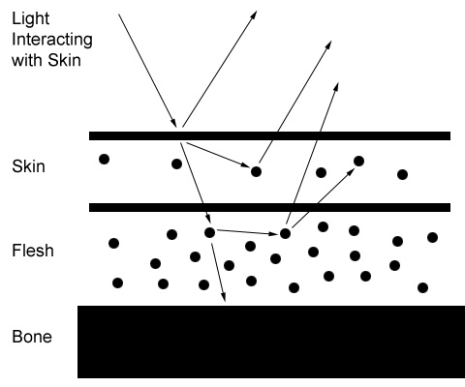
Diagram showing light interaction with skin [2].

Taking a more specific example, being skin. When light hits skin, some of the rays bounce right off, at different angles. Some get absorbed (i.e., die). Some of the rays enter into the skin, and bouncing around, this is also called scattering. Some of those get absorbed. Some bounce out at a slightly different angle than they entered. Some make it through the skin layer to the flesh layer (which includes blood, muscles, etc), again, more interactions. Some continue through this layer and hit the bone, stopping their journey.
The translucent component of the skin is what lets light penetrate it. [2]

Translucency has a few properties, which describe the specific ways that it reacts with light. This includes single scattering, multiple scattering, forward scattering and finally backward scattering. In the next section real world objects will be used to describe and explain these properties.

Leaves
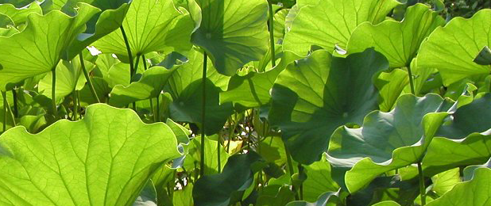
Photo showing the effects of translucency on leaves [2]

Leaves have large levels of translucency. This type of translucency is called “thin” translucency. As the light from the sun hits the top layer of leaves, they go through, quite easily, but less light penetrates the leaves underneath. Look closer, a using laser pointer.
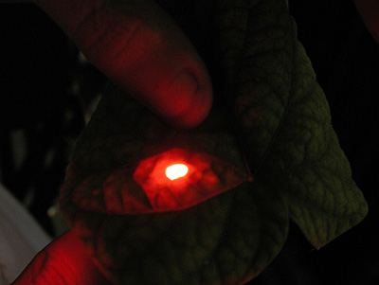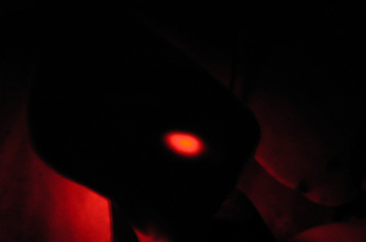
Photo showing leaves with a laser light pointed though it. [2]
Photo showing a single large thicker leaf with a laser light pointed though it. [2]

In the first photo, we have a few leaves and a laser light shooting from the bottom. The light penetrated all the way through the leaves, this can be seen due to the focused centre of light. This component is called single scattering. The soft glow around the focused central point is due to light penetrating the surface and diffusely scattering in the leaves. This is the multiscattering component. This photo has a high level of both single and multiscattering.

The second photo is a single thicker leaf. Notice that it has the focused centre point, but no soft glow. This is an example of translucency with a large single scattering component, and no multiscattering component.

Grapes

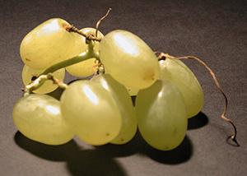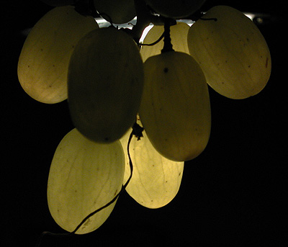
Photo showing grapes under backlighting [2]
Photo showing grapes under normal lighting [2].

The first photo shows grapes under normal lighting. The second photo shows the same grapes backlit. See how the light has travelled through the grapes and lit it from inside, showing the veins.
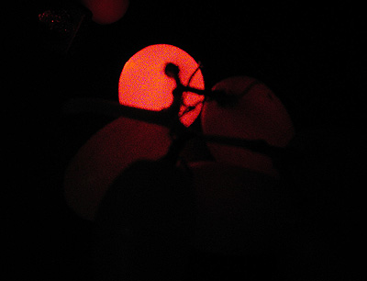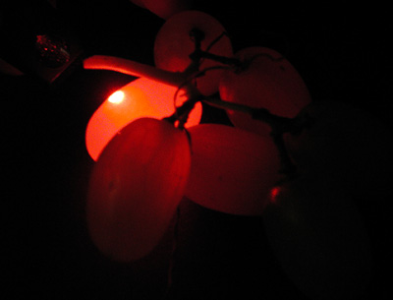
Photo showing multiscattering component [2].
Photo showing high multiscattering component [2].

In the photos above, using a laser pointer. You can see how the light has entered the grapes and spread from one grape to another. This is an example of a translucency with a very high multi scattering component. The light has diffusely scattered across the grapes. Also, notice that not only has intensity of the light been scattered, but with it is the colour of the light. This is an example of colour bleeding. As the light passes through objects it picks up colour.

Plum

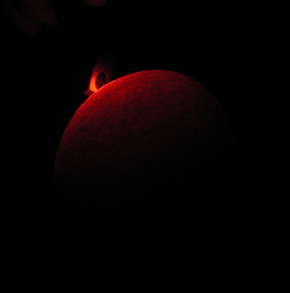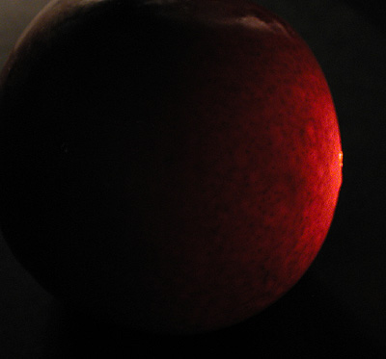
Test showing multiscattering component [2].

Test showing multiscattering component [2].

The above photos are plums, illuminated using a laser light. Even though the skin of a plum is thick, light still managed to penetrate the surface and multiscatter causing the glow you can see.

Wax

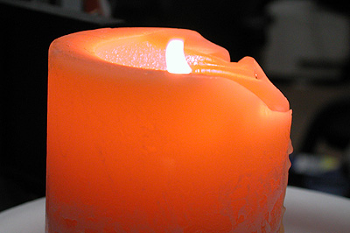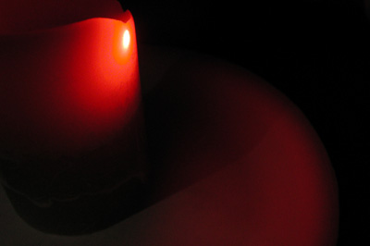
Test showing multiscattering component [2].
Test showing single scattering component [2].

Wax, has both, high levels of single scattering and multiscattering components. In the first photo you can see that, there is a very large glow in surface around the flame, caused by internal multiscattering of the light. In the second photo, you can see the single scattering component; notice how the light has gone completely thought the candle and lit the plate.

Skin

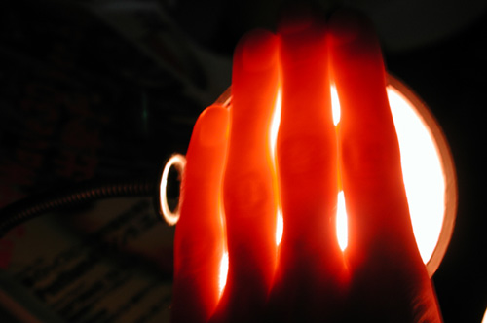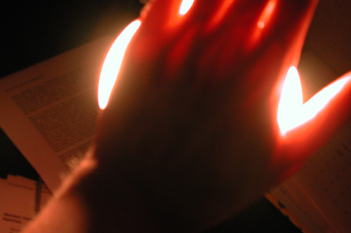
Test showing multiscattering component [2].

Test showing changes in density, affects translucency. [2]

Skin is probably one of the most complex materials, especially when it comes to explaining its translucency. This is due to the composition of humans. This includes many layers of skin, then flesh, and bone. Light travels differently in different materials, due to the density these materials have, for example light travels easier through the flesh than it does for the bone. Hence, been able to see the bones in the second image.

Another two properties of translucent materials are forward and backward scattering. Forward scattering is when light travels through the object from behind. The above two photos are examples of this property. Another more familiar, example is when an ear is lit from behind, causing to glow and go red.

Backward scattering is when light travels from the front to the back of the object, coming out through a shadowed area, causing it change colour. In the example of skin, due to human flush being the colour red, when the light forwardly scatters through the skin, the travelling light changes colour from white to red, causing the shadowed areas to have slightly reddish tones and not the expected grey.

We have discovered, that translucency is a very important factor, which influences what things look like to the human eye. We’ve also discovered that translucency comes in different forms, it being single, multi, forward and backward scattering, and that the thickness, the colour (colour bleeding), and the varying density of an objects influences how translucent, an object is.

Possible Implementations

Full Volume Rendering
To produce completely realistic images, the first obvious solution that comes to mind is full volume rendering. Volume rendering works by ray marching or ray casting, through a vowel dataset which holds information about every point in that volume. For instance, if we want to full volume render a cat, then you will need for accurate information of how the cat was made up slice be slice. This is somewhat unpractical, and due to the vast amount of information needed, this method would be very slow to setup and very slow during rendering. Also, volume rendering can sometimes be prone to aliasing problems [5].

Kubelka-Munk Pigment Model

The Kubelka-Munk Pigment Model, was developed in the 30s to describe light bouncing off wall paint [2]. They considered the problem of determining the resulting overall colour from a set of layers of differently coloured paints [6]. For example, say you had two layers of paint. The bottom layer being green and the top layer being white. You would end up with an over all colour of light green unless the white paint was thick enough to make the green have no effect.

Media like paint can be modeled volumetrically as collections of small colored particles. As
light passes through the medium, some of it misses all of the particles, and exits with reduced
intensity due to absorption in the medium. The rest of the light interacts with one or more particles in the medium, and is scattered in a new direction. The interactions with the particles cause some wavelengths of the light to be absorbed, so that the particles’ colors change the color of the light that hits it. Because there are so many particles, these interactions are often modeled statistically, rather than as individual interactions.
In order to model these situations accurately, it’s necessary to both model the scattering of light within each layer as well as the scattering between the layers. [6]

Kubelka and Munk, however, made a number of assumptions about the details of these interactions in order to develop a model that could be solved analytically:

- They assumed that the composition of each layer was homogeneous; i.e. having uniform colour and scattering properties throughout.
- They ignored the directional distribution of light: specifically they assumed that the top layer was irradiated by incident light uniformly from all directions, and that light exiting each layer after scattering was also uniformly distributed. [6]

The method has several problems though, such as it assumes the substance is homogenous all the way through. It does not take into account layers of different materials or different densities in a single surface.

Henrik Jensen's BSSRDF
The most advanced and accurate research so far in this area is a now well known paper by Henrik Wann Jensen, inventor of the photon map. This paper is entitled "A Practical Model For Sub-Surface Light Transport" [7].
BRDF

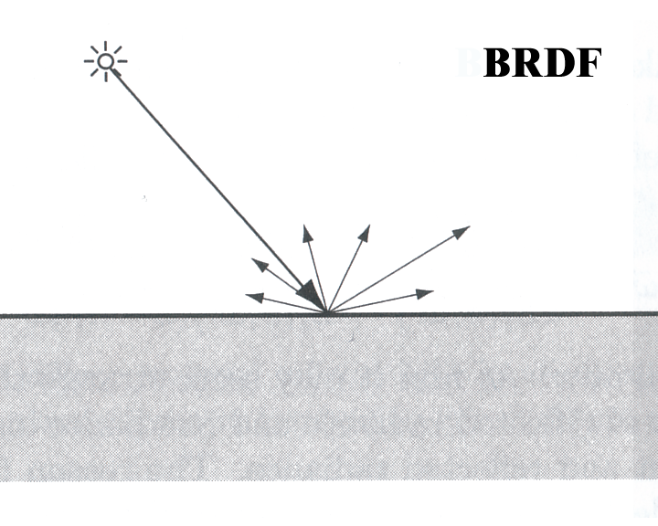

The Bidirectional Refractions Distribution Function, BRDF, was introduced by Nicodemus et al as a tool lighting model at a surface. A surface’s BRDF specifies how much of the light incident from only one direction is emitted in any second direction. For the BRDF it is assumed that light striking a surface location is reflected at the same location [9].

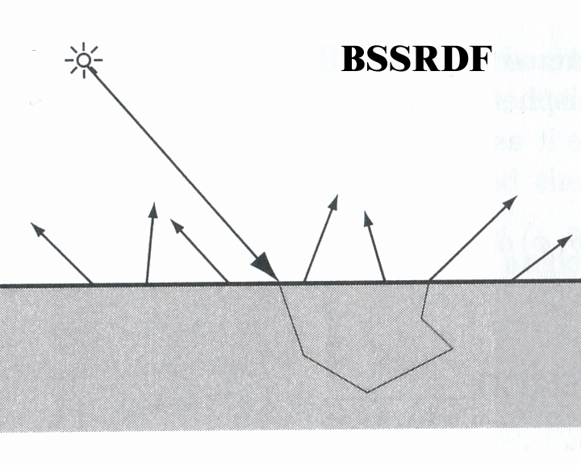

Jensen introduces a new lighting model, which replaces BRDF, called BSSRDF, which stands for Bidirectional Subsurface Scattering Refractions Distribution Function. This models describes how light enter the surface at one point and exits at a completely different point.

Implementation

The way the BSSRDF works is, a ray of light hits the surface. That ray of light either then is absorbed by the surface, reflected or it penetrates the surface. This ray of light will then scatter inside the medium, some of it intensity will be absorbed on the way, some will multi-scatter and some will single scatter, and then eventually some might come out of the surface, at a completely different position, from which it enter.

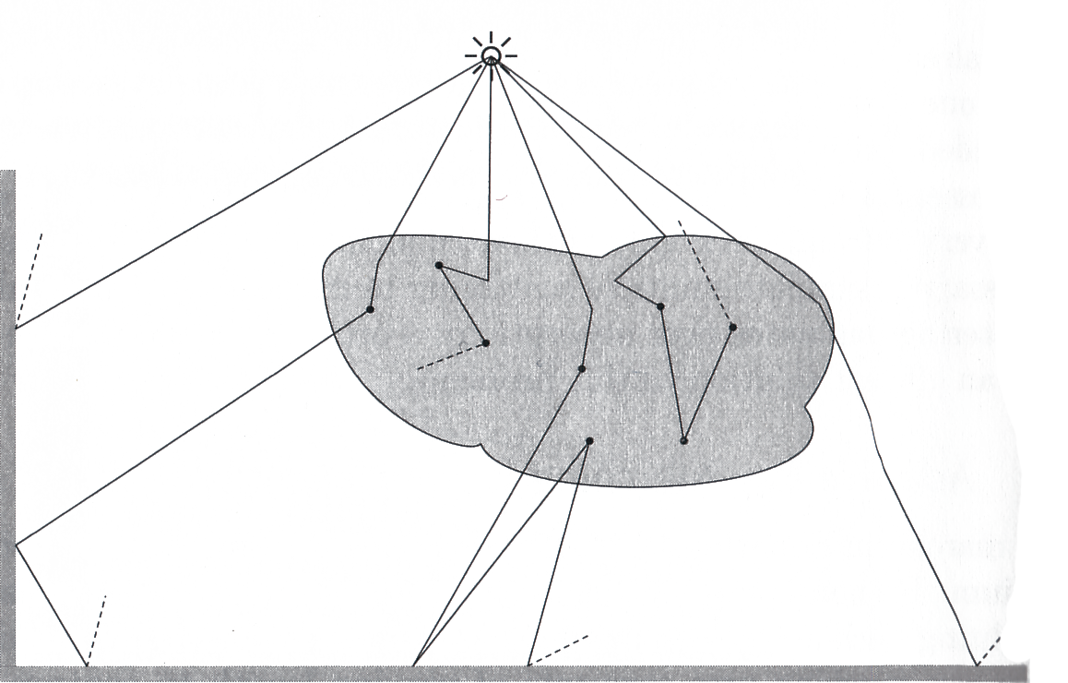
Image shows complex lighting calculation [7]

There are a lot of interactions that happens when a light enters the surface. Following each ray around the medium would require a global illumination renderer to calculate the “volume radiance estimator” for the multi-scattering component of the precipitating media.

Jensen’s implementation relays heavily on photon mapping, and even though this is the best way of implementing a BSSRDF illumination model, I did not want to be side tracked, and chose to concentrate my efforts purely on the concept behind the implementation of simulating translucency.

So a solution had to be achieved so it was possible to be implementation in a direct illumination scanline renderer like renderman. We decided that we will attempt to implement the single scattering component only, as this is the direct illumination component of the algorithm.

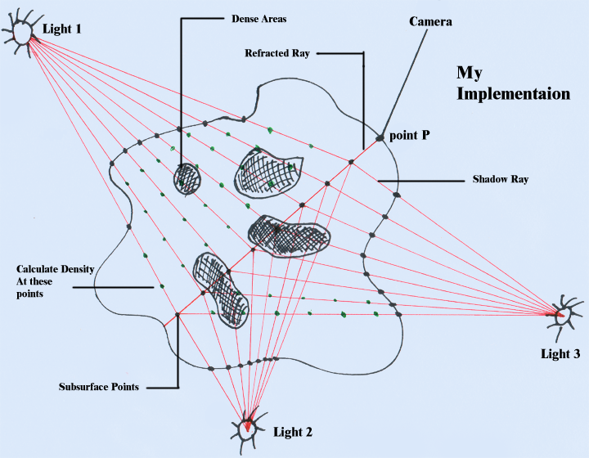
My implementation

Taking a very basic setup, a simple sphere and three lights. Due to our object being translucent photons emitted from the lights sources would penetrate the medium and scatter through it, eventually coming out from the other side.

Taking the first point that we’re calculating the irradiance for, we need to find out how much light from each of the lights in our scene, has reached point (P). We do this by tracing back to each light, taking a similar route to the route that each light would have taken to effects point (P).

We implement this concept by first working out the refracted ray from P going into the object.

Refraction is the bending of a wave when it enters a medium where it's speed is different. The refraction of light when it passes from a fast medium to a slow medium bends the light ray toward the normal to the boundary between the two media. The amount of bending depends on the indices of refraction of the two media and is described quantitatively by Snell's Law. Snell's Law relates the indices of refraction n of the two media to the directions of propagation in terms of the angles to the normal.

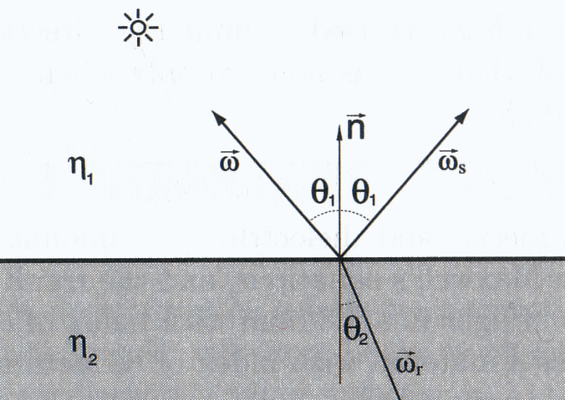
wr = Refracted Ray [7]

We then intersect the refracted ray with the object to work out the second point of intersection, the first point being at P. This can be done in two ways. The first method is retracing, the second is by using the raysphere function in renderman. The rayshere function assumes that your object is a sphere with a known radius, centered in the center of the scene and in turn, the raysphere would work out the intersection points by solving this quadratic equation:

(I . I)^{t^2} + 2 (E . I)t + E.E – r² = 0;

I = unit directionbal vector.
E = end point.
r = radius.
t = free parameter.

The raytracing version is extremely costly but allows you to use any object, for this purpose though the raysphere method is much more appropriate due to its simplicity and speed, put lacks the ability to compute objects that don’t lay in a sphere with a certain radius.

Once the end point is found and the distance is calculated, we are able to raymarch down the refracted ray in increments of small steps of x. Ray marching allows you to solve the volume rendering equation by using numerical integration.

Numerical integration can be done by taking small steps through the medium and making some local simplified assumptions within the segment considered.[4]

To calculate the radiance at every small step down the refracted ray, we need to find the shadow ray, which is from the subsurface point to each light. Once again we need to intersect the shadow ray with the object to find its intersection point.

I’ve implemented this section by using the raysphere function again, but the raytracing method has an extra advantage over the raysphere in this situation. Due to the fact that the shadow ray, describes the vector from the subsurface point P and the light we have not considered the fact that due to light transport between two medium, the shadow ray will refract. The raytracing version supplies us, with the normal at the intersection and in turn allows use to work out the true distance the light has travelled due to refraction.

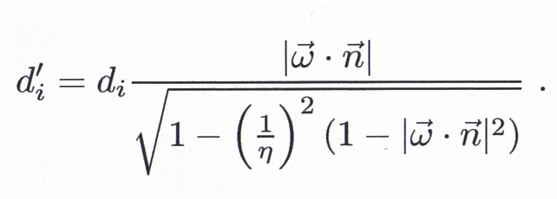

di = original distance travelled.
d’i = true distance.
w = shadow ray.
n = indices of refraction.

Armed with the step size (distance used for raymarching), the distance from each subsurface point to the edge of the subject and Cl (the radiance from each light), we are able to find out the radiance at each point by raymarching along the refracted ray by attenuating the radiance of each light according to the total distance the light has travelled and the extinction coefficient.

A beam of light passing through a medium will have its intensity reduced by:

e^{-δt * s}

where: s = total distance the light has travelled through the medium
δt = δa + δs
δt = Absorption coefficient + scattering coefficient

[7]

Also at every subsurface point the phase function has to be calculated, which describes the scattered light at each point in the participating media

The phase function depends on the angle (θ) between the refracted ray and the shadow ray.

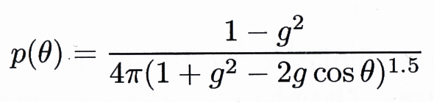

g = is an asymmetry parameter equal to the average cosine of the scattered directions
Positive g = backward scattering.
Negative g = forward scattering.

Point P = Radiance due to direct illumination + (total attenuated radiance from each light at each subsurface point) * the phase function.

This implementation assumes that the medium is homogenous, i.e. has a constant density. We can extend this algorithm to take into account varying densities in the media.

This is done by raymarching along the shadow ray, and calculating the density function like fbm(), a noise function in renderman. Using the density to affect the radiance at each subsurface point.

We can extend this algorithm even further by having a colour function describing the colours in the medium (useful for skin), and calling it with the density function during the raymarching of the shadow ray. Anymore extensions will the need the implementation of photon mapping and raytracing.

Pseudocode For Creating The Subsurface Scattering Shader

For each point P
(

surface MainSubsurfaceFunction (Imported variables from User)
{
Initializing variables;
Calculate Normalize Refracted Ray using refRay function;

Calculate the intersection between the refracted ray and the geometry:
Calculate the maximum distance;

Calculate StepSize;
Move Forward along refracted ray;
Calculate point on Refracted ray;

while (The distance “raymarched” is less than the maximum distance)
{
Increment distance
Raymarch through participating media
Calculate new point along refracted ray
Calculate Subsurface component using SubSurfaceCalc function
}
Calculate surface colour plus subsurface scattering component
}
}

color SubSurfaceCalc (Imported variables from MainSubsurface Function )
{
Declare and Initialize variables.

For every Light {

Calculate the shadow ray, which is ray from current point to light.
Calculate the intersection between the refracted ray and the geometry:
Calculate the maximum distance;
Calculate step size for density function;

Move Forward along Shadow ray;
Calculate point on Shadow ray;
Tranform point from current to object space.
Calculate oldDensity at object space(P);

while (The distance “raymarched” is less than the maximum distance)
{
Increment distanceTraveled
Raymarch through participating media
Calculate new point along shadow ray
Tranform point from current to object space.
Calculate Density at object space(P) plus old Density;
Assign density to oldDensity
}

Calculate the total distance the light has travelled
Calculate intensityScaler using intensityReduction function
Calculate Henyey-Greenstein Phase Function using HGPhase Function

Calculate total Attenuation of the light

}
return translucency;
}

float volumedensity (Current Point; radius of the object sefreq, Stepsize;)
{
Calculate the density at Current Point;
Return the density at that Point;
}

float IntensityReduction (Extinction coefficient, the distance light has travelled ;)
{
Returns attenuation value according to the distance the light has travelled and the extinction coefficient.
}

float HenyeyGreensteinPhaseFunction (Ray through volume, Ray to the light; g)
{
Calculates the phase function and then returns it to main surface function.
}

vector refRay(Variables from main surface function)
{
Calculate Refracted ray using fresnel function
return refracted ray
}

Criticism

This implementation works on specially designed situations, but there are many situations where it breaks down. Because I used the raysphere function, there where many aspects of translucency that I was not able to implement, for example:

- I was not able to implement the object to object interactions.
- I could not have colour bleeding from one object to another due to translucency.
- I could not implement the multi-scattering component.
- I was unable to calculate the true distance due to refraction, from the shadow ray to the light.
- Finally, this shader only model light extinction (absorption and out-scattering) inside the objects, not light in-scattering. In order to fully simulate scattering inside the objects, more complicated methods are necessary. Some of the methods that can be used are: brute-force Monte Carlo simulation, volume photon map, dipole approximation, or hierarchical integration techniques. [11]
- My implementation breaks down when there is an object between the light and the translucent object. Because my algorithm takes the colour information of the surface, directly from the light instead of taking the colour value of the actual surface, my implementation automatically thinks that the point its sampling is not in shadow.

This implementation seems to be computationally heavy, for example if I where to use:

100 sample point
100 shadow ray sample point
3 lights

Then the density function would be called 30’000 times, per point. I feel as though with more renderman experience I would be able to simplify certain parts of my implementation without losing quality. Also I feel as though by knowing the package better I would be able to apply hacks which mathematically and scientifically may not be correct but ultimately, improves the visual look of the image.

To solve the problem of the multiple noise calculations, I could have implemented a caching system that pre-cached al the data needed.

Conclusion

I am very happy, with the results of this innovations project. I have managed to successfully implement a shader that takes advantage of the BSSRDF lighting model.

We learned earlier, that there are number of components that effect translucency.
- Single scattering component.
- Muli-scattering component.
- Forward scattering.
- Backward scattering.
- Varying in density.
- Colour bleeding in shadowed areas.

I have managed to implement all these components except multi-scattering, which required global illumination.

Bibliography

[1] Cambridge International Dictionary of English:
<http://uk.cambridge.org/elt/cide>

[2] Translucency and Sub-Surface Scattering:
< http://www.neilblevins.com/cg_education/translucency/translucency.htm>

[3] http://www.1000plus.com/Imagic/

[4] Realistic Image Synthesis Using Photon Mapping.
Henrik Wann Jensen. 2001.

[5] Mathematics for Games and Programming.

[6] Advanced Renderman 3: Render Harder

[7] A practical Model for Subsurface Light Transport.
Henrik Wann Jensen. 2001.

[8] A Rapid Hierarchical Rendering Technique for Translucent Materials.
Henrik Wann Jensen. 2002.
[9] BSSRDF (Bidirectional Surface Scattering Distribution Function).
Helsinki University of Technology

[10] HyperPhsysics
http://hyperphysics.phy-astr.gsu.edu/hbase/hframe.html

[11] Renderman 11 – User guide

