A Spectrally Based Method for the Emulation of the
Technicolor Process on Digital Images
Thomas Edwards
NCCA Bournemouth 2006

Abstract

Before single strip multi-layered colour motion picture film was 'developed' at the end of the 1940's, the main method of producing colour movies was a system invented by the Technicolor corporation, and hence commonly known as Technicolor. Other systems existed but the methods were essentially the same. Light from the lens was split into separate beams, each of which passed through a coloured filter onto a strip of black and white negative, so creating colour records that could be combined with filters and lights at projection time to recreate the scene in colour. The technique was characterised by a rich, vibrant colour that distinguished it from single strip colour films that eventually replaced it. After filming in Technicolor was discontinued, it was still common to create release prints from the colour film using the Technicolor printing process and recent films have also emulated the process on digitised film([2] & [3]). Digitally captured images lack the depth of film and new methods of mimicking photography are continually being thought up – grain, lens flare etc. This paper aims to develop a physically based method of emulating the Technicolor process on digital images through the use of spectral data.

The Technicolor Process

Just as the colours of the visible spectrum are approximated for digital input and output with red, green and blue components, so colour film projection processes use a similar approximation method in capturing and displaying colour. The main difference is the colour methods employed by each. Computer monitors and television screens work on an additive colour method where each red, green and blue element adds hue and intensity to an otherwise ‘black’ pixel. Early colour film processes worked this way too but these were soon superseded by subtractive colour methods. With subtractive colour, as the name suggests, you start the other way round from additive - with white light. Red, green and blue portions of the spectrum are filtered out from regions of the frame, where filtering out 100% of all RGB will create a black area on screen – this is known as subtractive colour. The way that a component is subtracted is by passing the white light through a filter of the colours spectral complement ie. blue is filtered through yellow, red through cyan and green through magenta.

The first colour films used only two colour ‘channels’ – a red-orange and a blue-green – due to technical limitations. Later on a method for using three colours was introduced.

Let us start by examining two colour processes. The cameras were essentially the same for additive and subtractive – a prism would split light from the lens into two separate beams. One beam would pass through a blue-green filter onto the film thus creating a record of the blue-green portion of the spectrum. The second beam would pass through a red-orange filter onto an adjacent frame of the same strip of film – one frame would be upside down in relation to the other due to the light passing through the prism. In the additive process, colour would be introduced back at projection time. Frames would be projected in pairs with light projected through them passing through corresponding coloured filters and layered over each other by means of a prism. Registration was a major problem and fringing (coloured edges due to misalignment of projected frames) was common. Also, the range of the image was poor due to light loss from projecting through coloured filters as well as black and white negatives.

The two colour subtractive process eliminated these drawbacks by creating a single film strip with the colour filters on the film itself. In the original negative, red and blue-green colour information was recorded in adjacent frames. From this, two separate positive strips would be created – each strip being a mirror image of the other – and each being half the thickness of the original negative. Let these separation positives be known as ‘matrices’. After these strips had been developed, the photo-sensitive silver halide crystals would be chemically removed leaving the gelatine in a ‘relief’ formation of the image. These two strips would be floated on baths of dye complimentary to the colours they represent ie. the red record floated on a bath of cyan and the blue-green on magenta. Areas of the matrix where there were more silver crystals ie. darker would have less gelatine and thus take on more dye. The dye is complimentary to the colour the matrix represents so, for example with the red matrix, when light is projected through the matrix, a higher density of cyan dye will filter out more red light in that area. When the matrices had been dyed, they were ‘cemented’ together back to back – hence each matrix being half the thickness of the original negative and a mirror image of the other. Now each frame of the final print could be projected on its own thus eliminating registration issues. And the only light subtracted is by the colour dyes in the print as opposed to the silver in the negative and the colour filters as with the additive process. In addition to these benefits, the brightness/contrast of the matrices could be adjusted at development time as could the hue and density of the coloured dyes – colour control was as much with the printer as the director.

The three colour process worked in essentially the same way but abstracted the spectrum into red, green and blue, and the camera was slightly more complex. The most common three-strip camera was developed by the Technicolor corporation.

As with the two colour camera, light from the lens was split two ways through a prism. One beam would pass through a green filter onto black and white negative – thus the green record would contain approximately half of the light intensity information. The other beam would pass through a magenta filter to remove any green light. It would then hit the blue negative. The blue negative was orthochromatic (only sensitive to the blue end of the spectrum whereas the ‘red’ and ‘green’ negatives were sensitive to all portions of the spectrum – panchromatic) and so it was of no consequence that red light information was still present at this point. The blue negative was specially prepared with an orange-yellow dye on its reverse to filter out remaining blue light before the light passed on to the ‘red’ negative. Light reaching the ‘red’ negative had had blue and green portions of the spectrum removed. Light reaching the ‘green’ negative was dependant on the spectral characteristics of the green filter and light recorded on the ‘blue’ negative was dependant on the spectral sensitivity of the orthochromatic film. Then, as with the two colour process, three positive matrices would be made from the negatives and converted to gelatine relief prints. Creating the final print was slightly different – a separate ‘blank’ strip of black and white film was exposed with 50% of the green record (this gave the final image better contrast). The individual matrices were coated with their complimentary dyes (red with cyan, green with magenta , blue with yellow) and, one at a time, brought into contact with the ‘blank’ which received the dye – thus a three colour image was built up on the ‘blank’ film. Technicolor prints were renowned for their stability compared to the single strip layered colour film introduced in the early fifties – the dyes were more fade resistant than the emulsions used on the colour film – Technicolor release prints were often printed from the colour film.

In summary, the factors affecting the colour of the final print:
- spectral characteristics of the green and magenta filters in the camera
- spectral characteristics of the orthochromatic negative for the blue record
- spectral characteristics of yellow dye on back of ‘blue’ negative
- spectral characteristics of the panchromatic negative for red and green records
- adjustments of brightness/contrast when developing matrices
- hue and density of the dyes used in final print

And the main stages of production:
- filming of black and white negative for red, green and blue
- creation of positive ‘matrices’
- removal of silver halide crystals to leave gelatine relief
- transfer dye from matrices to ‘blank’

Approximation of spectral characteristics

The visible spectrum of light is the section of the electromagnetic spectrum with wavelength roughly between 380 and 780 nanometers(nm). White light consists of all wavelengths of the visible spectrum. An objects colour is due to the fact that it reflects light. Assuming the object is being illuminated by white light, the colour itself is defined by how much light of each wavelength the object reflects. Storing data in images for reflectance values of each wavelength in the visible spectrum would create unmanagably large images by todays standards and would require hugely complex output devices to display them. Instead, the spectrum is 'sampled' into three main sections that roughly correspond to the light primaries we know as red, green and blue. The boundaries are roughly: blue 400-500 nm, green 500-600nm, red 600-700nm. However, spectral graphs for various coloured objects reveal that although a 'red' object will mainly reflect light from the 'red' portion of the spectrum, it will also reflect, to a lesser extent, light from other areas of the spectrum. Therefore, spectral power distribution functions (SPDs - graphs showing contribution of each wavelength to the colour) for most colours will usually overlap with those for other colours. Saturation is basically how large an area of the spectrum a colours SPD extends over – a highly saturated colour will consist of wavelengths from a very narrow band of the spectrum whereas a less saturated colour will be composed of wavelengths from along the whole spectrum. The contribution of a particular wavelength of light to a particular colour can be calculated by the height of the SPD graph at that point. So by calculating the area under the graph for each of the three sections of the spectrum, the percentage of red, green and blue for the colour represented by that SPD can be approximated (figure[1]).
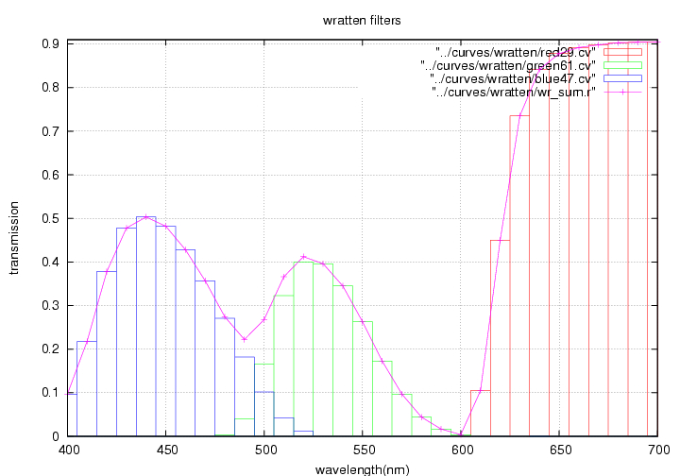
figure[1] – broad regions of the spectrum

Representing colours with varying proportions of these three broad portions of the spectrum allows most colours to be represented fairly well. Also, the human eye only contains three colour receptors and so representing colour data with three values is sufficient. The CIEXYZ standard defines three spectral power distribution functions for use in converting an SPD to three tristimulus values that represent that particular colour – they were developed in relation to the response of receptors in the eye to each wavelength along the spectrum. With XYZ, X and Z store colour information and Y is used to store luminance (loosely speaking, brightness). The functions X,Y and Z correlate roughly to R,G and B (the human eye is more sensitive to green light so green contributes more to the brightness of a colour than R or B) but RGB is a method of image encoding designed to offer the greatest range of colour representation on additive output devices such as monitors and television screens for minimum number of computations. Some digital devices such as DVCAMs capture data in the same way that an XYZ tristimulus value defines a colour – 2 light sensors are used to capture colour values while the third is for recording luminance. Just as RGB is a rough approximation of true spectra, calculations on RGB such as simulating coloured filters are just approximations of the variations in light energy transmission going on at each wavelength. In order to perform accurate physically based transformations such as simulating coloured filters it would be necessary to work in spectral space as opposed to a three colour image space such as RGB.

Characteristics of Technicolor

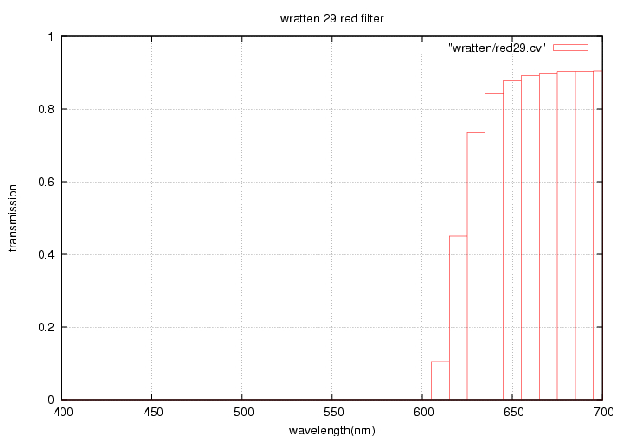
Technicolor was characterised by its rich, ‘saturated’ colour that resulted from filtering light from the scene through narrowband coloured filters – like a saturated colour, the transmission graph for narrowband filters has a fast falloff and so only allows light from a specific range of the spectrum to pass through (figure[2]).

figure[2] – characteristic graph of a narrowband red filter
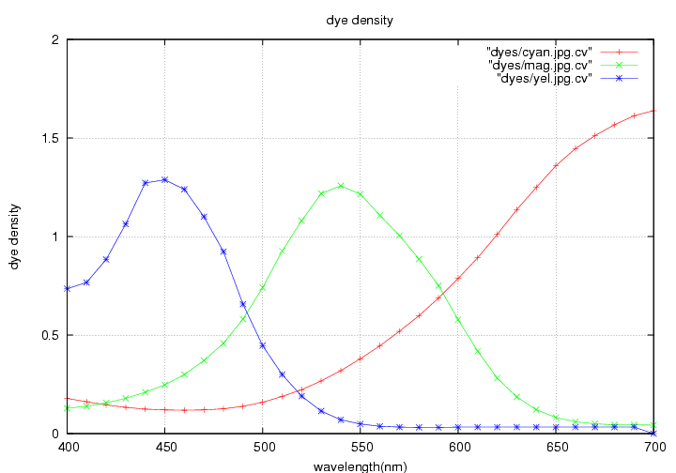
The dyes used in the final print also had minimal spectral overlap which meant that colour records represented clearly defined regions of the spectrum and offered accurate representation of hue. However, many discerning directors chose a much more muted colour palette which also benefited from Technicolors ability to distinguish subtle changes in colour.

figure[3]-characteristics of spectral print dyes

Let it be noted that actual colour is only introduced at the final print stage – up until then the process deals only with black and white matrices and this allows for greater flexibility in terms of colour balance right up to the printing stage. Black and white film is also more stable due to having only one layer of emulsion and this helped to preserve colour definition during the development process.

Simulating the Technicolor Process on Digital Images

From the graphs of dye density, it can be seen that each dye is most dense at the region of the spectrum representing light that the dye is filtering out ie. the yellow dye (blue graph) is most dense at 450 nm – the central region of the blue portion. Some blue light is also filtered out by the magenta and cyan filters at this point too though. The same happens at those points in the spectrum where green and red are dominant too. If we take the values of the graphs at 450, 550 and 700nm and lay them out in matrix format,

 | cyan | magenta | yellow
450nm | 0.1199 | 0.24695 | 1.2875
550nm | 0.37970 | 1.2148 | 0.048533
700nm | 1.6387 | 0.042823 | 0.0

we see that each 'channel' is not only dependent on its corresponding filter but also on the other two filters. By applying this observation to rgb pixels, a crude colour transformation that approximates the effect of the weighting of the dyes can be arrived at (see figure[4] below).

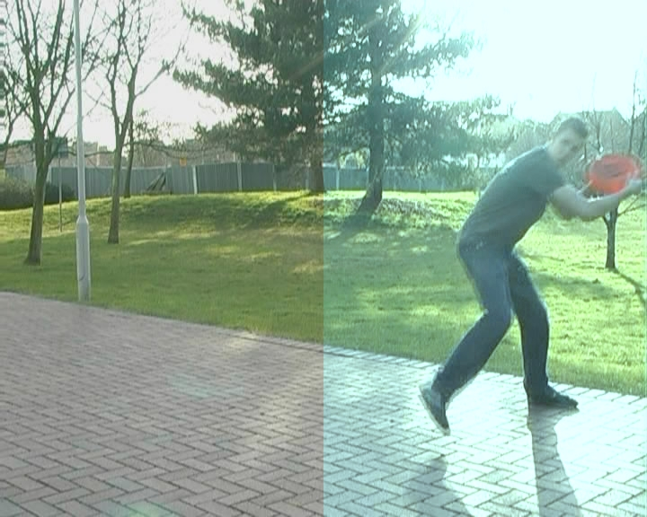
figure[4] – colour weighting based on spectral samples at 450,550 & 700nm

Spectrally Based Technicolor Emulation

A spectrally based model of filtering will use spectral data from film, filters and dyes in an attempt to refine the above process. If an RGB image is considered as an actual scene, then all the processes from filming that scene to creating the final print need to be considered. The main stages to consider are: filtering the light through coloured filters; exposing each strip to the filtered light; applying the dyes to each 'matrix'. If the colour value of each pixel is converted to an approximate spectral power distribution graph, spectral data for filters, films, and dyes can be used to apply complex colour transformations at that point in the image. The transformed data can then be converted back to RGB values for display purposes.

The advantages of spectrally based colour transformations over RGB transformation matrices like the one above are as follows: if the visible spectrum is considered to be between 400 and 700nm, storing data in an RGB image is like sampling the spectrum at three points. But because colours are defined by the energy at every wavelength, the more samples taken along the spectrum, the more accurate a representation of colour is achieved. The curves representing dye density showed how the graphs overlapped so that they all had an effect on each section of the spectrum – this allowed a crude transformation matrix to be formulated. Note, however that the yellow dye had zero density at 700nm. In the case of narrowband filters like those used in the Technicolor camera, there is far less overlap.

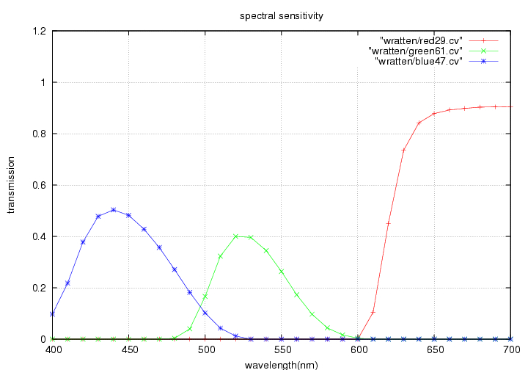
figure[5] – coloured filter transmission values

Figure 5 demonstrates the transmission values for standard red, green and blue filters. The values of the graphs at the same samples used for the dyes are shown in the following table:

 | red | green | blue
450nm | 0.0 | 0.0 | 0.482
550nm | 0.0 | 0.263 | 0.0
700nm | 0.905 | 0.0 | 0.0

If three samples were to be used to construct an RGB transformation matrix, the contribution from other parts of the spectrum would be lost. The values at these samples represent the average amount of energy being transmitted through the filter for that section of the graph. A more accurate method is to find the area under each graph by summing the values at each sample point. In this case, the values of the graphs at 450,550 and 700 are fairly representative of the area under the graph. If, however we were using these in conjunction with other graphs, the differences would be more noticeable.
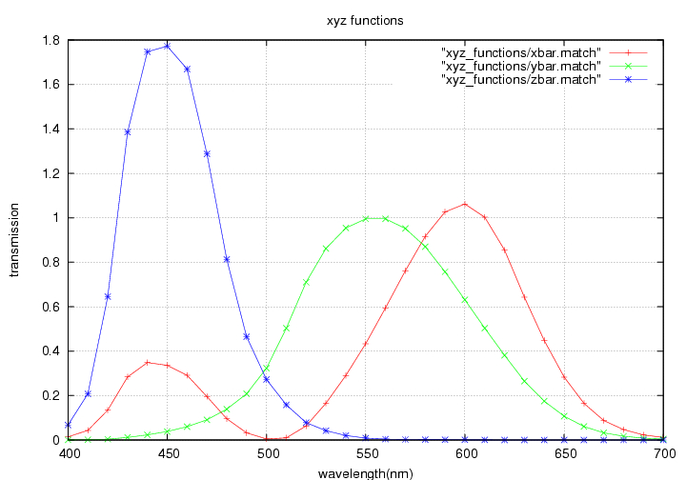
figure[6] CIE x,y,z functions
The first stage is to approximate spectral data from RGB pixel data. The RGB values are converted to XYZ colour space which is capable of representing far more colours. This is done by means of a simple transformation matrix. These XYZ values can then be multiplied by the corresponding x,y,z functions (see figure[6] above).

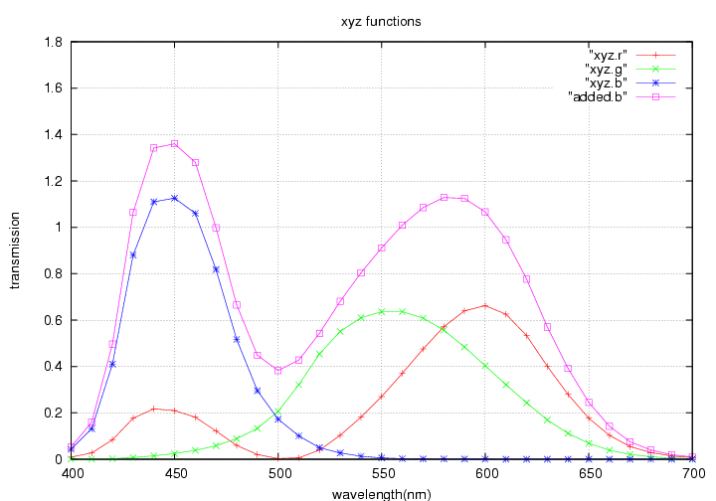
figure[7] – x,y,z functions multiplied by XYZ values and summed together

At this point, the pink curve (in figure[7]) represents the spectral power distribution curve for the colour at this particular point in the scene entering the camera. Emulating a filter on this curve involves simply multiplying it by the spectral transmission curve for the filter. In the camera, the light from the lens is first split in two, with one beam passing through a green filter and the other through a magenta to remove any green light.
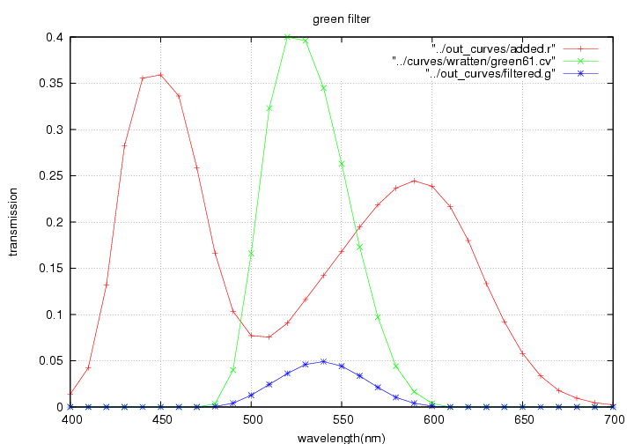
figure[8] green filter

Figure[8] shows how the green filter clamps values outside the range 480-600 to zero. The magenta filter does roughly the opposite(figure[9]) with the blue curve representing light from the scene after having been passed through the filter in order to remove green light. The magenta filtered curve is used to expose the 'blue' negative directly as it is orthochromatic and therefore not sensitive to the red light still present. The magenta curve is filtered through a yellow dye on the 'blue' negative before exposing the red film(figure[10]).
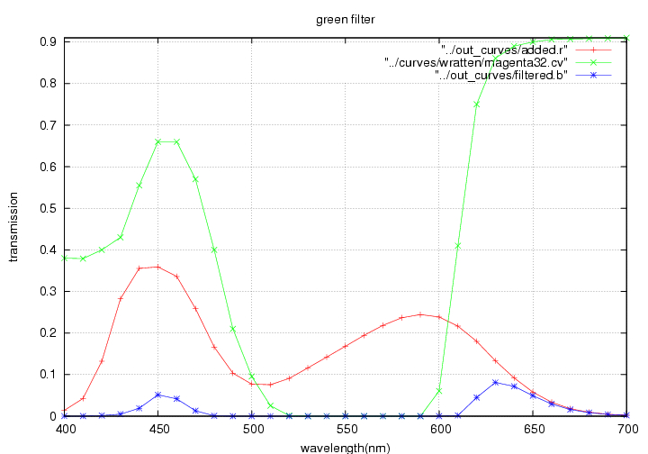
figure[9] magenta filter
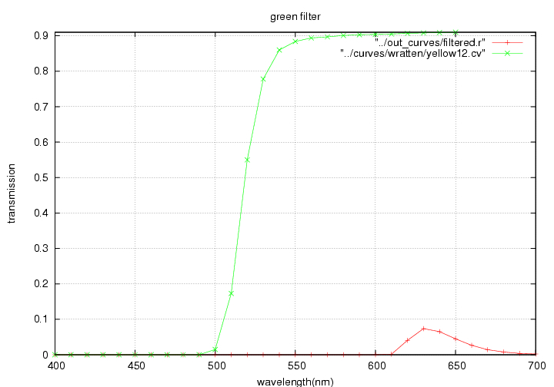
figure[10] yellow filter

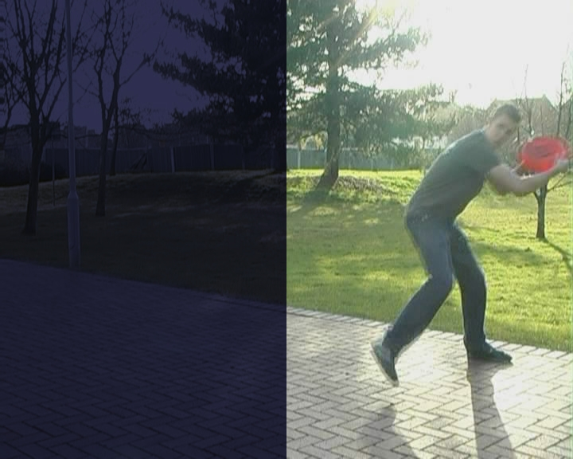
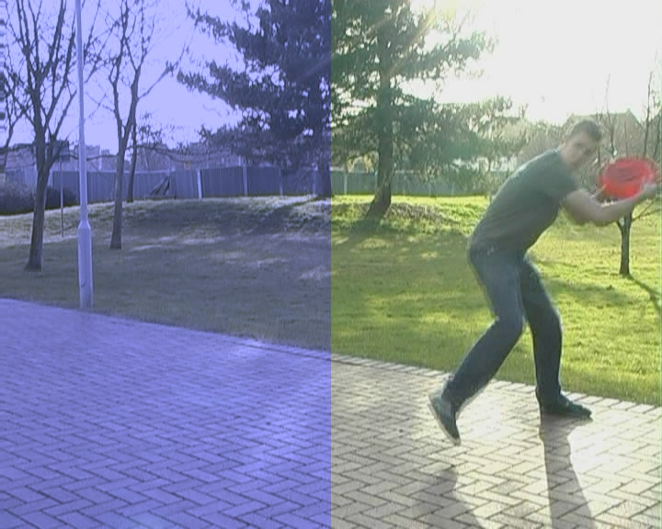
figure[11] – simulated colour filters

Figure[11] shows the image after being 'filtered' (left half of image has been filtered) – as with Technicolor, the image is now vastly underexposed as the filters remove a lot of energy from the light – the image on the right has been lightened multiplying the curves for each channel. The blue colour balance is due to not so much blue being filtered out – this happens when the light 'exposes' the orthochromatic film.

‘Exposing’ the filtered curves follows the same process as filtering the original curve. Each filtered curve is multiplied by a curve representing the sensitivity of the film used. The spectral sensitivity curve for film shows how it will react to different wavelengths. The ‘red’ and ‘green’ filtered curves are both multiplied by the curve for a panchromatic black and white film(sensitive to the whole spectrum) and blue by an orthochromatic curve (only sensitive to blue and green light – this is why it was not necessary to filter red light out of the blue curve before ‘exposing’ it).
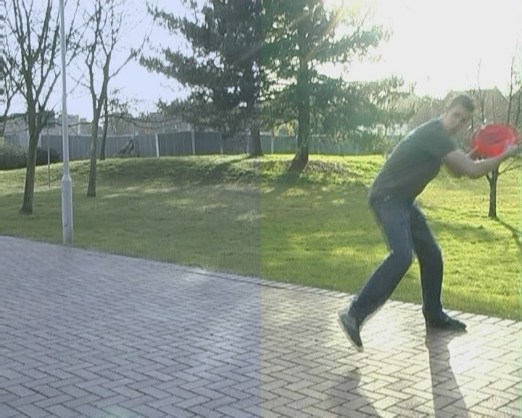
figure[12] – simulated filters and film exposure

Figure[12] illustrates the effect of multiplying the curves by the spectral sensitivity of the film. The overall 'blueness' is reduced as expected but the colours are now a lot less saturated than the original.

Having ‘exposed’ the film, the three curves now represent the exposure of each of the three negative film strips at that point on the image. Positive ‘matrices’ would then be created from these negatives but the graphs used to ‘expose’ the film plotted spectral sensitivity against wavelength, not log exposure, so the ‘exposed’ curves already represent positive exposure values.

The next step in the process was to remove the silver halide crystals from the positive ‘matrices’ in order to leave a gelatine ‘relief map’ of the separation channel – this can be thought of as a contour map with hills valleys: areas with more crystals would end up with deeper valleys. These relief matrices would be floated on dye baths and take on a higher concentration of dye in the ‘valleys’. It can be assumed that the depth of the contours on the relief map is directly proportional to the exposure of the matrices and so this stage may be bypassed.

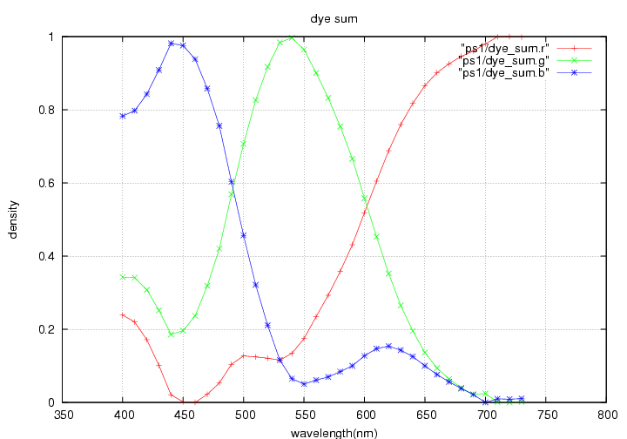
The dyes applied to the matrices can be seen as another set of filters. However, the dyes are CMY which work to subtract RGB so to get to any one of R,G or B the inverse of the sum of the other two dyes is taken. For example, where there is a high density of yellow and magenta dye, most of the blue and green light will be filtered out leaving mainly red. The graph showing yellow and magenta curves summed looks similar to that for a red filter (figure[13]) as it is still based on a subtractive colour space – this simply needs to be inverted (figure[14] shows these inverted graphs for all three channels). These inverted graphs are then combined with the curves for the actual dyes (figure[15])The same process is performed on each ‘matrix’. Once all three matrices have been ‘dyed’, their curves are again added together as in the original conversion stage (analogous to combining the dyes on the same strip) – the resulting curve shows the spectral power distribution at this point on the film.
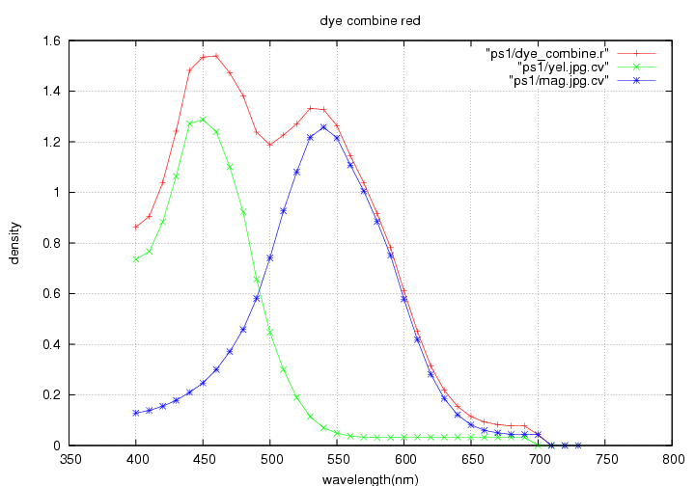
figure[13] – sum of yellow and magenta dye curves
figure[14] – complimentary dye pair curves

To arrive back at an RGB value for a point on the image, the x,y and z functions are each multiplied by the final curve – this gives XYZ values which can be converted to RGB with a simple transformation matrix.
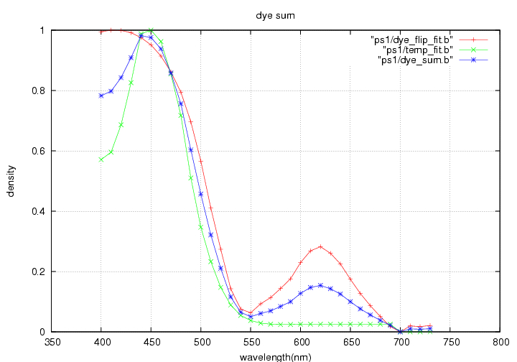
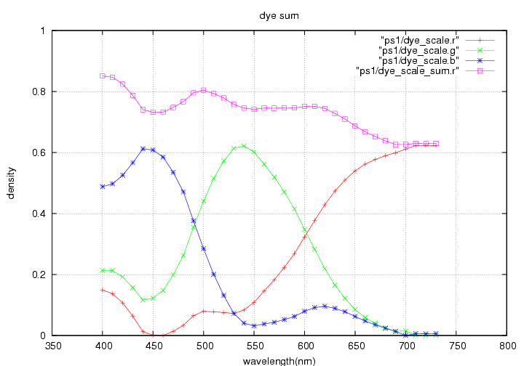
figure[16] – averaging complimentary with original

figure[17] – summing all three dye channels

Figure 17 shows the overall curve has no particular leaning to any part of the spectrum which is displayed in the total lack of colour definition in the result(figure[18]).
figure[18] – applying dyes to ‘exposed’ film matrices
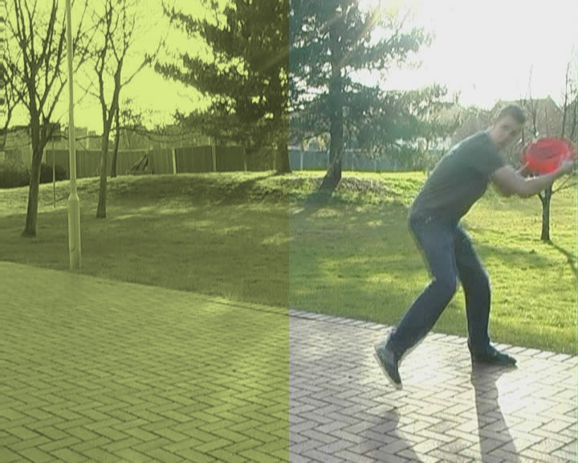

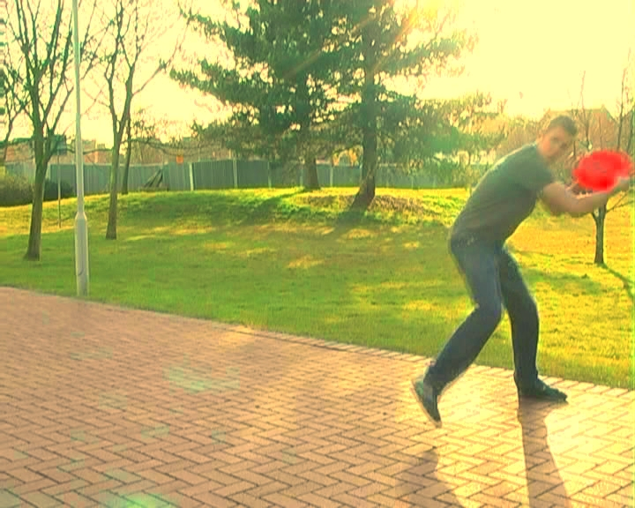
figure[19] – pixel based method with filter approximation

Figure[19] shows a pixel based method of colour transformation(see reference notes [2] & [11]) combined with a matrix created from the density data for colour film – the results are obviously far better.

Critical

The results of the spectral filters do not create the Technicolor effect as predicted. Although samples were taken every 10nm, some of the data used was derived from graphs of insufficient quality, in particular, that for the sensitivity of the film and dye density. The calculations were performed on 8-bit images: the algorithms were perhaps a little overkill considering the limited range of data available – figure[19] certainly seems to indicate that a pixel based method would offer more flexibility when working with such images. Spectral calculations would probably be more appropriate used on floating point images.

The graphs at various stages of filtration show decreasing intensity and the resulting images are lacking in contrast – it would probably help to allow the user to define parameters such as contrast: these adjustments were available to Technicolor technicians during the printing stage. The filters in the actual camera also decreased light intensity considerably – massively powerful lights were often used on set just in order to correctly expose the film.

Production on this project was disorganised. At one point, the code had to be completely re-written as it had been built upon as ideas had developed – patching bits on here and there as required.

Conclusion and Further Development

This study has concentrated on the Technicolor three strip process due to its obvious correlation with the RGB system – seeing as the principles behind the 2 and 3 colour separation processes are essentially the same, emulating the 2 strip process should prove a similar task: the main difficulty would be conversion between two and three colour systems. It might also be quite interesting to try and imitate some of the irregularities that sometimes occurred in these processes such as fringing and colour bleed.

The spectral calculations were performed on spectral data for every pixel – it would probably be faster to use the spectral data to construct a transformation somewhere between the full-on spectral calculations and a simple matrix. This might be a case of creating a way of interactively adjusting the number of samples taken along the spectrum. As it stands, the program is run from the command line – a graphical interface showing a low-sample version of the conversion would aid workflow; especially if a few parameters, allowing the user to make adjustments at various points in the process, were introduced. Such parameters could include ability to control dye density, filter types, film stock – these would be fairly easy to change/select as the data for these is loaded from text files at runtime.

Approximating spectral data from RGB images offers greater accuracy in terms of colour transformations but this is severely outweighed by the increased computation times and the extra depth is likely to be wasted when converted back. Native transformations in the original colour space can be based on spectral data without actually having to convert – this is faster and more intuitive. Merely simulating the physical processes involved in the camera and printing processes is inadequate – these need to be combined with an element of human judgement.

Appendices

Appendix 1 - Algorithm/code structure

The above describes the process for spectrally filtering and ‘exposing’ any point/pixel on the image. This is simply applied to every point on the image.

The spectral curves for the filters, film and dyes are essentially the same: consisting of wavelength-value pairs. When spectral data is approximated from a pixel, a curve is calculated for each channel. The spectral data for each pixel is stored as a set of three curves, where each curve is an array of wavelength-value pairs. The spectral data for the whole image is an array of these spectral pixels. The number of wavelength samples in each curve is determined by the number of samples in the original x,y and z functions. For example, if the functions are defined between 380-780nm at 10nm intervals, that’s (780-380)/10+1=41 samples. An instance of the x,y,z functions is created for every pixel. The subsequent transformations require that all spectral data be sampled at the same intervals – data error checking is lacking.

Appendix 2 – Point and Vector classes
class point
{
public:
double x,y;

point();
point(double _x, double _y);
~point();

void setx(double _x);
void sety(double _y);
void set(double _x, double _y);
void printx();
void printy();
void print();

point operator * (const point &rhs);
};

class curvy
{
private:
vector<point> r;
vector<point> g;
vector<point> b;
public:
curvy();
curvy(string rfile,string gfile,string bfile);
~curvy();

const curvy& curvy::operator = (const curvy &rhs);

void read_ch(string filename, int ch);
void read(string rfile,string gfile,string bfile);

void print_ch(int ch);
void print();
void scale(char ch, char xy, double val);
void fit_ch_x(int ch, double hi, double lo);
void fit_ch_y(int ch, double hi, double lo);
void fit_x(double hi, double lo);
void fit_y(double hi, double lo);

double sum_x(int ch);
double sum_y(int ch);

void fprint_ch(string filename, int ch);
void fprint(string filename);

double get(char ch, char xy, char id);
double setx(char ch, char id, double val);
double sety(char ch, char id, double val);
int sz(int id);

void mult_ch(curvy rhs, int ch, int ch1);
void delog_ch(int ch, bool xy);
void delogx();
void delogy();
void invertx_ch(int ch);
void inverty_ch(int ch);
void invertx();
void inverty();

void flip_y(int ch);
void sum_channels();

int max_y(int ch);
int min_y(int ch);
curvy operator * (curvy &rhs);
curvy operator + (const curvy &rhs);
};

Appendix 3 – Read Graph Program

This is a simple command line utility for reading points on a graph represented in an image into a plain text curve file listing data points. The image representing the graph must be a white with a solid black graph line (see figure[] below). It will usually be necessary to edit an existing graph in an image editing package. Graphs showing multiple graph lines will have to be split into separate images.

The program accepts a single argument – the name of the image representing the graph line. The plain text file takes the name of the image with an additional “.cv” extension. The user is prompted to enter minimum and maximum x and y bounds, specify the primary axis along which measurements are to be taken and the increment value for these measurements.
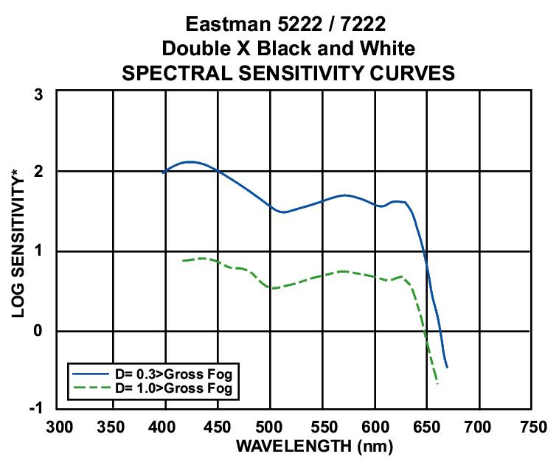
figure[20] –original image of graph

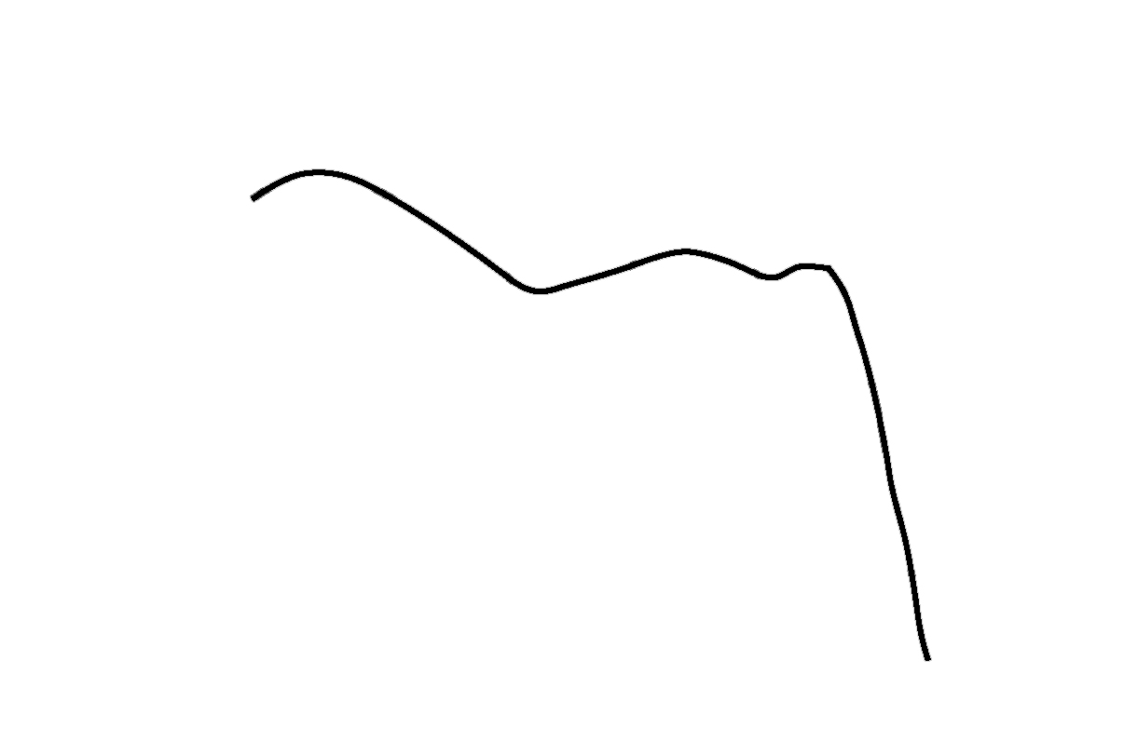
figure[21] - black and white standard for read_graph utility

Appendix 4 – Spectral Curve Data
Spectral curve data used in this project came from either publicly available sources or was derived from graphs using the 'read_graph' utility described above.

Graphs came from film manufacturers websites:

http://www.kodak.com/US/en/motion/products/curves/c2238.jhtml?id=0.1.4.6.6.10.6&lc=en

http://www.geocities.com/thombell/curves.html

http://www.ilford.com/html/us_english/bw.html

Although the data used here came from film stocks different to those that would have been used in the Technicolor process, it has been assumed that the characteristics would be similar enough to achieve a meaningful result. Switching the values would be straightforward.

Acknowledgements

Image libraries courtesy of Dr. Ian Stephenson:
libNCCAPixmap.a;
NCCAPixmap.h;
PixFileIO.h

References
[1] HALL, R. , Illumination and Color in Computer Generated Imagery, 1989, New York:Springer

[2]LEGATO, R. 2005 The Aviator – Visual Effects Behind the Scenes[online]available at: http://www.aviatorvfx.com/?cmd=frontendOverview&id=color

[3] Adobe Systems Inc. 2005, The Aviator – Hollywood Effects on the Desktop[online] http://www.adobe.com/products/aftereffects/pdfs/The_Aviator_021405.pdf

[4]GUNDELFINGER, A. M. 1949 Cinecolor Three Colour Process[online]Burbank, California, U.S. available at http://www.widescreenmuseum.com/oldcolor/cinecolor.htm

[5] LINDERMAN, R.G., HANDLEY, C.W. RODGERS,1942 A Illumination in Motion Picture Production[online] Los Angeles, California available at: http://www.mole.com/aboutus/history/smpte/1943-06p333.html

[6]EASTMAN KODAK COMPANY, Kodak Motion Picture Guide[online] available at: http://www.atthemountainsofmadness.com/resources/film/tech/kodak_motion_picture_guide.pdf

[7]HART, M.B 2006, Subtractive Colour Processes[online] available at: http://www.widescreenmuseum.com/oldcolor/subtract.htm

[8]HART, M.B. 2006, Technicolor[online] available at: http://www.widescreenmuseum.com/oldcolor/technicolor1.htm

[9]Wilhelm Research, 2003, The Extraordinarily Stable Technicolor Dye Imbibition Motion Picture Colour Print Process[online]available at: http://www.wilhelm-research.com/pdf/HW_Book_10_of_20_HiRes_v1a.pdf#search='dye%20imbib%20ition'

[10]POYNTON, C. 1997, Poyntons Colour FAQs[online]available at: http://homepages.inf.ed.ac.uk/rbf/CVonline/LOCAL_COPIES/POYNTON1/ColorFAQ.html#RTFToC0

[11]http://www.vfxtalk.com/forum/showthread.php?s=4307fa35b00268d0f52c2a4fb1423420&t=3515&page=1&pp=15

[12]LINDBLOOM,B.J. , computing XYZ form Spectral Data(emissive case)[online] available athttp://www.brucelindbloom.com/index.html?Eqn_RGB_XYZ_Matrix.html

