A Procedural Approach to Non-Photorealistic Rendering of Pen and Ink Illustrations from Three-Dimensional models.

Paul Dibden
BA (Hons) Computer Visualisation & Animation, Bournemouth University.
Innovations In Computer Animation

Abstract

This paper is concerned with the development of non photorealistic rendering in the form of pen-and-ink illustration. In particular, I will be presenting two methods of shader creation through the RenderMan process, a two-dimensional method that involves striping along the u and v directions of an object and a three-dimensional method that is based on solid texturing. Non-photorealistic rendering (NPR) is still a relatively new area in computer graphics but has developed a strong appreciation in recent years. In this report, related work in this field will be briefly addressed and then the development of my own techniques will be explained. Finally, an animated short will be created using the shader, intending to emulate the aesthetics of traditional Pen and Ink illustration in a digital medium.

The whole concept for this project was inspired by a Japanese animation called, “Castle in the sky”. The starting credits to this film were animated with traditional pen and ink images. (As shown below)

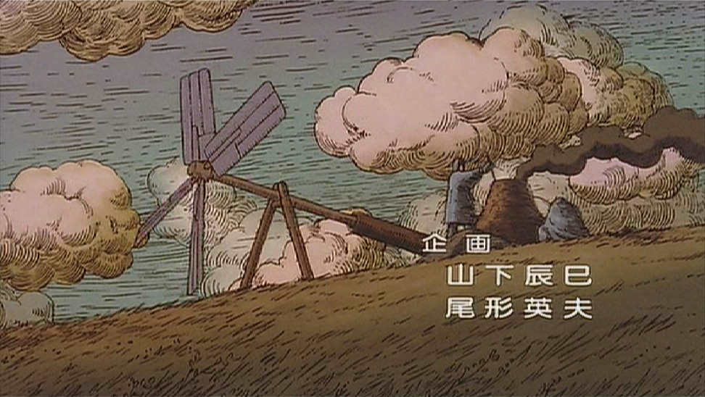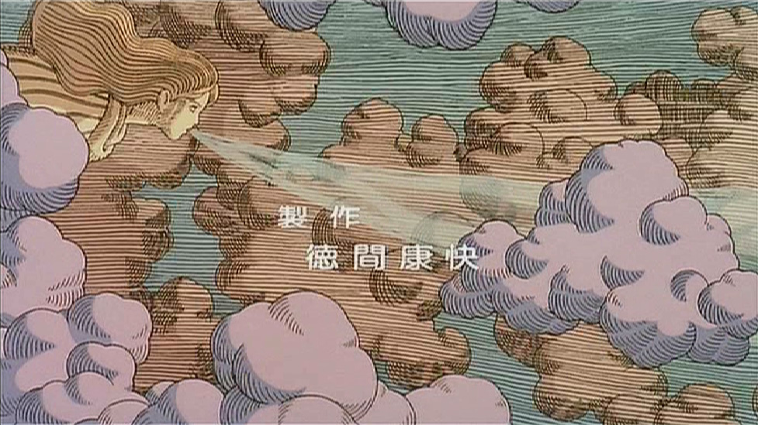

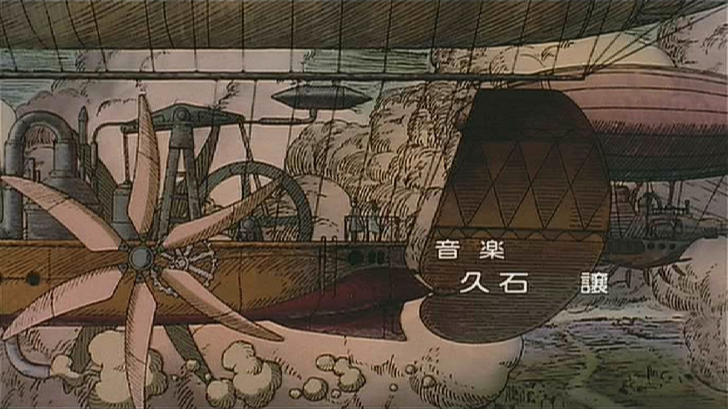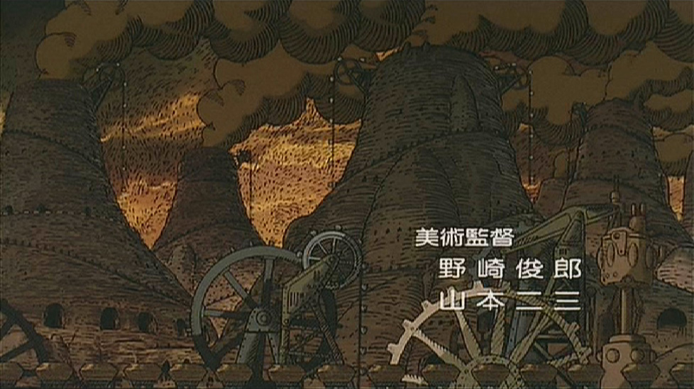

Figure 1: Castle In The Sky – Examples of Traditional Pen-and-Ink illustrations animated. All camera shots are stationary, and the animation is two-dimensional.
(Castle In The Sky ©1986 Nibariki. © Buena Vista Home Entertainment, Inc.)

Being hand drawn this short introduction would have taken many weeks to complete, so from this it was questioned whether you could produce the same effect using Computer Graphics, therefore drastically shortening the time period of the process.

The goal of my research is to provide a pen and ink shader that can be used on a 3D modelled scene to render out hand drawn effect images. This would then be providing a non-artist user with the ability to create convincing traditional pen and ink animation.

1 Introduction

The field of Non-Photorealistic Rendering has proposed a variety of techniques to create very convincing line drawings from 3D models. Unfortunately, these methods are generally hard-coded in monolithic software and lack a flexible specification structure. In contrast, the shading language available in Pixar’s RenderMan, permits the design of a variety of complex appearances.
As stated by (Upstill 1989):

”The key idea in the RenderMan Shading Language is to control shading, not only by adjusting parameters, but by telling the shader what you want it to do directly in the form of a procedure.”

The final outcome of this project will allow you to select a 3D model in Maya, attach the shader, specify the values needed for all parameters and then let the RenderMan do the rest. The concept was to let the computer do the tedious part of the work and let the artist guide it. Pen-and-ink illustration is only one of many styles in NPR, others include watercolour, impressionistic, engraving and etching. I believe traditional approaches once again need to be considered, as the quest in the last few decades for photorealistic animation has neglected what was initially the structure of animation.
Photorealism has opened the eyes of the general public to the potential of today’s technology, but as (Curtis 1998) has stated:

“Photorealism, like pornography, leaves nothing to the imagination. It presents the viewer with a world of objects complete with volume and texture, which is far more information than the viewer needs to get the point. Furthermore, unless great effort is devoted to every detail of modeling, shading, and lighting, much of that information will actually contradict the central idea, distracting the viewer.”

The intention is to bring this technique from the fine arts to the computer screen, to visually merge the barrier between traditional art and computer graphics. Pen and Ink sketching will have a different style to every individual; this suggests that the shader(s) needed to generalize to what ever is aesthetically pleasing to the majority. The task was to be able to understand the techniques of pen and ink illustration, and then to express them algorithmically.

When addressing the method of drawing you will find the subject cannot be easily explained. Generally, even professional artists themselves can not fully describe what decisions/choices they make when drawing. And with art being such an expressive form this would be difficult to concentrate into a methodical system. Pen-and-ink is an extremely limited medium, but because of its simplicity and economy, there are a lot of applications and advantages of this illustration technique. With only a simple form, artists are able to use expressive abstraction to emphasize the area of interest and focus the viewer’s attention without being forced to depicting every detail. Pen-and-ink drawings can illustrate ideas and concepts more than a photographic image, as these carry visual distractions such as shadows and lighting. Again (Curtis 1998) elaborates:

“A hand-drawn sketch can convey a lot of information in a much simpler package, if one draws only what is necessary. The gesture of line can also convey the energy of the artist's hand, or a character's mental state. And because a sketch is clearly an artist's interpretation of the world, it encourages the viewer to complete the picture by imagining the details that are missing. This engages the viewer's mind in a way that a photorealistic image cannot.”

Computer Graphics have always been inspired by ideas from different fields; such as photography, fine art, science or mathematics, and then applying them in a computing environment. Although many publications may consider the Pen-and-Ink illustration old fashioned, medical books and automotive manuals continue to use hand-drawn illustrations as these drawings allow the artist to focus attention on specific details.

1.1 Related Work

A few authors have addressed similar goals in their published work.

(Leister 1994) presented a technique to emulate copper-plate rendering. The goal was to render a copper plate drawing that consists of lines of varying thickness, and of single points from a 3D scene. A ray-tracing approach is used to render curves on free-form objects. An advantage of this approach is that it easily handled reflections and shadowing. Shading was done by regular hatchings in several thicknesses and distances. In the post-processing step an edge detection algorithm was then applied.

(Winkenbach and Salesin 1994) proposed an automatic object-centered rendering system. Whilst a lot of other computer drawing programs do not scale well, this method is resolution-independent. The limitation is that it can only illustrate polyhedral models and can not be used for curved surfaces.

(Landsdown and Schofield 1995) proposed the Piranesi system that used NPR to create illustrations from 3D models. Piranesi used a standard graphics pipeline to create a 2D reference image akin to a G-buffer. The user was then allowed to select specific regions of the image and apply textures that emulate natural media interactively or automatically.

(Winkenbach and Salesin 1996) extended the previous method, and proposed an algorithm that could handle curved surfaces formulated parametrically, such as B-spline surfaces and, NURBS. This mainly used an image processing technique in the post-processing stage for outline and hatching generation. It would use a grid of parallel lines, running in one or more user-specified directions in the parameter domain to orientate hatching strokes along a surface. Then a technique called “controlled-density hatching” allowed strokes to gradually disappear in light areas of a surface or in areas where too many strokes converge together. And allowed new strokes to gradually come into existence in dark areas or areas in which the existing strokes begin to diverge too much.

(Curtis 1998) implements a “loose and sketchy” filter to automatically draw the visible silhouette edges using image processing and a stochastic, physically-based particle system. The only input is a depth map of the model and it will be converted into two images: template image and force field. Template image represents the amount of ink needed for each pixel. And the force field pushes particles along the silhouette edges, generating ink and removing ink during its journey.

1.2 Overview

Creating illustrations with image-based rendering systems does have several advantages, first obviously being you do not need the geometric modeling. It also provides the flexibility of using both a computer-generated image and/or a photograph. The advantage of a geometry-based system is with the availability of the 3D geometry and viewing information they can produce illustrations whose strokes not only convey the tone and texture of the surfaces in the scene, but they also convey the 3D forms of the surfaces by placing strokes along the natural contours of surfaces.

With this project being innovations in 3D computer animation, the geometry based system would of course be more important to pursue. As (Winkenbach and Salesin 1996), I researched the methods and techniques of an artistic form, compile the rules that artists follow in order to produce images using this form, then wrote a shader to render objects according to the artistic rules.

2 Non-Photorealistic Rendering (NPR)

Non photorealistic rendering is a rapidly growing subgenre of computer graphics, and a trend among digital artists to imitate other media. Handcrafted flat media share several fundamental properties that must be mimicked well to represent the styles believably. The abstraction of a depicted scene can have essential advantages. The artist can simplify a picture by leaving out unnecessary and distorting details, and can focus the viewer’s attention on important features. Then the artist can stress the importance of certain parts of a depicted scene through variation of the drawing style.

3 Principles of Pen-and-Ink Illustration

There are two main characteristics of a pen-and-ink illustration: outlines and hatching. Outlines are the external boundaries and internal edges, used to define shapes. The choice of whether or not to use outlines is largely an aesthetic one. Hatching is used to indicate shading but should also follow the surface curvature. The Pen-and-Ink limitation in being monochromatic is overcome to some extent through the use of tone, style and texture.

In Pen and Ink Illustration, the line quality is consistent. As an objects apparent size changes, the line quality should be adjusted. A surface that pinches together should have fewer lines in the pinched area and more lines in the stretched area. And to work in animation these changes should evolve over time coherently. The density of these lines varies as a function of image intensity, but the individual line widths remain constant. When imitating this with computer graphics I needed to ensure the images appeared to have been rendered by people. The ink lines should not be perfectly smooth and clean; they should have a slight imperfections and tapering.

3.1 Identifying variables for the procedural shader which will affect the character of its lines:

- The line thickness would describe how wide a line is drawn and how this thickness changes over the length of the line. Remembering I would need to create the illusion that the “person” drawing the lines is pressing harder or moving the pen slower at the beginning and end of each line.

- A thickness drop-off or tapering parameter would enable the line thickness to change gradually or even abruptly.

- To control the handcrafted quality of the lines, noise would need to be used. The deviation of the given straight line can be controlled by setting a noise factor. This will create random displacements to give a vivid and non-regular look.

3.1.1 Techniques of Pen-and-Ink Illustration

The technique, ‘hatching’, would simply be a series of lines that are drawn across a surface, ranging from solid black to far apart (depending on the lighting conditions and the size of the surface). Cross-hatching is a more complicated method of hatching. The lines are drawn in two or more directions, (usually perpendicular for two directions) to create shading.

The line of the drawing is varied by the artist to make the image more visually appealing. The edges of the lines can vary between sharp and soft, as well as the lines thickness. A more advanced artist would often use different size nibbed pens in order to create a contrast between elements of the image. In most cases at least three different pens are made available, from around 0.3mm to about 1mm. This will develop the piece in respect to depth, detail and style. Thin lines tend to create sharper edges and clearer drawings, whilst thicker lines tend to blur elements.

Line direction is also important for parts of a drawing, so stroke directions can be varied as the lines should follow the curvature of the object being drawn.

Examples of Pen-and-Ink Illustration techniques:

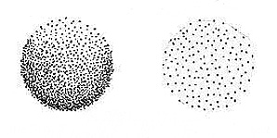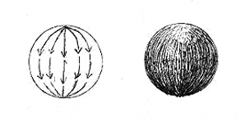
Figure 2: Stippling Figure 3: Contour Lines
By having the dots closer, the darker These lines follow the curves of an object.
the object appears. The farther
a part, the lighter.

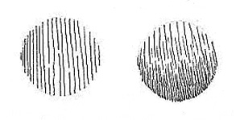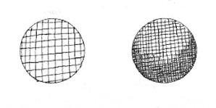
Figure 4: Parallel lines Figure 5: Cross hatching
These lines should be drawn straight, but This is usually 2 or more sets of freehand. parallel or contour lines. They need to be applied in different directions so that
they intersect.

3.2 Shading with lines
To give a drawing a three dimensional appearance you need to add the different degrees of shading, these shading strokes are determined by the artist. In the case of the shader, the judgements will be made using the intensity of the lighting and parameter values that can be adjusted to expand the range of shades. The shading can be divided into 10 grades, as shown below:
1 2 3 4 5 6 7 8 9 10 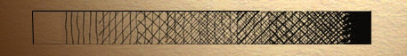
Figure 6: 1. Left empty.
2. Vertical shading only with a fine point pen.
3. Overlaying 45º shading with a 3mm gap, with fine point pen.
4. Overlaying 45º shading with a 3mm gap (the other direction) with fine point pen.
5. Overlaying 45º shading with a 1.5mm gap with fine point pen.
6. Overlaying 45º shading with a 1.5mm gap (the other direction) with fine point pen.
7. Overlaying 45º shading with a 3 mm gap with a Felt Tip Pen.
8. Overlaying 45º shading with a 3 mm gap (the other direction) with Felt Tip Pen.
9. Overlaying 45º shading with a 1.5 mm pitch with a Felt Tip Pen.
10. All black with black marker.
Usually cross-hatching with pen and ink, you will reach a point where the drawing is becoming overworked. It is suggested that sometimes you should work through this stage; building up the tones across the drawing, and this in turn will develop a new level of richness. On different sides of a lit object, there are usually different variations of hatching and crosshatching, the hatching on the side in the shadow being the one built up most heavily. For darkest tones, the crosshatching should not be allowed to become completely solid. The touches of white paper when allowed to show through create depth in the shadowed areas as well as giving a luminous quality.

3.2.1 Drawing “Artistic” lines – the path and style metaphor

Artistic techniques do not use randomness alone as a source for parameters determining the final appearance of lines being drawn. Actually, every single line is carefully placed and parameterized by an artist in order to fulfil the communicative goal. There are two particular aspects in which artists create a line drawing. First, there is the placement of lines, determining their position in the scene to be portrayed. Second, there is the appearance of the lines, how they are drawn with respect to their width and tone. Usually the method of pen-and-ink illustration involves first a rough pencil sketch being drawn. This shows the overall characteristics of the line being drawn. This sketch is then refined using the pen and ink. So the pen is actually moved along a certain “path”. Depending on the shape of the pen and the pressure applied the width of the line will change. In addition, the lines finally drawn do not correctly match the intended path due to irregular movements of the hand and to the unevenness of the paper.

3.2.2 Conveying shape versus Illumination

When shading is introduced into an image, it is generally used to add depth to an otherwise flat medium, but not necessarily to express illumination. Because of the way human perception works with respect to light sources and orientations, this shading does not even have to be consistent over a single illustration. As stated in (Strothotte and Schlechtweg 2002), illustrations do generally have a common set of conventions:

- Edge lines are drawn with black curves.
- Matte objects are shaded with intensities far from black and white.
- Shadows are rarely used. If shadows are used, they are placed in a way that they do not occlude important details or object features.
- Usually the objects are lit by one light source in a standard position (upper left hand-corner in front of the object).

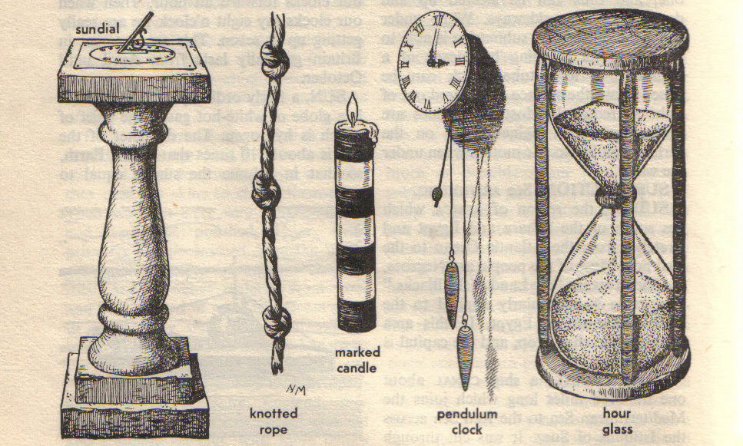

Figure 7: Example 1~ Traditional Pen-and-Ink Illustration presenting conventions.
(The Younger Children’s Encyclopaedia, Odhams Watford Ltd.)

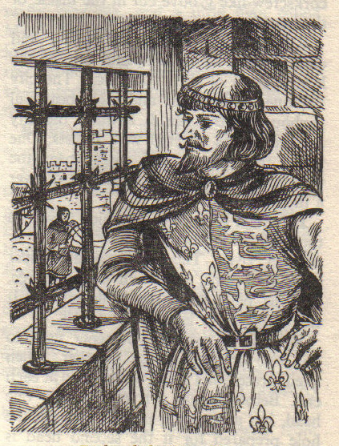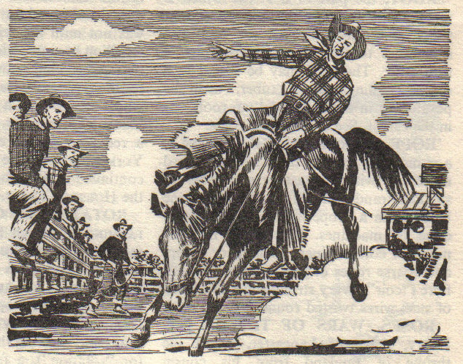

Figure 8: (Left) Example 2 ~ Cross hatching of contour lines in a variety of directions, also varying the number of hatch directions used on each object.
(The Younger Children’s Encyclopaedia, Odhams Watford Ltd.)

Figure 9: (Right) Example 3 ~ Horizontal parallel lines are used to describe the sky, where as the white paper is used to describe the clouds.
(The Younger Children’s Encyclopaedia, Odhams Watford Ltd.)

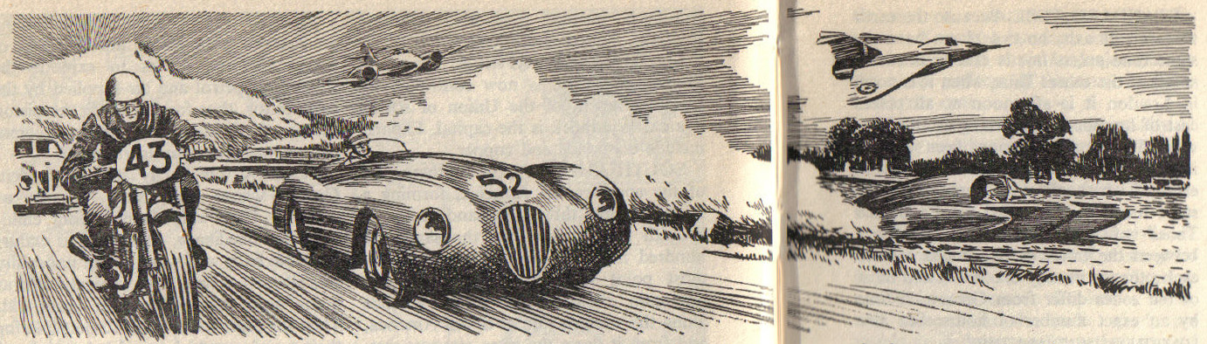
Figure 10: Example 4 ~ The cutting off and tapering of contour lines, gives a specular appearance to the car body.(The Younger Children’s Encyclopaedia, Odhams Watford Ltd.)

4 Pen-and-Ink rendering

The goal of the shader was to place ink strokes on the object surface to achieve the particular tone functions of illustrations. It was devised that the components of the shader needed to be addressed first were the stroke placement, tone specification and the stroke width computation. When considering the stroke placement, the two separate hatchings (forming crosshatching) will be placed along the isoparameter lines of the parameterized surface, using the u and v. Tone would be computed using an illumination model, that took the intensity from each point to calculate whether it would be part of a black ink line or not. The density of the cross hatching will be again due to the illumination intensity and the maximum allowable stroke width. Once these components were determined than I could address recursive filler strokes, these would fill in large gaps between lines by adding more lines. That was the plan; it then needed to be put it into practice with RenderMan’s shading language.

4.1 Pen-and-Ink rendering with parametric surface textures approach
Initially the intention was to create four separate shaders that would be used in post-production to create the final rendered image.

These shaders would have been:

1 – Pen-and-Ink hatching in the u direction of the objects surface.
2 – Pen-and-Ink hatching in the v direction of the objects surface.
3 - Edge detection shader to create a control image for post-production purposes.
4 - Two tone matte shader for colouring.

A .rib file was created containing simple geometry that could be used to during the development stages of the shader. This allowed quick rendering when adjusting the shader in the .sl file. The simple objects enabled the behaviour of the shader to be distinguished more easily before finally placing it on more complex models. Early on in the shader development I attempted a simple method to produce a line vertically down the centre of the object. The distance of the point being shaded from the centre was found, then the function abs( ) was used to throw away the sign of the result. From here an attempt on stripes across a surface patch was made, creating a regular striping pattern using mod( ). This was then adapted to resemble hatches. The stripe function worked by taking values from the u and v parameter coordinates of geometric primitive to be textured, and then attaching the stripes parallel to them.

Then by using a duty cycle (which dictates how wide the lines appear) made directly proportional to the illumination intensity you could vary the line width with respect to the intensity of light the object is receiving. From this stage a shader had been created to render out an image with the parallel contour lines in the u direction, and a shader to render out an image containing parallel contour lines in the v direction. Compositing them together would create the cross hatching effect.

  - Modified approach to Pen-and-Ink rendering
While the texture coordinates (u, v) were initially suitable for the first attempt at the shader whilst experimenting in rib files with simple geometric shapes, it became apparent that it may not be appropriate to use them in this instance. When it came to testing the shader on a NURBS or polygon objects in Maya and then rendering it with PRman, it was discovered that the shader cannot be mapped so easily.

After some research (Stephenson 2003) it was discovered that rendering polygons with PRman was not a wise choice as compared to other graphics APIs, RenderMan appeared to have less support for polygons as they are neither a parametric or curved surface. At this stage it was questioned whether a shader could be constructed that would contain multiple line directions rather than just one, therefore rendering out cross-hatching lines. Also the problem of the texture sliding through the object when rigid transformations were put on it had not yet been solved.

A new direction was commenced that began looking at creating a more flexible Pen and Ink shader; this would be using the position of points in 3D space to texture object surfaces.

4.2.1 Researching a ray-tracing approach

A technique that would give an object a solid texture involved a ray-tracing approach to create the ink lines (Strothotte and Schlechweg 2002). This particular technique used a three-dimensional description of a scene to be portrayed, and then used a modified ray-tracing algorithm to achieve a copperplate impression. The general procedure for this rendering process would be performed in five steps, given in the following algorithm:

- t = (tx,ty,tz) intersection point as a result of a “ray query”
- determine material properties
- determine colour(intensity) value at t for given illumination model
- compute geometric and intensity parameters for hatching lines
- post-processing to achieve the optical properties of copperplate images

It was discussed that this approach’s use of straight hatching lines (rather than curving to follow the objects surface as with 2D texturing), would widen the expressiveness and also give a better method to convey shape and illumination. For the creation of straight hatching lines, the objects in the scene would be overlaid with a set of parallel and equidistant planes in 3D space. From this you could then combine several hatching patterns generated this way by using several sets of planes.

    - Algorithm for solving the distance of a point from a plane

The ray tracing approach seemed appropriate for the shader, and after some research for into the mathematics of a ray-tracing (Comninos 2003) I found an algorithm that could be used (as shown below). By solving the distance of a point from a plane this would act as a ray query for the shader. The normal of the plane is given by n = [a, b, c] and dp is the signed distance of the plane from the origin.

The signed distance of a point P = [x, y, z] from a plane is given by:

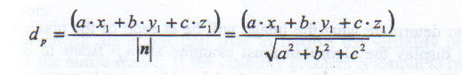
Figure 11: Equation for solving the distance of a point from a plane. (©Prof. Peter Comninos 2003)

Here, if dp > 0, then this point lies in front of the plane, and if dp<0, then this point lies behind the plane. Finally, if dp = 0, then this point lies on the plane.

  - Pen-and-Ink rendering with a ray-query approach

The standard plastic shader was a good starting point for developing and building my second attempt at the shader. It was intended that each object shaded would have hatched lines in one, two or three different directions that overlap creating the cross-hatching effect. These lines were produced by three direction planes. They produced a stack of black and white plates in 3D space that intersect the surface of the object. I specified each of the three direction planes by their normals. For every point that is shaded, the distance between itself and the direction plane needed to be calculated using the above algorithm. Then the value would be multiplied by the detail factor, and then the integer component is removed leaving a value in a range between 0 and 1. When this value is between 0 and the value of “widthofink” parameter the point sits in a black plate, else it is between widthofink and 1 therefore being within a white plate.

The default value of widthofink is adjusted according to the illumination intensity at that particular point. I then took the illumination value and placed into a smoothstep function that would transition the value from 0 (being no line) to the input value of widthofink (a full line). This development occurs due to the intensity of illumination reaching the clipvalue, causing the line to end. Using the smoothstep() function allows a smooth transition of interpolation because of the hermite curve, this allowed me to taper off the lines gradually rather than just cutting off square giving the line a blocked appearance, when illumination is at the cut off value. The taperinitialise parameter was put in so the user can decided how rapidly they wish their lines to taper off.
Varied clip values’ were assigned to the parameter defaults of each of the three direction planes as this would present the perception of many defined tonal values. Purposefully the size of the default value for the taperinitialise is quite high. This allows the lines to taper for most of the length of the line before finishing, creating some diversity within the tonal values.
Finally it was made that every other hatch line would be clipped to halve its value in all three plane directions. This method creates a few more distinct tone values, as all lines will be drawn in poor illumination; where as more illuminated areas will have half the amount of drawn lines.
When testing the shader at this point it was quite tedious changing both taperinitialise and clipvalue to find the suitable fall off from the illumination, I wanted both to be increased and reduced equally. To solve this I could quite simply attach a scale parameter in the shader that would be available to the user. This then allowed all thresholds to be scaled when wishing to set the most suitable cross-hatch on an object. When it came to shading a scene in Maya with elements at varied depths, all objects were being shaded with the same amount of detail. A levelofdetail parameter was placed into the shading language allowing myself the ability to adjust the cross-hatching on the different objects to suit their distance from the camera. Obviously when shading all objects with the Pen and Ink shader with all parameter values at default, this created quite a flat image with all the elements looking rather similar. So when it came to creating the animation, I adjusted parameter values for all the direction planes, per object. This brought more of a range to the scene, and allowed the objects to be effectively displayed.

4.3.1 Imperfections in the lines
The noise function in RenderMan can take a varying number of parameters, and return a range of types. The values returned will be between 0 and 1, but average at usually 0.5. I based the noise value on P rather than u and v; this resulted in a noise value which I could then use as a basis for my 3D solid texture. When I used noise on the texture coordinates, this broke up the straight lines that are generated by the line pattern. This approach prevented the hatchings from looking too geometric.

To generate a distorted P in shader space:

P = ptransform(“shader”,P)*scale;
PP = PP + point noise(PP*10) * 0.1;

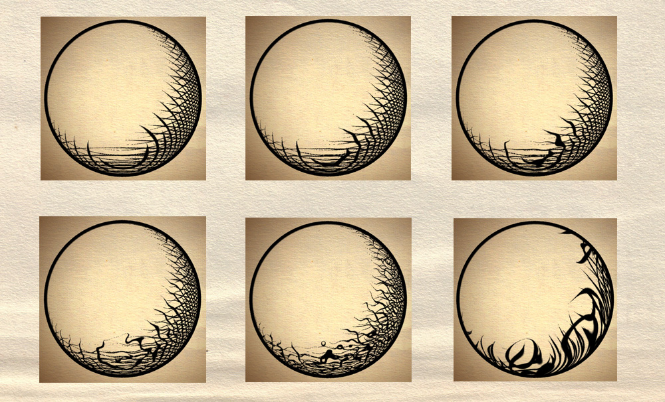
Figure 12: Tests renders whilst adding noise to point (PP).

    - Testing on parameter values
By making sure my shader was parameterized, this allows the shader to be flexible to most objects, also most of the time it allowed the shader to be written with out knowing the value of the parameters. It has been an effort to eliminate nearly all hard-coded constants from the code.
The added bonus is once the shader is used with RenderMan along side the Maya package, you can interactively set the parameters and re-render a thumb nail of the shader to find the perfect settings for that particular object.

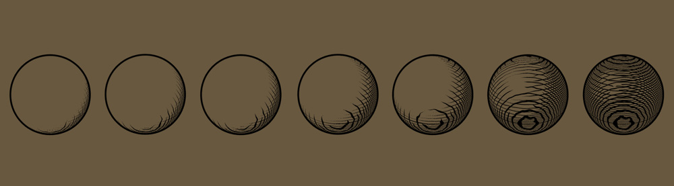
Figure 13: Variation in the “clipvalue” parameter value for all three hatch plane directions.
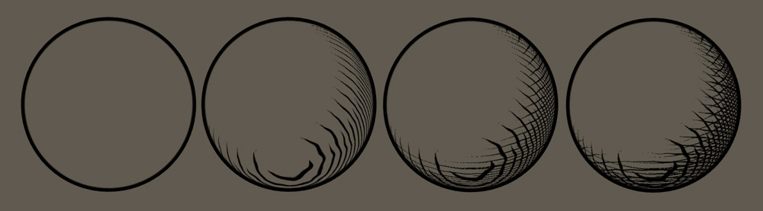
Figure 14: Varying the number of hatch plane directions to be displayed.
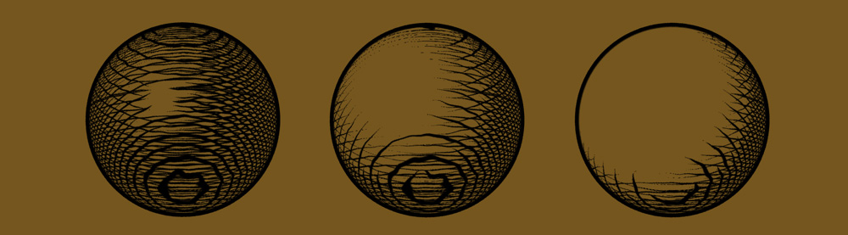
Figure 15: Varying the “color” component contained in the illumination model.

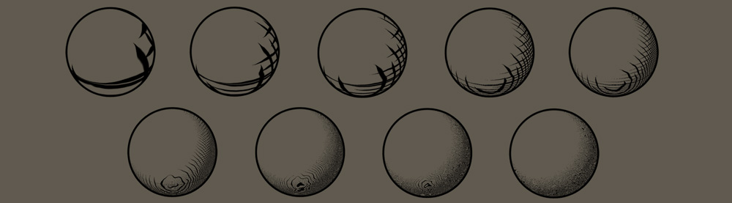
Figure 16: Varying the “levelofdetail” parameter value.
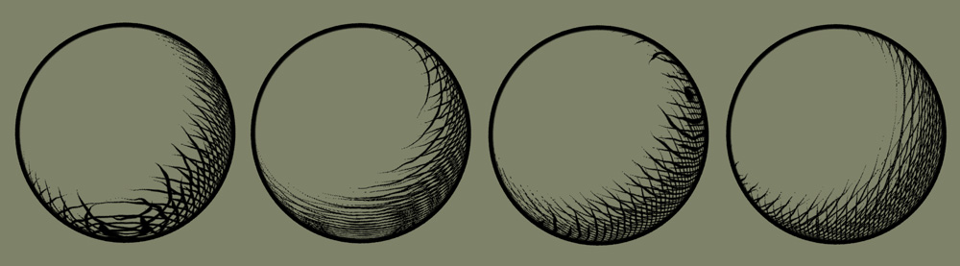
Figure 17: Changing the (x,y,z) values of the three hatch direction planes.
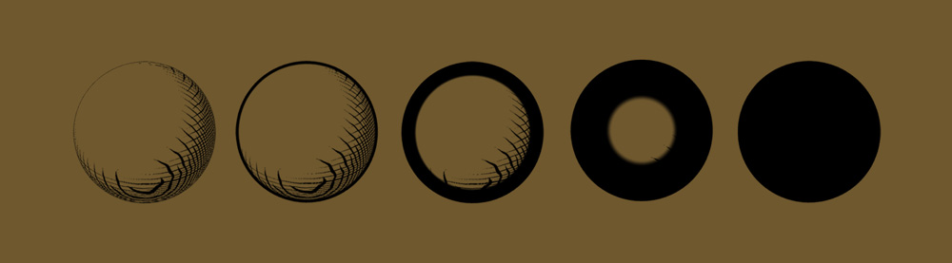
Figure 18: Varying the value of the “outline” parameter.
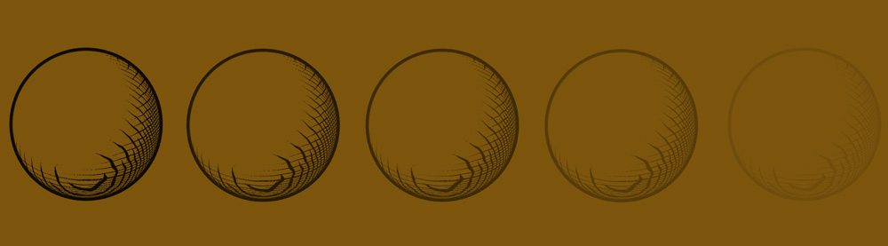
Figure 19: Varying the color value of the Pen between black to grey.
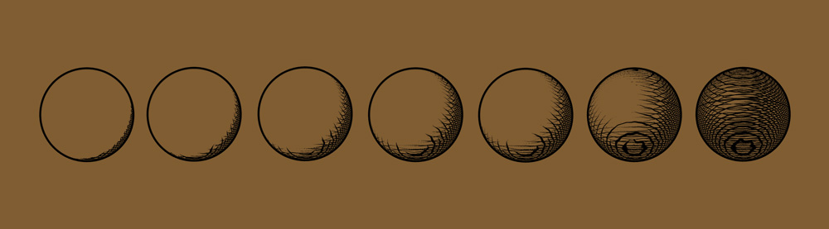
Figure 20: Varying the “scale” value.
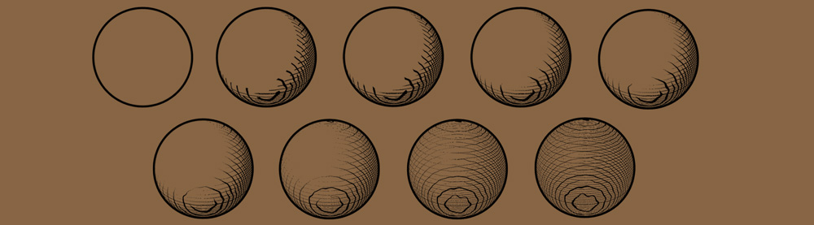
Figure 21: Varying the “taperinitialise” value of each of the direction planes.
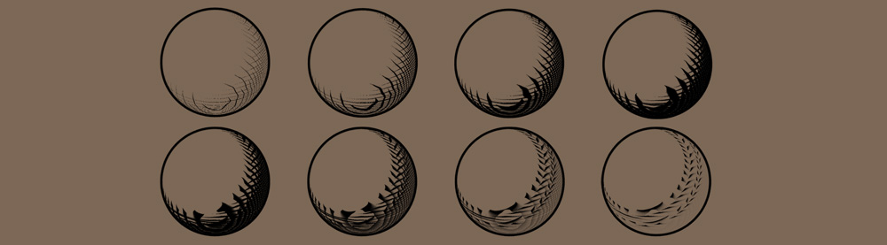
Figure 22: Varying the “widthofline” parameter values.

4.4 Deformation tests
From research (Apodaca and Gritz 2000) it was discovered that when creating procedural shader’s you should never texture in “current” space, as the object will travel through the texture when animating. By using the “shader” space for the 3D parallel lines, this prevented the texture from sliding along the surface. This worked for only rigid transformations (see Animation_tests, Anim1 and Anim2), so the shader is only suitable for objects that are translated or rotated. When shading on a deforming object I encountered a similar problem of the points moving around within the “shader” space, (see Animation_ tests, Anim3 to Anim7).

The reason for this was identified; by moving the control vertices of the cylinder mesh, its points are then moving non-rigidly through shader space. So the shader does slide on geometry when it is deforming. This can be solved by using a reference mesh for texturing, as this makes the texture “stick” to the deforming mesh. This is an aspect I would have liked to have pursued but only had a limited time to address.

  - Outline shader – creating feature edges
The three dimensional models in Maya needed to be used to render out the feature edges. Although I placed a silhouette detection function in the 3D pen and ink shader, it still would miss all the internal silhouettes and boundaries. The method I opted for was not to draw an edge using RenderMan, but to pass rendered edge information through to a channel of this shader’s output.
Pre-rendering was a suitable edge detection technique for my product. There are two types of edge I needed to define: the feature edges which were the lines that exist on an object formed by the boundaries formed by surfaces. And silhouette edges which occur where a surface bends away from the viewer. I found that front and back sides of an object can be shaded separately by comparing N to faceforward(N,I). As the sign of (N . faceforward(N,I)) will be different for each side. This is adequate for detecting internal silhouette edges.

Once this stage was tested I found the objects further from the camera were “over-powered” with the edge lines. This was due to the normals on the object changing more per pixel than that of an object close to the camera. To solve this I just placed a depth-based moderator on the magnitude of the normals, this restricted the problem. From this the normal dotted with the eye vector could be attached to the red channel of the shader's color output.

For better resolution in the depth image, I gave each surface a local near and far parameter. From here I could determine the boundaries between objects by a separate channel that aids in extracting internal silhouettes. This was attached to the green channel of the shader’s color output. The shader when put on an object would then render out RGB image files that could be used to determine edges in post-production, as the red and green channels of the color would contain the information needed for silhouette edges and edge classification.

  - Using the shader for animating non-photorealistic graphics

There are small .avi animations showing what the shader is capable of doing at this stage included on the CD in the directory (Animation_Tests, see Anim8 to Anim16). The shader was tested on both animated models in Maya, and its ability to have its single frame renders animated in post-production.

Any post-production work using Shake only involved layering the pen and ink illustration shader with the outliner shader onto a scanned image of paper. The saturation of the paper was varied, and a gradient was added to the paper to dull the edges. The outliner shader also was blurred slightly to give the illusion of the paper being indented by the pen nib.

- Conclusion

It is believed that measuring the success of the NPR work is still unclear, as there is no similarity measure for NPR. In photorealistic rendering, the measure of success is the closeness of the resulting images to photographs. My goal was to produce a Pen-and-Ink illustration shader and use it on a short animation, which to some extent I believe I have delivered.

The goal for this shader was to hopefully accomplish a method of illustration animation using computer graphics to minimise time and effort usually needed for hand-produced images.
But despite being close to my goal and realising a traditional style animation from the product, there are many aspects the product lacks. The shader is by no means completed but the foundations are there to be built on. The reusability, flexibility, and efficiency of this shader have met the expectations I originally hoped for when writing my proposal.

I have come to realise throughout this project that even if a computer generated animation was identical to a traditional style of flat media, once the viewer knows it was created by a computer the image can immediately lose the appeal of relating to the humanity and personal touch that an artist gives to his/her work. NPR is making giant leaps to being ever closer to its imitated media, but I have come to realise that they will never overcome the artist’s use of creatively producing graphics by hand.

Humans have always been generating the directions for computer graphics to follow, and they most probably will continue as role models for rendering software. Indeed, it is the goal that artists and illustrators will continue to carry out such creative processes as this will continue to feed the area of NPR with new challenges and topics of research.

Perhaps the biggest limitation of the product is that it I have only dealt with the ink lines within the model. Most illustrations, especially sketches do not have lines that finish perfectly on the corners. As the shader only renders on the objects surface, this restricted the hatching lines to this area. For future work I do wish to look into post-production methods that would allow the lines to continue outside of the rendered object. I did do some research into Shake macros, and was particularly interested in an algorithm that detects corners. This would most probably be the basis of a method to continue ink lines off of the corners contained in rendered images. There are plenty more flat media styles I would like to develop using this shader as a foundation including: Ink and bleach, animating light intensity to animate the drawing of the image and torn paper with ink.

It was good opportunity to put the shader into practice with the windmill animation. It allowed you to determine what the shader could be capable of. The short animation with the modeling and rendering time included, took a matter a days which I felt was quite impressive. But large percentage of this time was spent on tweaking the illustration lines. It became apparent very early on when creating the animation that to get a strong final animation or even an image, the parameters and orientations of the pen and Ink direction planes need to be adjusted for every object in the scene. When it came to the final part of the windmill animation that contained multiple windmills; this part became very tedious to bring to a satisfying conclusion. I did make the mistake of only using one spot light, as light linking each particular object would have allowed even more freedom for setting the hatchings on each object. But then only using one spot light in the top right hand corner stays true to one of illustrations common set of conventions.

To summarize the position of the ink lines on the object do depend on a few factors, these being the surface orientation of the object to be shaded, the direction and angle created by the direction planes, the direction the camera is viewing down and the lighting in the scene. If I was to do anything differently it would have been developing a method that allowed the user to enter angle values and the shader would then position the three planes relative to these angles for the cross-hatching.

I have described a method of the image creation process for the generation of pen and ink illustrations from 3D models using RenderMan. The ability to create procedural shader's for NPR has, for myself, open many interesting avenues for computer animation styles, and introduced the freedom for geometric and visual modifications of an underlying model that until now I had not discovered.

6 Bibliography

Apodaca, A.A. and Gritz, L. (2000). Advanced RenderMan creating CGI for motion pictures. San Francisco. Morgan Kaufmann Publishers.

Astin, D. Learn to Paint and Draw. Mulberry Editions. Victoria House Publishing Ltd. (1991).

Douglas-Cooper, H. Sketching Made Easy: a complete beginner’s guide. Great Britain. Parragon Book Service Ltd. (1995). All illustrations by Stephen Dew.

Gooch, B. and Gooch, A. (2001). Non-photorealistic rendering. Natick, Massachusetts. A K Peters.

S.Mealing. The Art and Science of Computer Animation. Intellect, Oxford, 1992.

Stephenson, I. (2003). Essential RenderMan fast. Great Britain, London. Springer.

Strothotte, T. (1998). Computational Visualisation. Berlin. Springer.

Strothotte, T. and Schlechtweg, S. (2002). Non-Photorealistic Computer Graphics:
Modelling, Rendering, and Animation. San Francisco, Morgan Kaufmann Publishers.

The Younger Children’s Encyclopaedia, made and printed in Great Britain by Odhams (Watford) Ltd.

Upstill, S. The RenderMan Companion - a programmer’s guide to realistic computer graphics.
Addison-Wesley, Reading, MA, 1989.

Vince, J. (2001). Essential Mathematics for Computer Graphics fast. Great Britain, London. Springer.

6.1 References

Comninos, P. (January 2003).Mathematical and Computer Programming Techniques for Computer Graphics. Lecture Notes.

Curtis, C. (1998). Loose and Sketchy Animation. In SIGGRAPH’98 Conference Abstracts and Applications, page 317. New York: ACM SIGGRAPH.

Klein et al. (2000). Non-photorealistic virtual environments. In proceedings of SIGGRAPH 2000, Computer Graphics Proceedings, Annual Conference Series, edited by Kurt Akeley, pp. 527-534,
Reading, MA: Addison-Wesley, 2000.

Landsdown, J. and Schofield, S. (1995). Expressive Rendering: A review of non-photorealistic techniques. IEEE Computer Graphics and Applications, pp. 29-37.

Leister, W. (1994). Computer generated copper plates. Computer Graphics Forum, pp.69-77.

Winkenbach, G. and Salesin, D. (1994). Computer-generated pen-and-ink illustration. In proceedings of SIGGRAPH 1994, vol.28, pp.91-100.

Winkenbach, G. and Salesin, D. (1996). Rendering parametric surfaces in pen and ink. In proceedings of SIGGRAPH 1996, pp.469-476.

6.2 Animations

Castle In The Sky. ©1986 Nibariki. © Buena Vista Home Entertainment, Inc.
A Studio Ghibli Production.

7 Appendix - Research and Project Proposal

BA Computer Visualisation & Animation
Innovations in Computer Animation

Research and Project Proposal

Student Name: Paul Dibden a1351414

Proposed Topic of Research:

To research into Procedural Shaders using RenderMan. Non-photorealistc rendering and shaders are a rapidly growing subgenre of Computer Graphics. Photorealism in CG is now within reaching distance, so there is now a trend to imitate other media.

Proposed Project:

To create a procedural shader in RenderMan that will simulate the appearance of a 'Pen and Ink' illustration. A high emphasis will be put on the visual quality, flexibility of the shader, its efficiency and reusability.

Method:

There are two ways RenderMan can be used to generate non photorealistic images: Direct and Indirect Rendering. Both methods will be researched and hopefully tested to find the most suitable for this shader's development. Initially I will research traditional ink illustrations, this will allow me to gain more knowledge into what the desired effect should be. I will test the shader throughout (e.g. how it performs under scaling,rotating,deforming,etc) and also attempt to have consistent feedback. Handcrafted media such as ink drawings are imperfect, so if the style is too rigidly locked the shader will not feel organic.

Product:

To submit a short animated sequence using the ‘Pen and Ink’ illustration shader.

Report:

To be produced using HTML.

Supporting Material:

Logbook.
Source code.
Examples of the Shader's development.
Drawings of the intended “look”.

