The effect I chose to explore for my innovations project was a section from an animation concept I came up with. The animation starts with a shot of a “beautiful” woman in profile, from the shoulders upwards. She has long perfectly straight and shiny hair. A strong wind suddenly starts blowing from behind her, blowing her long hair in front of her face horizontally. At first she looks surprised. Her hair starts to morph into butterflies which fly away reducing her hair to just a few strands of hair on her scalp. She looks confused and upset. The few remaining strand start to grow and bloom into flowers, seemingly causing the woman much pain in the process, hairline cracks form at the base of the stems. These flowers soon wilt and die, falling away from the scalp. Her face is frozen in pain and all colour has faded from her skin, it looks as though it has become porcelain. The cracks spread and become deeper, eventually her face crumbles and falls in pieces and dust.

I chose to try to implement the first section of this concept, the transformation of hair into butterflies, in three dimensional space. My aim was to explore different techniques in order to find one that was both an efficient and an effective way to create the transformation. The project is concerned with the technical aspects of implementing an artistic vision since it contains some complex effects. I want eventually for the whole of the animation to be realised and to do this successfully will involve exploring different ways of implementing each effect.

The concept of the animation is about the transient nature of physical beauty. The human female is used to illustrate this idea as well as incorporating the wilting of flowers and erosion. In contrast to this the destruction and decay is made to seem beautiful too, by using things considered beautiful and delicate, such as butterflies, flowers and porcelain. In fact in the case of the butterflies destruction on one hand is leading to creation on the other. These are all metaphors for the cycle of life as I see it. Death makes way for new life. Destruction leads to progress, sometimes good, sometimes bad, but still a form of creation. The last part of the animation, the crumbling porcelain is somewhat reminiscent of human destruction of environment. At this stage all life has seemingly drained from the woman. She has become something hard and lifeless, and the lack of creation from it implies a negative progress, or the ceasing of progress. This section of the animation is also the only part that doesn't suggest new life coming from the destruction.The end of all life.

The fact that the death or destruction of the woman happens gradually in stages is an attempt to represent my philosophical belief that life or energy usually ebbs away gradually and as it does this creates new life elsewhere. I suppose you could refer to it as some sort of 'soul' but since the idea of a soul isn't often applied to plants or animals I prefer to refer to it as a form of energy. I believe this because when you look at a person who is elderly and their so called sanity is waning, or someone dying of illness or disease they become more and more lifeless, deteriorating in body or mind. If death comes suddenly all of the energy would leave the body at once.

Both beauty and death are subjects often tackled in all forms of art. Death is something that occupies every person's thoughts. It is inescapable and inevitable. Everyone has a different interpretation of death, whether it be just a journey to a higher form of existance, a judgement, a form of regeneration or merely the end and all that is afterwards is nothingness. You might believe that there are two separate elements to human life, A personality or a soul, and a body, a shell. On the other hand you may see just one entity. These assumptions will dictate your feelings on the subject of death.

In a panel painting from 1560 known as “The Judd Marriage”, life and death are presented as part of a single process rather than two opposing values. The painting portrays a couple united in marriage making their vows upon a skull, interpreted as symbolising transience and mortality and below them, a corpse. There are three inscriptions, two between the married couple: “The worde of God, Hathe knit is twayne, And Death shall us, Divide agayne.” and “We behowlde ower ende.” The other is underneath the corpse: “Lyve to dye and dye to live, eternally.” It seems that the outlook of the Judd family on death is positive they don't regard it as something to be feared and don't feel the need to make their portrait beautiful and pleasing to the eye, as often requested for personal portraits. The painting seems morbid but at the same time it is to me at least, beautiful because of what it stands for and the noble values portrayed within.

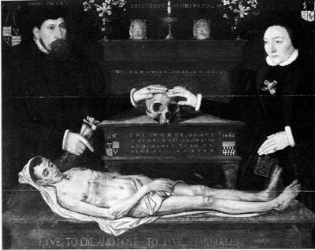
“The Judd Marriage” Oil on Panel 1560

Art has also always been occupied with the beautiful or grotesque. Either to please or to shock the viewer. The goal of the artist is to inspire some kind of reaction in their audience. People react strongly to material that they find pleasing or repulsive. We are a specie obsessed with beauty, when beauty fades we mourn its loss, and particularly in the society of today it is something we desperately cling to and try to maintain into old age through creams and lotions and even surgery. Beauty and death are unequivocally linked. Beauty is commonly associated with life, youth, and health. Our obession with beauty stems from our obsession with death.

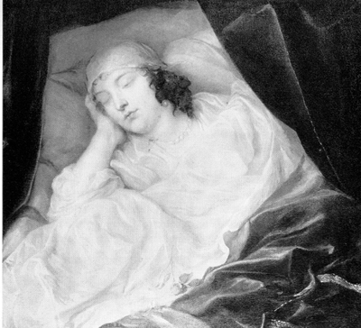

“Ventia Digby on her Deathbed” Anthony Van Dyck
Oil on canvas 1633

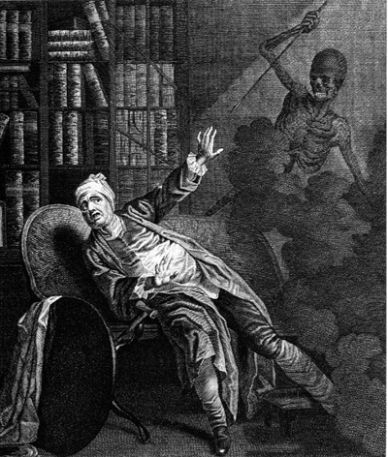

“The Bad Man at the Hour of his Death” - Francis Hayman 1783

In17th century England the protestant church produced images depicting “good” and “bad” deaths to stress virtue. Images depicting the deaths of the virtuous were peaceful and painted in light colours, generally a lot of white, they were pleasing, beautiful images. Or they were heroic and noble images of the deaths of strong looking heroes or martyrs, sometimes with people grieving and weeping for them. In contrast the deaths of the bad were dark shocking images of cowards getting what they deserved their limbs would be twisted and their expressions contorted, obviously suffering a very painful death. These images encouraged the people to live virtuous lives because then they would die a peaceful or noble death, and if they were bad then their death would be very painful. The people would prefer to look at the beautiful, peaceful images and aspire to be like the virtuous, heroic and noble men and woman portrayed. They would die a serene death and have no need to worry as they were going to heaven. The crucifiction of Christ is more often that not represented as a beautiful scene even though it is a horrific fate. This fits in with the idea of representing the death of virtuous figures and heroes as beautiful and serene, even in cases where the death would have actually benn extremely horrific.

In late medievil England decay was often depicted in art. The dead body was made more horrific by the addition of creatures which were considered evil or disgusting such as snakes, toads and snails. It was a reminder to the public of their own mortality. The corpse was seen as something that was dangerous and needed to be treated and disposed of or contained to get rid of the decay. It was a strong message and very important at that time for public health reasons.

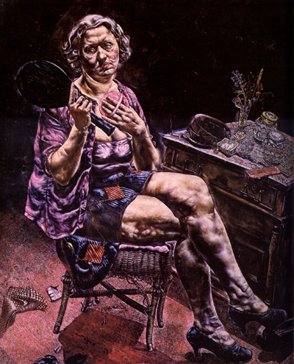
“Into The World There Came a Soul Called Ida” Ivan Le Lorraine Albright 1929-30

The painting “Into The World There Came a Soul Called Ida” portrays a grotesque image of a woman with scarred, swollen bruised and aged flesh. She looks old, but is skimpily dressed as if she were much younger. She is holding a powder-puff and looking into an old handheld mirror. Her expression is sad and longing. She sits at a dresser in what is presumably her bedroom. The carpet is ripped and damaged,. Her furniture is mis-matched and junky, the floor and dresser are messily strewn with various tacky items and bits of rubbish. It is a painful and powerful image of mortality. It could also be a comment on our obsession with appearance. When we look at the painting we are repelled by the mass of ugly swollen flesh and the swollen purple veins. It seems this is the reaction that was intended, an double attack on a society completely obessed with apperance and a society that creates such pathetic creatures as Ida, consumed by vanity and mourning her lost beauty.

Beautiful old masterpieces are also an example of beauty being transient in themselves. Paintings fade and craquelure sets in. These days many paintings, architectural and literary works are renovated in an attempt to preserve them, perhaps due to the desire to cheat death, to become immortal. We cling desperately to our history and heritage and often live in the past to avoid facing the future and the reality of death. Now though we have digital art that can be copied an infinite number of times and will never fade. It removes some of the magic of having something that won't look as it did the day it was finished and will deteriorate over time. I think that is something beautiful and special. As life would not be beautiful without death. The poet Walt Whitman wrote “Nothing can happen more beautiful than death.” I believe that without death and pain there would be no joy and beauty.

I came across a pair of collaborative artists, Heather Ackroyd and Dan Harvey in my research. They create installation artworks involving projection onto grass and then allowing it to decay. One installation in Paris, in close proximity to the catacombs involved rooms filled with grass, live funghi and mature barley. Later locusts were released into the room, desroying everything. Their artwork is designed to be transient and face death. Ackroyd said of their work “There is beauty in growing as there is also beauty in fading”. They see the whole cycle of life as something beautiful, but yet they aren't afraid to destroy the life of the plants they use. They see even the destruction as a beautiful thing.

When approaching the problem of how exactly to morph butterflies from hair the first technique that sprang to ming was to use paint effects and somehow blend between them. Unfortunately any attempt made to blend between brushes over time were unsuccessful and so that line of thought was discarded after many attempts to get it to work. I decided to use Maya's dynamic hair system combined with other techniques to get the desired effect. This system facilitates the creation of hair but has many limitations. The length could not be directly keyed and so I wanted to use transparency to make the hair reduce in length, unfortunately this was another limitation of the system and so I combined the keying of the variables 'thinning', “hairs per clump” and “hair width scale” to create the desired effect of the reduction and thinning of the hair. This worked out a lot better and created a lot more convincing effect than transparency or merely reducing the length would have done.

Another problem encountered in using the hair system was that the dynamics of the hair appear to be limited to only the variables provided within the system itself. Attempts to affect the hair system with fields proved unfruitful. It wasn't possible to get the hair to blow horizontally using the dynamics within the hair system. I got around this by rotating the object the hair system was attached to and rotating the camera also, creating the illusion of a wind picking up and blowing the hair forwards. Maya hair looks very smooth and far too perfect to be real but that is what was needed because I wanted to create a very beautiful, female image. One that everyone could identify as an image of beauty. She wasn't to look too real because in reality nobody could be so perfect and so the look of the hair was ideal.

The first method I considered to create the illusion of the hair turning into butterflies was to use a substitution method being explored by a fellow student, Peter Nancollis, on NURBS tubes extruded along the curves created for the hair system. After some tests involving this technique I decided that it was not the most efficient way of approaching the problem at hand as it would have been very time consuming and laborious to do it for as many butterflies I felt were necessary for the right effect. Additionally the hair system was dynamic and so different every time the simulation was run. Caching could have been used in order to get around the problems the dynamic nature of the hair system would cause, had I chosen to persue this technique.

Whilst exploring dynamics in the process of attempting to get the hair to look as though it was blowing in the wind I thought about the possibility of using particles with animated sprites for the butterflies. This technique could only carry the illusion so far though. It wouldn't be particularly convincing. I thought the effect would be nice anyway though and I'm not too concerned with making the effect entirely convincing, only getting across the concept. This technique was actually fully implemented. I used several royalty free photographs of butterflies from 'Comtech Enterprises' (comteche.com) and edited them in photoshop to create frames for the sprite animation. I then created several emitters and used an air field for each one to control the direction and flow of the sprites, rotating them around the emitters to create more variety and randomness to the movement.

Another method considered was to use the rendered hair as a guideline and paint the butterflies in by hand frame by frame. This technique would also have been highly inefficient and the most time consuming technique, although it could create very effective results. I didn't do any tests using this technique because although the shot is still, and I'm more focused on the ability of the image to portray my concept, I really wanted a technique that could be implemented in full 3D. It would give me more flexibility with the use of camera in the shot if I wanted to take the idea further. The technique I decided on to achieve this was to use thin NURBS tubes extruded over the hair curves of another hair system, and using the curves as motion paths for a NURBS butterfly with very simply blend shape animation for the flapping of the wings.. If the butterfly model itself was attached to the motion path it would not be able to go further than the end of the curve. By grouping the model to itself and then attaching the motion path to the group node the butterfly itself could be keyed freely and 'fly' away from the hair. It would still be attached to the motion path though, and the movement of the butterflies was made to seem somewhat erratic which was a happy accident. The butterfly model was scaled down so it could fit inside the tube and not be visible, and then scaled up as it left the end of the curve to create the illusion that it was morphing from the hair. Despite the large number of butterflies this seemed the most efficient way to solve the problem of making it work in 3D. Combining this technique with the sprites seemed a plausible solution to reducing the number of butterflies required.

The other effects in my animation concept are something I would like to explore in future. I know that it is possible to grow and wilt flowers in paint effects which seems like the most obvious solution for that effect. Of course then there would be the problem of making the last remaining pieces of hair seem to become the flowers. I imagine similar illusory techniques as used for the butterflies could be employed. More time would need to be spent making the transition seem a little more convincing because there isn't a lot of hair and ways of hiding the less than seamless 'morph' from hair to butterfly.

The cracking of the face is a slightly more complex problem and would probably require a lot of post production work in Shake. A different model than the one set up for blend shapes would need to be substituted which wouldn't be a problem considering that her face has frozen in an expression of extreme pain. This model would probably need to actually be split up into different parts in order to break it apart since the shatter tool in Maya is less than adequate. It would be textured more like porcelain and the two models would need to be blended between in Shake. The forming of cracks on the skin could cause some issues here since it begins before the head freezes and becomes porcelain. It would be possible to use paint effects for the cracking effect and copy it to the second model and key the growth and spread of the cracks. Then the lines of the paint effect could be used as a template for the splitting of the head. Particle effects would need to be used in order to generate the dust created by the collapse of the head.

I already had a head set up with the blend shapes required for this animation from when the idea was conceived last year and I did the facial expressions as my specialist project. The facial expressions were not implemented in this investigation since I was focusing on the morphing effect for the hair. I was unhappy with the look of the head anyway having had more modelling experience and would create a new one if I were to go on to complete the animation. I would properly texture the head manually also, to give the model more of a sense of gender. I might try to age her a little also but I don't think it is necessary in order to get across the meaning and would probably even be over-doing it.

I think i could improve upon the result by getting collisions to work correctly because it didn't seem to work very well using the collision detection inside the hair system. This may have been due to other variables within the hair system such as multi-streaking. I did not get a chance to look into the problem in detail. Also I would attempt to make the NURBS butterflies resemble the sprites more, both in appearance and movement, and create a lot more of them in order to make the difference between the two techniques as minimal as possible, thus making the illusion a lot more convincing. I think in many ways the movement of the NURBS butterflies is more convincing since they aren't always facing the camera, but I like the stylistic look of the sprite animation. It does contrast a little with the hair and I would work on the shader for the hair in order to make it fit in more stylistically with the sprites possibly something more painterly. The blend shape animation fo the NURBS butterflies was extremely simplistic and I would make the movement slightly more complex and random. I would look into using MEL scripts to create more random movement.

Maybe some other very subtle particle effects would add to the beauty of the scene as well, making it fit in better with my concept. Perhaps some sort of faint dust glinting somewhat like when a beam of sunlight catches dust when in a darker environment. I would consider adding a background, some sort of environment, rather than just blackness, a painterly background to fit in with the chosen style of the other elements.

In conclusion there are still many improvements that could be made and the technique could be refined in the ways I have already suggested. I learnt about Maya hair which I hadn't previously looked into. I may be able to make use of it for my major project. Hair takes a long time to render and I eventually managed to speed up render times a little by caching the movement of the hair systems so that it wasn't calculating the movement anew each time it was run. Right at the end of the project there were problems with rendering due to network issues and so I didn't manage to get as much rendered as I would have liked to done.

The project has made me want to finish the full animation and explore techniques for the other effects. I think it is a concept that is worthwhile persuing in the future. I am fascinated by life and death in art and philosophy and it is a subject I return to again and again in much of my artwork.

Turbulence test
This was a quick initial test with a hair system to check how turbulence looked. At this stage I discovered that I could not affect the hair system with dynamic fields such as Air.

NURBS tube test
This was an experiment with extruding NURBS along the curves in order to experiment with substitution.

Substitution test
An experiment with the substitution technique. The NURBS tube was duplicated every other frame after modifying it slightly and then their visibility was keyed to create a morphing effect.

Sprites test This was a test with one emitter emitting sprites, affected by an air field.

Detaching from path test Testing attaching a butterfly to the curves and getting it to seem to detach from the path.

Final render of the sprites. Hardware render of the butterfly sprites.

Partial render of hair and NURBS butterflies Unfortunately I didn't get the full render dues to network problems and the movement of the butterflies wasn't completely finalised but it gives an impression of how it would look.

