BA Computer Visualisation and Animation
Animation Design 3
Innovations in Computer Animation

Boona Taxi
Michael Bonnington
u9714795@bournemouth.ac.uk

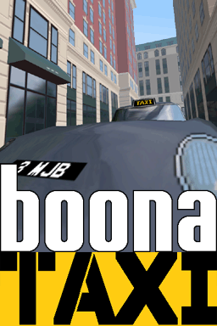
Abstract

This report draws from many divergent areas of research in the field of 3D game engine design and documents the varying degree of success of their implementation in the context of a real life game, Boona Taxi, created for this purpose. In the process of exploration and explanation of many of the theories and concepts, from the purely technical to the purely aesthetic, it is hoped that the reader will gain a knowledge of the subject in the same way that the Author has found this project to be a learning curve.

1. Background

1.1 Why Boona Taxi?

This project was born out of a desire to update Boona Racer 2000, an earlier project, which the Author had felt could make good use of some new and exciting graphics programming techniques that were just being tried out.
Boona Taxi began life as a straightforward update to Boona Racer 2000, provisionally titled Boona Racer 2100. However, rather than to reinvent the wheel by creating another racing game, the Author's enjoyment of the Sega game Crazy Taxi prompted a change of direction.

1.2 Influences

Obviously, Crazy Taxi was the primary motivation for undertaking this project – especially considering no such game exists for the PC. Grand Theft Auto and Driver for their approach to cities as a viable environment in a driving game, and to a greater extent The Getaway for it’s ambition and scope. Not forgetting the ultimate hover-car based racing game, F-Zero.
2. Game Engine Principles

A typical game engine consists many things, depending on the requirements of the individual game. It might include user interface functionality (keyboard, mouse or joypad reading routines), graphics and sound, file I/O, mathematical functionality, the list goes on. As we are using OpenGL and GLUT, a good deal of this basic stuff is dealt with for us, leaving us with the problem of how to sensibly manage everything that makes up our game scene.

2.1 Scene Management Problems

A major problem when it comes to 3D applications, particularly games, is that of speed. 3D rendering is a computationally expensive process by its very nature, and even with hardware acceleration, a badly organised scene can cause serious speed issues. Of course, this is a fundamental consideration in game design, where a consistently high framerate is critical for maintaining the illusion of a virtual world.
Generally we want a large complex level for our game, but we don’t want to be concerned with drawing the whole thing every frame when it’s quite obvious that, for most of the time, only a very small amount of the polygons making up the level will be visible to the player. What is required is a sensible method of storing the level data, incorporating some way by which large amounts of geometry can be rejected, or culled, and thus prevented from being drawn.

2.1.1 Binary Space Partitioning

Binary space partitioning is a classic and well-documented method of spatial sorting, in which n-dimensional space is recursively partitioned into convex subsets by hyperplanes. [1]
A BSP tree is a dynamic data structure to represent this partitioning, in which each node contains a pointer to two more nodes, creating a tree formation. In this sense, the principle is the same as that of a linked list of a binary tree. Implementation of a BSP tree potentially has many uses. It can be a method of drawing polygons on the screen in the correct order (a depth sort algorithm) if a Z-buffer is unavailable, or a way of culling polygons which will not be visible. Perhaps the most powerful functionality BSP trees offer us is a method of spatial partitioning. This enables many fundamental game engine concepts to be implemented, i.e. collision detection and line-of-sight functions (useful for bullet trajectories, picking, etc.)

2.1.2 Quadtrees and Octrees

A similar concept to BSP trees, a quadtree recursively subdivides 2D space into four regions. An octree is basically a quadtree applied to 3D space, which is subdivided into eight (2³) regions. It is possible to implement quadtrees or octrees as BSP trees, with four or eight siblings per node respectively. In addition to games, quadtrees have other uses, for example as a recursive compression method for bitmap images. Quadtrees and octrees are most useful for game environments that are large and open, and where there is only a small probability of a collision occurring between objects.

2.1.3 Portal Rendering

This method is best suited to enclosed environments such as a series of rooms connected by doors, and is used in many first-person shooter (FPS) games. Each room becomes a cell, and the doors connecting rooms are the portals. The principle is that it is only possible to see the surrounding cells through a portal of the cell the player is currently standing in. Therefore, objects that are obscured by the walls can be culled, or the renderer can be constrained to only draw the pixels of the portal when drawing the next room. In order to avoid the calculations necessary to determine which cells are visible from the current position, it is common for this information to be precalculated.

2.2 Choosing the Best Method

Originally it was intended to use a naive system of scene management whereby the player position is tested against a large two-dimensional array containing the level data. However research into the methods described above prompted a change of plan; using portals appeared to be a simple and appropriate method considering the level’s probable layout. However, after time was devoted attempting to create the level with this in mind, the shortcomings became apparent. The problem arose when the realisation was made that some tall buildings would be visible over the tops of others, although not in neighbouring cells. There would not be a problem if all the buildings lining the streets were approximately equal height, but this would undermine the visual ideas for the city, and most probably result in a very bland-looking cityscape. A quadtree method was considered briefly before being thrown out as impractical as it would not solve the car/wall collision problem. So a BSP tree was chosen due to the inherent flexibility and functionality. It is possible to see in the final level design how these decisions influenced the development of the level; originally grid based, then changed to convex cells.
Ironically, due to time constraints and brain deficiency, the first method is how it ended up being implemented anyway (for now at least).
3. Content Creation

It is a view held by many industry practitioners that, as computers become ever more powerful and programming techniques evolve, the major bottleneck in games production is steadily becoming the creation of game content by artists. [3] Level design, modelling, texturing, character setup and animation, to name just a few, are time-consuming processes often occupying large teams of skilled artists for years at a time. An example that most immediately springs to mind is The Getaway. With a development time of over two years, the PS2 replication of a large area of central London is possibly the most ambitious level design yet seen. [6]
Boona Taxi does not have the luxury of a large team of programmers, artists and designers finely shaping every facet of development. In this respect, it’s kind of a throwback to earlier days of “bedroom coders”, where games conceived and developed by an individual could be - and often were - huge successes; almost inconceivable in today’s development climate of big teams and even bigger budgets. Legendary lunatic programmer Jeff Minter, founder of Llamasoft, explains:
“…not only is it a pain in the arse [referring to the current trend of predefining every detail of the game before development begins proper], but it stifles creativity…if you’re locked down to this specific design then you can’t exploit those little discoveries you make along the way.” This is a philosophy which is perfectly applicable to the development of Boona Taxi.

3.1 Creating a Convincing Environment

One of the most important aspects of game design is the need to create a game world which the player actually feels part of, rather than just something they look at. Of course, this doesn’t apply (at least, not in the same capacity) to abstract games such as Tetris. Right from the start this was considered to be probably the most important part of Boona Taxi to get right, and it does succeed.
Although Boona Taxi is supposed to be set in the future, the city designs are quite contemporary. It was the intention to create a game environment that was recognisable, in much the same way that the car’s handling properties are derived from real-world physics (see section 4.2.1). Anything which could potentially detract from the overall illusion was to be avoided. It’s a pity then that in the game there are places where the streets stop and the city just ends. But there simply was not the time to dream up, model and texture a city level of an adequate size.

3.1.1 Development of a Visual Style

The Author was very influenced by the graphical style of Crazy Taxi, and Jet Set Radio in particular. Although the latter utilises a cel shading technique to render its characters, which would be far beyond the scope of this project to attempt to emulate, the backgrounds have a similar look to those in Boona Taxi. A concerted effort has been made to keep the style of models - and particularly textures - consistent and distinctive. Many textures were created from photographic source material.

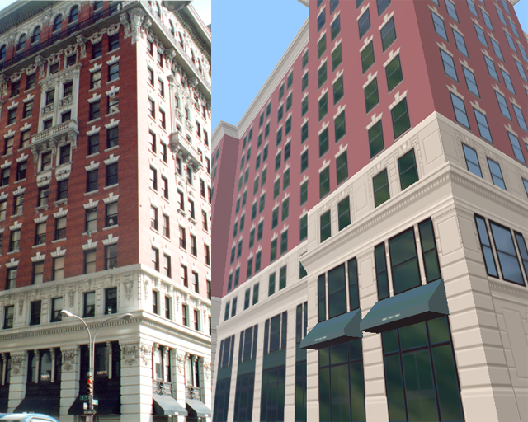
Figure 3.1: On the left is a photograph of a New York building, to the right is its equivalent in the game engine

3.2 Modelling

All modelling and texturing of the cars and city architecture was undertaken in Maya, using the standard set of tools. Of course, the E-type model was originally used in Boona Racer 2000, but due to the new constraints set by Boona Taxi modifications were needed. To start with, the game engine’s renderer only deals with triangles. Secondly, the texture map was completely reworked, as texture coordinates were not contained in the original model.
City modelling was satisfyingly straightforward, using for the most part simple planes and cube primitives as starting blocks.

3.3 Texturing

The textures used on the buildings were hand-painted in Photoshop, using photographs for reference. In keeping with the style guidelines set out above, a limited number of colours were used - approximately 16 for each texture. This approach was taken in order to steer the visual quality away from the photorealism seen in such games as The Getaway. Not having first-hand access to the source material or a digital camera was another factor. [6]
The files are stored as 32-bit TGA (Targa) images, where the alpha channel is used to calculate the level of reflectivity (see section 4.1.4: Gloss Mapping). For example, for a texture of a wall containing windows, the areas which represent brick or stone would have low or zero reflectivity, and the glass window areas would have high reflectivity. Some textures, by their nature, have an even amount of reflectivity across the whole texture (for example, a wall). These textures need not have an alpha channel, and therefore can be stored as 24-bit images, saving some disk space.

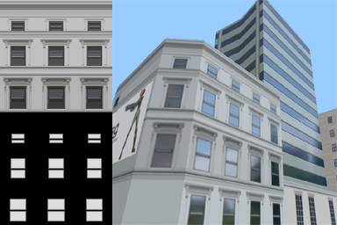
Figure 3.2: An example texture (top left) and the alpha channel stored in the texture (bottom left). The main image shows the effect running in the game engine. Note the walls are not reflective, but the windows are

3.4 Importing Data into the Game Engine

At the start of work on the project, techniques existed for the import and display of models and textures from Maya into an OpenGL scene. These methods are largely the same ones used for the Author’s previous work, Metal Squalid Gear - using the Alias|Wavefront OBJ model format and TGA textures. Over the duration of Boona Taxi’s development, these methods have been frequently revised and renewed, to the extent that many additional effects (such as environment mapping) have been incorporated.
4. Implementation

In this section we will discuss the ways in which certain elements of Boona Taxi have been implemented.
Boona Taxi has been written from the ground up in C++, using OpenGL and GLUT. The result of this is highly portable code – compilation of Windows or IRIX versions is possible (in most cases) by changing just one line in a header file. It should be noted that Boona Taxi is a complete rewrite, and as such uses very little (if any) of the original source code from Boona Racer 2000.

4.1 Rendering the Environment

Whilst it was originally intended for Boona Taxi’s graphical style to remain flat and simple, over time a number of techniques have been implemented to improve the quality of the graphics.

4.1.1 Precalculated Lighting

In order to achieve the desired effect of sunlight on the buildings, each vertex colour is precalculated when the object is loaded. This is achieved with a simple dot product calculation between a global light vector and the vertex normal (stored in the object file). This is advantageous in that it is considerably faster than OpenGL’s inbuilt lighting model, and it provides the right visual effect.
Despite this, the car still uses the OpenGL lighting model, as the car moves around and it can look odd if the lighting doesn't change.

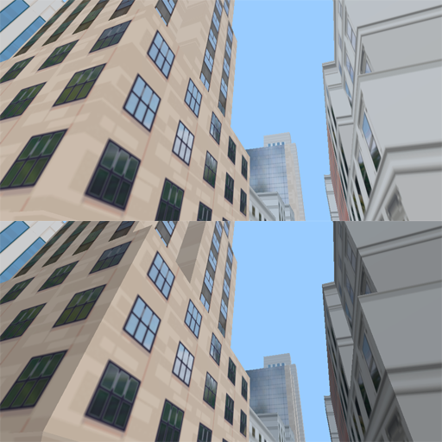
Figure 4.1: The bottom image is using precalculated lighting, the top one is not

4.1.2 Realtime Shadows

The global light vector described above can also be used to calculate realtime shadows. Each vertex is projected along this vector on to the ground and a dark coloured polygon is drawn using these projected vertices.

4.1.3 Environment Mapping

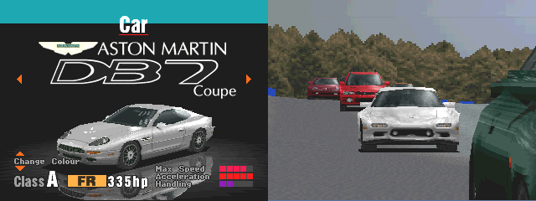
Figure 4.2: Environment mapped cars as seen in the Playstation game Gran Turismo

Environment mapping is a technique used to “fake” the effect of reflections on a surface. These reflections can be calculated accurately using raytracing, but this is an extremely processor-intensive task and even the fastest graphics chips are a long way off being able to do the necessary calculations in realtime. So environment mapping is used as a way to approximate this effect.
Used in the right circumstances, environment mapping can vastly improve the realism of a scene at little extra cost. Gran Turismo was, to the best of the Author's knowledge, one of the first examples of this and provided probably the best looking graphics in a racing game for the time.
There are two methods of environment mapping:

Cube Mapping
This method works by rendering the scene from six viewpoints, then combining these six images into a single texture which is then mapped on to the surface. The advantage of this method is accurate reflections; the surface does actually reflect its surroundings. The downside is that it is expensive; for each frame drawn, six more need to be rendered, plus the time required to create the reflection texture.

Sphere Mapping
A much faster method than above, and the method used in Boona Taxi, sphere mapping uses one texture as an approximation of the reflected environment. Acceptable effects are possible even if the texture bears little relation to the environment. In Boona Taxi, the environment texture is actually a mountain, lake and some trees - absolutely nothing like the urban environment of the game. Yet somehow this is not detrimental to the overall visual effect.

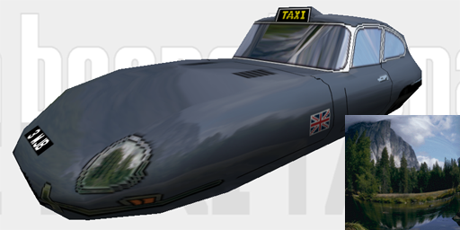
Figure 4.3: The E-Type rendered with environment mapping. Inset: The texture used for environment mapping

4.1.4 Gloss Mapping

This technique simply expands on the above in order to allow variations in reflectivity across a surface. The gloss information is taken from the alpha channel of the surface texture. [3]
Implementation is simple - each polygon is drawn twice. In the first rendering pass, if environment mapping is enabled the surface is drawn with the environment texture. OpenGL automatically creates the texture coordinates using the following commands:

glTexGeni(GL_S, GL_TEXTURE_GEN_MODE, GL_SPHERE_MAP);
glTexGeni(GL_T, GL_TEXTURE_GEN_MODE, GL_SPHERE_MAP);
glDepthFunc(GL_LEQUAL);
glEnable(GL_TEXTURE_GEN_S);
glEnable(GL_TEXTURE_GEN_T);

The second rendering pass draws the surface again, this time using the surface texture and texture coordinates stored in the object file. This is all drawn with blending enabled using the following blend function:

glBlendFunc(GL_ONE_MINUS_SRC_ALPHA, GL_SRC_ALPHA);

Why not draw the surface first and then the environment map on top - surely that would be more logical? Actually, no. That would require the GL_DST_ALPHA and GL_ONE_MINUS_DST_ALPHA parameters, which are unsupported on SGI’s IRIX OpenGL implementation. So it's just for compatibility. [2]

4.2 Car Physics

Development of the car handling model was a challenge. The Author was never particularly satisfied with this element in Boona Racer 2000; the implementation seems over-complex and the result is fussy, unpredictable and unsatisfying – cornering requires more luck than skill and even nudging a wall will cause the car to come to an almost complete standstill. Boona Taxi’s handling model should hopefully go some way towards rectifying this.

4.2.1 Why Hover Cars?

The primary reason why Boona Racer 2000’s hover cars were hover cars is that it meant not having to be concerned with wheels, friction, weight transfer and all the other physical trappings that could make programming a more daunting task. However, we cannot simply throw out all this real-world behaviour because it makes things simple; the car handling needs to be based in reality in order for the player to gain any satisfaction from the experience. The addition of a handbrake on a hover car may initially seem ludicrous, but by its inclusion the unusual becomes familiar. However obscure the idea of a hovering rocket-propelled two-seater taxi cab may be, if it drives like an ordinary car then there’s no problem.
Thus it could be argued that the justification for hover cars, rather than the more traditional four-wheeled variety, is purely aesthetic. Likewise, it’s not a though a Jaguar E-Type coupe would ever make a practical cab, but the design is an appealing one.

4.2.2 Explanation of the Car Handling Model

The development of a suitable physics model for the car presented a much greater challenge than was originally anticipated. As it currently stands, this element is perfunctory, rather than elegant. What it does have is simplicity. Two vectors are stored - one for the direction the car is facing, angle, and the other for the direction the car is going, heading. When turning, the status of the accelerator and/or the brakes are taken into consideration, providing a passable simulation of understeer and oversteer - again these are real-life characteristics whose inclusion makes the driving experience more gratifying.
All this stuff is implemented in a class (called car) which provides a very simple interface. There are Boolean variables for the accelerator, brake, handbrake, steering left or right, and whether the car is in drive or reverse. As this interface is consistent, it would be possible to create an instance of this class (or a derived class) to simulate an AI driver, which would act as an “agent” for the artificial intelligence functions. This is smarter than using pathfinding or path-following algorithms, and would go some way keep player-controlled and AI-controlled cars on a level playing field.

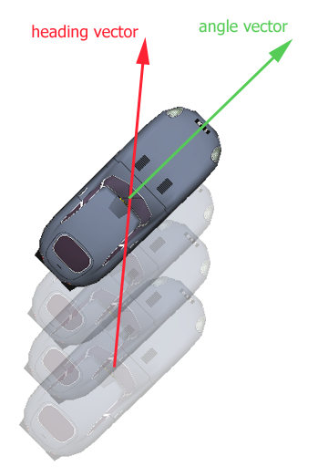
Figure 4.4: A diagram of how the heading and angle vectors control car position and movement

4.2.3 Ideal Car Handling Model

The ideal car handling model would be an extension of that described above, and preferably be a trade-off between the simplicity of the above method and a more realistic model [5], taking into account factors such as inertia and roll, the two most obvious deficiencies of the current model. Returning to Crazy Taxi for a moment, the car handling has an immediacy which is appealing, but also many subtleties which combine to make rewarding driving. This is especially good as the main focus of the game is not on driving ability (although extra points are awarded for skilled manoeuvres).

4.3 Gameplay Considerations

Whilst the way the car handles is very important, time must also be spent on the game’s underlying structure. In Boona Taxi, the game should consist of picking up fares and taking them to their preferred destinations in the shortest time possible. That is the core of the gameplay. Until this is implemented there really is nothing for the player to do except for drive around and admire the nice scenery. That is all very well, but it doesn’t really constitute a game.

4.4 Scene Management

Unfortunately, it has proved impossible to incorporate the BSP tree functionality into the game engine at this stage. In order to maintain the illusion of a solid, real environment, at the very least the player should not be able to drive through supposedly solid walls. It quickly became apparent that it would be necessary to implement a “quick and dirty” solution to this problem. This has been achieved by storing an array of values to depict the solid and empty space, in a very similar method to that used in Metal Squalid Gear. The contents of this array are obtained from a bitmap image, taken from the top-down view of the level when viewed in Maya. Using the Amiga paint package Personal Paint 7, this data is converted to an ASCII file, storing ones for the solid areas and zeroes for the empty space (The Author knows of no other graphics programs capable of this task, despite its apparent simplicity). In the game, the player's position is tested against the values in the array to determine how the car should move.
This approach is far from satisfactory, but in the short term it should provide adequate functionality for basic car to wall collision detection.
The other downside to the absence of a BSP tree is that there is no polygon culling routine. This results in a less-than-satisfactory frame rate, particularly under IRIX, as every single polygon in the scene is being drawn every frame (in fact, every polygon is being drawn twice every frame - see section 4.1.3: Environment Mapping).

4.5 Presentation and Graphic Design

As has been the case with previous projects, a great deal of effort has been expended on the presentation. A glance at an early prototype of Boona Taxi shows that the design and structure of the menu system was in place and functioning in much the same way as it is now. The font design is an amalgamation those from Boona Racer 2000 and Metal Squalid Gear. The method of designing and using fonts has not changed since Boona Racer 2000, and as the Author painfully recalls the process of creating the fonts in the first place, this goes some way to explaining why no new font was designed. Of course, using the same font establishes a connection between the two games.
The yellow colour scheme and checkerboard pattern is visually quite similar to the designs used for Crazy Taxi, but these colour schemes and motifs as seen down the side of the classic New York City yellow cab are an almost universally recognised symbol.
There also exists a Boona Taxi website which has been designed with the same visual style, in fact it’s quite possible you could be be reading this document from that very page. The URL is http://www.boonaracer.co.uk/taxi

5. Conclusion

What has been slowly but surely learned through the course of this project is that creating a computer game, no matter how simple (and Boona Taxi has turned out to be not that simple), can be a long and arduous task, especially when largely undertaken by one individual. The Author does not kid himself that he is any more than an adequate programmer, so a good deal of the code is messy and considerable optimisation is possible. Having said this though, the code is quite efficient and performs some admirable graphical effects such as environment mapping without taking too much of a performance hit, even on the Silicon Graphics machines. The in-game graphics and the general quality of the renderer is a definite success. The Author has no doubt that a little extra polish would have created a much more satisfying end result, and at present the game is more of a showcase for some high quality rendering than a game in itself, which is unfortunate.
Appendices

Appendix A: Playing the Game

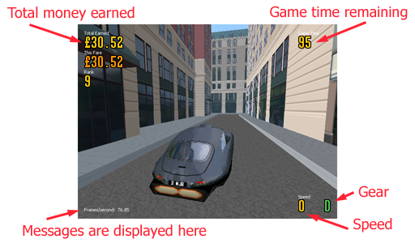
Figure A: elements of the in-game screen

Run the executable named taxi.exe (Windows) or taxi (IRIX).
The intro sequence can be skipped by pressing Enter or Esc.
At the title screen, choose either Begin Game, Options, Highscores, Credits or Exit Game.
Select your vehicle (the only car currently available to select is the E-type Jag).

Game keys:
Left/Right - Steer left/right
Up - Shift to Drive (forward)
Down - Shift to Reverse
Z - Brake
X - Accelerate
Space - Handbrake

P/Esc - Pause game
F2 - Show/hide fps counter
F3 - Show/hide HUD
F4 - Change camera view
F5 - Toggle top-down view (for playtesting purposes)
F9 - Toggle precalculated lighting
F10 - Toggle OpenGL lighting on car
F11 - Toggle environment mapping
F11 - Toggle fog

When the game is paused, and on the car select screen, it is possible to move the camera around in the same way you would in Maya: drag with the left mouse button to rotate, the middle button to translate, and the left and middle buttons together to dolly in/out.

Appendix B: Using the Configuration Editor

Run the executable named editor.exe (Windows) or editor (IRIX).
Usage is fairly straightforward, change the options set with the Display options for: listbox.
Defaults - Resets everything the default values
Save – Save the options. The next time Boona Taxi is started, it will be with the saved options
Cancel – Exits the program and doesn’t make any changes to the configuration

Appendix C: Known Bugs and Limitations

Please note that this list is not exhaustive, and some things may have been fixed by the most recent version.

- Collision resolution after hitting a wall is not properly implemented, the car is just translated back a bit from the vector it’s travelling in. So avoid collisions with walls.
- Do not reverse into a wall or the edge of the level. For the same reasons as above, the car will be sent careering into the void.
- It seems some vertex normals have been exported incorrectly. This results in either strange lighting on some triangles, or triangles not being displayed altogether.
- The scoring system and highscores table does not work (yet).
- The intro sequence does not behave as it should. Ignore it.
- There are no customers to pick up, and no designated locations to take them to.
- The camera does not behave correctly when driving in the in-car view.
- The camera “snaps” to the car’s heading vector when the throttle is applied. This can be disconcerting.
- The configuration editor utility does strange things on Windows platforms. This is most likely due to using the beta 2.0 version of the GLUI toolkit libraries.
Acknowledgements

The Author would like to thank the following people for their help and assistance (in no particular order):

Rob Bateman
Arthur Yarwood
Eike Anderson
John-Peter Li
Martin Johnson
Dave Fletcher
Miles Green
Adam Vanner

and anyone else I’ve forgotten about

References

[1] Eberly, David H. 3D Game Engine Design: A Practical Approach to Real-Time Computer Graphics. Morgan Kaufmann. 2001. ISBN 1-55860-593-2

[2] Woo, Mason et al. OpenGL Programming Guide Third Edition. Addison-Wesley. 1997. ISBN 0-261-60458-2

[3] Perez, Adrian with Dan Royer. Advanced 3D Game Programming Using DirectX 7.0. Wordware Publishing Inc. 2000. ISBN 1-55622-721-3

[4] Poole, Steven. Trigger Happy: The Inner Life of Videogames. Fourth Estate. 2000 ISBN 1-84115-120-3

[5] Beckman, Brian. The Physics of Racing (parts 1 – 8). 1991
A series of articles believed to be first published in a motor racing club magazine or newsletter.
URL: http://www.neutralzone.org/home/faqsys/cates/papers.html

[6] Coates, Sam. London Wasn't Built in a Day: Content Acquisition for Levels in The Getaway. Gamasutra. March 22, 2001.
URL: http://www.gamasutra.com/features/20010321/coates_01.htm

