INNOVATIONS PROJECT REPORT:
NicK Hales

A Beginners Guide To Building A Fur Network

Contents

Introduction Pg. 1

The Problems With Fur Pg. 1
Existing Methods To Produce Fur Pg. 3
Available Information Pg. 4

The Challenge Pg. 4

Research Pg. 5
Why Make Supporting Documentation Pg. 5
Existing Fur Options Pg. 2

Developing An Alternative Pg. 8
The Use Of Bump Maps Pg. 8
Fur Images Pg. 8

Trials & Testing Pg. 9

The Tutorials Pg. 10
Fur: The Breakdown Pg. 11
Transparency Pg. 12
Movement Pg. 12
Softness Pg. 13

The Problem With The Network Pg. 13

Reflection & Conclusion Pg. 14
The Final Network Pg. 14
The Tutorials Pg. 15
Future Improvements Pg. 16
In Conclusion Pg. 16

Bibliography & Reference Sources Pg. 17

Appendix I (Bump maps) Pg. 19

Appendix II (File Tests) Pg. 22

Appendix III (Help Example)

INNOVATIONS PROJECT REPORT:
NicK Hales

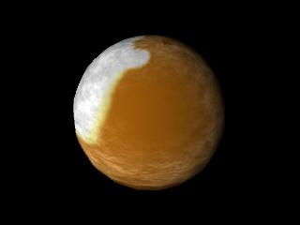
A Beginners Guide To Building A Fur Network

Introduction

Maya Fur is a tool increasingly seen in animation work throughout the industry in recent times, from adverts to such feature films as Monsters Inc. and Shrek. As “Most computer-generated films strive to impress the audience with realistic special effects.”¹ the means to create these effects become more and more complex and technical to accommodate the demand, causing more knowledge to be required to use them. This knowledge may not however be possessed by the newer users of the software, but with the desire to create the final effects, problems arise.

In this report the aim is to demonstrate the problems that exist with Fur in Maya, the options currently available and the lack of information on the subject. The objective is to research and develop a generic alternative, to be accompanied by a clear tutorial which would allow the user to create a similar effect to Fur, without the technical problems associated, and impart the knowledge to use and understand it.

The Problems with Fur

Fur is a vast subject area in Maya, and with such a topic relative expertise is required. On the simplest level it can be placed over a default object at the click of a button, but to cover more detailed objects is a far more complicated issue.

There are three types of material to create such objects within Maya, NURBS, polygons and sub-division surfaces. The main two used for modelling though are NURBS and polygons. This is due to their ease of manipulation and adaptation for creating more complex shapes.

NURBS surfaces are defined in two dimensions, U and V. This makes them ideal for 2D texturing as the mapping point on the texture can be simply matched to the relative position on the surface. This is known as UV mapping. NURBS are based on mathematical curve equations which gives them their smooth and flowing look, and that fact, in combination with the ease for texturing makes them ideal to apply Maya Fur to, as it can be simply and evenly mapped over the surface.

With reference to this information there would seem to be no problem, except that in most cases the preferred surface to model with is polygons. This causes issues as “polygons are defined in terms of vertices, faces and edges and unlike NURBS surfaces, aren’t always products of a regular mathematical formula. Because of this we need to provide polygonal surfaces with texture co-ordinates so that we can map 2D textures to a 3D surface.” ² It is this indirect method that causes issues with regard to texturing, and more importantly with fur.

Because Fur is placed using these UV co-ordinates it works perfectly with the NURBS surfaces yet “is severely compromised on polygonal models”³. This is due to their previously described structure. The only way to get a similar look as NURBS and “put Fur on a polygonal surface, the surface must have good Uvs (non-overlapping, and between 0 and 1)”⁴. But this is easier said than done, and a time consuming task, especially without relative expertise when creating more complex models.

Due to the problems with UV texturing when using a complex polygon object, Maya Fur on polygons is not always a viable option. As without the perfect texture map the fur effect will seem uneven at best and on top of this the “Fur tools are very unresponsive on polys”⁵ as the painting and combing tools used with fur attributes do not work on this surface, again meaning this is not a viable option for anyone other than a highly skilled user who could work around this issue.

This is a distinct problem with Fur for those who model with polygons, as on top of the facts already mentioned, to date it is impossible to convert a polygon mesh to a NURB mesh directly without the detail level increasing greatly, not good for working speed when later animating.

On a more general level Maya Fur can cause a great increase in render times. Even those writing articles for reputable sites such as HighEnd3D.com have problems. “The rendering of fine hair was hell. To get a noise free rendering of just one frame with some thousands of hairs took ages to render.”⁶. As even a simple frame with “200k hairs took with normal rendering 16 minutes”⁶ and with the large number of hairs needed to produce the look of just a basic covering coat this problem is common place.

This dilemma of the calculations needed for so many hairs doesn’t seem to have a definitive solution, merely quality compromises, an issue many people seem to come across in their work:

These extracts from a Q & A discussion found on Alias.com shows some of these problems and some examples of the compromises needed to get round them:

“Q:My Fur render is extremely slow - is there anything I can do to speed it up?
A:Fur render times increase linearly with the number of hairs used - rendering 10,000 hairs will take twice as long as rendering 5,000 hairs. Shadow map calculations take as much time as the render itself for EACH light which Shadow Maps turned on for Fur - so for using two shadow maps will cause your render to take three times as long as using no shadow maps. Conversely, Auto Shading is virtually free, and gives realistic back and root shading.
Solution: Try using fewer hairs with a broader base width to get good surface coverage. Limit the number of Fur Shadow Maps you use to 1 or 2 at most, and instead use Auto Shading or No Shading for most of the lights.
Q: I'm running out of memory when using Fur. Is there anything I can do to optimize memory usage?
A: You can control the number of hairs tracked per pixel for both the fur images and the shadow maps. This is trade-off between quality and memory usage. You can also reduce the size of shadow maps used for Fur, since using large shadow maps is extremely memory intensive.
Solution: Reduce the Hairs/Pixel value for both Fur Image Rendering and Shadow Map Rendering (where applicable) under the Advanced Options of Fur Globals, especially in scenes where your character is the distance. Don't use a larger shadow map for Fur than you require, and use Auto Shading instead wherever possible.”⁷

Existing Methods To Produce Fur

To produce Fur, or a Fur like look to an object, one of the following would be necessary.

- A good understanding of external rendering packages such as ‘Renderman’ along with the knowledge of how to create shaders or their equivalent within such programmes.

- A NURB mesh, in order to allow the application of numerous curves for paint Fx or Maya Fur.

- A powerful enough computer to cope with the addition of Maya Fur, and an understanding of the complex attributes and stages that go into producing a realistic fur effect.

This report was based on the fact that these requirements or knowledge are not commonly found in the average animator starting with the package.

In order to ensure this assumption was correct a range of animation students were asked their views on the use of Fur in Maya. Some of the responses are included below.

“I tried playing with Fur early in the course but gave up when it just wouldn’t sit right and I couldn’t fix it whatever I did, just got plain annoying. Haven’t used it since. Strange that!”

Fiona Mortimer 3rd year student BACVA
"I've always avoided using Maya Fur as much as possible as it is so complicated to use - especially when using it on polygons which is what I use for the majority of my modelling..."

Claire Galpin 3rd year student BACVA

“ You can’t really work with Fur in real time, it slows the processor down and generally crashes before you get very far”

Emma Clifton 3rd year student BACVA

“I haven’t really had much experience with it though I would say that one of the main limitations are that it is uv dependant. It requires loads of setting up for a person, on a character that doesn’t really need uv mapping for textures because its mainly covered with Fur!”

Jimmi Gravesen 2nd year student BACVA

From the responses gathered it was found that although the students were interested in the final effect and how the Fur could look, very few were interested in the time needed to fully understanding the topic. Those who did have knowledge of Fur were not keen to use it due to the time constraints of their projects.

Available Information

With most areas within Maya the first thing you would find while researching on the Internet would be pages of tutorials and examples of the chosen field from sources such as www.highend3d.com⁸

The problem with the information available about Fur is that it comes mainly in the form of questions and problems users of Maya have. Some examples of this are:

“Q: When I render, there is a gap between the edge of my NURBS surface and the hair growing out of it.

Q: Fur seems to be flipping or crawling on my animated trimmed surface.”⁷

This and the lack of in-depth information have caused difficulties in the researching of this topic. In order to try and combat this, most of this report’s research is from trial and error from practical work, along with the technical information provided in Maya help.

This led to the conclusion that there are problems with the complexity and level of technical knowledge needed in order to use even basic Fur. This issue is addressed later on.

The Challenge

At one stage or another the process of adding Fur onto a character has frustrated many students, especially with the way it runs so slowly on the computer, as demonstrated by previous comments. These issues were especially prominent when working with polygon meshes as in order to create a reasonable looking, editable Fur the entire model must be converted into NURBS (as explained earlier). This report is therefore aimed at finding another way to create a usable Fur substitute that can be used easily and effectively.

The results desired from this alternative method suggest that the Fur should be as simple as possible. The most effective way would be using texture networks or displacement maps, the same way you would any texture in Maya. This network would be able to use any ‘flat’ texture created by the user as the base colour or texture, and simply add a furry softness to the model without affecting the originally chosen texture’s colour and detail, ultimately taking it back to basics.

This network should also be simple in its construction to allow a relative novice in this area not just to work through it but to understand the concepts behind it. This would avoid the use of code needed for a shader, or the learning for packages such as Renderman, and would mean unlike Maya Fur, there would be no need to drop into a complex list of new attributes in order to change even the simplest details such as colours etc. Examples of which can be seen on many a Maya webpage.⁹

One of the limitations to be taken into account when creating this Fur effect was time.
It was imperative to create a Fur look that would not slow the user down during their animating or render times. This product would aim to compliment the user’s work rather than cause delays or detract from the time spent on their main objective, the animation. This would mean clear documentation to support the product would be necessary.

The challenge was to create a quick no fuss method for someone to use that would create a Fur like effect on their model, which should ideally avoid the pitfalls that can occur with existing methods. This would allow the viewer to believe the character is soft and covered in a short coat of Fur as well as allowing the user to animate the character with greater speed and hence far shorted render times than would be possible with Fur attached. But this finished product is useless if it cannot be adapted and be understood how it works. This would mean clear documentation to support and explain the product, so this also had to be created.

Research

Why Make Supporting Documentation?

Due to the majority of student animators having limited knowledge in this area, it was important this was taken into account when creating a Fur programme. By creating documentation the information acquired from this project could perhaps help them, through the solutions created step by step. The challenge was to use as simplistic an approach possible and be able to pass on the knowledge in the process.

In a wider context this area of the project was important when realising that although every year each student during this project investigates deep into an area of choice, this information is merely handed in and filed away, and if presented is only to their fellow final year students. This leads to none of this potentially valuable knowledge ever being passed on to the lower years. Potentially a huge error and great loss of valuable information. Instead being able to produce something that could be left, maybe this work, may lead to something being done about this and help future students on the course.

Another reason for choosing this topic was from looking at individuals attempt’s to create fur looks or to try and use Maya fur for their models on the Internet. (Fig. 1 & 2) This led to the question, how can it be improved?

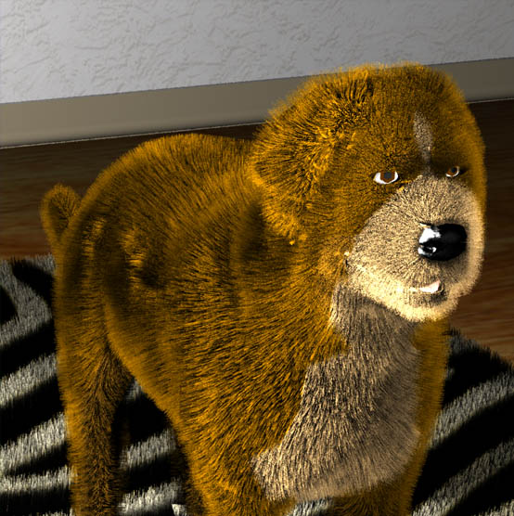
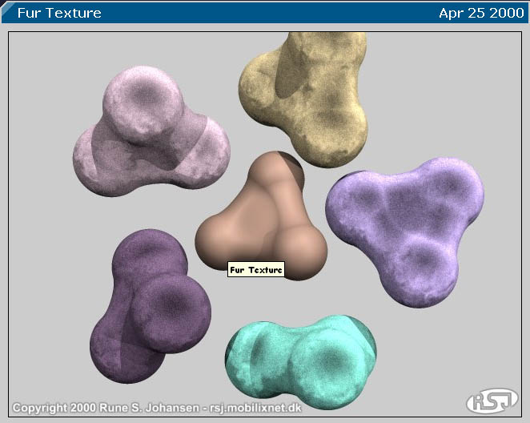
Fig. 1 Fig. 2

An example of Fur being used and not An example of another attempt to create
quite working as needed, found a Fur effect, from www.runevision.com¹¹
at www.stanford.edu¹⁰

Existing Fur Options

The next step was to look at the existing options and reveal their strengths and weaknesses.

Renderman

- High quality rendering results

X For the basic tasks is very similar to Maya, but using it would require acquiring and learning new software.

X Effects such as detailed Fur procedural texturing would need large amounts of code and therefore programming knowledge.

X There is very little documentation to accompany the package.

Maya Paint Fx

- A look similar to Maya - Fur simply painted on.

X Can only be used on a NURB surface. No good for polygon modelling.

X Painting on curves can be in-accurate and look messy.

X When painted over whole model can greatly reduces processing power and increase the render time.

Maya Fur

- Lovely effect due to this being custom designed for such a task
- Adds realistic softness and movement to the character

- Brings simple model to life with detail.

X Complex in its application.

X Time consuming to get right result.

X Many attributes to fine-tune for correct look

X Slow render and performance times

Industry have also created their own alternatives, including a geometrical based method ‘where Fur was modelled with a very great number of small triangles’¹² by TOPIX and many other companies have tried to create their own approaches:

Digital Domain – ‘Spent several months writing a shader for the micemen in the film The Island of Dr. Moreau’¹²

ILM- ‘Used a combination of techniques for Jumanji, both shaders and geometry Fur’¹²

PIXAR- ‘For Hannah’s hair used in Toy Story, involved shape-animating nested dome objects, mapped with hair textures’¹²
PIXAR also spent a great deal of time and money to create a realistic Fur for their lead character in the movie Monsters Inc. that they called Fizt. This “state-of-the-art simulator understands the physics of the characters’ virtual environment”¹ and although not perfect is one of the best systems to date.

This information proves that the resources available are never good enough or appropriate for the industry’s work. In a similar way the resources in Maya are not appropriate for the students using it, as their initial skill levels are usually not equal to those needed to fully implement the tools.

Additional problems with alternative Fur effects available are in the notation that accompanies them:

“Shell and Fin extrusion using Vertex Shaders
Vertex shaders allow for more flexibility in Fur rendering by performing the shell and fin extrusion in hardware. For shells, each shell vertex is moved in the direction of the normal a fraction of the fur height. For each of the fins, two of the four vertices are extruded in the same manner. The fin’s v texture co-ordinate is used to choose which vertices get extruded. One of the nice things about extrusion in a vertex shader is that it allows for the Fur length to be set using a vertex shader constant. A possible application of this is to have characters in a video game have shrinking or growing hair during the course of a game.”¹³

This to someone new to the software would probably confuse them and cause them to avoid the technical side put forward, and so not be willing to explore the area. Hence why an alternative would be of use.

Developing An Alternative

As previously stated the best course of action seems to be working through the most straightforward level in Maya, the Hypershade.

The first step involved in the process was to explore the default texture Nodes already available and build from those foundations.

The Use Of Bump Maps

The defaults:

The default textures for bump maps in Maya work to varying degrees of success. Many create too ordered a pattern to be appropriate for a Fur, but a few seemed to have qualities that would be of use, such as soft natural grains and a good range of variation. (For a full list of these defaults see Appendix I)

Fur Images:

The next step was to expand on this and test whether laying basic images of Fur onto objects as a bump map would give more interesting effects as starting points. Due to the manner in which bump maps work, the applied textures with the least colour extremes produced the most desirable results.

These seemed to create softer, more natural effects as bump maps than the defaults, with some working a great deal better than others. (See Appendix II)

The looks created seemed to have the most potential yet for creating a useable Fur texture. Unfortunately when placed upon the model, the bump map was rather harsh and this meant that the looks was not smooth or subtle enough to create a soft and realistic Fur effect.

This led to the problem of deciding if they were worth further work and adaptation.

Although these were interesting experiments into just how the bump maps were working and what needed to be created in order to get a soft and natural texture. One option at this point was to pick one and edit it with filters and different techniques in Photoshop, in order to get closer to a workable textured bump map. This however was deemed not to be the best course of action due to the light dependence of a bump map and the lengths to be taken in order to achieve one effect, let alone a generic effect so needed for the final product.

As stated earlier, these basic techniques and shaders would work for simpler default objects but this would not be of universal enough use. For this to be a viable option for using on a model a subtler texture would be needed. Hence, a more complex procedure would be called for, one that meant looking in more depth into the Hypershade and the networks.

Trials & Testing

The majority of this project was spent experimenting within the Hypershade building networks in an attempt to create the desired effect. This required a lot of trial and error as more was learnt about the working of the networks and the many uses of the individual and combined Nodes as the trials progressed. During this process it was noted that the existing documentation from the Maya Help pages for the Nodes and their effect within networks was not very clear and overly technical (See Appendix III). Therefore it was decided that it would be best to address this issue, most likely by defining each Node in simple language.

These tests, as expected, had varying success and in some cases produced extreme and random results, here are a selection, alongside their networks:

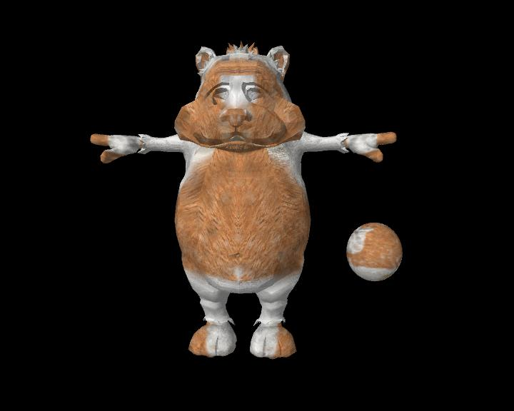
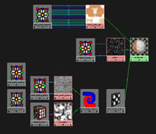
The network above provided a subtle surface texture, using a selection of Texture Nodes to give a varied map over the surface. This did not create a clear enough effect as ideally a texture that is easily and instantly recognised as Fur would be wanted.

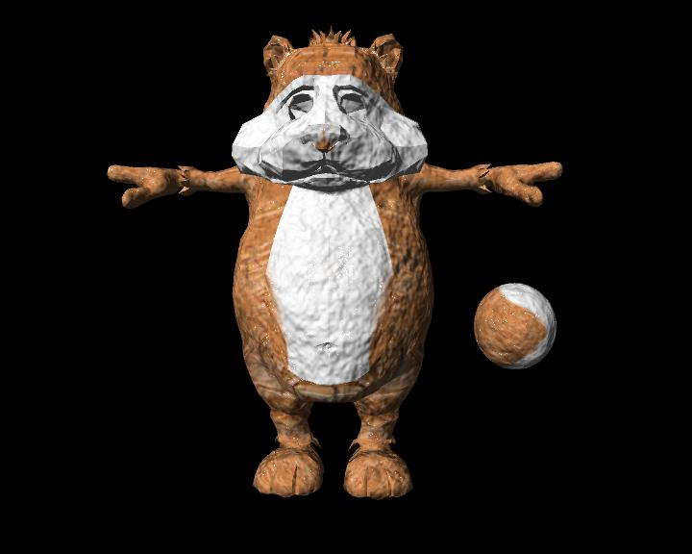
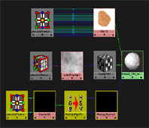
This example was based on a network similar to the one used to create a snow like texture. This gave a 3D texture to the surface but was reliant on the correct lighting levels due to the use of the bump map element, and was therefore not ideal to be used in a scene as all light levels would have to be adjusted to suit. This was an important issue if the network was to allow generic use.
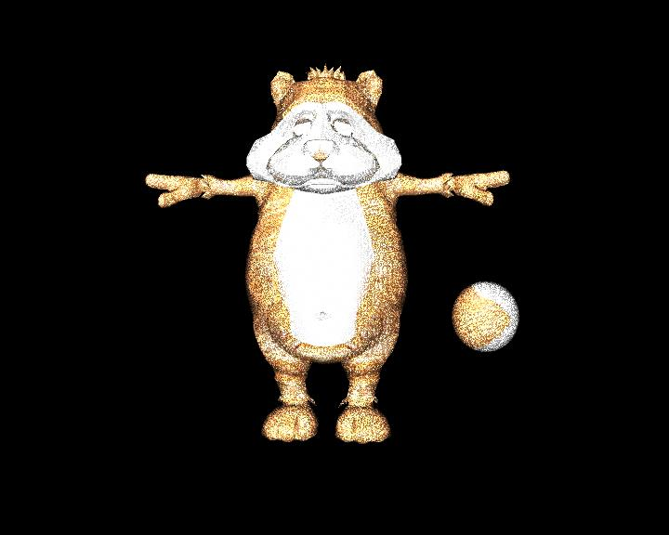
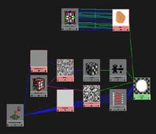

The network above was used to try and create a sense of transparency on the surface. But issues with light reflection and incorrect channel values meant this appeared far too bright and also seemed to have holes within the object meaning it was inappropriate to be used in a scene as background objects would be seen and a distinctly odd look would be created. These issues will be covered again in more detail later.
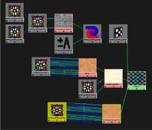
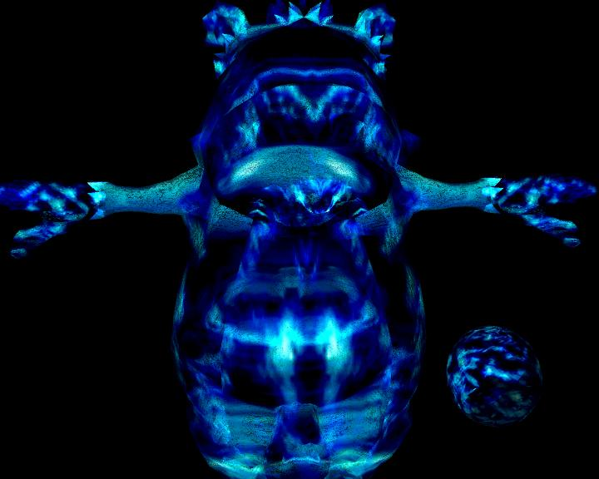
This was one of the most extreme results created in the trials. Although it may seem odd that this wispy blue haze was created when all the colour attributes are orange, it is simply an example of how different a result can be achieved by simply connecting the same nodes to different inputs.
This is another insight into the complexity of the networks that can be formed within Maya. Not at all useful for the project, but a very stylised look in itself.

The Tutorials

After much time spent testing networks it was decided that, if this was to be of a greater use the interim networks would need documenting as well. So instead of creating just the final tutorial, other useful development networks that could stand alone in their own right, were incorporated.

This project had from the beginning been intended as a means of sharing the results and discoveries with others and a selection of useful network tutorials seemed an idea vessel. This was due to the fact that such information was missing from the sites offering help with Maya Fur. Although the final products are easily downloadable from sites such as Highend3D.com¹⁴ when the shading networks are opened there is no information available on them. This leads to those using them not having an understanding of why they work or how to alter them when needed.

It was also clear that with a distinct lack of explanation and tutorials available the main source for information was through the forums and chat rooms. This involved hoping that someone else may have the answers, and that they were willing to share their work. Examples of this can be found at cgt.com¹⁵, although this would not be ideal if working within a tight timeframe.

The next step was to look around at existing tutorials. Many of the more ‘showy’ and very well presented tutorials, while looking impressive, lacked clarity at times and in fact hindered the information they were trying to put across and sometimes missing the key practical steps out altogether presuming a great deal of knowledge, such as tutorials found on 3drender.com¹⁶

The most effective tutorials turned out to be those that simply combined a straightforward description backed up with suitable diagrams. Therefore it was decided basing the tutorials on this would be the best approach.

The tutorial found at angelfire.com¹⁷ was extremely straightforward and easy to follow, to the extent that it has been included as part of the produced tutorials.

Although the simplicity of such tutorials were very appealing the most important thing was
to convey the instructions to create the networks, but also add enough information and explanation so that the user would understand the steps they were taking. Many examples found online required the viewer to simply follow them blind or would flood the viewer with too much information in just one or two diagrams, as shown on Animgraph.com ¹⁸

To avoid this, more explanation should be included than would usually be expected in a tutorial, to make sure of full understanding. This was to be at the core of the tutorials, which could lead to it being far wordier than the preferred online tutorials stated.

Fur: The Breakdown

The tutorials cover the three most successful and relevant networks created during the research, and the final network chosen as an end product. These networks covered the key areas associated with fur:

- Transparency

- Movement

- Softness

Transparency

This is a very complicated area to work with, which is why it was advantageous to find examples to experiment and work with. The key issue with this area was to create a texture that appeared split, like hair ends around the edges without dominating the object it was assigned to. In turn it should not allow the object itself to be too greatly effected by the transparency.

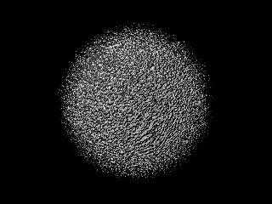
This network worked well for the purpose of creating a semi-transparent edge to an object, but no matter
how the network was edited it was clear to see this would not be viable for the results required. This was mainly due to the way the transparency network worked, as to create the above look meant making some areas of the surface transparent. This effectively meant the texture faded around the edges, it was fine on a simple sphere but useless on a detailed piece of curved geometry. This was because wherever you would find a curve, for example the nose, the edges would fade out leaving holes in the character.

Although this network failed in terms of Fur creation it is a valid texture in its own right and could be well utilised in a more abstract or stylised piece of work.

Were more time available to improve the network a good trial would be to find a way of mimicking the effect created via the transparency channel through one of the Surface Node’s other channels to avoid the issue of holes in the more complex objects. It would also be interesting to see if adapting the way an object is modelled would allow this texture to work more effectively.

Movement

Within Fur there is always some degree of movement, whether stationary or in action. Because of this the area needed to be looked into. Although on an already complex model this could look too fussy and perhaps distract, for more general use this could be needed for an added touch of realism.

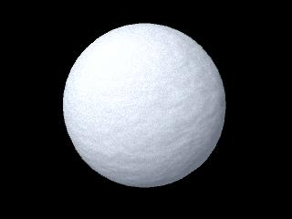
The network itself has been greatly simplified for ease of understanding but works well. It would be interesting to work further on creating more detailed networks around this area and expand on these by incorporating elements of Mel scripting in conjunction with the texture network. This concept will be further explained later.

Overall though this fitted its purpose well and in the scheme of the project was not worth taking further, but hopefully it has created a good starting point for others to work from.

Softness

This was the most time consuming element of the Fur process due to the difficulty and subtlety of the effect, and the amount of testing needed to achieve the final look.
The soft appearance is another important attribute in achieving the Fur effect as it is easily recognisable on a surface and so to suggest its soft look and feel was an important area to cover. If this could be faked to a decent level then convincing the eye would, perhaps, make the viewer believe that the object really could be furry to the touch.

In comparison to the previous elements the network to create a decent effect for this texture was far more complex to create, and in particular to discover. It involved a few similarities to the transparency network but also a great deal of connections that had not been considered beforehand. The majority of the time spent on this project was devoted to getting this element working at the correct level and then reducing the network to it’s most basic form. However, it was considered that there could have been easier, and more straightforward ways to get a similar result due to the vastness of options within Maya.

This effect was deemed suitable and it worked sufficiently on a rendered object once a few adjustments were made, these are to be discussed below.

The Problem With The Network

Although the texture seemed to work well on single rendered still frames it had not been tested on moving models. Though the texture gave the desired effect it would not move with the model in the scene, seeming instead to slip. Having a texture that does not move with the object meant it could not fulfil the initial aim.

As the wider aim was to create a texture for an animated character this would mean failure as a project. So more work was needed to adapt this texture so it would give a soft Fur look and move with the object assigned it.

It was first thought a solution may be possible by using other Nodes available. This was not the case, the key element of the problem was that there were 3D textures in the network, which projected the texture, rather than wrapping it round the surface as the 2D textures would. This meant a character would simply walk through them in the scene. The solution to this was to perform a method known as baking, which creates a 2D effect from this 3D texture to sit over the UV map of the character meaning it would react in the same manner as a default 2D Node. This was an interesting idea and one that without research would not easily be found. This discovery made the tutorials even more crucial to the project, so others would not stumble at such issues, and hence was covered in great detail within the instructions.

With this crucial issue resolved the texture was finalised. A network had been created that, although object specific would add to any flat colour to create a look of soft short fur. Overall completing a successful project:

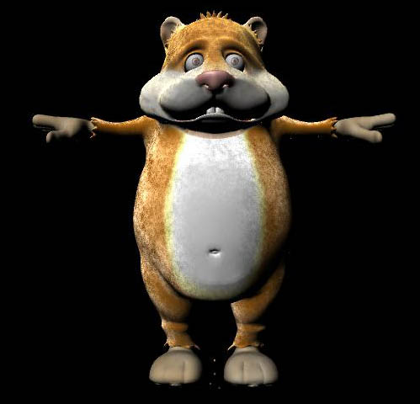
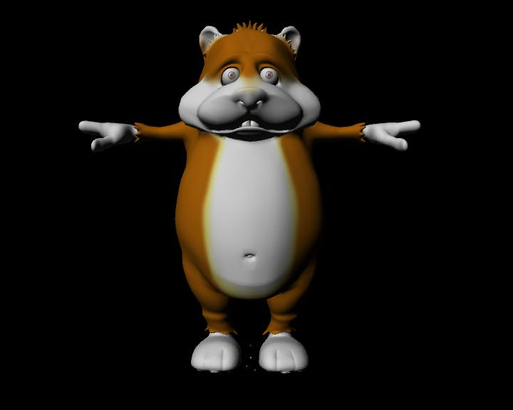

Example of the finished network’s effect on a flat colour texture

Reflection & Conclusion

The Final Network

The final product fulfilled its aim as the network created a soft and ‘believable’ Fur. Although an effect that appeared more like strands of hair would have be preferable, the plush toy look worked well.
The texture also fulfilled the aim of reducing the processor and render times compared to those when Maya Fur is used. Because this look was simply a texture it could also be applied to the character and not affect the speed of working within Maya, which is of great advantage for animation and allows for quick renders, all of which are beneficial with respect to working with tight deadlines.

The other area in which the network and tutorials worked well was clarity. The step by step approach to create the texture allowed the user to be comfortable in altering and adapting the final effect for their own needs, removing the problem of ready made shaders provided on the internet, as stated previously.

There were some ways in which the project was not a total success. The final network was intended to be generic, but in order to solve crucial problems it had to become object specific. This therefore means it did not fulfil one of the original aims. A means to compensate for this failure not reaching the aim was to ensure the tutorials explained the reasons behind this and the method of creation thoroughly.

Another reason the project was not a total success is that only one Fur was created in the time given. Therefore further work on this project could include attempting to make a wider range of Fur textures for differing needs. Although the network creates an effect of soft Fur the greater problems faced with Fur such as varying lengths, baldness and such features existing within Maya Fur were not fully resolved.

The Tutorials

The tutorials were not something considered at the beginning of the project but instead were a later addition. This was due to the realisation of the importance of good documentation. This would allow others to use Fur with a better understanding of the topic and alternatives available, thus giving them more time to develop ideas further and perhaps make more breakthroughs.

In terms of content, the approach was based less on an existing tutorial and more on creating one with the clarity and content that was considered the most helpful. Including additional comments of explanation mixed in with the usual step by step construction approach was important to allow an understanding for the user as they worked, instead of merely following instructions blindly pointing and clicking until it appeared to work.

The tone of the tutorials was done in a way that would not patronise but also presume little knowledge at the start. The basics were not covered time and again as to avoid a repetitive feel and to ensure it flowed well, but occasionally adding reminders to prompt the user. This assumed that the user would be building on information found earlier in the tutorial. Diagrams were used to back up the written material as Maya is such a visual, hands on package and animators in general are more receptive to images rather than words. Each of these diagrams was accompanied with a short explanation to avoid the user losing their way when shifting focus between the information and images.

Although more areas outside of the Hypershade could have been covered, such as the UV Texture Editor, it was decided to instead include existing tutorials. This was done to avoid disruption from the principle issues that were being covered. This then allowed users interested in other elements to look into such topics whilst those only wishing to use the Hypershade were not inundated with information they did not want.

The tutorials were tested on students on the course and a few people from outside the course. This was done to test their suitability and to check they were pitched at the right level. The feedback was positive and relative Maya novices felt comfortable working with them. This ensured even those with little or no background knowledge of Fur were capable of understanding the basics covered. Those not familiar with Maya had issues with the technical language but this was to be expected. These specialist terms were not explained in the tutorials as the guidelines for the unit specified to aim the project to someone familiar with the software.

Extending this type of tutorial to the novice user could be a beneficial area to explore further, as the Maya package itself becomes more widely accessible nowadays with free trial downloads. More immediately with the University holding Computer Animation Summer Workshops, having these type of documents could prove very useful for students during their time on the computers and teachers alike with lesson preparation.

These tutorials were, as with most documentation, not to the liking of all people. The tutorials were mainly aimed at a user familiar with the basics overview of what Maya had to offer but no expertise in the area of texturing of Fur. Including boxes around the direct steps in the tutorials though helped the more advanced users get on with the task at hand and not be slowed with the background information between steps, that they may already be aware of.

Limited knowledge in the designing of web pages meant the piece is not as fluent as it could have been. The introduction of tools such as hyperlinks would have made the tutorial far more accessible for use as quick reference material, meaning the user would not have to scroll through the whole document to find the area of interest, although a book-marked PDF version went someway to solving this. This also helped address another issue; to make this available online and so help to fill the void of information and tutorials, a problem mentioned previously.

Future Improvements

This project along with its research is still a long way off reaching its full potential. There is much wider scope and possibilities available to explore alternatives to what exists today by taking it back to basics and using the tools already available to their full potential.

Even within the networks there is room for extension and improvements. With the movement network in particular there are a few areas that would be worth pursuing. The most interesting would be to incorporate a means of movement through scripting that would be triggered by the manipulation and movement of the object itself, adding a more natural flowing look to the final effect. It may also be a case of using such tools within Maya such as jiggle weights to achieve this on a more simplistic level. Also it would be interesting to look at extending the Fur texture’s distribution over the object, perhaps using scripting to vary the baldness and cover over an object with an intuitive user control. These two factors could help produce an extremely useful Fur substitute with a greater degree of freedom and so a wider use.

The tutorials could have been expanded to cover a wider range of topics on areas around the networks. In particular a step-by-step guide to texture mapping in the UV Editor. Instead this area was glazed over and existing material used. Unfortunately time constraints meant expansion could not be done for this project.

Through the testing of the tutorials in Maya, novice’s distinct problems were realised with some of the software’s specialist language and terms, but as mentioned previously the guidelines for the unit specified the presumed level of understanding. It would have been interesting to be able to test the success of these tutorials on something like the Summer School to better gauge their exact level. But unfortunately this was not an option.

In Conclusion

In many ways this was a successful project as it fulfilled most of its basic aims. Although it is not ground breaking research it was a challenge to do and innovative for myself.

This project’s success in a wider context has directly advanced other projects and can hopefully be of use for others to follow, with two 3rd year student already interested in using the finished network for their own project as a fur substitute. This is an encouraging sign that this is a worthy project and result.

The work done in this project brings forth the possibility for plenty of improvement and development within the areas explored. I do though feel that significant ground has been covered in my personal understanding through the work to date, and know that what has been learnt, and the look of the finished product prove this to be a valid and innovative piece of work.

Bibliography & Reference Sources

Alias Wavefront, Maya 3 Using Maya Fur 2001, p12

Dan Lavender, Maya Manual, 2003, p185

Maximilian Schonherr , Exploring Maya 4, 2002

Jae-jin Choi, Maya Character Animation, 2002

www.benbathen.com http://www.benbathen.com/Tutorial.html

www.geocities.com http://www.geocities.com/sweekimlai/
[Visibility tutorial]

www.cgtalk.com http://www.cgtalk.com/showthread.php?t=177978&page=1&pp=15

http://www.cgtalk.com/archive/index.php/t-53522.html

http://www.cgtalk.com/archive/index.php/t-41932.html

http://caad.arch.ethz.ch/info/maya/manual/MayaCloth/UserGuide/Texture.fm.html

www.web3Dservice.com http://www.web3dservice.com/tutorials/Maya/Texturing_Shading/maya_tut_textshad_1.htm

[Uv mapping character tutorial]

www.creativecow.net http://www.creativecow.net/show.php?forumid=1&page=/articles/cherubini_christopher/brushstroke_paint/index.html

www.learning-maya.com http://www.learning-maya.com/texturing.php

http://caad.arch.ethz.ch/info/maya/manual/MayaFur/MasterIndex.html

www.cs.unc.edu http://www.cs.unc.edu/~wardk/comp238/Shader.html

www.members.tripod.com http://members.tripod.com/~siamkatze/cca/tut/tut6.html

www.furnation.com http://www.furnation.com/starshadow/noframes/story/tutorial.htm

www.ati.com http://www.ati.com/developer/SIGGRAPH02/CustomizableFur_Isodoro.pdf.uri

www.ecs.umich.edu http://www.eecs.umich.edu/~sapo/pubs/kowalski-s99-preprint-300dpi.pdf

www.eg.org http://www.eg.org/EG/CGF/Volume14/Issue4/v14i4pp203-215_abstract.pdf

www.stanford.edu http://www.stanford.edu/~turitzin/cs348b/results/

www.catbox.com http://www.catbox.com/firestorm/tutorial.htm

www.alias.com http://www.alias.com/eng/support/maya/faqs-tutorials/fur_faq.jhtml
[Fur Q & A]

http://www.alias.com/eng/community/textures_and_shaders/index.jhtml;$sessionid$VQZBGPTNAVOGBQCLCWSCFEWAJMK0KIV0

www.highend3d.com http://www.highend3d.com/reviews/maya65render/

http://www.highend3d.com/maya/plugins/?group=mayaplugins&section=rendering
[Finished Shader To Download]

http://www.highend3d.com/maya/tutorials/
[Tutorials]
www.animagraph.com http://www.animagraph.com.br/DeathBrain/Shaders/Maya_car_light.htm
[Example of a Bad Tutorial]

www.highend2d.com http://www.highend2d.com/boards/showflat.php?Cat=&Board=MayaPaintFX&Number=157904&page=0&view=collapsed&sb=3&o=0&fpart=

www.wired.com http://www.wired.com/news/digiwood/0,1412,48052,00.html?tw=wn_story_related

www.runevision.com http://runevision.com/show.asp?id=215

www.3drender.com http://www.3drender.com/jbirn/ea/Ant.html
[Example of a Bad Tutorial]

www.angelfire.com http://www.angelfire.com/zine2/zin64/tutBumpDistance.html
[Visibility Tutorial]

Appendix I

Maya has many default textures which can be used easily for bump maps. Each creates a different look, some ordered and uniform and others complex and natural. Here are the defaults with notes on their relevance and appropriateness with regard to the project:

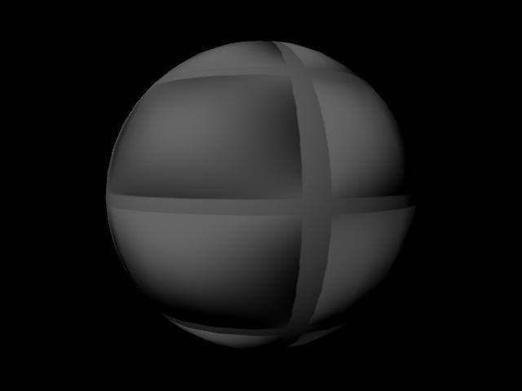
Bulge – This is one of the most basic and rough bump maps that Maya generates through default. Simply dividing the area into square tiles. This texture is not particularly useful in the creation of Fur.

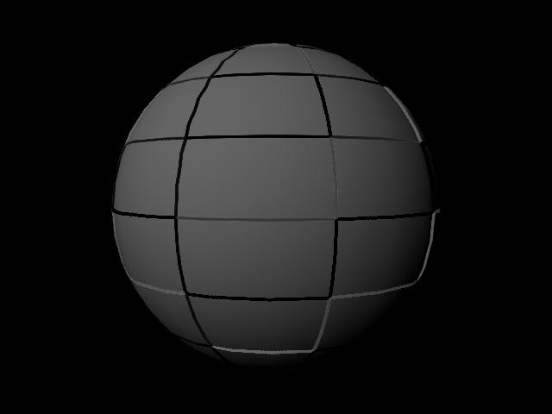
Checkers – Again this follow much the same theme as the first. So not what was being looked for in order to create the fur-like bump map. Far too rigid and uniform.

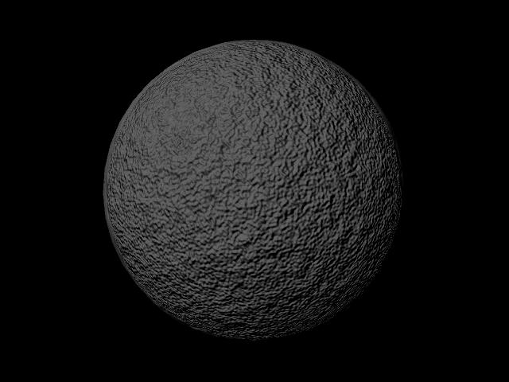

Brownian – The first of the ‘speckled’ textures. This shows at least how you can create a softer overall look to the material. The basis of what was needed to be created.

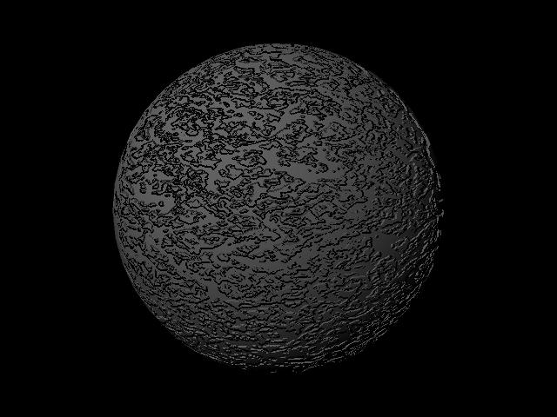

Mountain – Another example of this, although this one is less general and appears a lot harsher with clear chasms on the surface. This sort of thing must be avoided in the work to be able to suggest a thick covering of the hair. Unless baldness is needed of course.

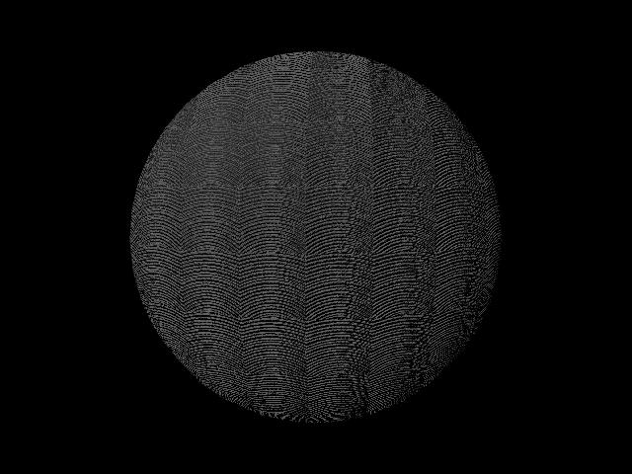
Wood – This texture was overly complex and fussy and left too uniform a feel to the image. This is one of the problems with a smaller bump map area as the pattern repeats itself over and over causing a very mechanical feel.

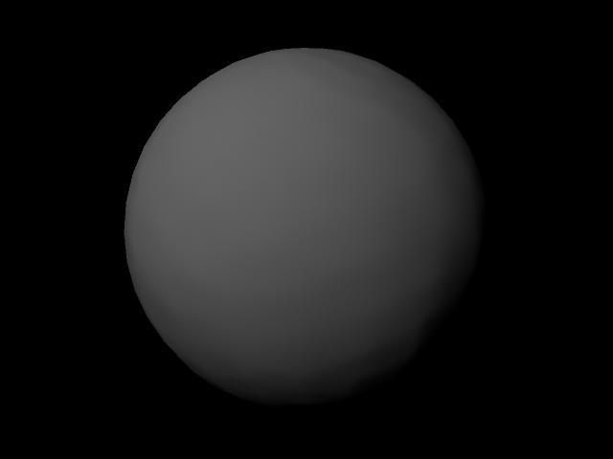

Ocean 2D – An extremely subtle texture that merely dampens the ‘edges’ and softens the whole look of the material. This could be a nice finish to a fur looking texture as it would help convince the viewer of the softness of the material.

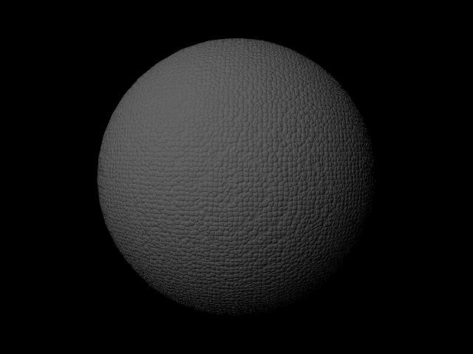

Leather – Again a very small and complex texture that creates a rather uniform look, again not what was desired.

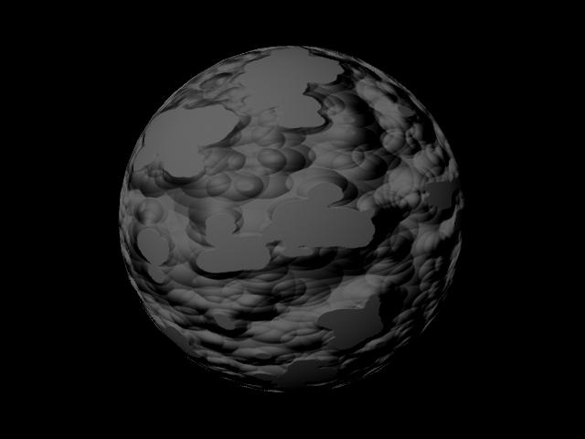

Noise – A rather different texture. This is almost ‘cartoon’ like in its appearance with the paint splatter look, which is very stylised. Interesting but it is not clear how relevant this would be.

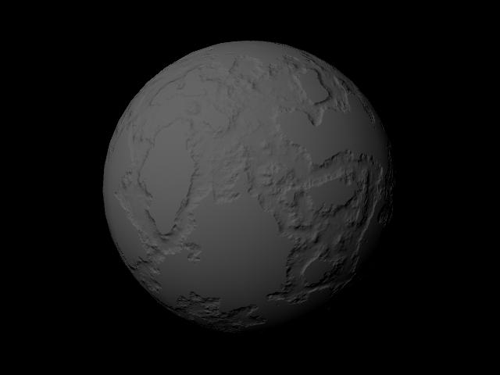

Stucco – This would be a texture more suited to creating the effect of raised land mass or uneven ground. This in itself means that it was not the sort of texture that is being looked for but may be good to use for rough skin or for decay.

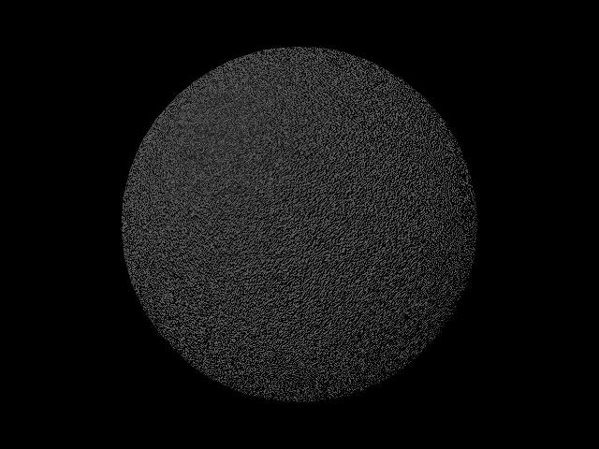

Rock – A very intrinsic fractal look, which may look far too fussy to be used unless looking to create a stubble like appearance. But by exploring the attributes maybe this has possibilities.

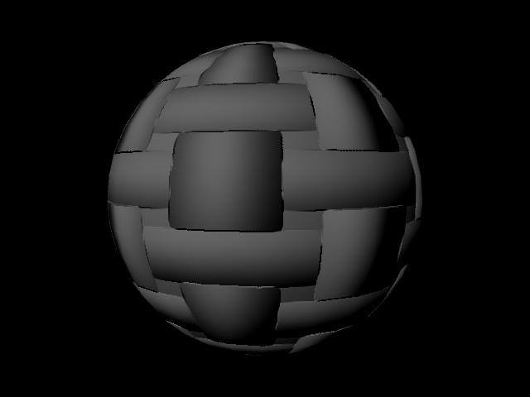

Cloth – Another of the simplest textures dividing the shape seemingly into faces. Mechanical and again no hint of an organic feel.

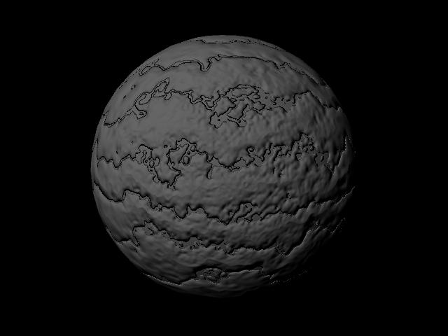

Marble – As it describes a marble line pattern running through the material. This again would be better suited to flesh or worn or harsh material.

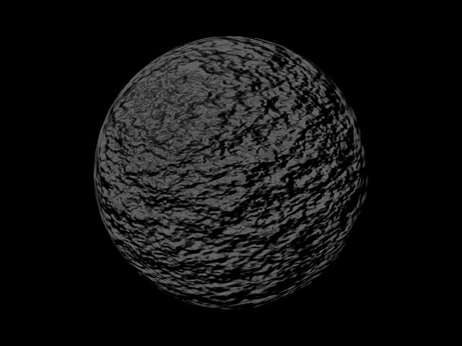

Fractal – This texture is far too rough for the purpose being worked towards. But a variation of this could be useful as a fractal effect. May be useful for ‘breaking up’ a surface.

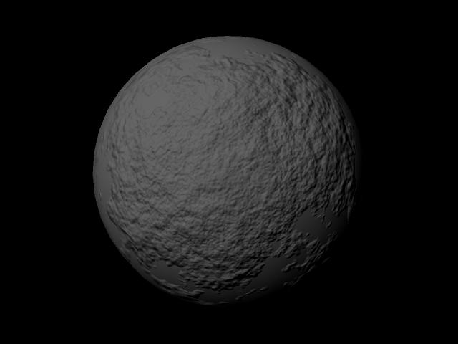

Cloud –This produces a soft texture and creates an uneven surface and a potentially decent base for the fur pattern, with alterations.

APPENDIX II

The results of testing images of real fur samples in the form of file textures to be used as bump maps on the surface:
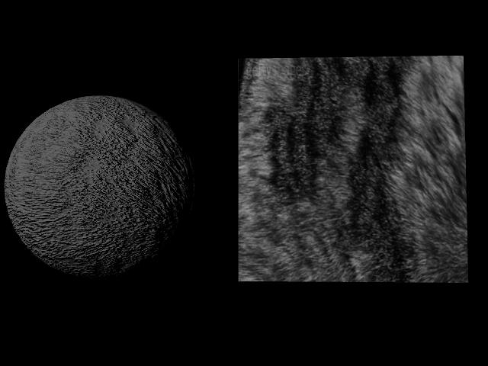
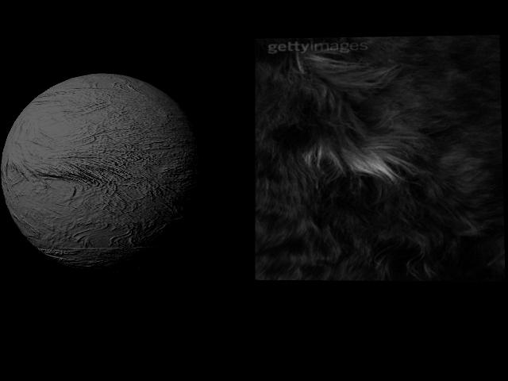

These seemed to create softer, more natural effects as bump maps with some working a great deal better than others:
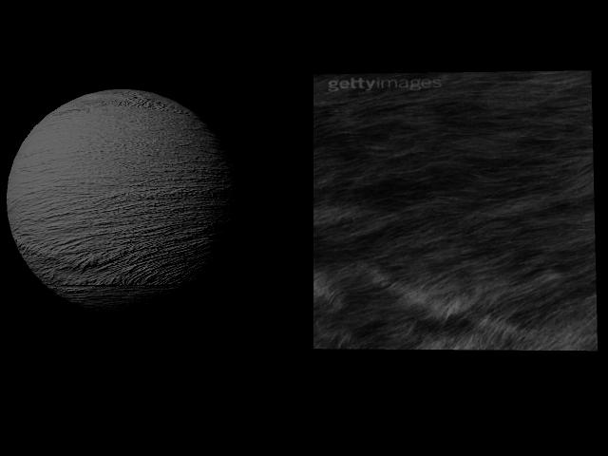
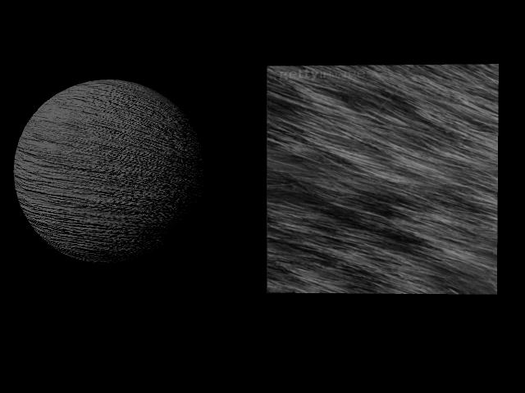

The furs above seemed to have the most potential for creating a useable Fur texture. Unfortunately when placed upon the model, the bump map was rather harsh and this meant that the looks were not smooth enough to create a soft and realistic Fur effect. This then led to the problem of deciding if they were worth further work and adaptation.

These were interesting experiments into just how the bump maps were working and what needed to be created in order to get a soft and natural texture. One option at this point was to pick one and edit it with filters and different techniques in Photoshop in order to get closer to a workable textured bump map. This however was deemed to not be the best course of action due to the light dependence of a bump map and the lengths to be taken in order to achieve one effect, let alone a generic effect so needed for the final product.
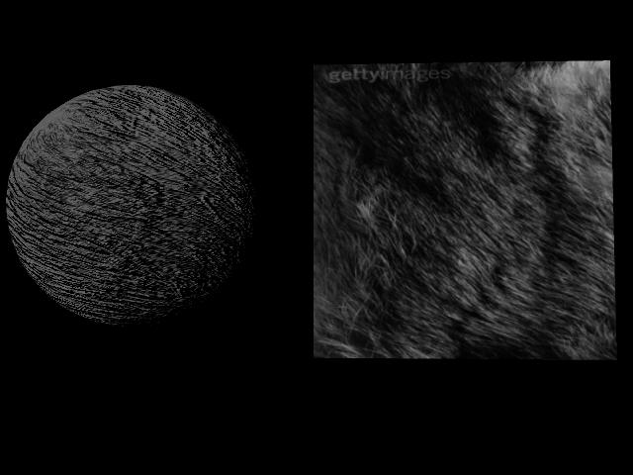
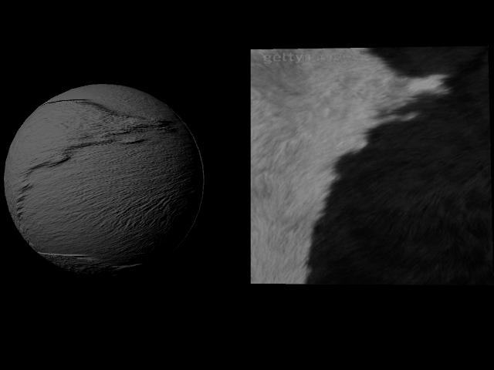

APPENDIX III

An example of the language and technical information given in the Maya Help Pages:

Surface Luminance is a utility node that tells you the luminance (brightness) of a point on a surface as it is being rendered. This luminance takes into account all the light sources shining on the object, and the angle at which they shine on the object. It does not take into account the specular properties of the object itself, such as 'hotspots'.
You can use this node to make interesting shaders that change based on the light in the environment.
Example: Say you are modelling a windscreen of a car, made of a special glass that becomes darker (more opaque) in bright light. To do this, create a Surface Luminance node, and connect its output to all three input channels of a Reverse node. Then connect the output of the Reverse node to the Transparency attribute of a shader.
In the table below, important attributes have their names listed in bold in the description column.
This node is MP safe
Node name | Parents | Classification | MFn type | Compatible function sets
surfaceLuminance | dependNode | utility/color | kSurfaceLuminance | kBase  kNamedObject  kDependencyNode  kSurfaceLuminance

Related nodes
blendColors, clamp, lightInfo, gammaCorrect, contrast, luminance, rgbToHsv, hsvToRgb, samplerInfo, setRange, resolution, renderQuality, renderGlobals, renderGlobalsList, baseShadingSwitch, singleShadingSwitch, doubleShadingSwitch, tripleShadingSwitch

Attributes (20)
lightAmbient, lightBlindData, lightDataArray, lightDiffuse, lightDirection, lightDirectionX, lightDirectionY, lightDirectionZ, lightIntensity, lightIntensityB, lightIntensityG, lightIntensityR, lightShadowFraction, lightSpecular, normalCamera, normalCameraX, normalCameraY, normalCameraZ, outValue, preShadowIntensity
Long name (short name) |  |  |  |  |  |  |  |  |  | Type |  |  |  |  | Default |  |  |  | Flags
normalCamera (n) |  |  |  |  |  |  |  |  |  | float3 |  |  |  |  | 0.0, 0.0, 1.0
 |  | The input normal
 |  |  |  | normalCameraX (nx) |  |  |  |  |  |  |  | float |  |  |  |  | 0.0
 |  |  |  |  |  | The X component of the input normal
 |  |  |  | normalCameraY (ny) |  |  |  |  |  |  |  | float |  |  |  |  | 0.0
 |  |  |  |  |  | The Y component of the input normal
 |  |  |  | normalCameraZ (nz) |  |  |  |  |  |  |  | float |  |  |  |  | 0.0
 |  |  |  |  |  | The Z component of the input normal
lightDataArray (ltd) |  |  |  |  |  |  |  |  |  | lightData |  |  |  |  | NULL
 |  | The lighting information this node computes.
 |  |  |  | lightDirection (ld) |  |  |  |  |  |  |  | float3
 |  |  |  |  |  | The light direction.
 |  |  |  |  |  |  | lightDirectionX (ldx) |  |  |  |  |  |  | float |  |  |  | 1.0
 |  |  |  |  |  |  |  |  | The x component of the direction.
 |  |  |  |  |  |  | lightDirectionY (ldy) |  |  |  |  |  |  | float |  |  |  | 1.0
 |  |  |  |  |  |  |  |  | The y component of the direction.
 |  |  |  |  |  |  | lightDirectionZ (ldz) |  |  |  |  |  |  | float |  |  |  | 1.0
 |  |  |  |  |  |  |  |  | The z component of the direction.
 |  |  |  | lightIntensity (li) |  |  |  |  |  |  |  | float3
 |  |  |  |  |  | The light intensity (its a colour).
 |  |  |  |  |  |  | lightIntensityR (lir) |  |  |  |  |  |  | float |  |  |  | 1.0
 |  |  |  |  |  |  |  |  | The red component of the intensity.
 |  |  |  |  |  |  | lightIntensityG (lig) |  |  |  |  |  |  | float |  |  |  | 1.0
 |  |  |  |  |  |  |  |  | The green component of the intensity.
 |  |  |  |  |  |  | lightIntensityB (lib) |  |  |  |  |  |  | float |  |  |  | 1.0
 |  |  |  |  |  |  |  |  | The blue component of the intensity.
 |  |  |  | lightAmbient (la) |  |  |  |  |  |  | bool |  |  |  |  | true
 |  |  |  |  |  | The boolean that indicates if the light has an ambient component.
 |  |  |  | lightDiffuse (ldf) |  |  |  |  |  |  | bool |  |  |  |  | true
 |  |  |  |  |  | The boolean that indicates if the light has a diffuse component.
 |  |  |  | lightSpecular (ls) |  |  |  |  |  |  |  | bool |  |  |  | false
 |  |  |  |  |  | The boolean that indicates if the light has a specular component.
 |  |  |  | lightShadowFraction (lsf) |  |  |  |  |  |  |  |  | float |  |  |  | 0.0
 |  |  |  |  |  | The visibility fraction to the light. value is in [0,1]
 |  |  |  | preShadowIntensity (psi) |  |  |  |  |  |  |  |  | float |  |  |  | 0.0
 |  |  |  |  |  | The light intensity without taking shadow into account.
 |  |  |  | lightBlindData (lbd) |  |  |  |  |  |  | Tint32 |  |  |  |  | 0
 |  |  |  |  |  | The light's blind data.
outValue (o) |  |  |  |  |  |  |  |  |  | float |  |  |  |  | 0.0
 |  |  | Out Value is the surface luminance of the surface being rendered.

  ¹ www.wired.com (http://www.wired.com/news/digiwood/0,1412,48052,00.html?tw=wn_story_related)
  ² Dan Lavender ,Maya Manual, p185 ³ www.benbathen.com (http://www.benbathen.com/Tutorial.html) ⁴ Alias Wavefront , Maya 3: Using Maya Fur, p12 ⁵ www.highend2D.com (http://www.highend2d.com/boards/showflat.php?Cat=&Board=MayaPaintFX&Number=157904&page=0&view=collapsed&sb=3&o=0&fpart=) ⁶ www.highend3D.com (http://www.highend3d.com/reviews/maya65render/)
  ⁷ www.alias.com (http://www.alias.com/eng/support/maya/faqs-tutorials/fur_faq.jhtml)
  ⁷ www.alias.com (http://www.alias.com/eng/support/maya/faqs-tutorials/fur_faq.jhtml) ⁸ www.highend3D.com (http://www.highend3d.com/maya/tutorials/)
  9 (http://caad.arch.ethz.ch/info/maya/manual/MayaFur/UserGuide/2CreatingFur.fm.html#176880)
  ¹⁰ www.stanford.edu (http://www.stanford.edu/~turitzin/cs348b/results/) ¹¹ www.runevision.com (http://runevision.com/show.asp?id=215)
  ¹² Frank Falcone with Colin Withers, Fur 101 ¹ www.wired.com (http://www.wired.com/news/digiwood/0,1412,48052,00.html?tw=wn_story_related) ¹³ John Isidoro & Jason L. Mitchell , User Customizable Real-Time Fur, SIGGRAPH 2002
  ¹⁴ www.highend3D.com (http://www.highend3d.com/maya/plugins/?group=mayaplugins&section=rendering)
  15 www.cgtalk.com (http://www.cgtalk.com/archive/index.php/t-41932.html) 16 www.3Drender.com (http://www.3drender.com/jbirn/ea/Ant.html) 17 www.angelfire.com (http://www.angelfire.com/zine2/zin64/tutBumpDistance.html) 18 www.animgraph.com (http://www.animagraph.com.br/DeathBrain/Shaders/Maya_car_light.htm)

