Abstract

This report discusses the physical process of aging, including the structure of the skin and wrinkle formation. Research into different approaches using the aging process in computer graphics is documented. The report proposes a tool designed for Maya using MEL scripting that allows a user to apply wrinkles or other textures, as layered bump maps, to selected faces. Further applications and future ideas are also discussed.

Introduction

It is a laborious task to create accurate and realistic wrinkles in computer animation, but the appearance of wrinkles due to facial expressions and aging adds immense realism to a piece of animation.

An important part of rendering realistic objects in computer graphics is to get them to appear to have had a lifetime. Real-life surfaces are often dirty and weathered. The biggest mistake made is to create surfaces that are clean and appear new and shiny.

There is a need for new tools and innovative methods to implement the effect of aging on surfaces, especially skin. This report presents the different techniques and a personal approach to solving the problem.

Aims and Objectives

The aim of the project was to research the simulation of the aging process in computer animation, documenting the different approaches. Research into how human skin ages is used as a basis to transfer the physical process into 3D graphics.

After researching examples of the simulation of the aging process and the practices used to achieve this in computer animation, tests and trials needed to be carried out to try and implement some of these methods and other personal approaches.

As the project evolved, it focussed more on producing a program to create wrinkles. Investigation into MEL scripting (the programming language for Maya) and Maya tools was undertaken in order to create a tool, which would apply wrinkles to faces of an object procedurally.

The Skin and Aging

Skin is the largest organ in the body accounting for 16% of body weight and consisting of 3 layers, epidermis, dermis and hypodermis. The general appearance of the skin and wrinkle formation is determined by a combination of these 3 layers. The outer layer of skin, the epidermis, is only about 20 cells thick, which is roughly as thick as a piece of paper. This is why it can become thin and fragile as the body ages. The next layer, the dermis, which ranges in thickness from one to four millimetres, contains blood and nymph vessels, which increase in number deeper in to the skin. The hypodermis mainly contains fat cells. (Nidus, 2001).

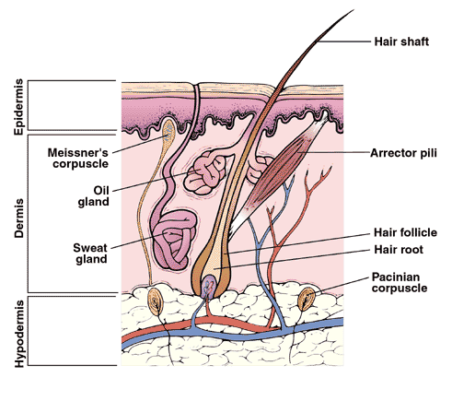
Figure 1: Shows the cross section of human skin. (McKesson, 2002)

The skin consists of four elements, ridges, furrows, hair follicle openings and sweat gland openings. Furrows and ridges are the dominant geometric features that establish the look of the skin. Skin furrows cross the skin, creating a net like pattern and ridges lie within the areas produced by the furrows (Parke & Waters, 1996).

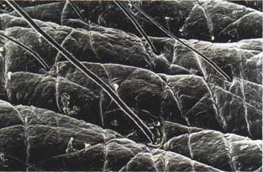

Figure 2: Shows a microscopic view showing the microstructure of human skin.

Beginning in our 20’s, the signs of aging start to become noticeable. The first signs appear in the delicate tissue around the eye. At the corners of the eyes the skin develops wrinkles and the supportive underlying tissue becomes weak, swells and sags resulting in bags under the eyes. Excess upper eyelid skin develops and fine lines increase (Meyer, 2004).

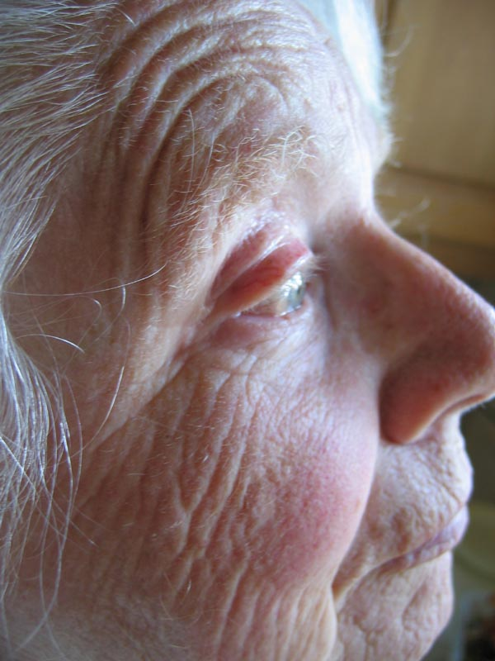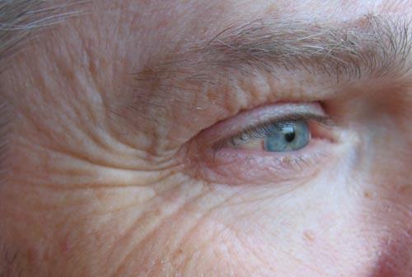

Figure 3: Shows examples of aging skin, a woman aged 78 and a man aged 53.

As the skin ages, it becomes thinner and dryer, contributing to the formation of wrinkles. It becomes yellowed, unevenly pigmented, develops dilated blood vessels and blemishes. The skin becomes more fragile, so any injuries to the skin take longer to heal. With age, the skull diminishes, allowing overlying tissue to move downward, causing sagging. Facial skin becomes gradually lax as it looses it’s elasticity. This can be noticeable around the jaw line and the eyelids. Deepening lines in the forehead and wrinkles around the mouth also develop, as well as elongation of the ear tips.
There are several factors that accelerate the formation of wrinkles, the most predominant being sun exposure. A lifetime of sun exposure will accelerate the aging process significantly. The sun damages collagen fibres and when the skin rebuilds it self the collagen fibres get disorganised, resulting in an uneven formation, creating wrinkles.

Other factors that add to the rate and extent of wrinkling are smoking, air pollution, rapid weight loss, poor diet and nutrition. Skin types are hereditary and can also play a role in the aging process.

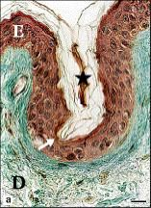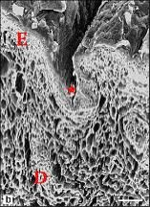

Figure 4: Shows microscopic views of a wrinkle. The image on the right shows a wrinkle forming in real human skin. The top layer of skin, the epidermis thins at the bottom of a wrinkle (Contet-Audonneau, et. Al., 2001).
D = Dermis E = Epidermis

There are two types of wrinkles, expressive wrinkles, which are temporary and appear at all ages, but can become permanent over time depending on how expressive a persons face is. Marionette lines around the mouth can often be referred to as ‘laughter lines’. Characteristic lines can be formed by habitual facial expressions.

Crow’s feet are the lines that radiate from the corners of the eyes. Frown lines develop on the forehead and between the eyebrows, because of permanent small muscle contractions. Lip lines are the vertical lines that surround the mouth, which are more prominent in females and smokers due to pursing of the lips.

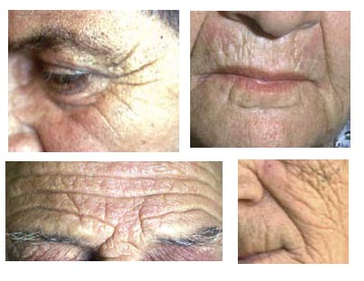
Figure 5: Shows some examples of different types of wrinkles, from left to right, crow’s feet, lip lines, frown lines and marionette lines.

The aging of skin produces a similar effect to dried out land, due to the loss of moisture. Essentially, the skin is ‘cracking’. The process of aging can be applied to other situations, for example, land and other weathered objects.

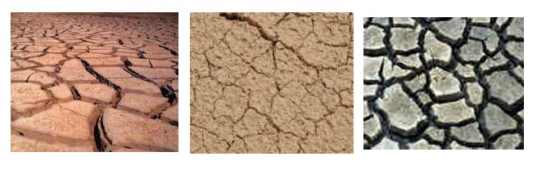
Figure 6: Shows a few examples of cracking, dry land due to drought.

Applications of the Aging Process in Computer Graphics

Police/forensics

Police and Forensic scientists rely heavily on the ability to digitally age a photo or digital image of missing or wanted people. This is mainly done by a specially trained artist who generates an impression of what a person might look like aged, using photographs of family members (if available) as reference.

Plastic Surgery and Cosmetics

The plastic surgery and cosmetic industry try to the reverse the signs of aging. A simulation of what a person might look like after the plastic surgery process may be produced digitally. Advertising anti-wrinkle products mainly use 2D graphics to simulate the reduction of aging.

Films and Entertainment

The main application of the aging process in computer graphics is the entertainment industry.
Advances in technology have enabled more powerful processing of 3D computer graphics and therefore has increased the level of detail, at which computer generated characters can be rendered.

Research

Computer Graphics Techniques

A museum exhibition called ‘The Secrets of Aging’, hosted at various institutions over the USA, boasts a computer program that procedurally generates an aged picture of a child. The program was developed by Ontario Science Centre and Core Digital Pictures, with assistance from the National Research Council of Canada.

The face-aging program invokes two steps: face recognition and then face aging. Firstly, it needs to recognise eighteen important points on the face and based on anthropometric data (human body measurements) determines how the face changes with age. Relative distances of aging features are computed e.g. how much the distance between the tip of the nose and chin changes.
The data was collated from measurements of over 700 people, and they consulted with cranial and forensic reconstructive surgeons to compile a database of these measurements. Since the software uses statistical averages to work out how to age the face, it does not take in to account a persons life style, and is therefore not completely accurate.
Although this system does not use 3D computer graphics, the concept of specifying landmarks on face is a viable method that can be considered (Core, 2004).

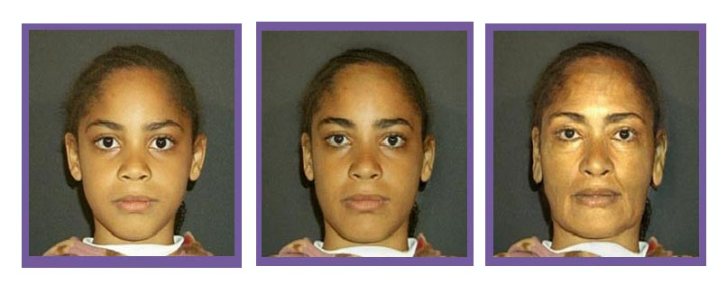 Age 12 Age 32 Age 62
Figure 7: Shows the digital aging of a photograph of a girl aged 12, a system in the Secrets of Aging Exhibition (Core, 2004).

MIRALab discuss two methods they have used to implement wrinkles. Below is a summary of their research and findings.
The first method uses image processing or warping, changing the luminance and colour to give the impression of wrinkles and other aging attributes. The image is then texture mapped on to a 3D model.
(Boissieux, 1997) states that:

“The gender determines wrinkles specific to a particular gender, for example, females have vertical wrinkles above the mouth region. The shape of the face also plays a role for wrinkle features: for a round, the wrinkles are deeper, shorter and less in number compared to a long face.”

Thus, they have created 8 generic masks as templates, which characterise wrinkles. These masks are based on the maximum age (80 years), from photos of people without any anti-age cosmetics.

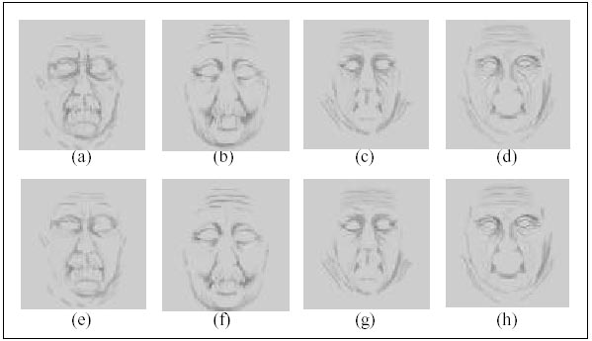
Figure 8: Shows the 8 generic masks produced from anthropometric data by MIRALab.

From collected data a linear relationship for depth of wrinkles and age was derived:
Wrinkle Depth = 2.74 *Age

MIRALab have developed their own method of ‘ virtual cloning’ people to produce a model, with the use of two orthographic view photographs (side and front). The most appropriate wrinkle mask can then be mapped on to the model. The cloned model has the same topology as the base model and therefore the mapping is straightforward.

However, the visible geometrical changes due to age cannot be modelled using this technique and this method does not take the extension of temporary wrinkles into consideration.

For the process of a muscle contraction, for every predefined wrinkle, the system constantly measures the shrinking of the skin surface. The rendering is done with bump maps or displacement maps, which changes the amplitude of the wrinkle. Further to this, a technique was created so that the wrinkle does not need to be predefined. The skin is considered as a volumetric substance, with different layers. When a muscle contracts, i.e. stretches in one direction, the skin either bulges or dips accordingly, mimicking human skin wrinkles. (Boissieux, 1997) states that:

“The position of the wrinkle is vertical to the muscle movement direction, and the height of it’s bulge depends on the amplitude of the muscle contraction.”

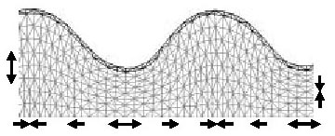
Figure 9: Showing the direction of the muscle controlling the height of the bulge. (Boissieux, 1997)

Kono, H. and Genda, E. propose a similar method. They have created a model with three layers, skeleton, skin and virtual muscle. The technique assumes that when the virtual muscle contracts or expands, the skeleton remains the same, while the skin deforms, creating wrinkles. When the virtual muscle contracts, the middle point between the two wrinkle points, the bulge point, moves in the direction normal to the curve of the muscle, making the skin surface protrude.

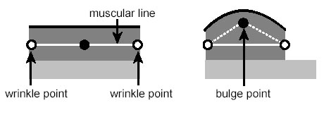
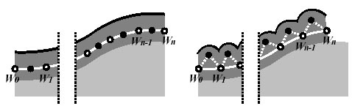
Figure 10: Showing bulge points protruding as a virtual muscle contracts. (Kono and Genda, 1996).

These two methods of using a virtual muscle provide a good way of creating wrinkles generated from expressions, i.e. temporary wrinkles, but not a good method of mimicking wrinkles due to aging.

There have been many attempts at creating realistic skin, by trying to reproduce the natural geometrical form of the microstructure of the skin. The macrostructure of the skin (wrinkles, folds, creases) can then be extracted from the furrows.

The Delaunay triangulation method and the Voronoi basis are functions that have been used to try and create this effect. Given a set of points, the Delaunay triangulation produces a set of lines joining each point to it’s nearest neighbours. This subdivides an area into triangles. One of its properties is that the out circle of every triangle does not contain any points of the triangulation. (Chew, 1997)

The Voronoi basis subdivides a space by dividing along a line equidistant from two neighbouring points. The intersection of these lines lies at the centre of a circle formed by the points.

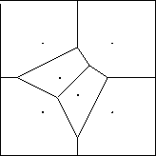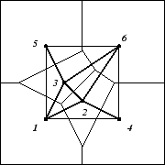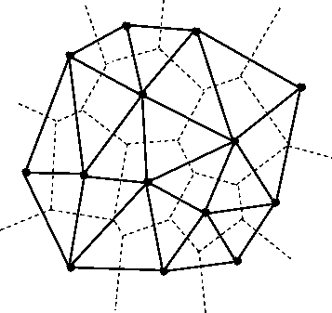
Voronoi Delaunay Delaunay on Vironoi
Figure 11: Shows the Voronoi basis, the Delaunay triangulation and the Delaunay triangulation on top of the Voroni (Chew 1997).

The microstructure of the skin presents a hierarchical structure i.e. inside the small ridges are even smaller ridges. The Delaunay and the Voronoi basis can be used recursively to produce these results. Figure shows the Delaunay triangulation being used recursively to three levels of detail. This was produced by MIRALab.

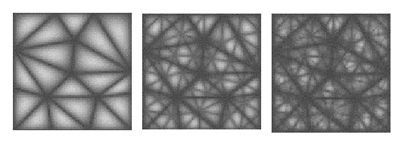
Level 1 Level 2 Level 3
Figure 12: Shows the Delaunay triangulation being used recursively to three levels of detail. This was produced by MIRALab (Wu, 1998).

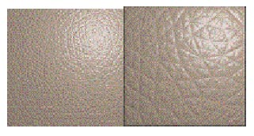
Figure 13: Renders produced by MIRALab using Delaunay triangulation.

The book ‘Computer Facial Animation’ (Parke and Waters, 1996) discusses this method of hierarchical structure of skin and shows how T. Ishii has produced renders of synthetic skin, which use recursion of the Voronoi basis.

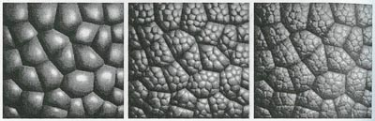
Level 1 Level 2 Level 3
Figure 14: Shows the Voronoi basis being used recursively to 3 levels. (Parke and Waters, 1996, p.172)

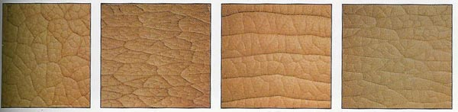
Courtesy T. Ishii
Figure 15: Shows renders of synthetic skin using Voronoi basis. (Parke and Waters, 1996, p.177)

Final Fantasy: The Spirits Within

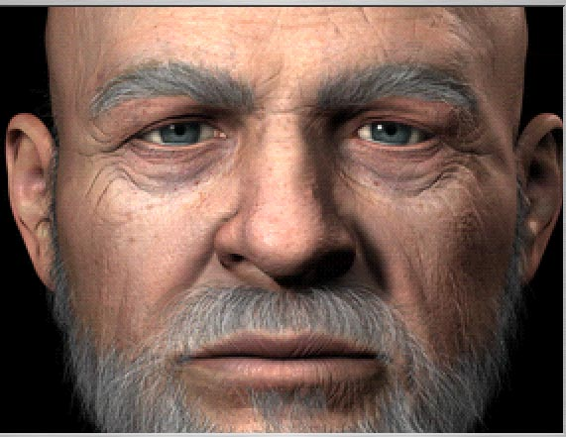

Figure 16: Dr Sid from ‘Final Fantasy: The Spirits Within’ (Final Fantasy DVD, 2001)

The artists working on ‘Final Fantasy: The Spirits Within’ overcame technical problems in the creation of the character Dr. Sid. The attention to detail exhibited on this digital actor represents the current level of realism that can be produced in computer graphics. This character contrasted greatly from the other cast members due to his age, which was accurately described through the implementation of wrinkles. The model and wrinkles were enhanced using a 3D paint program.

Gollum in Lord of the Rings
Gollum from the ‘Lord of the Rings’ trilogy is the best contemporary example of computer generated skin techniques. WETA Digital, the Visual Effects team working on ‘Lord of the Rings’ formed the look for Gollum by creating many clay models to get the right effect. Finally, the finalised model is digitally scanned. This clay model is produced to such a high standard, it contains fine detail, like wrinkles. Therefore, the digital model already has surface details sculpted, which would be a difficult task to replicate without the scanner.
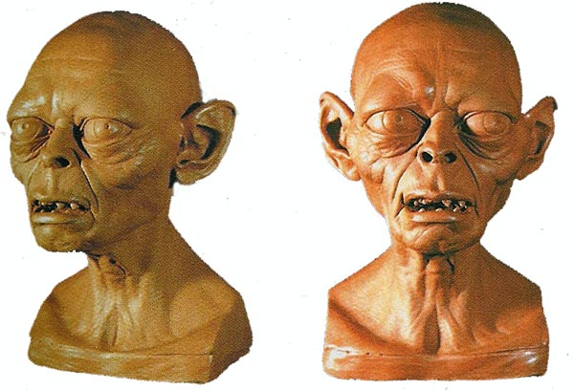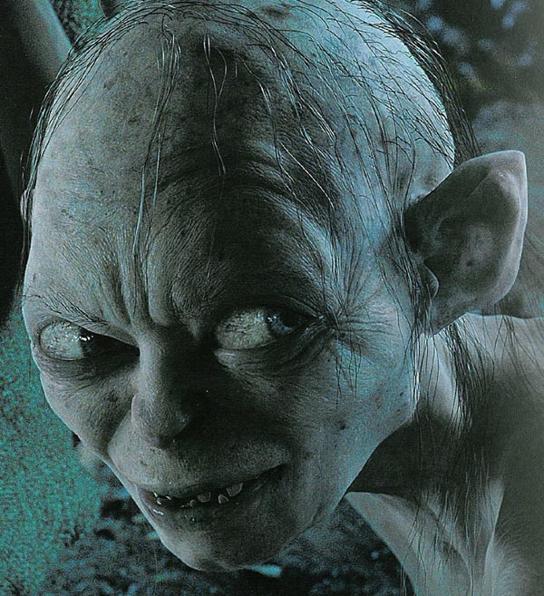
Figure 17: Models of Gollum from ‘Lord of the Rings’ and a rendered view from the film. (Serkis, 2003)

The digital texture painting for Gollum’s skin was actually created by an air brush artist, who had never used a computer before. The colour of the human skin is not generated from the top layer of skin, but from the blood vessels and fatty tissue underneath. Thus, many high resolution texture maps are created and layered together to create the realistic skin texture that Gollum possesses. It is built up in several layers to create the transparency factor that skin has. The technical director, Ken McGough created a subsurface scattering shader for Gollum’s skin. Subsurface scattering is the way light reflects of a semi translucent material.

Maya Tools and Methods
As seen from the research, there are a variety of methods used to produce wrinkles, the main difference being geometry based or faking it with texture mapping. There are many considerations, based on the individual specifications, but in general faking wrinkles seems a more cost effective method rather than altering geometry. For this project, it was decided that using bump or displacement maps was the best method, because modelling wrinkles, without the use of bump or displacement maps, would require an extremely highly dense mesh. This would be impractical to tweak modelling and to animate, creating a greater production and render time. A wrinkle modelled in a geometrical mesh can be replicated using a texture map with the alpha values connecting to a bump or displacement map producing a bumped surface.

Further research was carried out in order to solve the problem, to produce a personal and innovative way of generating wrinkles. The next step was to research into different tools available and implementation methods.

Bump and Displacement maps

Both bump and displacement maps utilise grayscale texture maps to raise and depress an otherwise flat NURBS or Polygon surface, by using the alpha values of the image. White on the image creates a raised surface, while black dips the surface.

Bump mapping simulates a rough or ‘bumpy’ surface, without actually displacing the geometry. By changing the positions of the surface normals, light is reflected from different directions off the surface, changing the texture appearance. Only the areas facing towards the camera appear bumpy, whilst the edges are still smooth as no displacement actually takes place. They create an illusion and therefore the relief does not cast any shadows. In general, bump maps are used for small reliefs and finer detail.

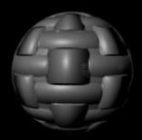
Figure 18: Bump map on a sphere

Displacement maps are similar to bump maps, in that the surface to which they are mapped is displaced along the normals, but they are applied to the geometry, not the shading. This means the geometry is actually displaced and appears bumpy from all views, thus the relief casts shadows. Displacement maps are mainly used for areas of large relief and greater bumps.

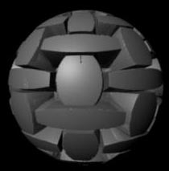
Figure 19: Displacement map on a sphere

Usually bump maps take less time to render than displacement maps and are more appropriate for finer detail, for example wrinkles. Therefore, due to this, bump mapping seems the most practical method for the purpose of this project.

Layering bump maps

Generally artists create a single bump map to produce the desired effect. The different types of bumps are usually layered in a 2D image processing package, like Photoshop, and then saved as a single texture. This requires tweaking each layer to achieve the desired effect, and resaving a single image, which can be a lengthy task. It seemed appropriate to look in to ways of layering bump maps, so that each layer can be tweaked in the 3D software as well as the 2D image processing software, giving the user more control and making the task easier.

The Maya Online Help, within the Maya application, shows how bump maps can be stacked on top of one another, by connecting the out normal of one to the normal camera attribute of another. This can be seen in the diagram below.

Checker Bump2d Cloth Bump2d Blinn
------- ------ ----- ------ -----
Out Alpha --> Bump Value Out Alpha --> Bump Value
Out Normal ---------------> Normal Camera
Out Normal ----->Normal Camera

Figure 20: A method of layering bump 2D nodes

Layering bump maps seemed to be a good method for layering wrinkled skin and also good for the transition of the aging process, with more wrinkles appearing.

Layered texture node

Another method for layering bump maps is using the layered texture node. Multiple textures can be connected to this node, which then layers them and produces a single result texture. The blend mode can be specified to control the way the textures combine together.

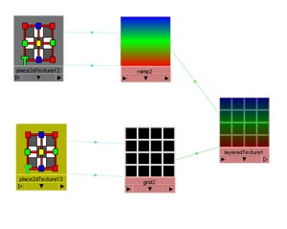

Figure 21: The layered texture node

Layering bump 2D nodes rather than using the layered texture node connecting to a bump node, seemed a more practical method. It was found that the layered texture method produced undesired blending. The method of layering the bump 2D nodes means that each bump depth can be independently controlled.

The wrinkle tool

It was later discovered that Maya has an inbuilt tool called ‘the wrinkle tool’, which did not turn out to be very useful. The tool creates wire deformers as NURBS (Non-Uniform Rational B-Spline) curves, which can be controlled using a cluster. The tool is not very user friendly as it was difficult to achieve the desired effect. It also produced a great number of wrinkle curves, which clutter the Outliner and are difficult to keep organised. The tool works for creating a large bumpy landscape, but not for fine wrinkles on skin.

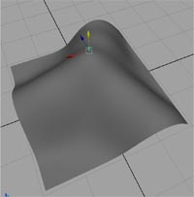

Figure 22: A sculpted NURBS surface produced with the inbuilt wrinkle tool in Maya

3D paint tool

The 3D paint tool, built into Maya, not only offers the ability to manipulate textures directly in the 3D view, but it can also be used interactively to modify other texture maps, including bump maps. The tool seems very practical as the user can see the bump map directly on the surface, when normally it is only seen when rendered, although the effect cannot be seen until render time.

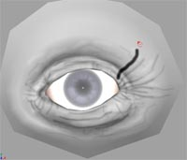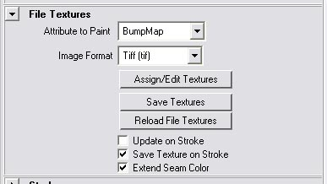

Figure 23: Example of using the 3D paint tool to alter the bump map

After researching the different possibilities for a personal and innovative approach, it was decided to aim to produce a tool, that implements wrinkles, using bump maps, which can be applied to selected areas of a mesh. The desired product would have a user interface and provide the user with a method of controlling the size and depth of the wrinkles. The tool would be specifically designed for use in Maya.

The Development of the Tool

It was earlier discovered that bump maps could be layered, but the initial problem encountered was finding out if it was at all possible for the bump maps just to affect certain areas and not the whole object. Linking UV sets was the answer. UVs are points that provide the information needed to apply textures to the surface. The UVs can be arranged so the texture looks correct when applied to a surface. These UVs can be grouped in a UV set and given a name, so that they can be linked to a texture using the relationship editor. The texture is then only mapped in that area.

The Hypershade is an area of Maya used for rendering purposes, it allows shading networks to be produced by creating and connecting rendering nodes, such as textures, materials and lights. The desired outcome of the tool could be produced manually by connecting nodes in the Hypershade. The purpose of the procedural tool was to replicate this shading network.

A simplified method of producing this is demonstrated in the following steps. This method is implemented in wrinkleFunction(). Please see Appendix 1 for details.

- Create a UV set for the selected faces and apply a texture projection.
- Normalise the UVs so that they fill the texture-mapped area.
- Create a texture node and assign the grayscale image texture (the chosen wrinkle).
- Create a place2d texture node and connect to the texture node with relevant connections.
- Create a bump2d node and connect the outAlpha of the texture to the outNormal of the bump2d node.
- Connect the current bump2d node to the previous one. (i.e. the last connected bump2d node to the material)
- Link the texture to the UV set using a UV chooser node.

The function produces the following outcome in the Hypershade, showing how all the nodes are attached together.

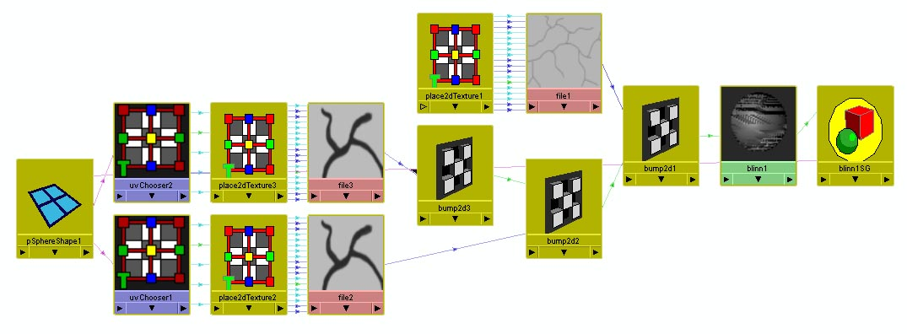

Figure 24: shows the how the nodes connect in the Hypershade after running the script.

The procedure can be applied to any object, with any name, as the current selected faces and object name are stored as variables in an array. To list all of the objects (in this case faces), the ls command and the –selected (-sl) flags are used.

//get selected faces names
string $selectedFaces[] = `ls –sl`;

//get shape name
string $shapeArray = `ls -o –sl;
string $shapeName = $shapeArray[0];

Each time a new node is created in the wrinkleFunction() (file node, place2D node, bump node, or UV chooser) it is automatically given a unique name, as it is not assigned a specific name in the code. For example, when a new file node is created, Maya automatically gives it a name like file 4 depending on how many are already in the scene. Each node is stored as a variable so it can be used later in the function.

It is necessary to use the tool multiple times, in order to add layers of wrinkles and effectively increase the age of the material, therefore the function requires the name of the last bump2D node connected. A new bump2D node can then be connected. The recursive function getLastBump(), reads in the material name as a parameter and returns the last bump2D node connected to the material passed in.
It does this using the listConnections command, which lists all the current connections to a node. The function is run recursively, as several bump2D nodes may be connected.

The wrinkle width slider effectively widens and thins the wrinkles by increasing and decreasing the edge span. This is done by connecting a colour remap node to the image texture. This produces a ramp texture, which the function then converts to a black and white image, which represents the wrinkle and background. The position of the ramp colours are scaled by the value of wrinkle width slider in the aging tool GUI (figure 25). It was necessary to limit the scaling of the colour position values to stop the texture edges from distorting, by creating minimum and maximum values of the colour positions for each texture.

The Graphical User Interface (GUI)

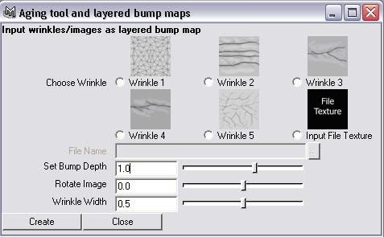

Figure 25: the aging tool GUI

The tool required an interactive user interface to allow the user to apply wrinkles to faces of an object, with the ability to control the width, style and depth of the wrinkle. The user can select from four different types of wrinkles, with the added option of inputting a file texture of their own design.

Radio Buttons

The circular radio buttons are used to select the required wrinkle type. The option to input a file texture can only be selected when that radio button is pressed. This enables the textFieldGrp below. The button on the right can then be pressed to navigate through a file browser.

Selecting a radio button, calls the function getWrinkleState(int $wrinkleState) passing in the selected radio button as an integer, which then uses a switch statement to assign the specified texture to the variable $file.

Sliders

The user can specify the value of the Bump Depth, the rotation and the wrinkle width before the wrinkle is created. It can then also be finely tuned in the Attribute Editor to achieve the desired effect. Whenever a slider is dragged and dropped, it calls a function called change Value( int $number, int $string) , which updates the value of the variable storing the number.

The Images

The default file textures, which are supplied in the tool represent the main types of wrinkles found on human skin. The first is a microscopic skin texture, created using Delaunay triangulation. The second is four parallel wrinkles, which can be tiled and scaled so that just 1 is produced. The third is a branching wrinkle commonly found in the palm and the around the eyes. The fourth is a straight wrinkle with a few branches for variation. The fifth is a fine pattern of overlapping wrinkles and the sixth allows the user to input a file texture.

Implementation of the tool

The tool was tested several times using a simple polygonal sphere.

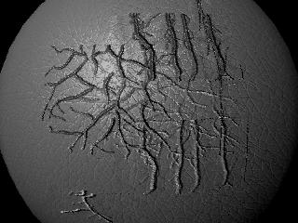
Figure 26: layered bump maps on a sphere produced using tool

A simple model of an eye was animated over time, with a blend shape controlling the shape of the eye. Wrinkles were then applied, increasing in number and depth over time with two different methods. One was non-procedural and the other using the developed tool, and the results were compared.

Without any previous research taken in to consideration, the first method was implemented by blending between 3 bump maps painted in Photoshop. This required laying out the UVs for all the faces of the model and taking this map into image processing software to paint the bump maps. Each bump map had progressively more wrinkles, with contrasting and darker shades of gray.

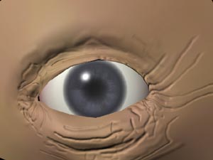

Figure 27: Eye aged non-procedurally

The second method was implemented using the procedural tool. Several layers of bump2D nodes are applied with the tool, keying the bump depth to animate wrinkles appearing over time. Since different bump maps are incorporated, the eye could be aged purely in the 3D software.
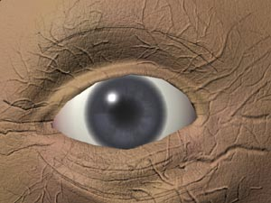

Figure 28: Eye aged using procedural tool

The two methods employed produce effective results and both have disadvantages and advantages.

The first method, without using the tool, incurred one main problem. The whole process was not very achievable. The layered texture node was used to blend between the bump maps but the transitions were not very smooth. Also, if a wrinkle was in the wrong place, the bump maps had to then be tweaked in separate software (2D image processing like Photoshop) and then reapplied. Removing wrinkles would be a difficult task.

Since the 3 painted bump maps were layered using their colour values rather than layering them as bump nodes, as the tool does, only one bump map is applied to the object. This means there is not much control over wrinkles appearing at different times.

The tool is good as it employs a microscopic skin texture, which can be tiled and applied over the whole object. The same effect without using the tool would require a lot of time preparing the skin texture.

Overall, both methods required about the same amount of time to produce these results. However the procedural method required more time to render. The results using the tool produced a subtler and more realistic effect. This is mainly due to fine wrinkles and underlying microscopic skin textures. An optimum result would be to have a base texture like one of the bump maps produced for the non-procedural method and then apply more wrinkles using the tool.

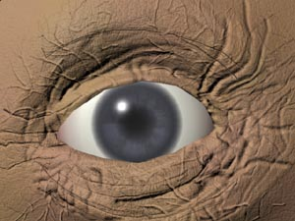

Figure 29: Eye aged using a combination of the non-procedural method and with the tool

Evaluation of the Tool and Production

The tool satisfies the requirements as it provides the facility to layer several bump maps without the need to create numerous materials. This makes it easier to organise, as all bump2D nodes associated with the object are connected to one material. This means that the depth of each bump node can be keyed.

If the application is being applied to a large area, it will have to be run multiple times, for example to create lots of fine wrinkles. This will make it difficult to determine which bump2D node affects which wrinkle on the surface. If a value needed to be tweaked, the user would need to open the Hypershade, show all the connections to the material and find the specific node to control values. One significant improvement that could be made is to have another window open once the wrinkle has been created. This will hold all the useful attributes to control the wrinkle, for example, bump depth, wrinkle width and rotation. It could even be extended so that the user could input a name for the wrinkle each time the tool is run and the second window would show all this information.

A disadvantage of working with bump maps is that the effect is not instantaneous, as it must be rendered to compute the bump mapping. It would be useful to see the bump map on the object as a colour map in the 3D view, so the user can see it updating. This is possible with the 3D paint tool in Maya, so it could be incorporated into the design. This could be extended so that if a wrinkle were selected, the specified wrinkle would be highlighted on the surface.

The Images in the GUI represent the wrinkles that can be selected. These are simply smaller versions. When an attribute is changed, for example, the rotation or the wrinkle width, the results are not previewed in the GUI. If the project was repeated, this would be a big consideration. The desired result would show the image updating in the GUI to make it more user friendly.

With the wrinkle textures already implemented in the tool, the user can choose from five different types to apply as a bump map, including a useful microscopic skin texture. The user has quite a lot of control as they can even input their own file texture. However, more trials and research is needed to find out if the user requires different styles of textures to the ones supplied.

The tool allows the bump map to affect certain faces and not the whole object. This is good because the UV sets created for applying the bump maps to selected areas do not affect the colour map. When the tool was used, however, sometimes the projection of the bump map on to the faces didn’t produce the desired effect. This means the user would need to arrange UVs in the UV texture editor, so the bump map fits the faces correctly. Usually only a few faces would be selected so this would not take much time. With more time, further research could have been done to produce an improved outcome.

If the project was undertaken again, or if there was more time, the 3D paint tool could be implemented to give the user more control. The aim of using the 3D paint tool would be to allow the user to interactively paint over the surface, and depending on the grayscale colour, would adjust the size or depth of the wrinkles in that area. This would allow greater variation.

The method of controlling the wrinkle width has its limitations. It can only adjust the original file images by a few pixels. Also, the wrinkle distorts sometimes and loses its definition. A procedural method of 2D texture generation should be implemented in Maya to allow more dynamic control over the wrinkle attributes.

Having a base bump map and then applying finer wrinkles and the microscopic skin texture afterwards utilises the tool to its optimum effect. This would also reduce render time, as the main bump map will be on one texture map, reducing the number of nodes in the Hypershade.

The tool is also good to animate expressive wrinkles. A similar method to the ones described earlier of having a virtual muscle drive the skin, can be set up. For example, if a blend shape was used to control the mouth smiling, it could create a marionette wrinkle. This can be set up with driven keys, the blend shape value would drive the bump depth or width of the wrinkle layered using the tool.

The tool is designed specifically for Maya and the outcome can be rendered with Maya software or using Mental Ray. If the project was done again, the feasibility of expanding this function to other applications could be investigated, for example using Pixar’s RenderMan.

As stated earlier, the biggest mistake made is often making objects appear new and shiny, when in reality most surfaces are weathered and aged. The developed tool is adaptable for other surfaces, not just skin. The user can input file textures that are more specific to the surface.

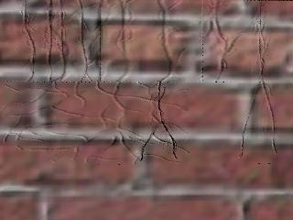

Figure 30: Cracks on a brick wall created using the tool

There are many ways that the application can be expanded. The tool could be designed to produce a more automatic way of producing wrinkles. For example, the user could specify how many wrinkles they want of each type to apply to an area of a surface. The tool could then distribute these in a random order and location. This will be time effective but the user would not have much control.

The application could be designed to produce automated wrinkles procedurally. This would be a difficult task to produce accurate wrinkles, but if achieved, it could have many advantages. The number of wrinkles could then be scaled up or down to produce one wrinkle or hundreds.

Another further application could be to choose regions of a face to age procedurally. The user could specify points on a face, for example the eye, to progressively age it. There could also be a method of inputting an age and the program would apply the necessary amount and depth of wrinkles according to statistical averages.

Conclusion

This project has highlighted many different methods of generating wrinkles and aging surfaces. The tool outlined is successful as it shortens the process of wrinkle implementation on polygonal surfaces in Maya. This tool also allows individual wrinkles to be animated over time, by keying the individual bump node attributes. This creates a viable method for expressive wrinkles.

There are, as always, further implementations of this tool other than those tested in this report. If the project was undertaken again or extended, further research could be done to improve the tool and implement some of the features as discussed in the evaluation.

The tool doesn’t have to be exclusively used for creating an aging process. It can also be utilised to layer any bump maps. This function of layering bump maps over different areas is innovative and a useful tool that Maya could benefit from.

Bibliography

NIDUS INFORMATION SERVICES, INC. 2001. WHAT CAUSES WRINKLES?
Aging Process and Wrinkles. Available at: http://www.ucdmc.ucdavis.edu/ucdhs/health/a-z/21SkinWrinkles/doc21.html

MEYER, DR. MED. MANUEL, ET. AL. 2004. The Swiss Working Group for the Treatment of Wrinkles. Available at: http://www.falte.ch/en/ageing_process.php

McKESSON HEALTH SOLUTIONS, 2002. Skin: Cross Section. Image available at: http://www.med.umich.edu/1libr/aha/aha_skincros_art.htm

PARKE, F.I. & WATERS, K. 1996. Computer Facial Animation.
Wellesley: A.K. Peters Ltd.

CONTET-AUDONNEAU, J.L. JEANMARIE, C. PAULY, G. March 2001. Skin Care Forum. Issue 24. Available at http://www.scfonline.com/english/24_e/24_e_pr/wrinkles_24_pr_e.htm

CORE DIGITAL PICTURES & ONTARIO SCIENCE CENTRE, 2004. SECRETS OF AGING. Face Aging Shockwave Activity. Ontario Institute. Available at: http://www.secretsofaging.org
BOISSIEUX, LAURENCE, ET. AL.,1997. Simulation of Skin Aging and Wrinkles with Cosmetics
Insight. MIRALab, CUI, University of Geneva. Available at http://www.miralab.unige.ch/papers/97.pdf

Wu, Yin. et. Al. 1998. Simulation of Static and Dynamic Wrinkles of Skin, MIRALab, University of Geneva.

KONO, H. GENDA, E. 1996. Kyushu.Institute of Design. Wrinkle Generation Model for 3D Facial Expression.

WORLEY, S. Texturing and Modelling. A procedural approach.

WILKINS, M AND KAZMIER, C. 2003. MEL scripting for Maya Animators.
San Fransisco : Morgan Kaufmann Publishers

CHEW, P. 1997 The Voronoi Diagram and Delaunay Triangulation
Available at: http://www.cs.cornell.edu/Info/People/chew/Delaunay.html

Gould, D. 2003 Complete Maya Programming.
San Francisco: Morgan Kaufmann Publishers

Final Fantasy: The spirits within. 2001. Square Pictures. Columbia TriStar Home Entertainment.

SERKIS, A. 2003 Gollum, how we made movie magic. Collins

Alias Wavefront. 2004 Maya Online Help

Appendix 1

MEL Script for Aging Tool

