Innovations Project
Depth Perception Through Aerial Perspective
Nicholas Warren

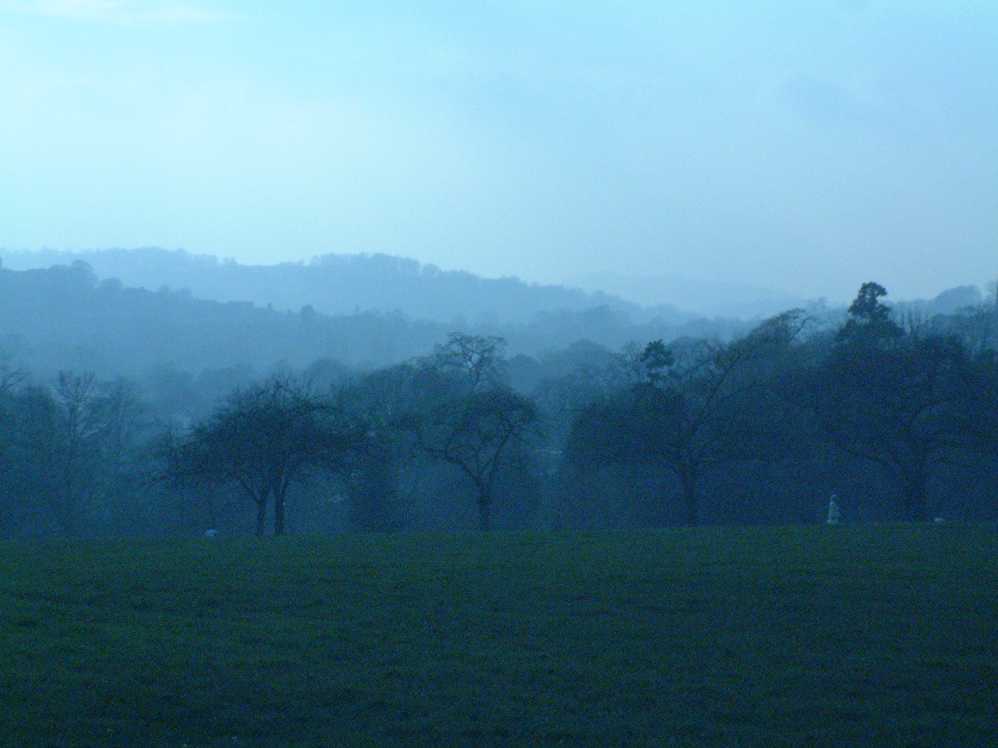
Contents
Abstract page 3
Introduction page 3
Primary Research – My Own Observations page 4
Climate Dependent page 4
Positioning of the Viewing Lens page 6
Scientific Research – What Is Actually Going On page 8
Aerial Perspective page 11
Aerial Perspective - Artists Interpretations page 13
Leonardo da Vinci (1452 – 1519) – The Author of Aerial Perspective
page 13
Joachim Patinir (1480 - 1524 ) - Pioneering Landscape Artist
page 16
Claude Lorrain (1600 – 1682) – Master of the Rendering of Light
page 18
Constructing a Plan for writing the Macro page 21
Macro Design page 21
Summary / Analysis page 23
Conlusion page 24
References page 25
Bibliography page 26
Appendices page 28
Appendix 1 – Macro Manual page 28
Appendix 2 – Macro Source Code page 34

Abstract
There exists a problem for compositors when the need arises to composite many layers together using aerial perspective. Management and consistency of these layers can be complex and hard to keep track off. This paper attempts to analyse the effect and to produce a solution to this problem.

Introduction
I aim to produce a project that investigates Aerial Perspective (the effect of objects getting bluer and less distinct over distance) and it’s role in depth perception when used in a compositing situation.
I propose to conduct my own primary research through observation. I will research the physical mechanics of the effect as well as looking at how artists have portrayed the effect in their work over time. I will then use this information to produce a macro for the shake compositing system that will allow the user to produce aerial perspective effects when combining several layers together in a composite.
Primary Research – My Own Observations

The effect of aerial perspective differs depending on the quality of light that reaches the human eye (or camera lens) over distance, thus various conditions will make the effect more, or less pronounced as well as altering the final colour that the distant objects are perceived to be.
From my observation I have determined that the factors that alter the quality of the light are many, and are as follows:
- Humidity
- Air temperature
- Amount of dust that is in the air
- Direction of viewing lens in relation to the main source of light (most often the sun)
- Elevation of the viewing lens
These can be sorted into two distinct groups, those where the effect is dependent upon the climate present in the area being viewed and the other positioning of the viewing lens.
I am going to look at each of these areas more closely, and note my observations about each of them.

Climate Dependent

Humidity:
The humidity of the air is how much moisture is in the air. From my experience the drier the air (less humidity) the more clear the day is, and thus one can see further into the distance then on a day where the humidity is higher. So the effect is much more subtle. This would make sense, as the more water droplets that are in the air the more the visible light will be refracted and therefore the more the light will be scattered, especially the blue part of the spectrum. If more of the blue light is being scattered then the objects most far away are going to be scattering the light so much that they appear to be the same colour as the sky at the horizon. The more the light is scattered due to the humidity the closer the most distant objects that can be seen will be.

Air Temperature:
The hotter the air the harder it is to see things in the distance, this sits hand in hand with the humidity. Hotter air makes the blue spectrum scatter more as the air particles themselves are more dense, due to the fact that more dust particles are being introduced into the atmosphere. In my observations I noted that the hotter the air was the harder it was to see distant objects and the more blue objects seemed to be.

Dust Ratio:
The amount of dust particles that are in the air is the main cause of the effect. Generally if the air is drier the more particles are in the air, when it is raining the particles are getting washed out of the air, and therefore some of the clearest conditions are after a rain storm. Obviously it is harder to see into the distance when it is actually raining because of so many water particles being in the air. The scattering of the blue spectrum is therefore more when there are more particles in the air.

An Image of aerial perspective with the progressive blueness. Picture taken by Nicholas Warren

Positioning of the Viewing Lens

Viewing Direction in Relation to the Sun
This was one of the most intriguing aspects of my own research through observation. It was almost stumbled upon by accident but yet is one of the more visually important aspect of the effect. I found that the viewing lens’ direction in relation to the main light source, which is usually the sun, dictated how pronounced the effect of aerial perspective was.
When the viewing lens was in direct opposition to the sun the effect was very subtle, the objects got bluer and bluer into the distance with very little difference between the layers, creating a sort of gradient effect. When the viewing lens is facing the sun the effect is very pronounced, the difference between layers is very stark, and very quickly the layers lost their blue colouration and in fact become more like shades of grey and almost even silhouette.
If you then imagined a circle being drawn around the horizon line between the two opposing viewing positions, the effect was blended between the two extremes.
This effect occurs, I believe, because the aperture of the lens (eye or camera) is made smaller so that a properly exposed picture can be taken of the scene. Thus less light information is getting in and as such it becomes more of a silhouette to the viewer.
Something else I noted was that when there was no visible light source (it was hidden behind dense cloud layers, and thus the light very diffuse) then the effect of relation to sun doesn’t appear instead the effect is fairly uniform around the horizon, but the light that is scattered is more grey, which I believe is because the blue light as well as the light from the remainder of the spectrum has already been scattered so much through the cloud layers

Elevation of the viewing lens:
The elevation is very much linked to the air temperature, the higher you go the colder the air becomes, and thus the higher you go the more clearly you are able to see because the air is less dense. Therefore you can see further the higher that you go.
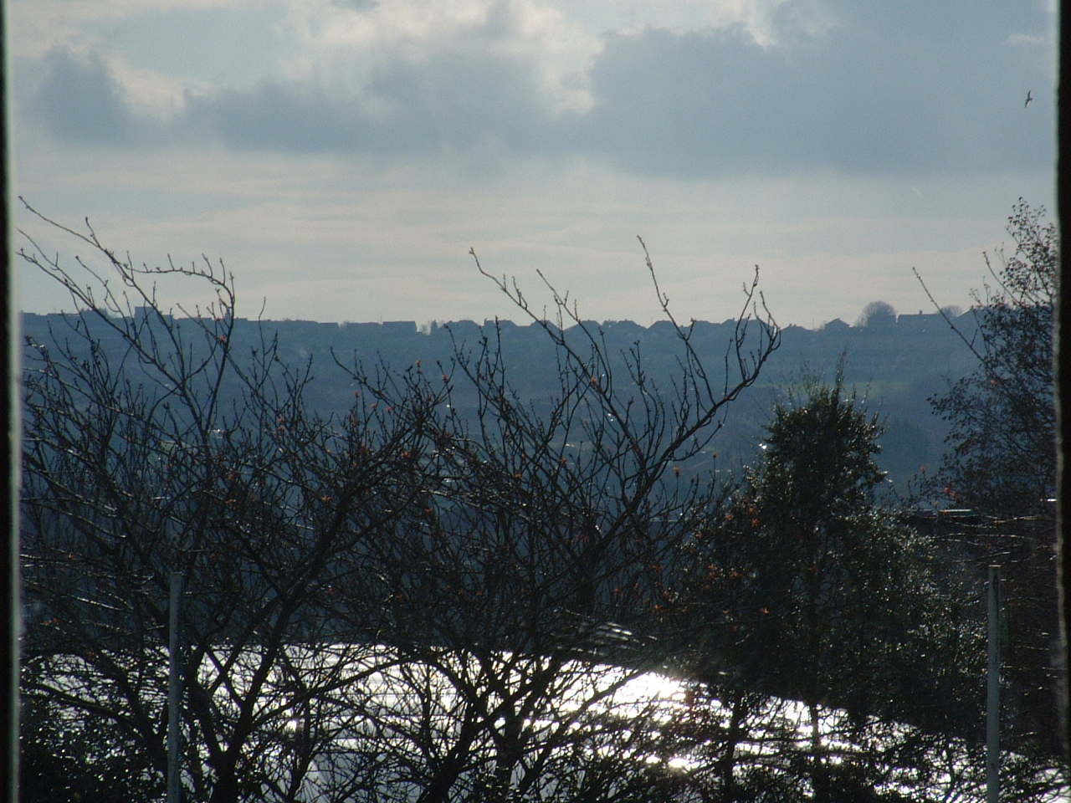
An image showing the way in which the layers become grey and silhouetted looking closer to the sun. Picture taken by Nicholas Warren.

We already know from the scientific study of this visual effect that objects appear more blue because of the scattering of that wavelength, in the visible spectrum, by the particles in the air, this is indeed borne out in my own observation. Objects receding into the distance do indeed become more blue, but I would suggest that when it comes to making my macro that the intended result would not be best achieved through adding more blue but rather removing more of the red and green components from the layer, thus we would be more closely modelling the real world effect whereby we aren’t seeing more blue light reflected from the object but in fact less of the red and green light being reflected. Obviously the blue level of each layer would also have to be changed so that it was more closely representing the change in the blue colour of the sky at the horizon.
Scientific Research – What Is Actually Going On

Aerial Perspective

Aerial Perspective is an optical effect caused by the bending of light in the atmosphere. To best understand how this effect is achieved it is prudent to look into the mechanics of light interacting with objects. There are four distinct ways in which light interacts with different media and these are detailed below before the explanation of what happens to the light in aerial perspective.

Reflection of light

Reflected light is a relatively simple concept to understand. Light is classed as reflected if the angle of the light when it initially strikes the surface is equal to the angle at which it bounces off of the same surface. Therefore in the example below the light is said to be reflected because the light strikes the surface at angle (a and leaves the same surface at angle (b, which is equal to angle (a.
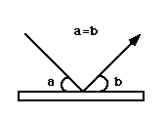Diagram showing reflection [01]

Scattering of Light

Scattering of light is different to reflection, where the light leaves the surface in only one direction. Scattering occurs as some particles in the atmosphere have the ability to scatter solar radiation in all directions. The particles that are responsible for this scattering of light are called scatterers and can include particulates produced by human industry.

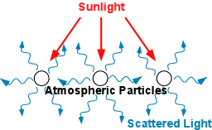
Diagram showing Scattered light [02]

Rayleigh Scattering
Rayleigh scattering or (selective scattering) occurs when some particles are more effective at scattering certain wavelengths, of the light, then others. Such an example of this is the blue of our sky on a clear sunny day. The particles which make up our atmosphere, oxygen and nitrogen, are relatively small in size and thus are only effective at scattering the shorter wavelengths of the light (blue and violet). This means that we perceive the sky as blue as our eyes pick up the scattered light.

Mie Scattering
There is another form of scattering that happens and is in fact responsible for the white appearance of the clouds. This scattering is called Mie scattering, and is where particles that are causing the scattering are large enough to more or less scatter all of the visible wavelengths of light. Thus the light reflected appears to be white. This happens in clouds as the ice particles are sufficiently large enough to scatter all of the wavelengths.

Refraction of Light

Refraction of light occurs when the light parses from a less dense medium to a more dense medium. When we say refracted it is easier to think of the light as getting bent, and it does this bending towards the normal of the surface between the two mediums. The normal is the line perpendicular to the surface boundary of the two mediums. The bending occurs because the light travels slower through the more dense medium then it does through the less dense medium. A good example of refraction is the passing of light from air into water. As the light passes through the air it is travelling faster then it does through the water, as water is more dense then air, when the light hits the water the light is refracted. This can easily be seen if a straight object, such as a pencil, is placed half in the water. The pencil will appear to bend, this is because the light is being refracted. Obviously if the light hits the surface boundary between the two mediums perpendicularly then no refraction will occur.

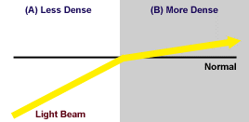
Diagram showing refraction [03]

Diffraction of Light

Diffraction of light is the name given to the process whereby light is slightly bent around the edges of an object. The amount of diffraction or bending is dependent upon the wavelength of the light and the size of the gap through which the light will pass. If the gap is large then the bending of the light will be barely noticeable as the wavelengths can easily fit through, but as the gap gets smaller then the larger wavelengths will get bent more and more, so much so that it is even possible to view with the naked eye.
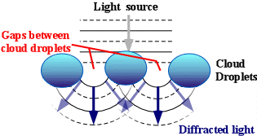
Diagram showing Diffraction [04]

The above diagram shows what happens to light in the atmosphere where it is most commonly diffracted, the clouds, it can be responsible for the silver lining on the clouds or the coronas found around the sun or the moon. The effects of diffracted light are light or dark or coloured fringes around objects. The optical effects produced by diffraction are the result of the interference of light waves, as such two waves of light that are diffracted by an object may produces three states. One, where the troughs and crests of the two waves combine, (constructive interference) and the light is amplified. Two, where the trough of one wave is the same as the crest of the other, (destructive interference) the result being that they cancel each other out. Three, where the two waves intersect each other somewhere between the two and a combination of the effects is achieved.

Aerial Perspective – The Processes Involved

From the above descriptions it is quite obvious to see that not all of the mechanics of light form part of the equation that is the effect called aerial perspective. The main component is that of scattering, as the main effect of that is the blue appearance due to the scattering of the shorter wavelengths of the visible spectrum by the gasses which compose our atmosphere. Thus as the light from more distant objects has to pass through more of the atmosphere to reach our eyes then more scattering will occur causing the objects to appear bluer and more blurred.
But one must also observe that changes to either the atmosphere or the light location will change the effect of the appearance of the objects, and thus may call some of the other mechanics of light in to play. One such example would be when it is raining. Obviously due to the amount of water that will be in the air refraction will come into play, and can cause more distant objects to be obscured and for the scattered light to combine back with the non scattered light in an interesting manor.
Thus when it comes to designing my macro I will have to take some of these factors into account. I have three possible paths to take, one where I take the purely scientific approach, and make it accurate, or make an artists tool whereby the visual effect is the only thing I am attempting to reproduce, or a blending of the two to create a tool that can be used to achieve a visual effect but that has some of the science, or principles of the science, built into the mechanics of the program. So in the next section I will be pursuing research into how artists have attempted to use aerial perspective to gain a better understanding of it’s context within art and therefore to better inform myself of how an artist would approach the challenge of painting with aerial perspective in mind.

Aerial Perspective - Artists Interpretations

In this section I will be looking at three artists which I believe have used aerial perspective to good effect in their work, or whom have suggested methodology for producing aerial perspective in paintings. For each I have included a brief history of their lives, to help put their work in context, and an analysis of their use of aerial perspective.

Leonardo da Vinci (1452 – 1519) – The Author of Aerial Perspective

Leonardo da Vinco was born in the small Italian town of Vinci, in 1452, to a noble man, Ser Piero, and a peasant girl, Caterina. Leonardo was an illegitimate son, and his father never married his mother. His father did go on to marry and Leonardo eventually ended up with 17 half brothers and sisters.
He wasn’t christened Leonardo, but Lionardo, in a chapel in his home town of Vinci. His father took custody of his son, and thus he had access to scholarly texts and was exposed to the art of the area, as Vinci had a strong tradition in painting. His father paid for the education of Leonardo, and at age 15 he was apprenticed to Andrea Del Verrochio, in Florence (close to Vinci).
It was whilst he was in his apprenticeship that he learnt the skills of painting and demonstrated an ability superior to that of his master. This evident in Verrochio’s ‘Baptism of Christ’, where Leonardo was permitted to paint one of the angels. Everyone noted that Leonardo’s work was so much better then his masters that Verrochio, allegedly, vowed never to paint again! Leonardo stayed at Verrochio’s workshop until 1477 when he left to set up shop himself. At this time he started to explore the way in which things work and their relation to his art, and thus the term aerial perspective was born from such experiments.
In 1482, after several commissions started but not finished, he entered the service of the Duke of Milan, with whom he stayed for 17 years. During this period he started to explore the areas of scientific study in which he was interested, and in fact he was employed as a designer of weapons of war, buildings and machinery. He left the employ of Duke Ludovico Sforza when he fell from power.
Over the next 16 years he travelled around Italy, working for many different employers. Including Cesare Borgia’s travelling army for whom he worked as a military engineer.
Leonardo’s father died in 1504 and due to his brothers and sisters, he was deprived of any inheritance, but had the use of his uncle’s land and money, which he managed to procure from his death shortly after. This was the year after that rumour says he started work on the Mona Lisa.
In 1513 he went to work for the Pope in the Vatican, Rome. During this time he continued his study of human anatomy and Physiology, but the Pope forbade him from dissecting cadavers. This severely hampered his progress in this area.
After the death of his Patron in 1516 he was offered employment by King Francis I, as premier painter, engineer and architect in France. He accepted and moved into the small castle Cloux, in Amboise.
He started to suffer from paralysis in his right hand, but he still managed to teach and draw until his death in 1519, aged 67. He was buried in the Chapel of St. Hubert in Amboise.
Leonardo was the first artist to coin the term ‘aerial perspective’. He studied the scientific principles involved with the effect, and although he didn’t get all of the details correct he formulated an effective method of it’s use in painting. He suggested that you should paint the fore most element it’s true colour and make the following layers progressively bluer.

Thus if one is to be five times as distant,
make it five times bluer’
~Leonardo [05]

Use of Aerial Perspective
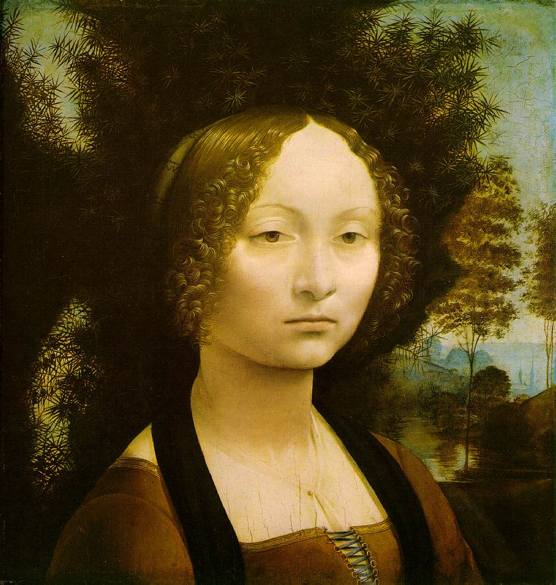
Ginevra de Benci : 1474 38.2x36.7cm; National Gallery of Art, Washington DC [06]
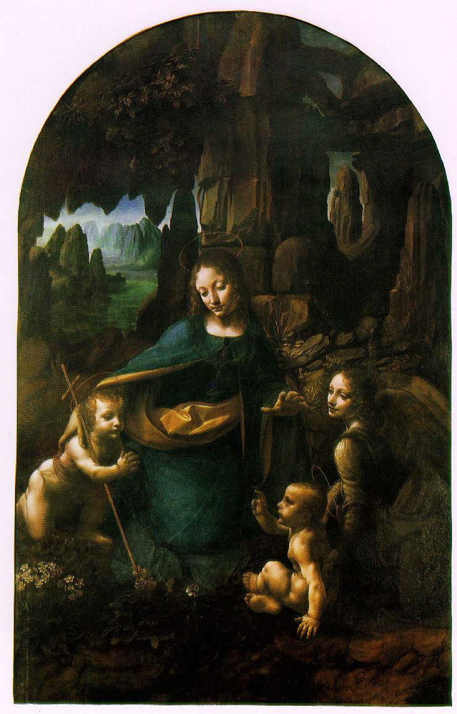
The Virgin at the Rocks : 1503 – 06 184.5x120cm; National Gallery, London [07}
From the two of Leonardo’s paintings that I have shown it is easy to see that he wanted to portray reality as much as possible in his paintings. Aerial Perspective is one of the techniques he uses to achieve this sense of reality. He renders the layers with very definite increases in blue and all though it does appear to aid in the perception of depth, in the scene it is almost too unrealistic to my eye. He obviously holds to his principle of painting the layers increasingly blue, but doesn’t allow for the fact that sometimes the shade of blue gradually increases into the distance. He built a stable ground work for other artists to build on.

Joachim Patinir (1480 – 1524 ) – Pioneering Landscape Artist

Joachim Patinir was born in 1480 in Dianant near Namur in the Netherlands. Not much is known about his early life, and so we don’t know anything about his training or his early work.
In 1515 he became a member of the Antwerp Guild and was elected to the status of master, a position he held for the remainder of his life.
He was noted for his pioneering work in making the Landscape the central focus of his paintings and as a genre in itself. In fact the term landscape wasn’t even in use at the time, and as far as we know it first appears in his friend, Dürer’s 1521 account of his journey to the Netherlands. He refers to Joachim as

‘. . . master Joachim, the good landscape painter ‘.

During his lifetime he managed to garner international acclaim for his work in the field and is noted as producing works of great contrasts in height, depth and object interrelationships. As such his work had lasting impact on not only his contemporaries but also the generations to come.

Use of Aerial Perspective
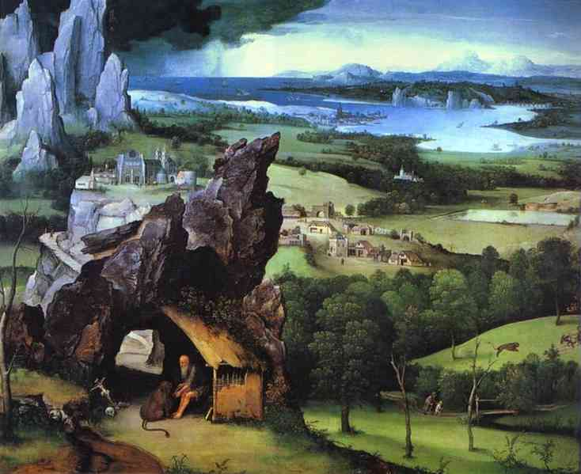
Landscape with St.Jerome : 1515-24; Museo del Prado, Madrid [08]
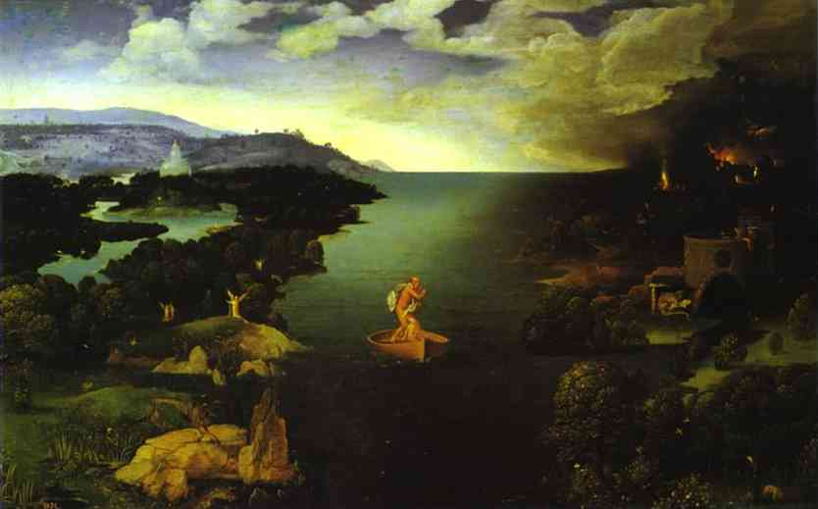
Crossing the Styx : Museo del Prado, Madrid [09]
Patinir’s use of Aerial Perspective is much more fluid then Leonardo’s. He seems to have a better grasp of the distance between layers and utilising how blue to make them. In landscape with St.Jerome we are able to see into the far distance and the scene gets progressively bluer towards the horizon. The layers also get less distinct as the layers recede, and this shows that the artists of the time were starting to include the fact that the light would be getting scattered a lot and therefore a clear edge wouldn’t be seen. In Crossing the Styx, Patinir gives a more definite distinction to the layers, this shows an understanding of how the light changes when looking towards the sun.

Claude Lorrain (1600 – 1682) – Master of the Rendering of Light

Claude Lorrain was born in the duchy of Lorraine (from which his name is derived) in 1600. His earliest works noted from the 1620’s until his death on November 23rd in 1682. During his lifetime he witnessed almost all of the main changes of artistic style, mostly because of his long stay in Rome.
He left France for Rome in 1613, at the young age of 13 to study mainly under the Italian Artist Agostino Tassi. It was under Tassi’s instruction the he learnt the principles of landscape, seascape and perspective.
Claude’s work can be identified as having three specific phases. The first ranging from his earliest works until the early 1630’s which was noted as being largely experimental with the effects and portrayal of light.
The second starting in the 1640’s became more realistic in their description of how light bathes a scene. Causing a calm and tranquil sense to all his paintings in this period.
The third period which started in the 1660’s brought in the use of dynamic and dramatic lighting, as well as a more visionary and symbolic style.
In the early 1630’s forgeries of his work started appearing on the market, and to stop his work from being copied, he started to keep accurate records of his work in the form of the ‘Liber Veritatis’ (Book of truth’), which is know held in the British Musem London. In this book he would make detailed sketches of the composition of each piece and noted the buyer. This he maintained for almost fifty years and it contains a record of some two hundred paintings.

Use of Aerial Perspective
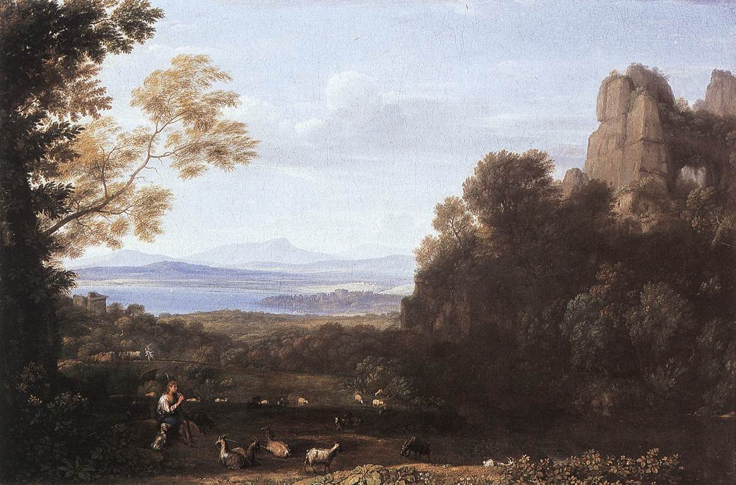
Landscape with Apollo and Mercury : 1660 745x1105cm; Wallace Collection London [10]
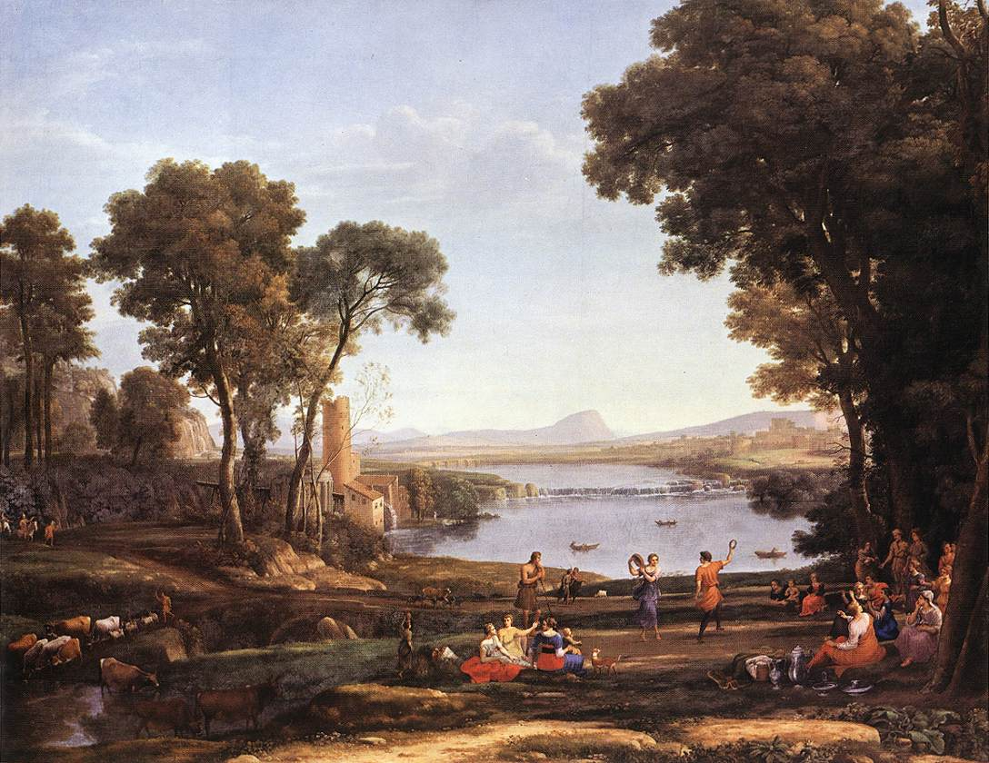
The Marriage of Isaac and Rebekah : 1648149x197cm; National Gallery London [11]
It’s easy to see from Claude’s paintings that he had fully mastered the techniques used to simulate Aerial Perspective. He uses natural colours which portray the way the light is being scattered over distance. His paintings portray a vast knowledge of how the way light interacts with his objects, and shows a large amount of study in this area. He uses every device that I have observed. In the landscape with Apollo and Mercury he even paints the distant mountains almost the exact same shade as his sky at the horizon, which actually happens due to the scattering of the light when an object is far enough away.
Out of the artists I have looked at he uses aerial perspective the best to achieve a sense of realism in his pictures, and shows the progression of the Artist to the point where they produce a painting that makes the viewer believe that is how the effect would look. This is the way in which I want to approach my macro. I want to produce a macro that will simulate the effect but that allows the user a lot of freedom to change the appearance so that the viewer believes that this is what it will actually look like.

Constructing a Plan for writing the Macro
From my research I concluded that the macro I wish to write is more of an artists tool then a realistic reconstruction of the scientific processes involved in aerial perspective. As such this will influence the design of my macro, but I also wanted to maintain some kind of level of control for the user, this isn’t to be a one hit wonder macro, the user needs to be able to influence the look of the effect, and so I have decided to include variables which the user can tweak to change the look of the result. These variables, though, had to make sense, they couldn’t be for example, make more or less blue. I therefore determined that these variables would describe functions of the actual process of aerial perspective.

Macro Design

I desire my macro to fit neatly amongst the standard nodes of shake, to be used when is needed. As ultimately it is just a sophisticated way of combining several layers together, I propose to include it in the layers tab.
Unless I can find a way of allowing the macro to continue to add more and more layers, it will be set to a static amount of layers. Thus each layers position in the knot of the node would indicate it’s overall position in relation to the others. I would intend to use standard shake procedure, having the most foreground element connected to the left most knot, and the background layer connected to the right most knot.
The position of each layer though would only determine loosely the depth of the layers in relation to one another, so each layer would include a parameter allowing the user to specify depth from the camera (0 closest to the lens). This value range could be in real world terms such as meters (say 1 to 2000 meters), but a much more practical use would be to have it in a range from zero to one, thus I can plug the depth value directly into the linear interpolation formula, using depth as the t value. It would obviously be interpolating between no effect at the camera lens to full effect (back most layer the same colour as the sky element).
To arrange for the smoother effect that is exhibited when looking away from the sun, another variable would be included to alter the percentage of the picked colour that is used in the interpolation, thus the difference between layers will be less and therefore smoother. Also this variable would alter the saturation value of the picked colour so that when looking towards the sun the layers have the colour values that are more uniform.
I would also have a variable that would help to influence the picked colour in terms of what kind of day it is – overcast or sunny, this would basically alter the colour to more of a grey blue when the day is overcast.
Another parameter that would be needed would be a way in which the user could specify if the layer that is being added is premultiplied or not so that the colour calculations would be done correctly.
The other thing to take into consideration will be the amount at which the layers will be blurred due to the scattering of the light. This would also be a linear interpolation function between no effect and full effect set by the user with a variable that would represent particles in the atmosphere, the denser the particulate the greater the effect of the blur.
I would propose to set out the user interface in such a way that it was familiar to those who already use shake. It would be neat and tidy and easy to read utilising branches to reveal more parameters when needed.
Summary / Analysis
Depth Perception through aerial perspective is an important aspect of creating a life like representation of scenes. When the artist does not render his work including this effect it looks utterly wrong, elements that are supposed to be occupying space in the distance take on the same properties as the elements foremost to the lens. Therefore it is vital for a compositing artist to fully understand the processes and mechanics of aerial perspective so that they can maintain the aspect of believability and realism in the work they produce.
Three Dimensional computer graphics systems have a solution to the problem built in through the use of environment fog, but in practice this is not practical to use (longer render times), but also yields results that are often, not the desire of the director.
The need therefore for the compositing artist to be able to produce realistic and believable results that do not take a long time to process and render is very present. The creation and maintenance of these effects during the composite, is a task that wastes a lot of time. Thus to create a system that will allow the composite artist to quickly and easily set up and tweak would be a very profitable solution for not only the artist but the company that they work for.
During my research it became apparent to me that to simulate the effects of aerial perspective would be a much simpler and more relevant task then modelling the exact physics. An artist wants to be able to create the effect but also to be able to twist the effect to suit their needs, to have something rigidly set would not only be limiting it would also be more difficult for the general artist to comprehend.
After having written a macro that simulates the effects of aerial perspective it is possible to see that it is not an easy effect to achieve.
Simulating the real world physics of the aerial perspective effect would also be prohibitive for the user, as generally in a compositing system, ‘if it looks right it is right’. As such a compromise needs to be made, where there is sacrifice of the real world simulation to allow the needs of the user to be met.
One area that could improve the integration of the elements would be to allow a z depth channel to be read in for each layer thus allowing the calculation to compose and adjust each pixel according to the effect. This would be useful and an area I would have investigated more had it not been for shakes cumbersome way of handling z channel data. It would also have required a rewrite of the calculation so that it would apply the effect per pixel as opposed to per layer.
Various other variables could have been introduced such as the weather conditions, so that the use could specify that it was raining and thus that the layer should be more or less visible to the user. In the end though I decided not to add elements such as this as it would not only complicate the use of the macro but also just alter variables that were already set. Doing that becomes counter intuitive as the user will have set the fist set of variables that they desired and then the would go onto change the new ones only to find out that the had set the previous ones wrong because the effect has now been changed.
Another Improvement to the system would be to combine the multi-layer node so that only one node need be used to produce the effect allowing each layer to be progressively added, and controls appended to the parameters. This though was beyond what I felt I could achieve in this project as the nodes used to create the effect would have to be applied afresh to each successive layer added.

Conclusion
The macro I have written performs it’s duties well allowing the user a lot of freedom in adjusting how the effect appears. This reaches the goal I set to create a macro that uses aerial perspective that fits well into the standard shake interface. The linear interpolation I have used is both efficient and robust and will allow for a theoretical, infinite amount of layers to be added, meaning that the macro is both versatile and easy to use for the common shake user.
References
[1], [2], [3], [4]
Accessed: December 2003
BRAMER Daniel, HALL Steven E., WILHELMSON Bob, RAMAMURTHY Mohan
Light & Optics: Online Meteorology Guide
University of Illinois Meteorology Department
ww2010.atmos.uiuc.edu/(Gh)/guides/mtr/opt/home.rxml
[5] – Accessed in February 2004
Museum of Science, Boston
Leonardo da Vinci: Scientist, Inventor, Artist
www.mos.org/leonardo/InvestiagtingAerialP.html
[6], [7] – Accessed in February 2004
PIOCH, Nicolas
Web Museum, Paris : Leonardo da Vinci
www.ibiblio.org/wm/paint/auth/vinci/
[8], [9] – Accessed in February 2004
Olga’s Gallery: Joahim Patinir
www.abcgallery.com/P/patinir/patinir.html
[10], [11] – Accessed in February 2004
KREN Emil, MARX Daniel
Claude Lorrain: French Painter
www.kfki.hu/~arthp/html/c/claude/
Bibliography
BECKETT, Sister Wendy
1994
Sister Wendy’s Story of Painting
1st edition
Dorling Kindersley Limited

CUMMING, Robert
1996
Annotated Art
2nd Edition
Dorling Kindersley Limited

REYNOLDS, Ross
2000
Philips’ Guide to Weather
1st Edition
Octopus Publishing Group Ltd., London

DUNLOP, Storm
1999
Collin’s Gem Weather
HarperCollin’s Publishers Ltd., Glasgow

Accessed: December 2003
BRAMER Daniel, HALL Steven E., WILHELMSON Bob, RAMAMURTHY Mohan
Light & Optics: Online Meteorology Guide
University of Illinois Meteorology Department
ww2010.atmos.uiuc.edu/(Gh)/guides/mtr/opt/home.rxml

Accessed in February 2004
Museum of Science, Boston
Leonardo da Vinci: Scientist, Inventor, Artist
www.mos.org/leonardo/InvestiagtingAerialP.html

Accessed in February 2004
PIOCH, Nicolas
Web Museum, Paris : Leonardo da Vinci
www.ibiblio.org/wm/paint/auth/vinci/

Accessed in February 2004
PIOCH, Nicolas
Web Museum, Paris : Lorrain, Claude
www.ibiblio.org/wm/paint/auth/lorrain/

Accessed in February 2004
KAUSAL, Martin
Leonardo da Vinci
www.kausal.com/leonardo/

Accessed in February 2004
KREN Emil, MARX Daniel
Web Gallery of Art
www.kfki.hu

Accessed in February 2004
Triax/ Mezich Design Bureau
E.G. Bührle Sammlung: Joachim Patinir
www.buehrle.ch/index.asp?lang=e&id_pic=158

Accessed in February 2004
Vincent Art Gallery
About Joachim Patinir
www.vincent.nl/?/gallery/about/patinir.htm

Accessed in February 2004
JMW Turner .co.uk
Claude Lorrain
www.j-m-w-turner.co.uk/artist/turner-claude.htm

Appendix 1 – Macro Manual

Contents
1 – introduction – page 1
2 – Installation – page 1
3 – Using The Macro – page 2
3.1 – The Layer Tab – page 2
3.2 – The Macro Interface – 3
3.3 – Functions – page 4
4 – Conclusion – page 6

1 Introduction
This macro is a shake macro that is used to simulate the effects of aerial perspective (the effect the atmosphere has on objects being viewed over a distance so that they become bluer and less distinct). It follows common shake practice and allows for up to seven layers for each node. Theoretically with the attachment of more nodes it is possible for the user to add an infinite number of layers, making the macro extremely versatile.
The times at which someone may wish to use the macro is when compositing several computer generated elements together that recede into the distance, when combining several plate elements that need to be colour corrected into a seamless whole, or when trying to incorporate a computer generated element into a plate.

2 Installation
Installation of this macro is extremely simple and easy. The first requirement is to have shake installed. The macro consists of three files which need to be placed in the correct shake folders. These files are named as follows:
AerialPerspective.h – the macro itself
AerialPerspective_ui.h – the user interface file
layer.AerialPerspective.nri – the icon file
The following locations are in C:\Program Files\Shake in windows or in your home/nreal folder on a unix system.
All files must be placed in the correct folders before the macro is available. As shake compiles the macros at run time, if a file is missing then shake will not start, except in the case of the icon file, in which case shake will display an artwork missing icon instead, but everything will work properly.
The AerialPerspective.h file must be placed in the startup/include folder.
The AerialPerspective_ui.h file must be placed in the startup/include/ui folder.
The layer.AerialPerspective.nri file must be placed in the icons folder.
Once all of the files are in place launch shake.

Page 1
3 Using the macro
3.1 – The Layer Tab
The aerial perspective node is part of the layer set and as such it is found in the layer tab, in the toolbox at the bottom left of the shake window.
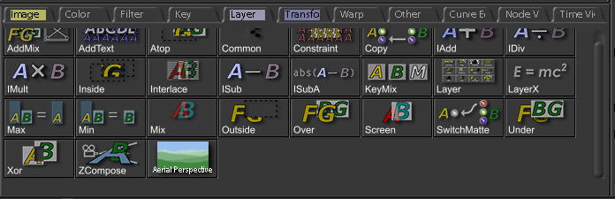
Click on the aerial perspective icon to create a new aerial perspective node in the node view in the top right hand corner of the shake window. If you shift-click shake will branch the node, if you ctrl-click shake will replace the currently selected node with an aerial perspective one, otherwise it will just append it to the last selected node.

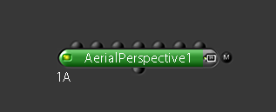

An aerial perspective node will be created with seven input knots and one output knot. The knot to the far left is for the most foreground layer and the knot to the far right for the most background layer.

Page 2

3.2 – The Macro Interface
The macro interface has been designed so that it is as easy to use as possible for people familiar with shake, it follows the usual layout of the default nodes. In this section we will look at the interface elements and in the next section a description of the various functions will be given.
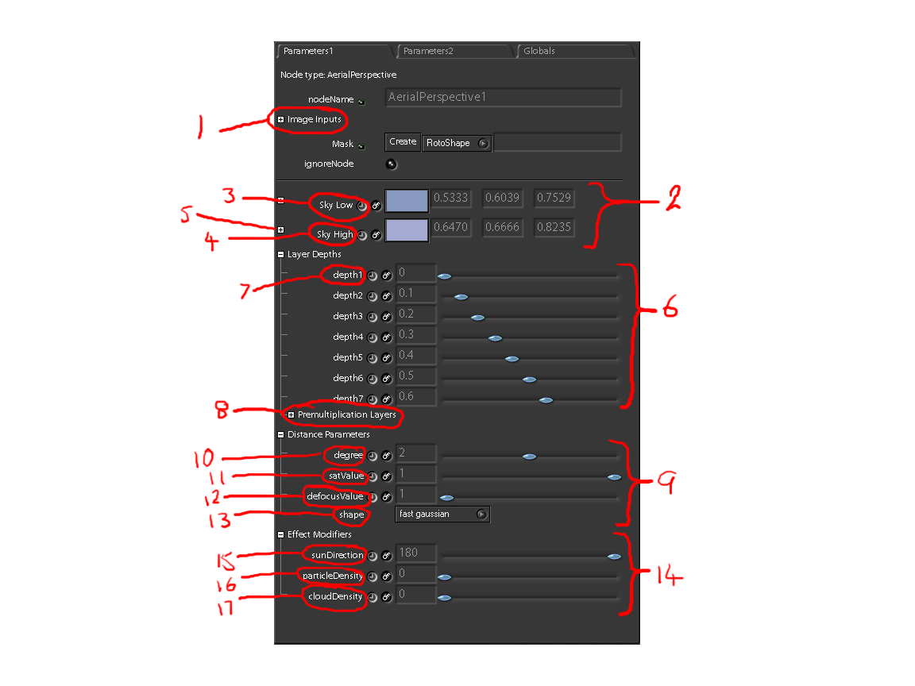
List of Interface Elements
- Image Inputs
- Sky Colour compression section
- Sky Low colour picker
- Sky High colour picker
- Colour picker sub branch
- Layer Depths section
- Depth parameters
- Premultiplication Layers sub branch
- Distance Parameters section
- Degree
- Saturation value
- Defocus value
- Defocus shape
- Effect Modifiers section
- Sun Direction
- Particle Density
- Cloud Density

Page 3
3.3 – Functions
Image Inputs
The image inputs is a sub branch that lists all of the input nodes or images that are currently connected to the aerial perspective node.

Sky Colour Compression Section
The macro uses shake compress nodes to achieve it’s colour correction of the layers, and as such a high and a low colour have to be selected in order for the effect to work. The macro sets defaults which can be used but it is advised to change them depending upon the composite.
Sky Low Colour Picker
The Sky Low colour picker determines the colour that the darkest parts of the image will be raised too.
Sky High Colour Picker
The Sky High colour picker determines the colour that the lightest parts of the image will be raised too.
Colour Picker sub branch
Each of the colour pickers are standard shake colour pickers and so they both have a sub branch giving the user more options when selecting a colour. For more information on the standard shake colour picker see the shake documentation.

Layer Depths Section
All of the calculations within the macro are based upon the depth of the layer, this is a user defined variable and can be tweaked by the user to achieve the best results.
Depth Parameters
Each of the layers has a separate depth parameter which can be set using the slider or by entering a value between 0 and 1. A value of 0 means that no effect will be calculated as this indicates the element closest to the camera lens. A value of 1 means that total effect will be calculated as this indicates the element furthest from the camera lens. Values in between have a percentage of the total effect calculated for them. The defaults put the layers depth in steps of 0.1.
Premultiplication Layers sub branch
Each layer needs to know if it’s input is premultiplied or not, so the parameters under this sub branch allow the user to indicate this to the macro using toggle switches, a 0 tells the macro that the layer is already premultiplied, a 1 tells it to multiply the inputs by their alpha channels. The defaults are 1.

Page 4
Depth Parameters Section
The section is a closed sub branch by default. Within it are variables which allow the user to change various settings that modify the depth calculations.
Degree
The degree determines what power the depth will be raised to during the calculation, this is used to more correctly simulate the effect of the falloff through the atmosphere. The value is set using a slider or by entering a value. Valid entries are 1, 2, and 3. The default is 2.
Saturation Value
Saturation value lets the user tweak the saturation of the layers. The effect will be most on the furthest layer. The user can alter the value using the slider or by entering a value. The slider ranges from 0 to1, 0 being full effect and 1 being no effect. The default is 1.
Defocus Value
Defocus value lets the user define how much the layers get progressively blurred towards the horizon. The user can set the value using the slider or by entering a value. The slider ranges from 0 to 50 where 0 is no effect and 50 is full effect. The default is set to 1.
Defocus Shape
Defocus shape determines what shape shake uses for the defocus calculation. Some shapes are more intensive then others for shake to calculate. Standard use is to generally choose a faster shape when refining the composite and switch to a more accurate but intensive shape at render time. The default is set to fast gaussian .

Effect Modifiers Section
The effect modifiers section contains variables which allow the user to modify various parts of the calculation to achieve different results. These are modelled on a visual analysis of the effects of aerial perspective and therefore are not physically accurate.
Sun Direction
The sun direction allows the user to specify what angle the viewing lens is from the sun. This will change the effect from a subtle gradation with blue colours facing away from the sun and more grey high contrast layering facing towards the sun. The user can set the angle using the slider or by entering a value. The slider ranges from 0 to 180 degrees. 0 degrees means fully facing the sun, and 180 degrees means facing fully away from the sun. The default is 180 degrees.

Page 5
Particle Density
The particle density variable allows the user to simulate the effect of more particles in the atmosphere. The denser the particles the bluer and less distinct the effect becomes due to more light being scattered. The user can set the value using a slider or by entering a value. The slider ranges from 0 and 1. 0 is no effect, 1 is full effect. The default is 0.
Cloud Density
The cloud density variable allows the user to simulate the effects of more or less cloud cover. When there are no clouds the effect is very blue, when there is complete cloud cover then the effect becomes a grey blue. The user can set the value using a slider or by entering a value. The slider ranges from 0 to 1. 0 is no effect, 1 is full effect. The default is 0.

4 – Conclusion
The macro has been written to simulate the effect of aerial perspective for an artist and as such doesn’t physically replicate the processes of the effect. All of the parameters have been defined with this in mind. The macro is fairly robust and should work well for people wishing to use it with an artists eye as opposed to a technical one. Anyone wanting to use a physically accurate model should look elsewhere.
If there are any problems with the macro I would appreciate feedback.
Contact: nicnapier@aol.com

Page 6
Appendix 2 – Macro Source Code

Source Code for Macro Body:

//Aerial Perspective Macro written by Nicholas Warren March 2004
//All of the following code is my own work
//This file is to be placed in the shake/include/startup folder

//This macro simulates aerial perspective, the effect of layers becoming bluer
//and less distinct over distance.

//The following is the macro definition

image AerialPerspective(
//the image inputs (creates seven knots on the node)
image input1,
image input2,
image input3,
image input4,
image input5,
image input6,
image input7,
//RGB variables for the colour selection
float red = 0.533333,
float green = 0.603922,
float blue = 0.752941,
float red1 = 0.647059,
float green1 = 0.666667,
float blue1 = 0.823529,
//A set of variables to specify the layers depth in relation to the camera
float depth1 = 0,
float depth2 = 0.1,
float depth3 = 0.2,
float depth4 = 0.3,
float depth5 = 0.4,
float depth6 = 0.5,
float depth7 = 0.6,
//A variable to allow for the change in the degree of the calculation
int degree = 2,
//A variable to allow the anount of saturation to be changed
float satValue = 1,
//a variable to aalow the amount of defocus to be changed
float defocusValue =1,
//A variable to allow the selction of the shape of the defocus effect
string shape = "fast gaussian",
//A variable to allow for the change in the camera's relation to the sun
float sunDirection =180,
//A variable to allow particle density to be increased (bluer, less distinct)
float particleDensity = 0,
//A variable to allow cloudDensity to be increased (greyer)
float cloudDensity = 0,
//Variables to allow the premultiplication of the layers to be toggled
int premult1 = 1,
int premult2 = 1,
int premult3 = 1,
int premult4 = 1,
int premult5 = 1,
int premult6 = 1,
)
//Macro body

{

//The following two nodes hold the colours that will be used to interpolate the effect. Each of the RGB
//values has a calculation which is the sum of the various components affecting that channel

Color1 = Color(1,1,1,clamp(red+cloudDensity,0,(blue+(particleDensity/0.5))-0.1),
clamp(green+cloudDensity,0,(blue+(particleDensity/0.5))-0.1),
clamp((blue+(particleDensity/0.5)),0,1),0,0);
Color2 = Color(1,1,1,clamp(red1+cloudDensity,0,(blue+(particleDensity/0.5))-0.1),
clamp(green1+cloudDensity,0,(blue+(particleDensity/0.5))-0.1),
clamp((blue1+(particleDensity/0.5)),0,1),0,0);

//The following nodes allow the saturation of the layers to be altered, they interpolate between complete
//saturation (value of 1) and no saturation (value of 0), the function uses the depth of each layer as
//the t parameter in the form n1(1-t) + n2t. Each of the depth values is raised to the power of the degree

Saturation1 = Saturation(input1,(1-pow(depth1,degree))+(satValue*pow(depth1,degree)));
Saturation2 = Saturation(input2,(1-pow(depth2,degree))+(satValue*pow(depth2,degree)));
Saturation3 = Saturation(input3,(1-pow(depth3,degree))+(satValue*pow(depth3,degree)));
Saturation4 = Saturation(input4,(1-pow(depth4,degree))+(satValue*pow(depth4,degree)));
Saturation5 = Saturation(input5,(1-pow(depth5,degree))+(satValue*pow(depth5,degree)));
Saturation6 = Saturation(input6,(1-pow(depth6,degree))+(satValue*pow(depth6,degree)));
Saturation7 = Saturation(input7,(1-pow(depth7,degree))+(satValue*pow(depth7,degree)));

//The following nodes compress each layers colour values into an interpolated range. The interpolation is linear
//in the same form as above. The difference being it is interpolated between two interpolated values, thus allowing
//for the effects of the camera looking directly at the sun. It takes the following form:
// (n1(1-t) + n2t)(1-t) + (n3(1-t) + n4t)t
//Each of the layers depths is plugged in to the calculation to determine that layers compression colours. The depth
//is raised to the power of the degree. Each RGB value is clamped between the range 0 to 1.

Compress1 = Compress(Saturation1,
clamp(((0.01*(1-pow(depth1,degree))+(0.6*pow(depth1,degree)))*(1-((sunDirection/180)+cloudDensity))) +
(((sunDirection/180)+cloudDensity)*((0.01*(1-pow(depth1,degree))) + (Color1.red*pow(depth1,degree)))),0,1),
clamp(((0.01*(1-pow(depth1,degree))+(0.6*pow(depth1,degree)))*(1-((sunDirection/180)+cloudDensity))) +
(((sunDirection/180)+cloudDensity)*((0.01*(1-pow(depth1,degree))) + (Color1.green*pow(depth1,degree)))),0,1),
clamp(((0.01*(1-pow(depth1,degree))+(0.6*pow(depth1,degree)))*(1-((sunDirection/180)+cloudDensity))) +
(((sunDirection/180)+cloudDensity)*((0.01*(1-pow(depth1,degree))) + (Color1.blue*pow(depth1,degree)))),0,1),
0,
clamp((0.65*(1-pow(depth1,degree))+(1*pow(depth1,degree)))*(1-((sunDirection/180)+cloudDensity))+
(((sunDirection/180)+cloudDensity)*((1-pow(depth1,degree)) + (Color2.red*pow(depth1,degree)))),0,1),
clamp((0.65*(1-pow(depth1,degree))+(1*pow(depth1,degree)))*(1-((sunDirection/180)+cloudDensity))+
(((sunDirection/180)+cloudDensity)*((1-pow(depth1,degree)) + (Color2.green*pow(depth1,degree)))),0,1),
clamp((0.65*(1-pow(depth1,degree))+(1*pow(depth1,degree)))*(1-((sunDirection/180)+cloudDensity))+
(((sunDirection/180)+cloudDensity)*((1-pow(depth1,degree)) + (Color2.blue*pow(depth1,degree)))),0,1),
1);

Compress2 = Compress(Saturation2,
clamp(((0.1*(1-pow(depth2,degree))+(0.6*pow(depth2,degree)))*(1-((sunDirection/180)+cloudDensity))) +
(((sunDirection/180)+cloudDensity)*((0.01*(1-pow(depth2,degree))) + (Color1.red*pow(depth2,degree)))),0,1),
clamp(((0.1*(1-pow(depth2,degree))+(0.6*pow(depth2,degree)))*(1-((sunDirection/180)+cloudDensity))) +
(((sunDirection/180)+cloudDensity)*((0.01*(1-pow(depth2,degree))) + (Color1.green*pow(depth2,degree)))),0,1),
clamp(((0.1*(1-pow(depth2,degree))+(0.6*pow(depth2,degree)))*(1-((sunDirection/180)+cloudDensity))) +
(((sunDirection/180)+cloudDensity)*((0.01*(1-pow(depth2,degree))) + (Color1.blue*pow(depth2,degree)))),0,1),
0,
clamp((0.65*(1-pow(depth2,degree))+(1*pow(depth2,degree)))*(1-((sunDirection/180)+cloudDensity))+
(((sunDirection/180)+cloudDensity)*((1-pow(depth2,degree)) + (Color2.red*pow(depth2,degree)))),0,1),
clamp((0.65*(1-pow(depth2,degree))+(1*pow(depth2,degree)))*(1-((sunDirection/180)+cloudDensity))+
(((sunDirection/180)+cloudDensity)*((1-pow(depth2,degree)) + (Color2.green*pow(depth2,degree)))),0,1),
clamp((0.65*(1-pow(depth2,degree))+(1*pow(depth2,degree)))*(1-((sunDirection/180)+cloudDensity))+
(((sunDirection/180)+cloudDensity)*((1-pow(depth2,degree)) + (Color2.blue*pow(depth2,degree)))),0,1),
1);

Compress3 = Compress(Saturation3,
clamp(((0.01*(1-pow(depth3,degree))+(0.6*pow(depth3,degree)))*(1-((sunDirection/180)+cloudDensity))) +
(((sunDirection/180)+cloudDensity)*((0.01*(1-pow(depth3,degree))) + (Color1.red*pow(depth3,degree)))),0,1),
clamp(((0.01*(1-pow(depth3,degree))+(0.6*pow(depth3,degree)))*(1-((sunDirection/180)+cloudDensity))) +
(((sunDirection/180)+cloudDensity)*((0.01*(1-pow(depth3,degree))) + (Color1.green*pow(depth3,degree)))),0,1),
clamp(((0.01*(1-pow(depth3,degree))+(0.6*pow(depth3,degree)))*(1-((sunDirection/180)+cloudDensity))) +
(((sunDirection/180)+cloudDensity)*((0.01*(1-pow(depth3,degree))) + (Color1.blue*pow(depth3,degree)))),0,1),
0,
clamp((0.65*(1-pow(depth3,degree))+(1*pow(depth3,degree)))*(1-((sunDirection/180)+cloudDensity))+
(((sunDirection/180)+cloudDensity)*((1-pow(depth3,degree)) + (Color2.red*pow(depth3,degree)))),0,1),
clamp((0.65*(1-pow(depth3,degree))+(1*pow(depth3,degree)))*(1-((sunDirection/180)+cloudDensity))+
(((sunDirection/180)+cloudDensity)*((1-pow(depth3,degree)) + (Color2.green*pow(depth3,degree)))),0,1),
clamp((0.65*(1-pow(depth3,degree))+(1*pow(depth3,degree)))*(1-((sunDirection/180)+cloudDensity))+
(((sunDirection/180)+cloudDensity)*((1-pow(depth3,degree)) + (Color2.blue*pow(depth3,degree)))),0,1),
1);

Compress4 = Compress(Saturation4,
clamp(((0.01*(1-pow(depth4,degree))+(0.6*pow(depth4,degree)))*(1-((sunDirection/180)+cloudDensity))) +
(((sunDirection/180)+cloudDensity)*((0.01*(1-pow(depth4,degree))) + (Color1.red*pow(depth4,degree)))),0,1),
clamp(((0.01*(1-pow(depth4,degree))+(0.6*pow(depth4,degree)))*(1-((sunDirection/180)+cloudDensity))) +
(((sunDirection/180)+cloudDensity)*((0.01*(1-pow(depth4,degree))) + (Color1.green*pow(depth4,degree)))),0,1),
clamp(((0.01*(1-pow(depth4,degree))+(0.6*pow(depth4,degree)))*(1-((sunDirection/180)+cloudDensity))) +
(((sunDirection/180)+cloudDensity)*((0.01*(1-pow(depth4,degree))) + (Color1.blue*pow(depth4,degree)))),0,1),
0,
clamp((0.65*(1-pow(depth4,degree))+(1*pow(depth4,degree)))*(1-((sunDirection/180)+cloudDensity))+
(((sunDirection/180)+cloudDensity)*((1-pow(depth4,degree)) + (Color2.red*pow(depth4,degree)))),0,1),
clamp((0.65*(1-pow(depth4,degree))+(1*pow(depth4,degree)))*(1-((sunDirection/180)+cloudDensity))+
(((sunDirection/180)+cloudDensity)*((1-pow(depth4,degree)) + (Color2.green*pow(depth4,degree)))),0,1),
clamp((0.65*(1-pow(depth4,degree))+(1*pow(depth4,degree)))*(1-((sunDirection/180)+cloudDensity))+
(((sunDirection/180)+cloudDensity)*((1-pow(depth4,degree)) + (Color2.blue*pow(depth4,degree)))),0,1),
1);

Compress5 = Compress(Saturation5,
clamp(((0.01*(1-pow(depth5,degree))+(0.6*pow(depth5,degree)))*(1-((sunDirection/180)+cloudDensity))) +
(((sunDirection/180)+cloudDensity)*((0.01*(1-pow(depth5,degree))) + (Color1.red*pow(depth5,degree)))),0,1),
clamp(((0.01*(1-pow(depth5,degree))+(0.6*pow(depth5,degree)))*(1-((sunDirection/180)+cloudDensity))) +
(((sunDirection/180)+cloudDensity)*((0.01*(1-pow(depth5,degree))) + (Color1.green*pow(depth5,degree)))),0,1),
clamp(((0.01*(1-pow(depth5,degree))+(0.6*pow(depth5,degree)))*(1-((sunDirection/180)+cloudDensity))) +
(((sunDirection/180)+cloudDensity)*((0.01*(1-pow(depth5,degree))) + (Color1.blue*pow(depth5,degree)))),0,1),
0,
clamp((0.65*(1-pow(depth5,degree))+(1*pow(depth5,degree)))*(1-((sunDirection/180)+cloudDensity))+
(((sunDirection/180)+cloudDensity)*((1-pow(depth5,degree)) + (Color2.red*pow(depth5,degree)))),0,1),
clamp((0.65*(1-pow(depth5,degree))+(1*pow(depth5,degree)))*(1-((sunDirection/180)+cloudDensity))+
(((sunDirection/180)+cloudDensity)*((1-pow(depth5,degree)) + (Color2.green*pow(depth5,degree)))),0,1),
clamp((0.65*(1-pow(depth5,degree))+(1*pow(depth5,degree)))*(1-((sunDirection/180)+cloudDensity))+
(((sunDirection/180)+cloudDensity)*((1-pow(depth5,degree)) + (Color2.blue*pow(depth5,degree)))),0,1),
1);

Compress6 = Compress(Saturation6,
clamp(((0.01*(1-pow(depth6,degree))+(0.6*pow(depth6,degree)))*(1-((sunDirection/180)+cloudDensity))) +
(((sunDirection/180)+cloudDensity)*((0.01*(1-pow(depth6,degree))) + (Color1.red*pow(depth6,degree)))),0,1),
clamp(((0.01*(1-pow(depth6,degree))+(0.6*pow(depth6,degree)))*(1-((sunDirection/180)+cloudDensity))) +
(((sunDirection/180)+cloudDensity)*((0.01*(1-pow(depth6,degree))) + (Color1.green*pow(depth6,degree)))),0,1),
clamp(((0.01*(1-pow(depth6,degree))+(0.6*pow(depth6,degree)))*(1-((sunDirection/180)+cloudDensity))) +
(((sunDirection/180)+cloudDensity)*((0.01*(1-pow(depth6,degree))) + (Color1.blue*pow(depth6,degree)))),0,1),
0,
clamp((0.65*(1-pow(depth6,degree))+(1*pow(depth6,degree)))*(1-((sunDirection/180)+cloudDensity))+
(((sunDirection/180)+cloudDensity)*((1-pow(depth6,degree)) + (Color2.red*pow(depth6,degree)))),0,1),
clamp((0.65*(1-pow(depth6,degree))+(1*pow(depth6,degree)))*(1-((sunDirection/180)+cloudDensity))+
(((sunDirection/180)+cloudDensity)*((1-pow(depth6,degree)) + (Color2.green*pow(depth6,degree)))),0,1),
clamp((0.65*(1-pow(depth6,degree))+(1*pow(depth6,degree)))*(1-((sunDirection/180)+cloudDensity))+
(((sunDirection/180)+cloudDensity)*((1-pow(depth6,degree)) + (Color2.blue*pow(depth6,degree)))),0,1),
1);

Compress7 = Compress(Saturation7,
clamp(((0.01*(1-pow(depth7,degree))+(0.6*pow(depth7,degree)))*(1-((sunDirection/180)+cloudDensity))) +
(((sunDirection/180)+cloudDensity)*((0.01*(1-pow(depth7,degree))) + (Color1.red*pow(depth7,degree)))),0,1),
clamp(((0.01*(1-pow(depth7,degree))+(0.6*pow(depth7,degree)))*(1-((sunDirection/180)+cloudDensity))) +
(((sunDirection/180)+cloudDensity)*((0.01*(1-pow(depth7,degree))) + (Color1.green*pow(depth7,degree)))),0,1),
clamp(((0.01*(1-pow(depth7,degree))+(0.6*pow(depth7,degree)))*(1-((sunDirection/180)+cloudDensity))) +
(((sunDirection/180)+cloudDensity)*((0.01*(1-pow(depth7,degree))) + (Color1.blue*pow(depth7,degree)))),0,1),
0,
clamp((0.65*(1-pow(depth7,degree))+(1*pow(depth7,degree)))*(1-((sunDirection/180)+cloudDensity))+
(((sunDirection/180)+cloudDensity)*((1-pow(depth7,degree)) + (Color2.red*pow(depth7,degree)))),0,1),
clamp((0.65*(1-pow(depth7,degree))+(1*pow(depth7,degree)))*(1-((sunDirection/180)+cloudDensity))+
(((sunDirection/180)+cloudDensity)*((1-pow(depth7,degree)) + (Color2.green*pow(depth7,degree)))),0,1),
clamp((0.65*(1-pow(depth7,degree))+(1*pow(depth7,degree)))*(1-((sunDirection/180)+cloudDensity))+
(((sunDirection/180)+cloudDensity)*((1-pow(depth7,degree)) + (Color2.blue*pow(depth7,degree)))),0,1),
1);

//The following nodes determine the amount of defocus that each layer gets, by linearly interpolating based upon
//the layers depth and the focus amount. Each of the depth values is raised to the power of the degree.

Defocus1 = Defocus(Compress1,
(1-pow(depth1,degree))+((defocusValue+(20*particleDensity))*pow(depth1,degree)),
xPixels, "rgba",100, shape, 0.95, 1);
Defocus2 = Defocus(Compress2,
(1-pow(depth2,degree))+((defocusValue+(20*particleDensity))*pow(depth2,degree)),
xPixels, "rgba",100, shape, 0.95, 1);
Defocus3 = Defocus(Compress3,
(1-pow(depth3,degree))+((defocusValue+(20*particleDensity))*pow(depth3,degree)),
xPixels, "rgba",100, shape, 0.95, 1);
Defocus4 = Defocus(Compress4,
(1-pow(depth4,degree))+((defocusValue+(20*particleDensity))*pow(depth4,degree)),
xPixels, "rgba",100, shape, 0.95, 1);
Defocus5 = Defocus(Compress5,
(1-pow(depth5,degree))+((defocusValue+(20*particleDensity))*pow(depth5,degree)),
xPixels, "rgba",100, shape, 0.95, 1);
Defocus6 = Defocus(Compress6,
(1-pow(depth6,degree))+((defocusValue+(20*particleDensity))*pow(depth6,degree)),
xPixels, "rgba",100, shape, 0.95, 1);
Defocus7 = Defocus(Compress7,
(1-pow(depth7,degree))+((defocusValue+(20*particleDensity))*pow(depth7,degree)),
xPixels, "rgba",100, shape, 0.95, 1);

//The following nodes combine all of the layers together in their correct order, and takes a variable that allows
//the user to specify whether the layer is to be premultiplied or not.

Over1 = Over(Defocus1, Defocus2, 1, premult1, 0);
Over2 = Over(Over1, Defocus3, 1, premult2, 0);
Over3 = Over(Over2, Defocus4, 1, premult3, 0);
Over4 = Over(Over3, Defocus5, 1, premult4, 0);
Over5 = Over(Over4, Defocus6, 1, premult5, 0);
Over6 = Over(Over5, Defocus7, 1, premult6, 0);

//This statement tells the macro to return the output of thelast node in the chain which is Over6

return Over6;
}
Source Code for Macro UI

//Aerial Perspective Macro UI written by Nicholas Warren March 2004
//All of the following code is my own work
//This file is to be placed in the shake/include/startup/UI folder

//The following block tells shake to put the macro in the layer tab, to look for the icon and
//the image parameters for the node

nuiPushToolBox("Layer");
nuiToolBoxItem("AerialPerspective", AerialPerspective(0,0,0,0,0,0,0));
nuiPopToolBox();

//The following block tells shake to group all of the image inputs under a group called image
//inputs. This will fold them away neatly in the interface.

nuiPushControlGroup("Image Inputs");
nuiGroupControl("AerialPerspective.input1");
nuiGroupControl("AerialPerspective.input2");
nuiGroupControl("AerialPerspective.input3");
nuiGroupControl("AerialPerspective.input4");
nuiGroupControl("AerialPerspective.input5");
nuiGroupControl("AerialPerspective.input6");
nuiGroupControl("AerialPerspective.input7");
nuiPopControlGroup();

//The following declarations tell shake what kind of interface element to use with each variable

//These declarations tell shake to use a slider set between the specified ranges and using the
//specified hard and soft snaps

nuiDefSlider("AerialPerspective.sunDirection", 0,180,1);
nuiDefSlider("AerialPerspective.particleDensity", 0,1,0.001,0.01);
nuiDefSlider("AerialPerspective.cloudDensity", 0,1,0.001,0.01);
nuiDefSlider("AerialPerspective.degree", 1,3,1);
nuiDefSlider("AerialPerspective.satValue", 0,1,0.0001,0.01);
nuiDefSlider("AerialPerspective.defocusValue", 0,50,0.001,1);

//These delarations tell shake to use a toggle for these variables. The togle is either 0 or 1

nuxDefExprToggle("AerialPerspective.premult1");
nuxDefExprToggle("AerialPerspective.premult2");
nuxDefExprToggle("AerialPerspective.premult3");
nuxDefExprToggle("AerialPerspective.premult4");
nuxDefExprToggle("AerialPerspective.premult5");
nuxDefExprToggle("AerialPerspective.premult6");

//The following blocks all define groups for which the variables will be tucked away into

//Put the following RGB values into a colour picker called Sky low

nuiPushControlGroup("Sky Low");
nuiGroupControl("AerialPerspective.red");
nuiGroupControl("AerialPerspective.green");
nuiGroupControl("AerialPerspective.blue");
nuiPopControlGroup();
nuiPushControlWidget("Sky Low",nuiConnectColorTriplet(kRGBToggle,kCurrentColor,1));

//Put the following RGB values into a colour picker called Sky High

nuiPushControlGroup("Sky High");
nuiGroupControl("AerialPerspective.red1");
nuiGroupControl("AerialPerspective.green1");
nuiGroupControl("AerialPerspective.blue1");
nuiPopControlGroup();
nuiPushControlWidget("Sky High",nuiConnectColorTriplet(kRGBToggle,kCurrentColor,1));

//Group the following attributes together. The group is called Layer Depths

nuiPushControlGroup("AerialPerspective.Layer Depths");
nuiGroupControl("AerialPerspective.depth1");
nuiGroupControl("AerialPerspective.depth2");
nuiGroupControl("AerialPerspective.depth3");
nuiGroupControl("AerialPerspective.depth4");
nuiGroupControl("AerialPerspective.depth5");
nuiGroupControl("AerialPerspective.depth6");
nuiGroupControl("AerialPerspective.depth7");
//Add a subgroup called Premultiplication Layers to the Layer Depths group
nuiPushControlGroup("AerialPerspective.Premultiplication Layers");
nuiGroupControl("AerialPerspective.premult1");
nuiGroupControl("AerialPerspective.premult2");
nuiGroupControl("AerialPerspective.premult3");
nuiGroupControl("AerialPerspective.premult4");
nuiGroupControl("AerialPerspective.premult5");
nuiGroupControl("AerialPerspective.premult6");
nuiPopControlGroup();
nuiPopControlGroup();

//Group the following attributes together. The group is called Distance Parameters

nuiPushControlGroup("AerialPerspective.Distance Parameters");
nuiGroupControl("AerialPerspective.degree");
nuiGroupControl("AerialPerspective.satValue");
nuiGroupControl("AerialPerspective.defocusValue");
nuiGroupControl("AerialPerspective.shape");
nuiPopControlGroup();

//Group the following attributes together. The group is called Effect Modifiers

nuiPushControlGroup("AerialPerspective.Effect Modifiers");
nuiGroupControl("AerialPerspective.sunDirection");
nuiGroupControl("AerialPerspective.particleDensity");
nuiGroupControl("AerialPerspective.cloudDensity");
nuiPopControlGroup();

