Keith Burgess. Innovations Project.

Real Time Animated Typography Tool.

Introduction.

As video art becomes a more prominent part of nightclub entertainment, promoters are also becoming more aware of the advertising potential of video projected information. For the most part, financial assistance is not generally offered to produce sophisticated animated typographic sequences, rather it is an expected service to be provided as part of a show. Production of animated sequences takes time. The process involves creating the type, marking key frames or choosing paths for the type to follow, rendering and finally editing and outputting to a format to be displayed. By having a quick and easy tool to display logos and text on-screen the video artist is given more time to work on sequences outside the realms of unpaid corporate advertising.

A nightclub may have projectors installed but no real method of displaying information in a graphic context. Software that displayed multiple lines of information could be set up and run in an autopilot mode.

Aim:

The aim of this project is to produce an easy to use piece of software to quickly create 3D animated logos and to display text information on screen in real-time. The user should have full control of colour, font, scale, position and motion.

The software should have features that go beyond that of currently selling video mixing tools as well as containing the most common features used in television advertising.

Objectives:

- To get to grips with design and coding of a graphical user interface.
- Research current typographic features of current real-time software.
- To analyse and reproduce common trends in animated typography.

Approach.

One approach to this project would be to spend less time on the construction of a graphical user interface and just concentrate on the motion, timing and distortion of typography in an OpenGL environment. Another would be to work solely on the GUI design. Simple quads could be used to represent a string of text without going into the complexity of vectorized type modelling and extrusion.

For this project a balanced approach of both GUI design and typographic display was chosen as a tool useful to anyone would need to allow the input of user specific data.

Computer Methods For Displaying Type.

TTF fonts.
Apple and Microsoft developed the TrueType font system in the late 1980s. It is considered to be the standard format for describing fonts. Each glyph (letter) is described as a series of quadratic B-splines that describe the contour outline of a glyph.

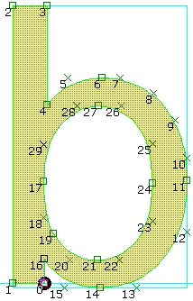
The letter 'b' of Monotype Arial.
(TYPE*caster screen, with squares for on-curve points,
crosses for off-curve points, blue lines for co-ordinate axes and bounding-box)
The outline of solid shapes (such as L, M, E etc) is defined by control points ordered clockwise. White spaces or holes within letters (such as O, P, R) contain extra contours that are defined as anti-clockwise.

Vectorized Font Output
When a TTF file is loaded a parametric quadratic equation is used to create points on the curve surface. The points are then connected together to create the letter contours. Each point is given an (x,y,z) coordinate, plotted and points joined together. Programmes such as Maya and Adobe Illustrator use this method for displaying typographic data.

The advantage of using this method to display text is that scaling or zooming into the image does not diminish the quality, as each glyph is a formula that describes the shape. This allows for processes such as extrusion and manipulation of the glyph shape without causing pixelation.

Pixel Bitmaps.
Glyphs are displayed on screen as a rectangular array of pixel fragments. The TTF file is loaded, processed by a parametric, quadratic equation and then hard coded into the rasterizer. If there's a 0 in the bitmap, the contents of the pixel are unaffected. Wherever there's a 1 in the bitmap, the corresponding pixel is replaced by a coloured pixel. The most common use of bitmaps is for drawing characters on the screen.

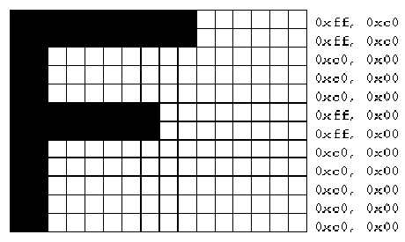
Bitmap Font. OpenGL programming guide fig 8.1

Programs such as a word processor or Adobe Photoshop generally use rasterized fonts to display text.

A disadvantage of pixmap display of glyphs is that if an image is created at a
Low pixel count and then enlarged the quality becomes blocky and pixelated.
If a pixmap is created at a high pixel count, many more pixels are needed to describe each glyph. To increase the amount of pixels that make up a pixmap over time may produce unexpected jumping results.

Font Display In OpenGL.

OpenGL provides no support for displaying fonts. It has the ability to draw points and lines in 3D space as well as drawing pixels at a given raster position. The information that describes a font must be solved through programming, however a number of libraries exist to help in the development of font displays.

GLUT.
Glut has the ability to display vectorized as well as bitmap fonts. However the choice of fonts is limited to times New Roman, Helvetica and X standard font. The choice of sized output is also limited. As a result, GLUT was not used in this project.

The FreeType Library.
The FreeType engine is a free and portable TrueType font-rendering engine. It has been developed to provide TrueType support to a variety of different platforms and environments.

The GLTT library.
GLTT is a library that allows you to read and draw TrueType fonts in any OpenGL application. It supports anti-aliased bitmapped font drawing as well as vectorized outline and polygonized drawing of fonts through C++ classes and functions. The GLTT library requires the Freetype library to draw fonts in an OpenGL environment.

For this project both the Freetype and GLTT libraries where used. The Freetype library is used to describe true type fonts and the GLTT library is used for drawing both pixmap and vectorized fonts in OpenGL. Both libraries come under the GNU licence and are therefore free to use and be modified. A number of functions in the GLTT library where modified in this project to allow more control of positioning and transformations on type display.

GUI Design and Programming.

A number of systems exist to help with the production of GUI design and implementation. These include MFC (Windows), Motif (all systems) and QT (all systems). All of these API’s provide widgets for the control of menus, spin bars, combo boxes etc.

For this project the Microsoft Foundation Classes (MFC) where used in a Visual Studio 6 environment. MFC is a C++ class library for Windows programming. It provides functions and classes for the control of windows, menus, dialog boxes and user controls as well as the standard windows file opening dialog boxes common to most windows applications. By using these classes much time is saved in the design and control of a GUI. A limitation of using the MFC libraries is that it is Windows specific and cannot easily be ported to Linux or Apple systems.

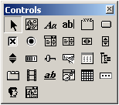
Controls Available in an MFC application

Although the MFC library makes development of applications much quicker, it is a deep and complex system with a steep learning curve.

When an MFC project is created in Visual Studio a number of files are created by the application Wizard for the programmer. The files do not contain a main loop but instead, a project is laid out using the Document/View Architecture. The Document/View architecture is used to separate application data from the routines needed to draw the data.

An MFC project usually contains source and header files for

- The Application (type.cpp/h)
- The MainFrame (MainFrm.cpp/h)
- The Document Classes. (typeDoc.cpp/h)
- The View Classes. (typeView.cpp/h)

The App files set up run time classes for the document, view and mainframe classes. The mainframe class is responsible for menu operations. As dialog Boxes are programmed MFC sets up source and header files for each dialog box. For this project the doc/view architecture is not used to allow easier portability to other systems.

THE RESEARCH

Current Software Available for Animated Font Display.

Almost all 3D animation packages such as Maya and 3DStudio have good support for type display far beyond the expectation of this project. However production of animated typography is reasonably complex and time consuming. Sequences must be first constructed, keyed and rendered before they can be displayed and therefore cannot be considered real-time.

A number of small enthusiast driven companies have been creating real-time visual mixing and processing software for video artist to use as a live performance tool. Some provide support for text display as part of their package. Most packages go as far as producing one line of rasterized text output at a time or require the user to render sequences in an avi or quicktime video file to be used.

- Motion Dive (Japan) - has a text module for rasterized font display with plans to introduce flash text animations at a later date. At present Motion Dive features include text enter from left, zoom out from large scale, zoom in, static text, and a traditional title sequence (multiple lines of text centrally aligned moving upwards).

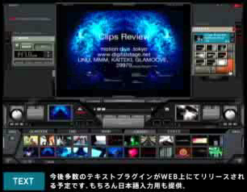
Motion Dive demo reel screenshot

- Vjamm (ColdCut UK) - proves single line text input without animation. Data can be entered in a .txt file in the program directory.

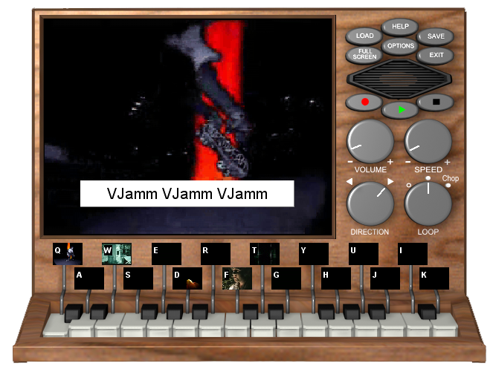
VJamm screen shot

- Resolme (Holland) – No text support.

- Vidvox Suite (Canada) – for the Apple provides rasterized text support.

- PixelToy 2.6 - for the Apple Macintosh has a pixel based text-editing tool which allows for up to 16 different text objects. The user has control over scale, brightness and motion.

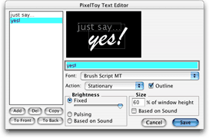
PixelToy text editor dialog box.

The user has seven methods in which to move the text.

- Jitter – causes the text to vibrate
- Bouncing - (zero gravity) causes the text to bounce to screen extents
- Bouncing – (gravity) text bounces like a ball in a box.
- Wandering – text objects bumble around at random.
- Mouse – makes text appear where the mouse pointer is located.

Of all the tested real-time software, PixelToy and Motion Dive had the largest range of features for animated and static type display.
From the research none of the products deal with 3D geometry. They are all pixel based. Also none of the products on tested have any control for dissolving type.

Analysis of typographic trends on television

To make sure that the software product had the most useful features, 100 Television adverts where recorded and analysis was made of typographic sequences in adverts to spot trends in dissolves, zooms, pans and scale transforms. For a more balanced approach the recording took place over the course of twenty-four hours and over a number of channels as different trends may be used at different times and different target groups.

For this project, typography placed on a 3D product where noted in the results but not a requirement of this project.

The Results

- 99% of all adverts contain text.
- 51% of all adverts contain white text.
- 34% of all adverts contain dissolving text.
- 32% of all adverts contain centrally aligned text in the bottom third of the screen.
- 22% of all adverts use 3D products to represent text.
- 15% of all adverts contain animated text.

From the results it became apparent that text:

- is aligned to the left, right or centre
- is aligned to the top, bottom or centre
- is predominately white.
- Is predominately static.
- Usually dissolves.
- Never usually contains more than four lines at one time.

Text generally never enters from the left of the screen. Such a motion would be confusing to the viewer as a sentence would be revealed backwards, making little sense until fully visible.

From the test results, a system will be needed for aligning text in the nine most prominent positions being top-left, top-centre, top-right, centre-left, centre, centre-right, bottom-left, bottom-centre, bottom-right and always within the title safe region. A dissolve feature would also be useful.

see accompanying CDROM for recorded adverts.

The Product

The Product requirements.

A common demand of a nightclub promoter is to show branding and performers names to be displayed at a given time. The user of the software must be able to produce the correct information in a manner that suits the identity of the event when needed.

- The animation tool should allow for a quick method to produce a vectorized logo capable of rotation and translation within the frame.

- The tool should also allow for pages of text to be imported and reproduced in the OpenGL environment. These pages should be reproduced as all lines of text displayed at once or by breaking down the text into separate sentences and displayed them individually. Based on the advertising research dissolving type should be a feature of the product. (Alpha value interpolation)

- The nature and energy of music may require the text and logo to be displayed and animated in different ways. The user must be able to quickly change the method in which the typography appears.

- The user must be able to import video files to act as a background layer for the typographic foreground. Ideally a dynamic list of video files should be installed to allow multiple video files to be chosen from.

- The user must be able to load and save a series of ready set up logos, text file animations and background layers to and from disk. The software should not have to be set up each time the software is loaded.

- The user must be able to change colour and opacity of text to match the colours and transparency of the background plate.

- Text should be aligned to the nine major positions (TL,TC,TR,CL,C etc)

- An auto timing dissolve system should be implemented

Coding the Typography Tool.

Classes and libraries used.
The typography tool was written in C++ using OpenGL and tied into the following Classes and libraries.

- Freetype Library.
- GLTT library.
- MFC.
- Rob Bateman’s (NCCA) Avi Player.
- Rob Bateman’s (NCCA) OpenGL in MFC rendering context.
- Jon Macey’s (NCCA) Graphics Library.
- Utility Functions for finding font file based on a given font display name.
- Utility Functions for loading and saving data to binary files on disk.

Classes where added for the control of text file processing and for logo creation.

- MyLogo
- MyText

These classes hold all the values needed to create and control each typographic element.

Use of the std::vector class
All type and background data for this product are dynamically created during runtime. The classes are defined at compile time but not instantiated. Whenever an object is created it is added to a dynamic vector list. This greatly simplifies accessing data from a number of similar objects.

vectorizerList[LetterCount]->setPrecision(precision);

As each text string contains a number of letters a vector list of letters is created and destroyed when necessary.

while ( vectorizerList.size() < CmyLogoList[0]->stringName.GetLength())
{
FTGlyphVectorizer* vectorizer = new FTGlyphVectorizer;
vectorizerList.push_back(vectorizer);
}

All lists are declared global so that other classes can gain access to their elements. For the logo editing dialog box to gain access to logo object variables an extern flag is added to the dialog boxes class implementation file.

extern vector <CmyLogo*> CmyLogoList;

Modifications to the GLTT Library

The GLTT library creates a vectorized outline one letter at a time, adds it to an OpenGL display list and then destroys it. The transformation matrix is then advanced and the next letter is created. The Initial letter is always drawn in the lower left hand side of the screen. A number of modifications needed to be set up before the library could be used effectively in this project.

- Disabling of calls to glTranslate. Instead offset letters after the first letter by the same value passed to glTranslate.

- Adding a new constructor that does not assign a face object to an outline or fill GLTT object. Instead create an extra function to set the face after construction. This way more than one object can use the same face.

- Addition of functions in GLTTOutlineFont to centralize the type on screen as well as scale and rotation transformations

- Disabling of display lists, as matrix transformations will constantly be changing the type geometry.

- A vector list of font contours had to be set up so the algorithm for centralizing the logo could be used. All points on all letters are needed to calculate the centre point of the type. Also all points of all letters need to be passed on to the rotation and translation matrices.

- Instead of recreating vector outlines for polygonally filled letters, it would make sense to use the vectorized data used for the outlines as they have already been transformed. Two functions where written to get the GLTTPolygonized font classes to access point data from the global vectorizerList. GLTTPolygonizedHandler classes needed Z coords plotted.

Once all the points are in a vector list, it is possible to manipulate points iteratively.

void GLTTOutlineFont::centralize() //KGB added function to find and move text string to centre
{
double totalX=0;
double totalY=0;
double pointCount=0;

for( int i= 0; i < vectorizerList.size(); i++ ) // for all letters
{
for( int j= 0; j < vectorizerList[i]->getNContours(); ++j ) // for all lines in letter
{
FTGlyphVectorizer::Contour* contour= vectorizerList[i]->getContour(j);
if( contour == 0 )
continue;

if( contour->nPoints <= 0 ) //if no points in the letter
continue;

for( int k= 0; k < contour->nPoints; ++k ) // for all points in the letter
{
FTGlyphVectorizer::POINT& p= contour->points[k]; //heres the point class

totalX+=p.x;
totalY+=p.y;
pointCount++;

}
}
}
totalX = totalX / pointCount; //find centre of letters
totalY = totally / pointCount; //find centre of letters

double dispX=360-totalX; //amount to move letters to be in the centre
double dispY=288-totalY; //amount to move letters to be in the centre

for( i= 0; i < vectorizerList.size(); i++ )
{
for(int j= 0; j < vectorizerList[i]->getNContours(); ++j)
{
FTGlyphVectorizer::Contour* contour= vectorizerList[i]->getContour(j);
if( contour == 0 )
continue;

if( contour->nPoints <= 0 )
continue;

glBegin(GL_LINE_LOOP);

for( int k= 0; k < contour->nPoints; ++k )
{
FTGlyphVectorizer::POINT& p= contour->points[k]; //heres the point class

glVertex3f( p.x+dispX, p.y+dispY, 0.0f ); // multiply p.x and y for deformations.
}

glEnd();
}
}
}

Modified GLTT function in file GLTTOutlineFont.cpp

Dialog Class Interaction.

For the background, text and logo features of the software a class was built to store and operate each feature. To gain access to the data and process it a dialog box was created to deal with the respective feature.

Class myLogoDialog knows about MyLogo.
Class myTextDialog knows about MyText.

When a dialog box for editing is called, the dialog class’s onInitDialog() function gets the data needed from the type object.

When the values of the type object have been set, the dialog boxes OK or Cancel button is pressed. If the OK button was pressed the new data is sent back to type object.

BOOL LogoDialog::OnInitDialog()
{
CDialog::OnInitDialog();

m_editbox.SetWindowText(m_editString); // the text string of the logo

FillListBox(); // fill list box with fonts installed

m_listBox.SetCurSel(index); // highlight current font selected

m_red.SetRange(0,100); // set min-max range of colour variations
m_red.SetPos(CmyLogoList[0]->logoOutlineColour.r * 100); // set red value
m_green.SetRange(0,100);
m_green.SetPos(CmyLogoList[0]->logoOutlineColour.g*100); // set green outline value
m_blue.SetRange(0,100);
m_blue.SetPos(CmyLogoList[0]->logoOutlineColour.b*100); // set blue outline value
m_alpha.SetRange(0,100);
m_alpha.SetPos(CmyLogoList[0]->logoOutlineColour.a*100); // set alpha outline value

m_redFill.SetRange(0,100);
m_redFill.SetPos(CmyLogoList[0]->logoFillColour.r * 100); // set red fill value
m_greenFill.SetRange(0,100);
m_greenFill.SetPos(CmyLogoList[0]->logoFillColour.g*100); // set green fill value
m_blueFill.SetRange(0,100);
m_blueFill.SetPos(CmyLogoList[0]->logoFillColour.b*100); // set blue fill value
m_alphaFill.SetRange(0,100);
m_alphaFill.SetPos(CmyLogoList[0]->logoFillColour.a*100); // set alpha fill value

m_height.SetRange(0,20);
m_height.SetPos((int)CmyLogoList[0]->height); //set height

m_OutlineWidth.SetRange(0,10);
m_OutlineWidth.SetPos(CmyLogoList[0]->outlineWidth); //set outline width

return TRUE;
}

OnInitDialog function to get object values into the dialog box. OnOK does the reverse.

Type Dialog Boxes.
The dialog boxes contain all the controls needed to modify the style and behaviour of the type objects. These controls include radio buttons, text edit boxes, list boxes and sliders. All these controls get and set values of there respective objects.

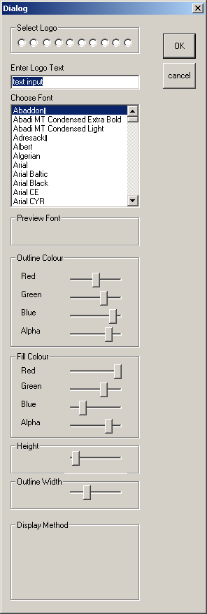
Dialog Box for control of logo Objects.

Dialog boxes for the text input and background video files have a similar layout.

MFC has two different varieties of dialog boxes. A modal dialog box disables the window to which it is assigned until the OK button is pressed (OK, Cancel style). No changes occur until then. A modeless dialog box behaves more like a conventional window. Its owner can be reactivated whilst the dialog box is displayed (OK, Cancel, Apply style). Tutorials recommend getting to grips with modal dialog boxes before moving onto modeless so these where used in this project. A more suitable method would be for interaction between object and controls as soon as values are changed and should be addressed for the product to be fully interactive.

Further modifications

To make the software more useful in a live performance setting, using a library for line-in audio capture could be advantageous. This way certain frequencies of sound could be used to change values of the typography. For example a bass drum could drive a slight scale shift in the type or change rotational controls.

At present, the logo component only supports rotation set by the user. A useful feature would be for rotational variables to change over time or a system to stop the type from being rotated fully preventing the logo from being viewed upside down or back to front. The Reset buttons on the spin control dialog box sets all slider values to default. A better animated effect could be achieved by creating a timed reset button that gradually interpolated all sliders from their current position to the default position. The user could then use an extra control to set how long this process should take.

Some event promoters may have 3D type geometry of their own. In this case it would be beneficial to have a menu option and controls for importing this geometry. Colouring and transformation could then be applied.

Control over the software would be much more practical if all controls could be displayed on screen at all time. To make this applicable, a different style of MFC application must be set up. The ideal solution would be for a dialog style application. This would be more complicated to set up but is possible. Also if controls within dialog boxes directly affected changes onscreen.

At the completion of this project, extrusion of font faces has not been set up. To set up this feature the normals need to be set up for the front face, the front face could be duplicated and moved along the Z-axis with reversed normals. Quad faces could then be built by joining similar numbered N points of the front and back glyphs.

Join Nfront to Nback to Nback-1 to Nfront-1 to Nfront for all of N points.

The Pixel based text display proves to be slow. The amount of pixels needed to draw a whole page of text at a time makes the system sluggish, especially when all lines are panned across the screen in one line. A faster method would need to only load to load characters that are visible onscreen.

SUMMARY AND CONCLUSION

Although OpenGL does not support text in its list of features, C++ libraries exist for drawing typography as both pixels and point geometry.

Animating typography in a graphic setting is time consuming. By narrowing down particular trends in animated typography a system can be created to reproduce these trends.

Once the basic functions and classes have been built to deal with the input and control of the type adding features becomes simpler. Values need to be passed from the type object to the control box, modified and returned. The type object then acts on the instructions given.

GUI design and coding is time consuming. It is commonly regarded that setting up a GUI takes as much time, if not longer than writing the code for program execution. Plenty of time must be spent in understanding the elements of a GUI before increased productivity can take place.

Reading and Online Resources

Programming Windows with MFC – Jeff Prosise.
Computer Graphics using OpenGL – F.S. Hill.
OpenGL Programming Guide – The Red Book.

www.digitalstage.net - (MotionDive)
www.vjcentral.com - (Forum for audio visual tools)
www.vidvox.net - (VidVox suite)

www.truetype.demon.co.uk - (Information regarding TrueType)
http://oglft.sourceforge.net/ - (FreeType Library)
http://geoxel.org/gltt/ - (GLTT Library)
http://nehe.gamedev.net/data/lessons/vc/lesson43.zip ( FreeType Tutorial)

www.msdn.com - (Microsoft Web for Windows Programming)
www.codeproject.com - (Various MFC tutorials)
www.mindcracker.com - (Various MFC tutorials)
www.codeguru.com - (Various MFC tutorials)

Progress Log

15th January - begin analysis of current trends in animated typography. Recorded 2 hours of
Adverts from broadcast TV at random times. Need to work out how frequently
different method of type animation appear.

22nd January - need to look at methods of displaying typography in an OpenGL context. GLUT
provides a simple method for producing typography but is limited to using pixmaps
and only has a limited number of font styles. What i need is to produce vectorized
typography to allow scaling, extrusion without producing any pixelation.

27th January Seems like freetype is a good method to use. Basically it is free and it works but has
no support for OpenGL. Found a library that translates freetype into code to draw
type in OpenGL (GLTT). this library can produce vectorized and bitmaped fonts. have
to get it working.

5th february - GLTT won't install on unix system and no make file for visual c++. Freetype library
operational in visual c++. might have to stick to bitmap fonts and avoid extrusions
of vector geometry.

9th february At last. I have the freetype library installed. Because I couldn't find a make file for
GLTT i had to import all c++ and .h files into the project workspace. Managed to
produce vectorized type in a simple GLUT project. Need to add control over the
size and position of type as well as design a user interface for entering and
modifying text.

12th february Have the type libraries working in a windows MFC project. I chose MFC over
QT for the GUI interface as my major project is using the same windows libraries.
There is alot to learn and feel that getting to grips with two windowing systems
is to much.

15th february Bult a dialog with the help of tutorials that produces a list of all the fonts installed
on the system. although the list is there i have no way to access the file name of
the font. Only a list of the font names. Also working on an edit box for the user
to enter there own text feild. need to find out how to convert a windows CString
into char* format.
18st february Have pixmap fonts working. Initial starting location worked out by passing x,y
coordinates to the type draw function.

20rd february The GLTT classes for producing type are useful for diplaying type, however more
control is needed to specify location of points. I will need to derive classes to add
more control.

21rd february found a useful tutorial that provides functions for finding the filename of an installed
font when only given the screen name. The user can now enter the logofont to be
created.

23th february user now has control over logo type as well as choice of font. I have found some font
files crash the program. When debugging the error appears to be in the freetype
engine memory allocation routines. The error only happens with special fonts like
wingdings and symbol fonts. For the purpose of this project I intend to leave these
fonts alone as too much time will be taken on fiddling with fonts that bear little
importance to this project.Just avoid them.

24th february have found the code that draws the vectorized font in openGL. I need to back track
from here to get access to the point data so I can apply matrix transformations.
It seems the GLTT library uses diplay lists to draw the type. It draws one letter at
a time and then advances to the next letter.

25th february user can now choose the colour of vectorized fonts using sliders.

27th february Have written a function to move vectorized contours. I need to redesign some
GLTT classes to find the centre point etc. (take out the need for glTranslatef
in the drawing routine). I need all the points as one.

29th february taken out the call to glTranslate for letter offset. the problem i have now is that
each glyph is drawn and then advances to the next letter. I need to find ALL of
the points of ALL glyphs before they are drawn so that i can centralize them all.
Plan to create al vector list of letters, this way i can scan through all points on the
list to find the centre. It works. The Type can now be centralized.
Finding it really hard working without a consol output. Maybe there is a way to
have command consol standard output in MFC apps.

1st March The user can control how high the logo should be. Outline Font now working
properly. Start work on the filling method. The classes for solid vectorized fonts
are different to the outline. Lets try.

2nd March Started working on dialog box for control of pixmap text input. The user will be
able to choose a text file to display on screen in any font, colour or size.

3rd March Pixmap text dialog getting there. Starting on background avi file input. The user
can now choose an avi file to play as a background image. Blending doesn't seem
to be working very well. Need to investigate. Sorted alot of problems in one go.
Needed to turn off depth testing. Makes the anti-aliasing loads nicer.

4th March Start work on report.

6th March Logo now tied into matrix functions to rotate around x,y,z axis. Seem to be having
some gimbal lock problems.

7th March Slider Dialog box setup for changes in x,y,z rotation. Text files now supports
multiple lines. Need to start work on solid fill centralization.the GLTT library use
different classes and builds more vectorizer. if only i can re-wire the vectorizer to
the outline vectorizerList?

8th March Yes I can. rewritten GLTT polygonizer routines to tie into vectorized list instead
of recreating its own. Only problem now is that there is no Z coord so when
spinning about x,y axes the type just shrinks on the x,y plane rather than rotate.
Sorted. Needed to add z-coord to GLTT polygonizerHandler classes also.
The LogoDialog class now has the ability to select from a number of different
dynamically created logos.

9th March Text Display now contain radio buttons and code for aligning text in the 9 most
prominent display positions (TL,TC,TR,CL,C,CR,BL,BC,BR)

