Contents

The mental Ray experience
Project synopsis 2
Motivation 2
mental Ray 3
mental Ray custom shaders 4
Shaders and the renderer 8
Work process for writing shaders 10
My experience writing mental Ray shaders 12

Innovation after mental Ray
Innovation after mental Ray 14
Materials inside Maya 15
Dirtmap hacking 19
Sub surface scattering 21
miss Phenomena set 24
Conclusion 28

Bibliography 31

Project Synopsis

The work for my Innovations project comes under two broad categories. My first idea was to look at the use, authoring and implementation of mental Ray shaders. As work on the project progressed, my work was more focussed upon skin and the techniques used in 3d computer graphics to represent it.

Motivation

I chose to look at writing mental Ray shaders for a several reasons. I am interested in what goes in to creating the appearance of real life materials and surface. I was curious as to how renderers simulate these surfaces and how the shaders relate to the renderers.

I am of the opinion that knowing mental Ray as a renderer and being able to write shaders for it will be very desirable skills to have in the workplace. mental Ray is now integrated with each of the ‘big 3’ modelling packages – Maya, 3DSMax and XSi. As such I believe that smaller production companies will opt to save money from buying a Renderman compliant renderer, and will use mental Ray instead. Presuming this happens, and coupled with the current lack of mental Ray shader writing specialists, I am lead to the opinion that graduates with mental Ray shader writing skills will be wanted by the industry.

Another reason for my wanting to learn about shader writing was that the work I did would help with my Major project. My Major project is concerned with creating an animation ready, high detail character model. The work on shader writing would conceivably save me time on my Major project.

The final reason for looking at shader writing was because I thought it would make a rich, interesting and useful Innovations project.

mental Ray

mental Ray is a standalone renderer made by mental Images. Work started on its creation in 1988 and it is still undergoing development. It was originally fashioned for use with CAD type programs, but more recently has been adopted by the entertainment industries. Although it has always been available as a standalone renderer, mental Ray has been integrated within many of the leading 3d modelling and animation packages.
mental Ray Custom Shaders

What is a shader?

The term shader is a generic term applicable to most 3d renderers. Most people use the term shader to refer to the code that determines the look (colour, transparency, reaction to light, etc) of a particular surface – a material shader. Shaders as a group are far more pervasive in the workings of a renderer. Shaders are written to describe the behaviour of a great number of elements in a 3d scene. Mental Ray supports the following shaders

• material shaders describe the visible material of an object. They are the only mandatory part of any material description. Material shaders are called whenever a visible ray (eye ray, reflected ray, refracted ray, or transparency ray) hits an object. Material shaders have a central function in mental ray.

• volume shaders are called to account for atmospheric effects encountered by a ray. The state (see below) distinguishes two types of volume shaders: the standard volume shader that is called in most cases, and the refraction volume shader that is taken from the object material at the current intersection point, and becomes the standard volume shader if a refraction or transparency ray is cast. Many material shaders substitute a new standard volume shader based on inside/outside calculations. Volume shaders, unlike other shaders, accept an input color (such as the one calculated by the material shader at the last intersection point) that they are expected to modify.

• light shaders implement the characteristics of a light source. For example, a spot light shader would use the illumination direction to attenuate the amount of light emitted. A light shader is called whenever a material shader uses a built-in function to evaluate a light. Light shaders normally cast shadow rays if shadows are enabled to detect obscuring objects between the light source and the illuminated point.

• shadow shaders are called instead of material shaders when a shadow ray intersects with an object. Shadow rays are cast by light sources to determine visibility of an illuminated object. Shadow shaders are basically light-weight material shaders that calculate the transmitted color of an object without casting secondary or shadow rays. Frequently, material shaders are written such that they can also be used as shadow shaders.

• environment shaders are called instead of a material shader when a visible ray leaves the scene entirely without intersecting an object. Typical environment shaders evaluate a texture mapped on a virtual infinite sphere enclosing the scene (virtual because it is not part of the scene geometry).

• photon shaders are used to propagate photons through the model in order to simulate caustics and global illumination. Photon shaders are used in a preprocessing step in which photons are emitted from the light sources into the model (just as a real light source emits photons into the world). Each photon is traced through the scene using a technique called photon tracing which is similar to ray tracing. As with ray tracing a photon is reflected of a specular mirror surface in the mirror direction. The most important difference is the fact that the photon shader modifies the photon energy before reflecting the photon unlike ray tracing which traces a ray and then modifies the result accordingly (for example multiplies it with the specular reflection coefficients). Photon shaders also store information about the incoming photon in a global photon map which contains all photons stored in the model. This photon map is then used by the material shaders during the rendering step (ray tracing step) to simulate caustics and global illumination. Frequently, material shaders are written such that they can also be used as photon shaders (and also shadow shaders).

• photon volume shaders are similar to photon shaders in the same way that volume shaders are similar to material shaders: they compute indirect light interactions in volumes, such as volume scattering.

• photon emitter shaders are used to control the emission of photons from a light source. Combined with the light shaders it is possible to simulate complex light sources with complex emission characteristics. Photon emitters are only used if caustics or global illumination are enabled, to construct a photon map before the actual rendering takes place.

• texture shaders come in three flavors: color, scalar, and vector. Each calculates and returns the respective type. Typical texture shaders return a color from a texture image after some appropriate coordinate transformation, or compute a color at a location in 3D space using some sort of noise function. Their main purpose is to relieve other shaders, such as material or environment shaders, from performing color and other computations. For example, if a marble surface were needed, it should be written as a texture shader and not a material shader because a texture shader does not have to calculate illumination by light sources, reflections, and so on. It is much easier to write a texture shader than a material shader. mental ray never calls a texture shader directly, it is always called from one of the other types of shaders.

• displacement shaders are called during tessellation of polygonal or free-form surface geometry, a procedure that creates triangles to be rendered. Displacement shaders are called to shift the created vertices along their normals by a scalar distance returned by the shader. mental ray supports approximation controls that allow adjusting the tessellation to better resolve curvature introduced by displacement shaders.

• geometry shaders are run before rendering begins. They create geometry procedurally by using a function call library that closely follows the .mi2 scene description language. Unlike displacement shaders, which are called once per vertex, geometry shaders are responsible for creating an entire object or object hierarchy (each of which, when tessellated later, can cause displacement shader calls).

• contour shaders come in four different flavors: contour store shaders, contour contrast shaders, contour shaders, and contour output shaders. For details see section contour.

• lens shaders are called when a primary ray is cast by the camera. They may modify the eye ray's origin and direction to implement cameras other than the standard pinhole camera, and may modify the result of the primary ray to implement effects such as lens flares.

• output shaders are different from all other shaders and receive different parameters. They are called when the entire scene has been completely rendered and the output image resides in memory. Output shaders operate on the output image to implement special filtering or compositing operations. Output shaders are not associated with any particular ray because they are called after the last ray is completed.

• lightmap shaders can be attached to materials to scan the surface of an object, collecting data and optionally writing a writable texture to disk. This can be used to ``bake'' illumination solutions into a texture, for example.

• state shaders can be attached to the options block. They are called on four occasions: Once a state is created, once a state is destroyed, just before the first regular shader for a sample is called, and just before the computed sample is written to the frame buffer. These four cases may be distinguished by different constants passed to the shader. These shaders may be used to manipulate the state of mental ray. A common application is to add some data to the state that is needed by various shaders during rendering.

[1]

As shown the term shader is pretty vague and encompasses a large array of subjects. For this project I wanted to focus on material shaders – the shaders that determine the aesthetics of the surface of the material. For the sake of convenience, this project will from now on refer to material shaders when the term shader is used.
Shaders and the Renderer

Shaders are a required attribute of every renderable object inside the scene. Inside mental Ray, shaders are written in the c or c++ programming languages. The shader code is called whenever the renderer projects a visible ray hits a point on an objects surface. The shader code is executed when this happens, with the renderer supplying the shader code with the parameters of the state of the renderer and the attributes of the visible ray which has hit the surface. Using these parameters the shader can pass back to the renderer the given colour at the surface point of ray contact and also any information of what happens to the ray afterwards. If raytracing is enabled, the trajectory of the ray can be calculated again to predict if any further interactions with surfaces in the scene will occur. Raytracing is suitable for rendering reflective, refractive and metallic surfaces, although it carries a significant performance cost.

In addition to the compiled code, the shader should in most cases be accompanied by a mi file. The mi file specifies the name, type and user parameters for the shader. Typical parameters for a material shader are colour, diffuse colour, transparency and ambient colour. These parameters help make the shader more versatile, although a shader still is perfectly functional without them.

Once the shader code has been written, it needs to be compiled into a dll file. In the case of mental Ray for Maya, the dll file and needs to be copied to the \mentalray\lib\ directory and the mi file should be copied to the \mentalray\include\ directory.

When working with Maya, custom shaders need to be referenced in the file \mentalray\maya.rayrc which is located in the Maya install directory. This file is a text file with the names of all the mental Ray shaders to be started with Maya. Two lines need to be added for each shader or set of shaders that the user wants to start up.

link "{MAYABASE}/lib/mix8layer.{DSO}"

mi "{MAYABASE}/include/mix8layer.mi"

These lines are added to the existing blocks ‘link’ and ‘mi’ statements respectively. In this case the shader being included is the 8 shader layer mixing node – mix8layer.dll and mix8layer.mi.

The shader should then appear inside the Maya Hypershade under mental Ray nodes. The shader can then be hooked up to any object in the usual manner. Unlike native Maya shaders, mental Ray shaders are not evaluated in the view ports of Maya. Maya will display mental Ray shaders on objects with a green colour.

All that is left once materials have been assigned to objects is to render. Mental Ray shaders only display correctly when rendering with mental Ray. Rendering a mental Ray shader with Maya results in the object with the shader applied being shaded constantly with the colour black.

Work Process for Writing Shaders

In preparation for this project I dedicated time towards making my workflow more efficient. The full steps for writing and testing a shader are:
- Write source file
- Write .mi file
- Compile source file
- Link source object file
- Copy mi file to \mentalray\include\
- Copy dll file to \mentalray\lib\
- Open Maya
- Create a primitive object
- Assign the new material to the primitive
- Render with mental Ray

This process is extremely inefficient, and there are some obvious ways to shorten it. First of all, in 99% of cases the shader author does not modify the .mi file. This removes in most cases step 2 and 5 from the list. Another obvious way of speeding things up would be to save a scene in Maya with the custom shader assigned to a simple primitive. This way the file can be quickly opened and rendered to see changes in our shader.

Although this trims down some of the process, there is still more that can be done. During the project I developed my code using the command line to compile link and use the mental Ray render command. This meant that I did not have to run Visual Studio or Maya in the background. This helped to keep system resource usage to a minimum and allowed me to work between notepad and a terminal window for the majority of the development time.

In addition to the above list of steps, I thought it wise to add some features to help keep track of my progress. I wanted to have my code stored with a snapshot of a render – both with a unique name. This would allow me to see the shader and the code that gave rise to the shader side by side.

To achieve this, I took time to see how windows scripting worked. In short, I wanted to create my own scripts that would automate much of my working process. Windows scripting is not as advanced as it’s Unix equivalent, but is more then adequate for this task. After some research into Windows batch file scripting I decided to write a script that would recompile my code, render a frame using the updated shader and finally archive the new code and render. All this was to be handled by a script, and it must drop out of the script if any part of the process did not work. By making this script I was able to test my shaders quickly – the only thing I was left to do each time I wanted to look at a new shader was to open or refresh the outputted image.

My Experience Writing mental Ray Shaders

My experience writing mental Ray shaders is overwhelmingly negative. My major complaint about the topic is the stunning lack of information on the subject. The main source most people are advised to look at when learning about shader writing is the book ‘Programming mental Ray’. Whilst this book is comprehensive, it was very little help to me. It does not contain tutorials, it does not contain enough clear examples and the miniscule amounts of code that are provided are barely commented. As such I felt like I was in the dark whenever I was writing shader code. A look at the help files included with Maya merely gave me a slightly more concise version of what I found in the book.

Online support is non-existent - the large number of unanswered requests for help on various 3d websites holding testament to this. Compare this for a moment with the wealth of online support for Renderman. This really highlights a big, surprising and more importantly, a self perpetuating problem with mental Ray. Consulting with students and tutors at university, I found that many of them had reached the same conclusion. During my project, my research became so desperate that I turned to articles written for Renderman to try and help me. Unfortunately this did not help, as Renderman has many inbuilt functions for writing shaders and a structured way of working that does not translate to mental Ray.

It has been put to me that I could have changed the project to work with Renderman. Whilst this would have made things easier for me, the whole point of my project was that I wanted to work with mental Ray. Another option for me was to use the MRayNotes library. This is a set of header files written by a former Renderman user to add similar functions to mental Ray. I felt that using this library would be no better then using Renderman itself for the project – I wanted a comparative experience from working with mental Ray, one that would demonstrate its strengths and weaknesses.

With these problems my progress was extremely limited, and with only two weeks to go before the deadline I was forced to reconsider what I was going to be handing in.

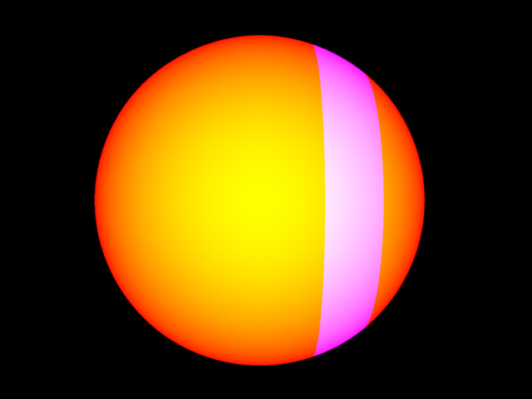
A rendered shader test. The extent of my modest progress is shown here
[2]
Innovation After mental Ray

After conceding to being unable to write the shaders for this project, I consulted as many tutors as I could for advice for where to take the project. I received a variety of suggestions, and worked on a number of them.
Materials Inside Maya

Following my difficulties writing mental Ray shaders, one suggestion that I acted upon was to see what I could create inside Maya’s Hypergraph.

To keep things objective, I decided early on that it would be best to have one fixed piece of geometry to test on, with fixed lighting conditions. I also decided to have a recognisable form on which to test my materials. I understand there are merits to testing materials and shaders on spheres and other primitive geometry, but in this situation I wanted the goal of the exercise to be clearer.

The material for the creature’s skin was to be comprised of two layers, one pale translucent pink/purple top layer, with a cooler green layer beneath.

After considering what meshes I had available to me, I decided to use an unrefined, unfinished mesh of an imaginary creatures head. I applied some basic Lambert shaders to the three distinct areas of the creature: the teeth, the mouth with the tongue and lastly to the outer skin of the creature. I then created a fixed camera to use for comparative renders and started working on the lighting. I read up on three point lighting, and implemented it in my scene. I spent a little extra time making sure I was satisfied with the scene, with the understanding that it could save me a lot of problems in the future.

I then spent time looking at tutorials, other peoples’ shading network and reading threads on cgtalk.com about this subject. Although my knowledge on creating materials in Maya was limited, it served me well and I found the techniques I had read about easy to understand and apply.

Looking at other peoples’ work on skin materials I picked up a few ideas to try when making my own materials. My biggest influence during this period was Steven Stahlberg – a regular poster on cgtalk. His tutorial on skin shaders contains many of the core ideas behind my own work.

The main technique used in my material was using a toon shader to tightly control the shading, and also to define transparency masks. Another node which I learned about during this project is the surface luminance node. This node calculates the value for the light hitting a point of a surface. This node was used to control how the shading on various layers behaved in relation to light levels.
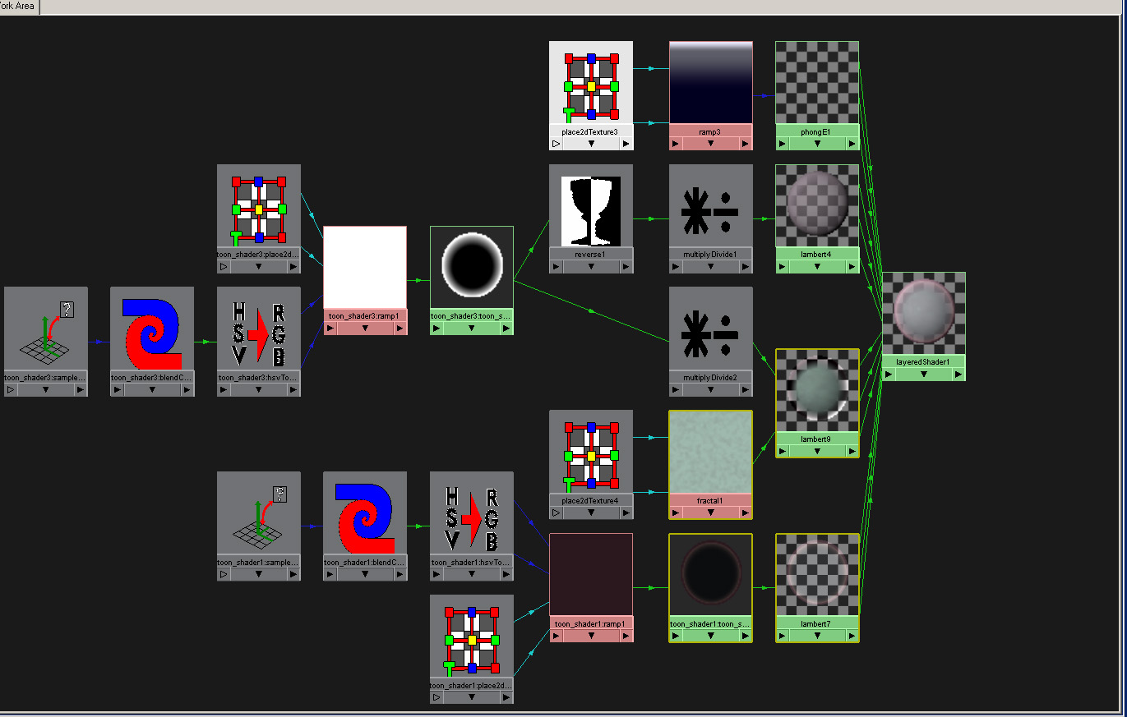
The fully expanded Hypergraph of the final layered material
[3]

The final relevant node that was introduced to me was the sampler node. This node provides a plethora of information about the point being rendered; most usefully the facing ratio value. This is the inverse of the dot product of the normalised camera direction and the surface normal. The behaviour of this value is such that the narrower the angle which the camera is in relation to the surface normal, the smaller the value. The reverse of this is that the closer we get to being parallel with the surface normal (or the closer we get to looking ‘head on’ for want of a better word) the closer the value gets to being 1.0. This node had possibilities, but did not appear in my shader network because the toon shaders made it redundant for what I wanted to do. My material node network also made use of some standard maths nodes, whose purpose is self explanatory.

When I had finished developing this shading network, I was pleasantly surprised. The process had been more intuitive and easier then I had expected, and the results went some way to realising my idea to have a two layer skin shader. The speed with which it rendered was also was a big help – it allowed me to get feedback very quickly, helping me figure out what worked and what didn’t.

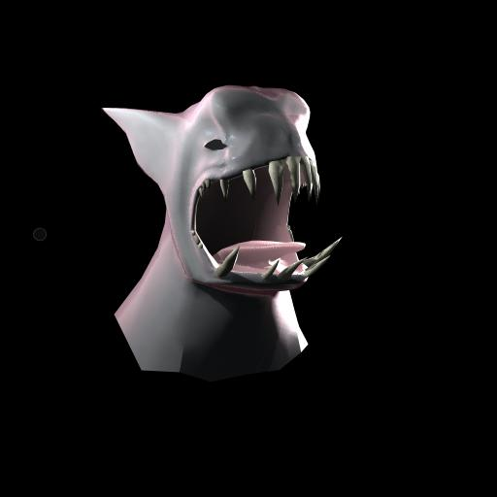
Final Skin material test shot. Note the translucent appearance at the edges
[4]

Generally I found the whole experience of making shading networks inside Maya enlightening. My awareness of what can be accomplished, and how to go about it has improved greatly, and this is an area which I am interested in coming back to. My primary shortcoming with this phase of my work came from not knowing what to expect when I started and hence not having a clear enough vision of what I wanted the skin material to look like at the start.
Dirtmap Hacking

The next idea I worked on was given to me by Adam Vanner, my assigned tutor. He proposed an idea, when I was still unsure about where the project was going. He suggested I try writing a shader that fakes sub surface scattering.

His idea was that when a visible ray hits a surface with the shader applied, it would cast out a random series of rays from the opposite side of the surface. The shader would then calculate the average distance which the rays travelled before they hit another surface, giving a rough number for the internal proximity of other surfaces in an object. Knowing roughly how close two surfaces are will give us a per point approximation of the thickness of an object. The colour of the point could then be modified based on the thickness of the geometry, resulting in thinner meshes giving off a secondary diffuse colour.

Although at first I did not act upon this idea, after I had experienced such a frustrating lack of progress in writing my own shaders I reconsidered this option. The main reason for looking at this technique was the Dirtmap shader.

The Dirtmap shader is an occlusion shader. It works in a similar way to the proposed fake sub surface scattering shader I described earlier. Each time the shader is called, it shoots out a user defined number of rays, which then are terminated and measured when they either hit another surface or breach a predetermined boundary. The values are then averaged and then depending on the proximity of the surrounding geometry, a colour is assigned. Dirtmap creates shading similar to that of a scene lit by a hemisphere using Final Gathering, although at much quicker speeds.

After reading about and testing the Dirtmap shader, I started to realise how similar Adam Vanner’s idea was. The author of the Dirtmap shader has made his source code available online, which made the thought of modifying it tempting. I did end up looking at the source code, and to my relief it was clearly if somewhat concisely commented.

Despite my early enthusiasm, I still had a lot of problems trying to modify the code. I was running very short on time, and research on how real sub surface scattering work left me unconvinced of the merit of this particular project. Modifying someone else’s work to produce a meaningful product has its place, but doing so to produce a poor imitation does not in my opinion provide adequate justification for working on the back of someone else.
Sub Surface Scattering

sub surface scattering has become a real buzzword over recent years in the world of computer visualisation. sub surface scattering refers to the real world interaction of non-metallic objects with light. All non sub surface scattering shading algorithms work on the principle that light rays will always leave a surface at the point they arrived at. Whilst this is true for metallic objects, it does not account for everything else. It is one of the reasons why in metallic objects in the world around us look harder and sharper then organic objects. Although it is hard to quantify these qualities in such terms, one can clearly see that the visual effects industry has suffered from these kinds of criticisms over the years. People regularly respond to subtle visual cues and complain that cg characters look manufactured, cold and just plain wrong. Part of the problem is the quality of animation, and one could argue that the photo realistic still cg image, which has been established for a number of years, now proves this. I would however argue that a still image has had things like lighting and colour balance been tweaked to a level that cannot be achieved in animation. Regular shading algorithms do not adequately describe participating media and this weakness is highlighted within complex, shifting lighting setups – like those found in animation.

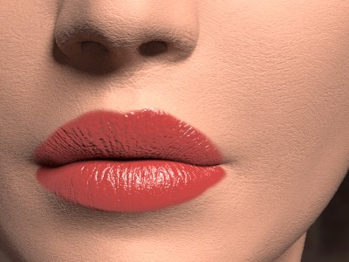
Skin rendered with a traditional shading model. Notice the flat powdery appearance

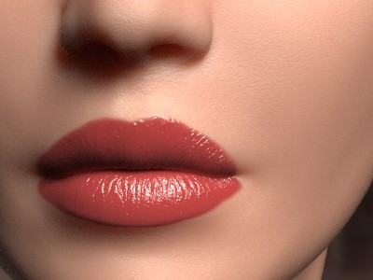
Skin rendered with the newer sub surface scattering model to give a more realistic appearance
[5]
This is where SUB SURFACE SCATTERING provides a solution. Sub surface scattering is a shading algorithm based upon real world surfaces which absorb light. Rather then light merely bouncing off a surface at the point where was hit, sub surface scattering allows the light ray to penetrate the surface, fragment and diffuse randomly to different depths. The difference in appearance that this shading model yields is subtle. The most common, and to me the most gimmicky aspect of sub surface scattering is the effect of light passing through a characters ear. SSS will take into account the relative thinness of the ear and will allow a percentage of the light to pass through from the one side to the other. Time after time, the example of a character’s glowing red ear is used to show the most obvious elements of sub surface scattering. Although this situation based example is important, it has broader implications for the shader. The translucency that sub surface scattering offers, allows for a controllable, softer and deeper look to models. Shadows cast by sub surface scattering geometry will be softer and have more depth – this is especially noticeable with small bump mapped features such as pores and wrinkles. Lastly colour bleeding gives transitions a much more believable appearance.
miSS Phenomena Set

As part of my project investigating skin shaders I decided to look at sub surface scattering shaders for Maya. Based on official support, community support and community recommendations I chose to work with the sub surface scattering shader included with the Maya 6 bonus tools. This shader is the product of mental Images, and impressed me not only with its image quality, but also with the volume of supporting tutorials and articles written for it.

Strictly speaking it would be wrong to refer to the miSS package as a shader. It is a Phenomenon – a mental Ray group of shaders with restricted user controls. For clarity however, I will refer to the Phenomena here as shaders. There are quite a few shaders included with the Maya 6 bonus tools, all relating to sub surface scattering, so to keep things simple I will only look at two of them.

The first is miss_physical – this is a physics based shader that requires raytracing to be enabled. This would be ideal for photorealistic situations where the absorption rate of the sub surface scattering materials and scale of the scene are known. The physical shader is full accuracy and requires a great deal of fine tuning to achieve the kind of results it is capable of.

The second and more interesting shader is miss_fast_skin_maya. As the name suggests, this shader is designed to be used for skin, and quick to render. It does not require raytracing to work, and has a wholly different interface to the physical shader. The skin shader has 4 layers to it. The epidermal, top layer of skin, below this the subdermal layer and then a flesh layer. On top of all of these layers is a simple, controllable specular level. Values for the colour of each level can be set, along with the thickness and diffraction radius of each of the skin layers. There’s also a hugely useful multiplication factor to scale all these values uniformly.

On first impressions, I was let down by this shader. I took my testing scene, applied the shader and ran a few renders, and a lighting test. My immediate reaction was that this was a case of ‘the emperor’s new clothes’. I tried to see what was different or special about this shader and ended up convincing myself that it was somehow slightly softer looking. I assumed this was down to my settings and that tweaking them would make a difference. After trying various combinations of settings, I still was unable to see any real evidence that this shader was any better then a regular Lambert shader. The real frustration for me was in my inability to recreate the ‘glowing ear’ effect I mentioned earlier. It’s fast becoming the new cliché of computer graphics, but it’s still an obvious indicator that the sub surface scattering is working. Unsatisfied with my results I turned to the cgtalk.com forums, where there are several threads each more then 20 pages long. After much reading, I worked out where I was going wrong. The miss_fast_skin_maya shader does not require raytracing to be turned on – this is one of the advantages it has over other sub surface scattering shaders written for Maya, and an advantage it holds over the physical shader. However some form of raytracing is typically needed to calculate the scattering of light in the surface. To get around this, the fast shader requires a lightmap. Lightmaps store baked light information for each point in a scene. The miss_fast_skin_maya shader needs to be connected to two nodes in the Hypergraph; a misss_fast_lmap_maya node to generate the lightmap, and a mi_texture node to plug into the shader.

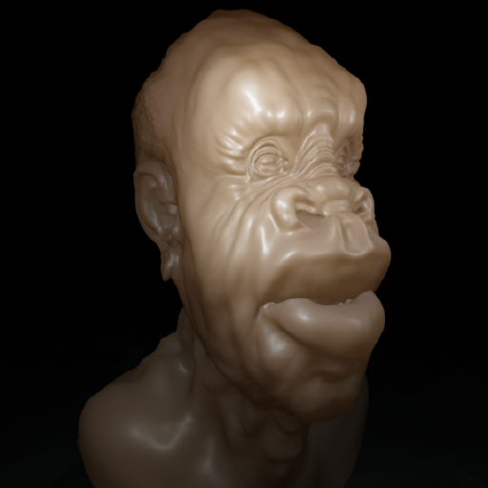
Mesh with displacement map, using miSS_fast_skin_maya shader
[6]
At this point I was starting to see what everyone I had read writing on this shader was raving about. Even with settings ‘out of the box’, a fairly unsuitable model and without any form of texture, the shader was remarkably convincing and surprisingly fast. With an interest in seeing this shader in a better light, I loaded up a scene that I was testing last year. The scene contained a model I had downloaded, designed for users to test out their renderers with a displacement map. The model is the head of a human character and contains significantly more detail then my makeshift monster head. The tests impressed me a lot, but without creating textures for the various channels I couldn’t take my tests much further. I chose not to do this as it would have taken too much of my time and would have introduced my artistic ability into the critical appraisal of the shader. The last thing I tried, as a way to examine how the shader dealt with finer details, was to apply a noise node to the bump channel. This caused a problem at first, research online indicating that the creation and assignment of a bump node was necessary, as opposed to just clicking on the ‘map to’ icon. Once this small problem was overcome, I was satisfied to see predictable and consistent results.

All things considered I was and still am amazed by this shader. Although every case is different, and each case requires its own considerations, adaptations and modifications, in my opinion this shader can be used as the basis for a huge variety of skin materials. Working with this shader is extremely straight forward – the shader looks great with default settings and requires very little tweaking to modify it. The shader really does take away a lot of the hard work in making a professional looking material, and with some well thought out texture maps it saves a lot of hassle when setting up the lighting for animation.

Conclusion

Needless to say this project did not turn out as I expected. It has meandered from topic to topic with not enough to show at the end. I have found that as a learning experience this project has had many positive aspects. Although I have not come out of this as a fully fledged shader author, I am much more comfortable setting up and working with shading networks. Despite my failures with mental Ray, I am in a better position to try again to learn the shader language.

From my point of view, the mental Ray shader writing part of my project was the least successful. Considering that I spent 75% of the project time working on getting up to writing very basic shaders, I hope my frustration is understandable. To put so much time and effort into getting this working, and then being unable to take it any further was disappointing. I felt I was very much alone when trying to write my shaders, with no one at university able to offer me much in the way of advice.

The responsibility for picking too ambitious a project is of course ultimately my own, however I do feel slightly aggrieved that until I came into university and explained how horribly my project was going that I got several responses indicating that my experience was not unusual. I am disappointed that early on in my project, when I was talking to the university’s resident mental Ray shader expert, asking for advice; I received nothing in the way of suggestions for learning mental Ray or any such warnings about the difficulty of the subject. I can take responsibility for my poor judgement, but being talking to users at university and hearing other people talk about how unapproachable they found the subject, I am more then a little confused as to why no one mentioned to me that this might be too challenging a project.

If I ever decide to attempt to write mental Ray shaders again, it will be with a better teaching reference. Although complete, the Programming mental Ray book in not suitable to learn from. I think there is a big gap in the market for someone to write a ‘mental Ray – shaders for dummies’ type book, and when it is written, Ill be at the front of the line to get my copy. Until something like that materialises, there’s just not enough information either written in books or floating around in cyberspace to make me want to go through the tedious process of near trial and error writing shaders.

Concluding this part of my project was frustrating. Accepting defeat with so little to show for it is on a personal level upsetting, and especially so when you know that your error in judgement 4 months ago will have an impact on your degree. I am convinced now more then ever that mental Ray is going to be PRMan’s biggest rival in the coming years, and that shader writers will be in short supply for the industry. I am still positive that this project; done right, would be a hugely useful experience to have under ones belt. It’s just immensely frustrating to think that until there is a respectable body of supporting material, I don’t it is reasonable to expect an undergraduate student to complete this project.

The project went in a few directions after I had finished working writing shaders. Although I had success hooking up my own shader network inside Maya, and despite enjoying learning about what sub surface scattering shaders were available and how one of them worked in detail, I cannot help but feel disappointed that I was reduced to working on top of an API with other peoples’ code. After my early enthusiasm for writing my own shaders, this work did not feel worthy to be part of a project titled Innovations. All things considered the second half of the project seemed to go smoothly, and although broad in scope I learned a great many things along the way.

In an ideal world I would have a typical project; a fairly well established solution to arrive at, a mostly complete ‘product’ and a report to say how I overcame the problems I met along the way. Reality was not like the paradigm however, and I have made a genuine effort to make the best out of a bad situation.

It is normal practise for a report to contain a section detailing what the student would have changed in his working method if he had the benefit of hindsight. I think my change is particularly poignant and is a good indication of my feeling towards this project. If I had the benefit of hindsight, the first and only change I would make for this project would be to change the proposal altogether.

Bibliography

“Human Skin Shading” Steven Stahlberg 2002 http://www.optidigit.com/stevens/shadetut.html

“SSS Tutorial” mental Images, Berlin, 2004 (see references\ sss-skin-tutorial.pdf)

“Programming mental Ray”. Thomas Driemeyer. SpringerWienNewYork. 2000 (also see references\prog21.pdf)

"A Practical Model for Subsurface Light Transport". Henrik Wann Jensen, Stephen R. Marschner, Marc Levoy and Pat Hanrahan Proceedings of SIGGRAPH'2001. (see references\bssrdf.pdf)

“BSSRDF Notes” Andy Scukanec, Cornell University 28/7/2004 (see references\BSSRDF_Notes.pdf

“Shader Writing” Jan Walter 9/2/2004 (see references\filmakademie.pdf)

“Renderman, Theory and Practice” Siggraph 2003 Course 9 27/7/2003 (see references\sig03.course09.pdf)

“Sub Surface Rendering” Author unknown (see references\SubRendering.ppt)

“Jeffpatton.net” Jeff Patton 2005 http://jeffpatton.net/index.html

“Nanomation tutorials” Dave Rowntree 2005 http://www.nanomation.co.uk/Tutorial.html

“LA mental Ray user Group” 2005 www.lamrug.com

“Jan Sandstrom” Jan Sandstrom http://www.sandstrom.on.to/

“Using Shading Switch in Hypershade” David Harjanto 2003 http://cloud.prohosting.com/misterdi/tutorial/ShadingSwitch/shadingSwitch.html

“animusartis” Daniel Rind 2004 http://animus.brinkster.net/index.html (author of dirtmap)

www.cgtalk.com forums; with specific reference to the following threads

“mental Ray Shader Discussion” http://www.cgtalk.com/showthread.php?t=104578&highlight=SSS

“More mental Ray shaders!” http://www.cgtalk.com/showthread.php?t=162242&highlight=SSS

“pSSSt”
http://www.cgtalk.com/showthread.php?t=144747&highlight=SSS

“Realistic Image Synthesis Using Photon Mapping” Henrik Wann Jensen A K Peters Ltd 2004

Citations

[1] “Programming mental Ray”. Thomas Driemeyer. SpringerWienNewYork. 2000

Image Credits

[2] Copyright held by author
[3] Copyright held by author
[4] Copyright held by author
[5] Henrik Wann Jensen, Stephen R. Marschner, Marc Levoy and Pat Hanrahan: "A Practical Model for Subsurface Light Transport". Proceedings of SIGGRAPH'2001. (see references\bssrdf.pdf)
[6] Mesh copyright of ‘Pixolator’ posted at www.pixolator.com 2004

Other Credits

Special thanks to George Cherouvim for help getting me set up for shader writing, Steve Stahlberg for writing a great tutorial on skin shading and the people at mi for writing a great sub surface scattering shader

