Implementing a Practical Renderman Skin Shader

Peter Dudley-Ryder

NCCA Bournemouth University 2005

Contents

1 Introduction

1.1 Previous Work

2 Theory

2.1 Reflected Photons

2.1.0 Ambient Light Reflection

2.1.1 Diffuse Light Reflection

2.1.2 Specular Light Reflection

2.1.3 Fresnel Reflection

2.2 Scattered Photons

2.2.0 Front Scattering

2.2.1 Back Scattering

2.2.2 Concave Attenuation

2.3 Total Light Intensity Function

3 Implementation

3.1 Front Scattering

3.1.0 Finding Sample Point P_{i}
3.1.1 Calculating Irradiance at Sample Point

3.2 Back Scattering
3.2.0 Finding Sample Point P_{i}
3.2.1 Calculating Irradiance at Sample Point

4 Optimization

4.1 Exclusion of the Concave Function

4.2 Caching Scatter Illumination

4.3 Caching Scatter Positions

4.4 Caching Sample Points UV’s

5 Results

6 Improvements

7 Future Work and Extensions

8 Acknowledgements

9 References

Please note that if this is a printed copy then some of the images may not display the subtle differences between them. If this is the case please refer to the CD and view the images on a computer.

Implementing a Practical Renderman Skin Shader

Peter Dudley-Ryder

NCCA Bournemouth University

Abstract

This paper presents a simple method for implementing a practical skin shader for use within a production pipeline. The method enables effects that BRDF (see introduction) models cannot capture, such as subsurface light transport within the skin. The model was designed with the purpose of providing a practical skin shader to be easily integrated into a production pipeline.
The paper can be divided into three parts. The first part of the paper introduces the reader to the proposed method in theoretical terms. The second part covers the methods used to implement this theory into a Renderman shader. The third part discusses the implementation of a caching system to enable the use of the shader within a production pipeline.

1 Introduction

People are particularly perceptive when looking at human characters. Even if the character design does not call for strict realism, people still quickly get a sense that “something is wrong” when looking at skin rendered without consideration of skin’s organic properties.
Skin is an organic material, in which photons can be scattered in many different ways. However, we can group this scattering into two main types.
The first is surface scattering, where light is reflected at the air/surface boundary. This reflectance can be described using BRDF’s (Bidirectional Reflectance Distribution Function”), which just describe how incoming light at a surface is reflected back towards the viewer. However, one should note that the BRDF assumes that light entering a material leaves the material at the same position as it entered.
The second is the subsurface scattering reflectance, where light enters the object’s surface layer, interacts with those particles, and then exits the layer at a different location (Figure

1). This is known as a BSSRDF (Bidirectional Surface Scattering Reflectance Distribution Function). This property of organic materials means that the standard BRDF approximation cannot be used to simulate the effect of subsurface light transport. Therefore, in order to effectively model the scattering of light by skin, one must devise a method to account for this subsurface effect.
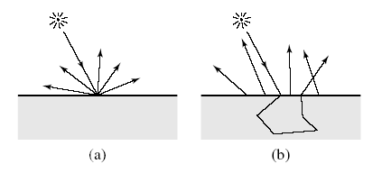

Figure 1: (a) BRDF reflectance
(b) BSSRDF reflectance

  - Previous Work

Almost all BRDF models are derived from surface scattering, with any subsurface scattering approximated by a Lambertian component. However, an early approach to modeling subsurface scattering which extended the BRDF was developed by Kubelka and Monk [2] whilst researching the problem of modeling the appearance of layered surfaces. They considered the problem of determining the resulting overall color from a set of layers of differently coloured paints. Hanrahan and Krueger [1] took this further and developed an analytic expression for single scattering in a uniformly lit slab. Pharr simplified this model and presented a model to simulate reflection of skin [2]. However, all BRDF models ultimately assume that light scatters at one surface point and they do not model subsurface transport from one point to another.
Subsurface transport can be simulated accurately but slowly by solving the full radiative transfer equation [3]. Only a few papers have taken this approach to subsurface scattering. Dorsey et al. [4] simulated full subsurface scattering using photon mapping to capture the appearance of weathering in stone. Pharr and Hanrahan [5] used scattering functions and Monte Carlo evaluation to simulate subsurface scattering effects. However, these approaches, while capable of simulating all of the effects of subsurface scattering, were computationally very expensive compared to the simulation of opaque materials.
Jensen et al. [7] proposed a new method for subsurface scattering. The problem with techniques based on path sampling was that they were particularly inefficient with highly scattering materials such as skin and milk as these materials tend to scatter light in an isotropic fashion. Stam [6] had already developed a method for simulating this using diffusion theory. Jensen’s proposed BSSRDF combined both the Hanrahan and Krueger Model for the single scattering component, and Stam’s diffusion theory for multiple scattering. His results were physically correct whilst retaining reasonable speed.

- Theory

In order for the model to be easily integrated into a production pipeline, the method must satisfy the following criteria:
- The rendering time should be relatively fast.
- The lighter should be able to simply enable scattering without having to make changes to the lighting setup.
With these criteria in mind, none of the methods mentioned in section 1 can be used in their entirety. Therefore, a new approach must be developed to cater for these criteria.

To develop a practical model for our skin shader, we must first consider the huge number of complex paths a light photon can take when it interacts with the skin surface. As our model is just simulating the effects of a skin surface, we can simplify the paths taken into four main groups (Figure 2). The next two sections discuss these paths grouped as either being a reflected photon or a scattered photon.

2.1 Reflected Photons

On interaction with the skin surface, some of the light will be reflected without entering into the skin (Figure 2(a)). For this

Air
Bone
Air
Skin
(a)
(b)
(c)
(d)
Light
Figure 2: Simplified path of light photons on interaction with skin surface.
- Reflected photon
- Front scattered photons
- Blocked scattered photons
- Back scattered photons

reason we can use our standard BRDF to calculate the amount reflected. However there are four reflection models that we must consider: ambient light reflection; diffuse light reflection; specular light reflection and the Fresnel reflection.

2.1.0 Ambient Light Reflection

In most environments there is ambient light from a variety of sources that is repeatedly reflected off various surfaces and eventually reaches the surface of interest. Rather than model such light sources individually, we can make the simplifying assumption that ambient light comes equally from all directions. Then we can model the reflection of this ambient light as a constant term that has no dependence on the viewer.

I_{a} = L_{a} . k_{a}

Where I_{a} is the intensity of the reflected ambient
light,
L_{a} is the intensity of the incident ambient
light,
k_{a} is the coefficient of ambient reflection

2.1.1 Diffuse Light Reflection

The surface of skin like many other surfaces, exhibit a rough surface finish. When parallel light rays hit such a surface they are reflected in a random fashion thus scattering in all directions. According to Lambert’s law, what determines the brightness of such surfaces is the incidence angle i. The model for diffuse light reflection can be expressed as:

I_{d =} L_{p} . k_{d} . (L dot N)

Where I_{d} is the intensity of the reflected diffuse
light,
L_{p} is the intensity of light of point source,
L is the unit vector in direction of light
source,
N is the surface normal vector,
k_{d} is the diffuse coefficient,
dot is the dot product of two vectors.

2.1.2 Specular Light Reflection

Skin can often have an oily layer, especially in areas on the face, which exhibit a smooth surface finish. When parallel light rays hit such a surface and are reflected off it, they remain parallel. The best visual indicators of this effect are highlights i.e. the specular reflections of the light sources. We can calculate the specular reflection function using Blinn’s method:

I_{s} = (N dot H)^{n}

Where n is the specular sharpness,
I_{s} is the intensity of reflected specular,
E is the vector in the direction of the
viewer,
H = (E+L)/|E+L|, the vector halfway
between E and L.

2.1.3 Fresnel Reflection

Another important effect to account for is Fresnel reflection. At the boundary between two objects with different indices of refraction, such as air and skin, some incident light if reflected back from the boundary and some of it is transmitted depending on the angle of the incident light ray and the indices of refraction of the surfaces. The Fresnel formula describes this effect (see [2] for a detailed explanation of the Fresnel formula). Pharr [2] suggests using the Fresnel reflectance in conjunction with specular reflectance to intensify the oily property of skin. The Fresnel Reflectance is given by:

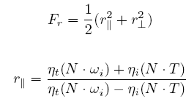

where
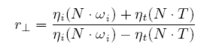

w_{i} is the incident vector,
η_{i} is the index of refraction of air
in this example,
η_{t} is the index of refraction of skin
in this example.

2.2 Scattered Photons

So far we have only discussed photons that reflect at the air/surface boundary, and therefore do not enter the skin surface. However, a proportion of the light photons will enter the surface of the skin. As light enters the skin, it will interact with the particles causing some of it to be absorbed and some to be scattered. Some of the remaining light is then scattered out of the top of the skin surface, which we will call front scattering (Figure 2(b)). Of the remaining light some is absorbed by blocking materials, such as bone, which we will call blocked scattering (Figure 2(c)), and some will make through without being absorbed, exiting on the opposite side of the surface, which we will call back scattering (Figure 2(d)).

2.2.0 Front Scattering

We can approximate front scattering by calculating the intensity of light from the light source L₁ exiting at point P having entered at point P_{i} (Figure 3). As skin tends to scatter light in an isotropic fashion (i.e. uniformly scatters light in all directions), we can simply take the distance between the point P_{i} and P to be the distance the photon has traveled within the surface, and then use this distance, along with the attenuation coefficient to attenuate the intensity of the light. The attenuation coefficient describes the differential attenuation per distance traveled in the medium. Hence it is necessary to know both the coefficient and the distance the light has traveled.

L₁
Air
Skin
P_{i}
P
d

Figure 3: Front Scatter
P_{i} – Photon entry point
P – Photon exit point
d – Distance photon traveled
L₁ – Light Source

If light travels a distance of d between P_{i} and P, the attenuation of light from L₁ can be modeled as:

I_{Fatt} = I . e^{( - σa d)}

Where I_{Fatt} is the intensity of front scattered
light at P,
I is the intensity of light at P_{i,}
σa is the attenuation coefficient,

2.2.1 Back Scattering

We can approximate the back scattering in the same manner as the front scattering. However there are some assumptions that must be pointed out. We are neglecting the correct refraction as the light enters the skin, and we are assuming there is no refraction as the light exits the skin (Figure 4). These assumptions make the calculation of distance d easier to implement with minimal loss to the attenuation accuracy.

L₁
Air
Skin
P_{i}
P
d
Air
Figure 4: Back Scatter
P_{i} – Photon entry point
P – Photon exit point
d – Distance photon traveled
L₁ – Light source

We must also take into account the blocked scattered light, the fraction of light which enters the skin but then is absorbed by blocking materials. This fraction will only have effect on the back scattered light, and hence we can add a blocking coefficient k_{b} to the attenuation calculation for back scattered light:

I_{Batt} = K_{b} . I . e^{( - σa d)}

Where I_{Batt} is the intensity of back scattered
light at P,
I is the intensity of light at P_{i,}
σa is the attenuation coefficient,
K_{b} is the blocking coefficient.

2.2.2 Concave Attenuation

So far the model assumes that the path between P and P_{i} is through skin, not air. This will generally be the case, or at least close to the case anytime P and P_{i} are on a surface that is locally flat or convex. However, if the surface is locally concave, then light will appear to ‘jump’ from one surface to the other. In Figure 5 the path from P_{i} to P is through skin.

N
N_{i}
P_{i}
P
Skin
Air
L
Figure 5: Convex surface
N_{i} – Normal at point P_{i}
N – Normal at point P

Figure 7: Cardioid Function

N
N_{i}
P_{i}
P
Skin
Air
L
Figure 6: Concave surface
N_{i} – Normal at point P_{i}
N – Normal at point P

Hence we can calculate the attenuated light from P_{i} using our attenuation functions for front and back scatter as defined previously. But in Figure 6 the surface is locally concave. As a result, light will be transported through air and will appear to ‘jump’ from P_{i} to P. This effect can be overcome by introducing a ‘concave attenuation’ factor.
The undesirable effect occurs when the surface at the point being shaded faces the surface at the sample point. This is the case when two conditions are met:
- The normal N at point P and the normal N_{i} at point P_{i} oppose each other.
- The normal N at point P and the vector L from P_{i} to P oppose each other.
Using a Cardioid function suggested in [8] for each of the two conditions we can calculate when wish to attenuate (Figure 7):
- (1-NdotN_{i})/2 is near 1
- (1-NdotL) is near 1
We can now define the Concave attenuation as:

C_{a} = 1 – (1 – NdotNi)(1 – NdotL)/2

where C_{a} is the Concave attenuation factor.
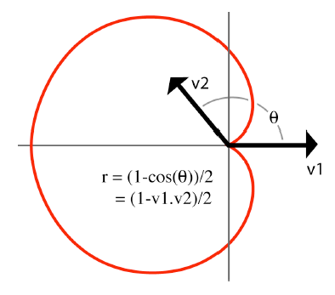

It should be noted that the Concave attenuation factor only needs to be taken into account when calculating the front scatter attenuation. Hence we can rewrite the front scatter attenuation function as:

I_{Fatt} = C_{a} . I . e^{( - σa d)}

Where I_{Fatt} is the intensity of front scattered
light at P,
I is the intensity of light at P_{i,}
σa is the attenuation coefficient,
C_{a} is the Concave attenuation factor.

2.3 Total Light Intensity Function

We can combine the functions for reflected photons and scattered photons into one function which describes the total intensity of the light at a point P. The reflection function for reflected light intensity at point P can be given by:

I_{Rp} = I_{a} + I_{d} + I_{s} + I_{s .} F_{r}

The scattering function for the scattered light intensity at P (Figure 8), coming from point Pi, can be given by:

I_{Sp} = I(P_{Fi}) . I_{Fatt} + I(P_{Bi}) . I_{Batt}

where I(P_{Fi}) is the illumination at point P_{Fi,}
P_{Fi} is the point contributing to the
front scattering,
I(P_{Bi}) is the illumination at point P_{Bi,}
P_{Bi} is the point contributing to the
back scattering.

Hence the total intensity of the light at point P is given by:

I_{total} = I_{Rp} + I_{Sp}

Air
Bone
Air
Skin
P
Light
P_{Fi}
P_{Bi}
Eye
I_{total}
Figure 8: Total Light Intensity Function
I_{total} total light intensity at point P
P_{Fi} is the point contributing to the
front scattering
P_{Bi} point contributing to the back
scattering

3 Implementation

We can implement the theoretical functions derived in the previous section taking advantage of Renderman’s built in functions. The reflection function,

I_{Rp} = I_{a} + I_{d} + I_{s} + I_{s .} F_{r,}

can be implemented using Renderman’s standard ambient, diffuse, specular and fresnel functions. The implementation of these functions will not be discussed in this paper. For a detailed explanation of all the renderman built in functions and how to use them, please refer to [9]. Figure 9 shows a rendering using the reflection function but without the added Fresnel function. It is clear to see the added effect of the Fresnel term in figure 10, where the glossy property of skin is simulated.

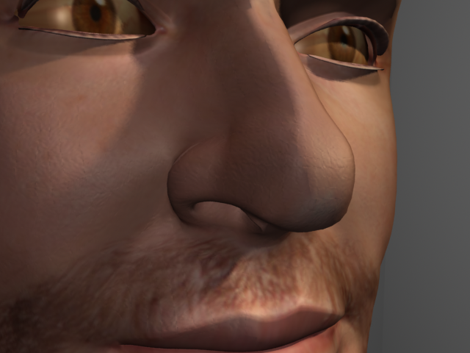
Figure 9: Render using Reflection function with
no fresnel term.

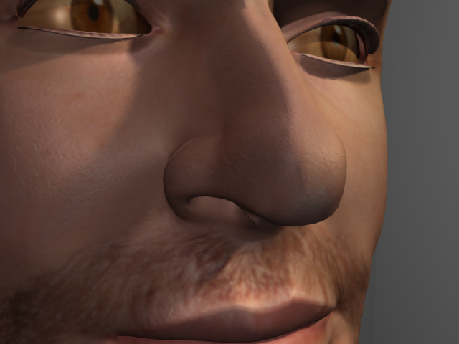
Figure 10: Render using Reflection function with
fresnel term. Notice highlights on
edges (especially the nose).

The scattering function however requires a little more thought.

3.1 Front Scattering

In order to accurately model the illumination due to subsurface scattering we must consider the scattering function at a number of sample points, P_{i,} centered around the shaded point P. Using the derived functions from the previous section we can define the front scattering function as the sum of the contributions of all the irradiance samples at other points on the surface:

frontScatt(P,N)=ΣI(P_{i},N_{i})Att(P,P_{i})Ccave(P,P_{i},N,N_{i})

I(P_{i,} N_{i}) is the irradiance at sample point P_{i}, which can be calculated simply by using the ambient and diffuse functions. Att(P, P_{i}) is the attenuation of light as it travels from point P_{i} to P. Ccave(P,P_{i},N,N_{i}) is the concave attenuation used to suppress light ‘jumping’ from P_{i} to P on a concave surface.

3.1.0 Finding Sample point P_{i}

Our front scatter function states that we must sum up the irradiance contributions of each sample point on the surface. Therefore, we must derive a method to find a number of sample points around P. We can do this by first creating a tangent plane at point P. The renderman global variable dPdu stores the tangent of the surface at P. Hence we have B1, one of the base vectors defining our tangent plane. The cross product of this tangent vector with the normal at P will give us B2, the second base vector defining our plane (Figure 11).

Skin surface
Tangent Plane at P
P
N
B1
B2
Figure 11: Illustrating tangent plane at P created by base vectors B1 and B2.

A certain number of samples (defined by the user) can now be distributed randomly on the plane. However, simply calculating the irradiance at the sample point on the plane will produce inaccurate results. We must find the actual point on the surface that the sample point represents (Figure 12). The renderman ‘gather’ function can be used to trace a ray from point P_{samp} on the plane, in the direction opposite to the normal (-N). When the ray hits something, it can return the point of intersection giving us P_{i} . However, there are some conditions that will return the wrong value of P_{i}.
The first condition occurs if the tangent plane is very large. It may then extend beyond the size of the surface. Therefore when we trace in the direction of –N, either nothing will be hit, or another objects surface will be hit. If nothing is hit, P_{i} will be undefined. But if another object is hit, it will appear that light is ‘jumping’ from that object to our surface. To avoid this situation a unique ID can be assigned to the skin surface.

Skin surface
Tangent Plane
N
P_{samp}
P_{i}
P
Figure 12: Illustrating that we must trace from P_{samp} on tangent plane in direction –N to find point P_{i} on surface.

When the traced ray hits something, the ID of the surface hit will be queried as well as the surface position. If this ID does not match the ID of the surface we are shading, then the value of P_{i} returned will be ignored.
The second condition will occur if the surface around P is concave. If this is the case, the tangent plane will intersect the surface (Figure 13).

N
P
P_{samp}
Skin surface
Tangent Plane
Figure 13: Tangent Plane intersecting with surface.

When the ray is sent from P_{samp} in the direction of –N, it will miss the side of the surface we are shading, and will hit the other side of the surface. We can avoid this occurring by comparing the surface normal at P with the surface normal of the point of intersection. The dot product of the two normals will return the angle in between them. If they are in opposite directions (i.e. the angle in between in greater than 90º), then we can assume that for the majority of cases, the ray has hit the other side of the surface and we ignore P_{i} returned. Sending a second ray, but this time in the direction of N, should return the correct value of P_{i}.
In order to use Renderman’s ray tracing in this way we must be aware that our surface shader is being called every time a ray intersects our surface. Therefore, the shader needs to know if it running on a directly visible point, or running as a ray hit point. If the shader does not distinguish this, rays will be sent by every invoked shader, which in turn will invoke more rays to be sent. The shader will not be able to exit this loop as recursively more rays will be sent, eventually causing the renderer to crash. Fortunately, Renderman provides a way to deal with this using ray labels. When the ‘gather’ function is called, it is possible to assign a label to every ray that we send. When the shader is invoked it will check this label to see if the ray was sent by a point on the same surface. If it was, a different section of code in the shader is used, hence avoiding the recursive calling to send rays.
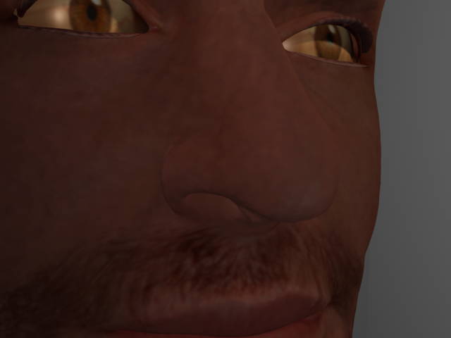
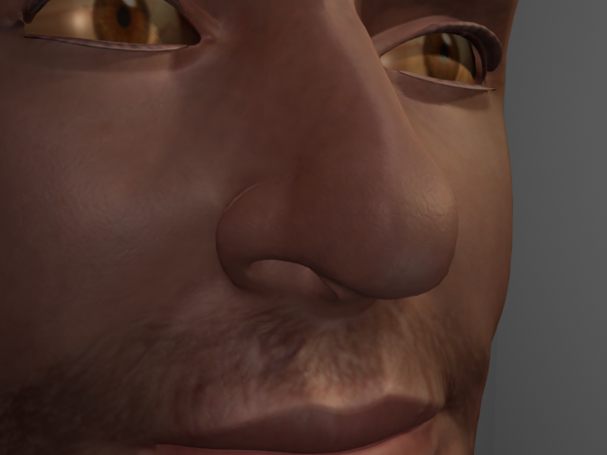

3.1.1 Calculating Irradiance at Sample Point

Fortunately the ‘gather’ function provides a way to access any variables in the shader invoked by a ray intersection. Our shader will know that it has been called by a ray sent from the same surface using ray labels as described in the previous section. When this is the case, we calculate the irradiance at P_{i} using the ambient and diffuse functions, and return its value back to the shader which sent the ray. This irradiance is then attenuated using the Att(P,P_{i}) and Ccave(P,P_{i},N,N_{i}) functions as described in section 2. The resulting value will be the intensity of light at P due to front scattering.
However, to simulate the effect of different wavelengths being absorbed by different amounts, we can provide the user with a ‘tint’ factor to modify the colour of the front scattering. Jensen [7] suggests using the following values for skin:
R 0.032
G 0.17
B 0.48

Figure 14: Illumination due to Front Scattering

Figure 15: Illumination due to Front Scattering and the reflectance function. Mix factor – 0.8

Figure 16: Illumination due to Reflectance function only.

Figure 14 shows the illumination from front scattering. The dark red coloring is the effect of the tint factor. To combine our front scattering with the reflection function, we mix our front scattering illumination with the diffuse illumination using the renderman function ‘mix’. This way the user is able to define a mix factor which will determine how much of the front scattering illumination should be mixed with the diffuse illumination. The mixed result can be seen in Figure 15. Comparing this with Figure 16, the effect of the front scattering can clearly be seen. In particular, the effect of subsurface light transport can be seen by the softened shadows and smoother transitions of contrast in Figure 15, which are essential characteristics displayed when light interacts with skin.

3.2 Back Scattering

We can implement back scattering using very similar techniques described in the previous section to implement front scattering. Using the derived functions from the previous section we can define the back scattering function as the sum of the contributions of all the irradiance samples at other points on the surface:

backScatt(P,N)=ΣI(P_{i},N_{i})Att(P,P_{i})Block(P,s,t)

I(P_{i,} N_{i}) is the irradiance at sample P_{i}, which can be calculated simply by using the ambient and diffuse functions. Att(P, P_{i}) is the attenuation of light as it travels from point P_{i} to P. Block(P,s,t) is the attenuation due to the blocking coefficient.

3.2.0 Finding Sample point P_{i}

Our back scatter function states that we must sum up the irradiance contributions of each sample point on the surface. With front scattering, a tangent plane was used. However, this is unnecessary for back scattering, as we wish to take sample points on the other side of the surface. Once again we can take advantage of the ‘gather’ function to accomplish this. By tracing from P in the direction –N, we can retrieve P_{i} in the same way explained in the previous section. However we wish to sample a number of points along the opposite side, not just one. Therefore we can tell ‘gather’ to fire a number of rays specified by the user, from point P in the direction –N. The ‘gather’ function now requires an extra parameter called ‘angle’, to be passed into it. This angle defines the cone within which rays are cast (Figure 17). We can use an angle of PI/2 which will cast the rays over a hemispherical area.

P_{i1}
P_{i2}
P_{i3}
P
Skin Front Surface

Air
Skin Back Surface

Air
N
σ
Figure 17: Shooting rays from P in direction –N over angle σ in order to retrieve sample points P_{i21,}
P_{i2 ,} P_{i3 .}

3.2.1 Calculating Irradiance at Sample Point

The irradiance can be calculated in exactly the same way as for front scattering: using ray labels to determine which part of the shader should be used; and using the ambient and diffuse functions. Once the irradiance has been returned it is then attenuated by the Att(P,P_{i}) as described in Section 2, and by the Block(P,s,t) function. The Block(P,s,t) function looks up a texture using the s and t parameters as texture coordinates. The texture describes which areas of the surface have a blocking material behind them (black signifying full blocking, white signifying no blocking). As with front scattering we also have a tint factor for the back scattering. Figure 18 shows the illumination from back scattering attenuated with a texture map that leaves only areas of the nose white.
We can combine the back scattering with the other functions by adding it to the front scattering and then using the result to mix with the diffuse (Figure 19). Comparing Figure 19 with Figure 20, we can see the increased illumination around the nose area. It is a subtle effect which adds greater realism.

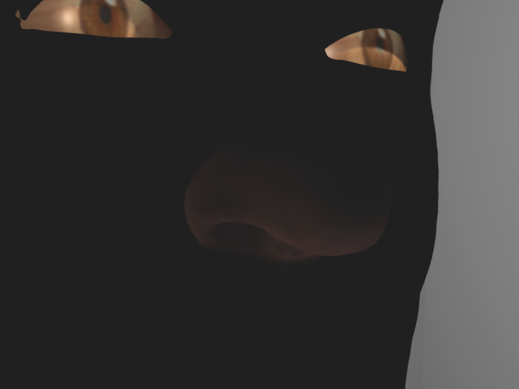
Figure 18: Illumination from back scattering only.

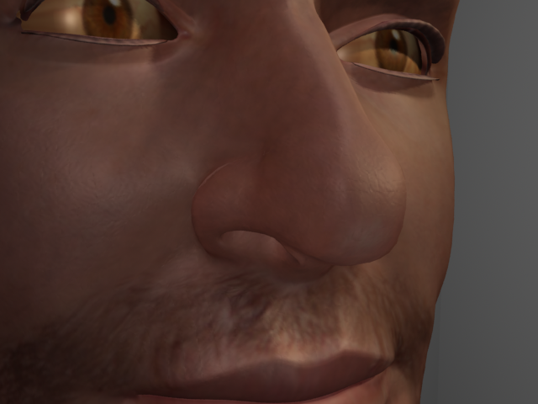
Figure 19:Illumination from the reflection function combined with both the scattering functions.

Figure 20: Illumination from the reflection function combined with just front scattering.

4 Optimization

A method for implementing a skin shader has been presented. However, the shader is not yet ready to be integrated into a production pipeline. Although one of the criteria has been satisfied, in that the shader requires no extra lighting setup and can be enabled and disabled at the will of the lighting team, we have not so far addressed the issue of rendering speed. It is clear that the use of the ‘gather’ function used to calculate front and back scattering is the main factor affecting the render speed. Hence, presented in the following sections are methods to speed up the calculation of the scattering functions.

4.1 Exclusion of the Concave Function

Discussed in Section 3.1.0 is the problem of finding P_{i} for front scattering when the tangent plane intersects with a concave surface (Figure 13). The solution was to calculate whether the ray hit the other side of the surface, and if it did, fire another ray in the other direction N to find P_{i}. As a result, in areas where the surface is even slightly concave, we will be doubling the number of calls to the gather function. This will have a significant effect on our rendering times.
However, if we omit firing a second ray and just ignore the value of P_{i} (as it is on the other side of the surface), we in effect are approximating the Concave function by excluding the contribution of any points that lie concave relative to P. As there is no need for the Concave function anymore, it can be omitted from the scattering calculations. The inaccuracy in doing this appears to be minimal unless there are large areas of the surface which are concave. However, the decrease in rendering time is far more beneficial than the added accuracy gained by evaluating illumination at concave sample points.

  - Caching Scatter Illumination

One option to speed up future rendering times is to cache the illumination from front and back scattering into a file. When rendering subsequent frames, the illumination from front and back scattering can be looked up in the file, which is significantly quicker than ray tracing. We can use the Renderman function ‘irradiancecache’ to efficiently cache the illumination values. However, one must note that the following RIB attributes must be added so that the scattering illumination at all of the points is cached, as opposed to just the visible points:

Attribute “cull” “hidden” 0
Attribute “cull” “backfacing” 0
Attribute “dice” “rasterorient” 0

Although this is an efficient method for caching illumination values, there are some major limitations. The cache will only remain valid if the surface is static and the lighting conditions do not change. This immediately rules out the use of this type of cache with our skin shader for everything but a still image. Therefore we must devise our own caching method unique to our skin shader.

  - Caching Scatter positions

In order to devise a suitable caching system for the skin shader, we must first consider the possible production requirements of the surface that the skin shader is attached to.
The skin shader would most likely be used on a character in areas where a realistic skin shading model would be needed, such as the face. We can assume that the character will employ complex facial deformations to convey emotion. We can also assume that the character’s movements will not be subtle and therefore the lighting conditions will be varying. Caching illumination values would therefore not be sufficient.
However, at each point P, we could cache the positions of the sample points P_{i}. Then when we come to render, instead of tracing to find the sample points, we can just look them up and then calculate the scattering illumination in the usual way. This solves the problem of varying lighting conditions, but would only be sufficient if the character was fairly static and the facial deformations were very subtle.
Therefore, we need a way to almost “glue” the cached positions of sample points to the surface so that if it moves or deforms, the cache will move and deform with the surface. One possible solution to achieving this is to store the u and v coordinates at the sample points instead of the points themselves. Then when we come to render, instead of ray tracing to find P_{i,} we just lookup the relevant uv coordinate representing the sample point and find the point that corresponds to this uv. However, this is quite a bit more complex than it sounds and is discussed in the next section.

4.4 Caching Sample Point’s UVs

As calculating the illumination for front scattering involves sending many more rays than it does for back scattering, we will discuss the implementation of this caching method for front scattering only. However, the same method could be applied to back scattering.
To implement the method discussed at the end of Section 3.3, we will consider the various stages of the method in a simplified way by considering the stages involved for rendering one shading point on an arbitrary frame.

Pre Pass
- Before rendering any frames we must render a caching pass.
- We use the ray tracing method discussed in the previous sections to find the sample points on the surface used to calculate the front scattering at point P.
- We then store the uv coordinates at each sample point into a file.

Frame n
- When we come to render frame n the surface that we are shading has moved and therefore our point P has also moved. When it comes to shading our moved point P, we open our cached uv file for P and read each uv coordinate one at a time, finding the new sample point which corresponds to the uv. With the new sample points we can now calculate the scattering illumination using the same methods as described in the previous sections.

However, if we consider caching data for more than one point then this operation becomes a little more complex. We will need a way of specifying which uv coordinates represent sample points belonging to which shading points. We can do this by first caching the uv at the point being shaded followed by the all the uv coordinates at the sample points.
To enable us to implement this method, we will have to write some of our own Renderman functions (shadeops) in C++, linking them as dynamic shared objects. For information on writing shadeops please refer to [10]. The first shadeop we need to write must enable us to write out the uv coordinates of the point being shaded followed by the uv coordinates at the sample points. We declare this function as:

cacheFrontScatter(uv_{p} , uv_{pi1} , uv_{pi2}, …, uv_{pin}) ,

and it is called after we have found all the sample points for P. We also need a shadeop capable of searching the cached file for the current uv_{p} and returning the corresponding scatter uv’s. We can define this shadeop as:

getScattUV(uv_{p})

Fortunately the renderman global variables u and v are set to the u and v coordinates of the current shading point. Therefore it is easy for us to convert from the current shading point to the uv coordinate at that shading point.
However, when we come to read in our cache file, we will need to find the point on the surface where the uv coordinate representing the sample point lies. This will require us to make an additional cache prior to rendering each frame. This cache will store a list of all the shading points and their corresponding uv coordinates. We can write a second shadeop to accomplish this:

cachePointUV(P, uv_{p})

We now need one more shadeop that takes a sample uv returned from readScattCache() and searches the file generated by cachePointUV() to find the sample point. Hence we can define this shadeop as:

getPoint(uv_{i})

We can now rewrite the stages involved for rendering one shading point on an arbitrary frame, to rendering many shading points on an arbitrary frame.

Pre Pass
- Before rendering any frames we must render a caching pass.
- Use ray tracing to find the sample points on the surface used to calculate the front scattering at point P.
- We use cacheFrontScatter() to cache sample points as uv coordinates.

Frame n
- When we come to render frame n, the first thing we must do is use cachePointUV() to cache a list of all the shading points and their corresponding uv coordinates.
- Then we pass the shading point’s uv into getScattUV() which returns a list of the sample points as uv coordinates.
- We then pass each of these sample uv’s into getPoint() which finds the corresponding point at that uv coordinate.
- We now have the new sample point to be used in the scattering calculations.

The benefits of this method are numerable. Firstly, we only need to calculate the positions of the sample points once. The file cached from cacheFrontScatter() can be used throughout an entire animation and will be valid even if the character moves and deforms. In fact, the only time it would need to be recalculated is if the underlying geometry of the surface changed.

- Results

A method for implementing a practical skin shader for use within a production pipeline has been presented. I have implemented this method as a skin shader in Renderman. Figures 22 and 24 are some of the renders in this paper using the shader. The model used has a colour map and a bump map attached to the surface. Comparing the results with Figures 21 and 23, we can clearly see the effects of the front and back scattering terms. Also notice the added sheen on the edge of the nose due to the Fresnel reflectance.
I have also implemented the illuminance caching method discussed in Section 3.1, which significantly reduces render time. Using this method the render time for Figure 22 was reduced from 23 minutes and 2 seconds to 41 seconds.
I have written the two caching functions, cacheFrontScatter() and cachePointUV(), as Renderman shadeops, but unfortunately the two search functions, getScattUV() and getPoint() are still in the debugging stage and therefore I have not been able to test the rendering speed with this method.

Figure 21: Rendered with Reflectance functions only, with no added fresnel reflectance term. Lit with two spotlights and two point light. Key light casts shadows. Used for comparison with Figure 22

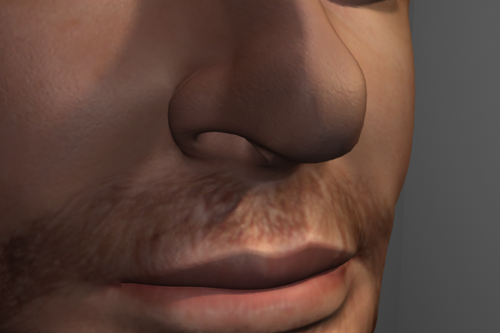
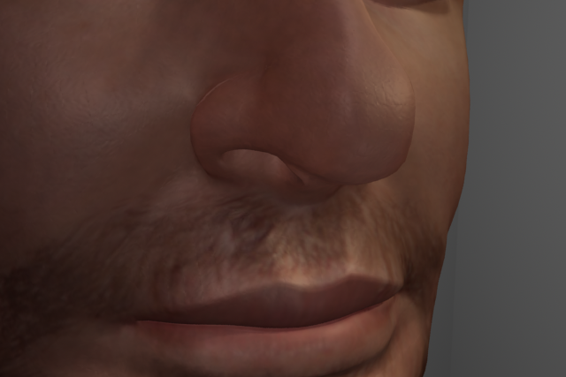

Figure 22: Rendered with the full skin shading model. 200 samples front scattering. Lit with the same lighting conditions as Figure 21. 64 samples back scattering. Time taken to render: 23mins 2secs. Time taken to render using illuminance cache: 41secs.
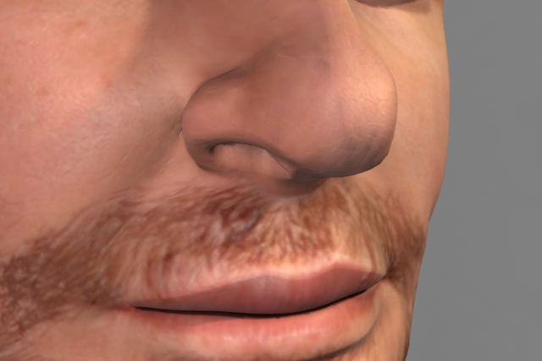

Figure 23: Rendered with reflection functions and an occlusion pass only. Lit with two spotlights.
Used for comparison with Figure 24.

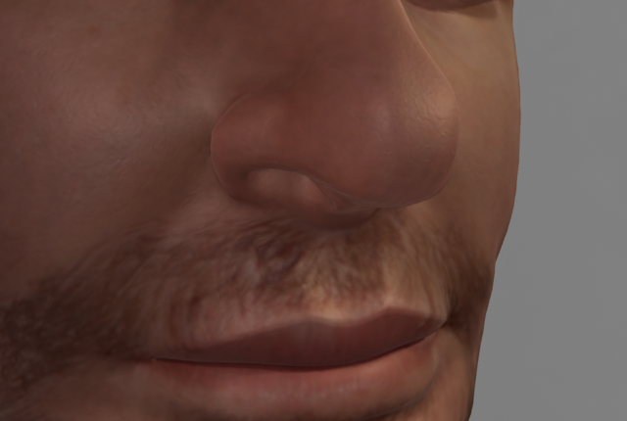

Figure 24: Rendered with the full skin shading model and an occlusion pass. 200 samples front scattering. 64 samples back scattering. Time taken to render: 25mins 10secs. Time taken to render using illuminance cache: 1min 22secs. Lit with same lighting conditions as Figure 23.

6 Improvements

Despite the caching method proposed in Section 3.4, we still have the cache pass which utilizes the use of ray tracing. The ray tracing combined with the time taken to cache the desired data, results in an incredibly slow caching pass. Even though this only needs to be calculated once for the entire animation, it would be best if we could alter the skin shading model proposed in this paper to utilize a different method of finding P_{i}. We could use the faces of the surface instead of points for the samples by somehow laying out the faces in the camera plane and then rendering to produce maps as suggested by Tomson [8].
So far the implementation of the UV caching method suggested in section 3.4 uses text files to store the cached data. Reading the file is not only slow but searching the file for the required data becomes an awkward task. A solution to this problem would be to write the data as a texture which can be ‘lookedup’ and searched in a much more efficient manner.

7 Future Work and Extensions

I plan to shortly complete the implementation of the UV caching method, and depending on the speed improvements I may rewrite the caching method to write to texture files as opposed to text files.
I plan to extend the skin shading model to include support for global illumination effects.

8 Acknowledgements

Special thanks to Mauricio Villamil for providing the head model textured with the color map.

9 References

[1] P.Hanrahan and W.Kruegar. Reflection from layered surfaces due to subsurface scattering. SIGGRAPH ‘93

[2] M.Pharr. Layered Media for surface shaders. Advanced Renderman Siggraph 2002 course notes, chapter 3.

[3] S.Chandrasekhar. Radiative Transfer. Oxford Univ. Press, 1960.
[4] J.Dorsey et al. Modeling and rendering of weathered stone. Computer Graphics Proceedings 1999.

[5] M.Pharr and P.Hanrahan, Monte Carlo evaluation of non-linear scattering equations for subsurface reflection. Computer Graphics Proceedings 2000.

[6] J.Stam. Multiple scattering as a diffusion process. Eurographics 1995.

[7] H.Jensen et al. A Practical Model for Subsurface Light Transport. SIGGRAPH 2001.

[8] E.Tomson. Human skin for “Finding Nemo”. Siggraph course notes 2003.

[9] Renderman Specification 3.2

[10] The Renderman Documentation.

[11] L.Gritz and A.Apodaca. Advanced Renderman, Creating CGI for Motion Pictures.

[12] I.Stephenson. Essential Renderman Fast.

