FRACTALS.
AN INVESTIGATION INTO THE GEOMETRY OF CHAOS.

Fiona Mortimer
National Centre for Computer Animation
Bournemouth University

ABSTRACT
This report describes methods of creating fractals and the ways they are used in computer graphics.
We compare different methods of creating clouds in Maya and discuss algorithms for generating fractal terrain. We explain how we implemented these algorithms in Maya using MEL scripting. Our approach uses simple geometry and overcomes problems that arise because of limitations in MEL.

1. INTRODUCTION
Fractals serve two main purposes in computer graphics. They can either be used solely as an art form to create beautiful patterns or as a way of generating patterns and forms found in nature, such as: fern or maple leaves, landscapes, galaxies, rivers, clouds and coastlines. The initial aim for this project is to research different fractals and the algorithms needed to create them. We then take a particular interest into fractals used to replicate patterns in nature, especially fractal terrain.

2. FRACTALS
A fractal is a self-similar geometric object. This means if you divide one into parts, each part is similar, or identical, to the original object. They are infinitely detailed so if you zoom in on a smaller area it will look just as detailed and magnificent as the whole.

The history of fractals began with the mathematician Benoit Mandelbrot [Oliver and Hoviss 1994]. In 1975 he introduced the term fractal to describe these self-similar structures and published his ideas through numerous papers including A Theory of Fractal Set. The fractals featured in his papers had all been described by other mathematicians previously but had not been recognised as all having the same common properties. It was Mandelbrot who established the connection between them.

Fractals can be classified into three main categories. These are: Iterated Function System fractals (IFS), complex number fractals and orbit fractals [Ibrahim and Krawczyk].

2.1 The Mandelbrot Set and complex numbers.
The Mandelbrot set is often referred to as the “granddaddy of all fractals” [Mason 2003]. Like other fractals, it had been discovered by other mathematicians long before Mandelbrot did but they were unable to visualise the set because of its complexity. Mandelbrot was the first person to use a computer to plot the set that was then named after him.

Although the Mandelbrot set is incredibly complex the process of generating it is based on an extremely simple equation involving complex numbers. Complex numbers are made up of a real part (a real number such as 4) and an imaginary part. This imaginary part is a real number multiplied by an imaginary number i, for example 3i. The number i is defined as the square root of -1. Therefore, i multiplied by itself is -1. The real part of a complex number can be represented on a one dimensional line called the real number line. Another dimension is needed to represent the imaginary part thus creating a two dimension plane. This plane is known as the complex number plane (Figure 1) and we can graph any complex number on it.

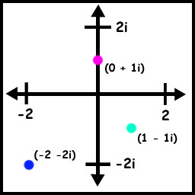
Figure 1. The Complex number plane.

Complex numbers are represented as points C in the complex plane The Mandelbrot set is simply a set of these points. All that needs to be calculated is which points are in the set and which are not. To do this we iterate through the sequence:

Equation 1:
Equation 2:

for each value of C. If Z tends towards infinity the point C is not in the set. Therefore if Z does not tend towards infinity the point C is in the set.

2.2 Julia sets and Quaternion Julia fractals
The Julia set is named after the French mathematician Gaston Julia who investigated their properties circa 1915 [Bourke 2001]. They are very closely related to the Mandelbrot set as they are created using the same sequence, except for one vital difference; the Z value is initialised to numbers other than 0. Quaternion Julia fractals are created by the same principle as Julia sets except that they use 4 dimensional complex numbers instead of 2 dimensional complex numbers.

2.3 Strange Attractors
“An attractor is a 'set', 'curve', or 'space' to which a system irreversibly evolves, if left undisturbed. It is otherwise known as a 'limit set'. There are five known types of attractors; point attractors, periodic point attractors, periodic attractors, strange attractors, and spatial attractors.”[Wikipedia 2001]

Strange attractors belong to the orbit fractal category. They provide a way of visualizing what is known as chaotic motion. The motion of a particle described by one of these attractors will neither converge to a steady state nor diverge to infinity. They will stay in a bounded but chaotically defined region. Another common property of these attractors is the Butterfly effect also known as sensitive dependence on initial conditions. “Sensitivity to initial conditions means that two such systems with however small a difference in their initial state eventually will end up with a finite difference between their states (however, two deterministic systems with identical initial conditions will remain identical).” [Wikipedia 2001]

Attractors are defined by a set of insolvable differential equations and, when computed, can create some very interesting patterns.

2.31 The Lorenz Attractor
The Lorenz attractor was the first attractor to be discovered. It was discovered by the meteorologist Edward Lorenz in 1962 while he was trying to simulate weather on a computer [Bourke 2001]. It can be defined by a set of three differential equations:

Equation 1: | dx/dt = -ax + ay
Equation 2: | dy/dt = bx –y –zx
Equation 3: | dz/dt = -cz + xy

One commonly used set of constants is a = 10, b = 28, c = 8 / 3. Another is a = 28, b = 46.92, c = 4.

2.3.2 The Rossler Attractor
The Rossler attractor was discovered by Otto Rossler during his work on chemical kinetics [Bourke 2001]. It is defined by a set of three differential equations:

Equation 1: | x' = - y + z
Equation 2: | y' = x + ay
Equation 3: | z' = b + z(x – c)

(where a = 0.2, b = 0.2, c = 5.7).

3 MEL SCRIPTS
3.1 Mandelbrot script
Using the MEL scripting language in Maya we created a script that generated the Mandelbrot set. (Appendix 1). The code creates a large number of different coloured spheres. The black spheres represent the actual Mandelbrot set (the values of C whereby Z does not tend towards infinity). The spheres outside of the set all represent values of C whereby Z does tend towards infinity, but at different rates. It is this rate that determines their colour.

Within the code there is a ‘for’ loop that iterates through the sequence

Equation 1:
Equation 2:

for every sphere. If the value of Z reaches, or is greater than, 2 it breaks out of the ‘for’ loop because by that point it is certain to tend towards infinity. However, the number of iterations through the ‘for’ loop are counted. If the number of iterations is less than or equal to 1 it is assigned the light blue colour, if the number of iterations if less than or equal to 2 but more than 1 it is assigned the colour green, and so on.

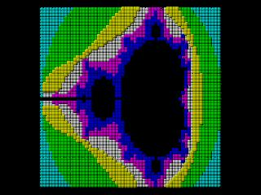
Figure 2. The Mandelbrot set created in Maya.

3.2 Lorenz attractor script
The script we wrote for the Lorenz attractor (Appendix 2) creates a large number of circles that are then lofted together. Initially the script generated spheres but that idea was rejected as it was very time consuming; Maya ran very slowly with 2000 spheres in a scene. The x, y and z positions of the circles are determined by the three differential equations that were discussed earlier.

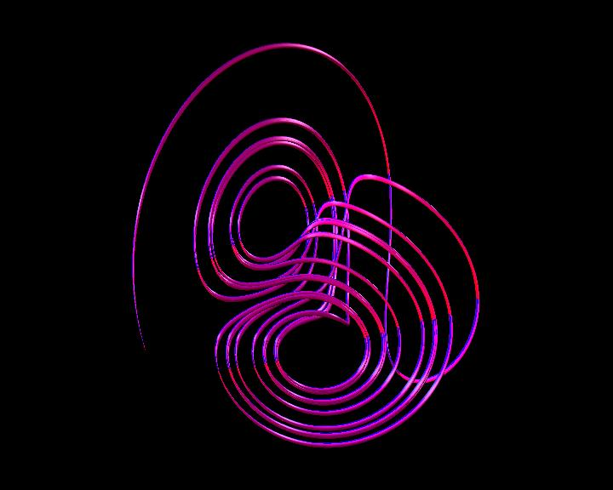
Figure 3. The Lorenz attractor created in Maya.

3.3 Rossler attractor script
The code for the Rossler attractor (Appendix 3), like the code for the Lorenz attractor, creates a large number of circles that are then lofted together. The x, y and z positions for the circles are determined by the three differential equations explained earlier.

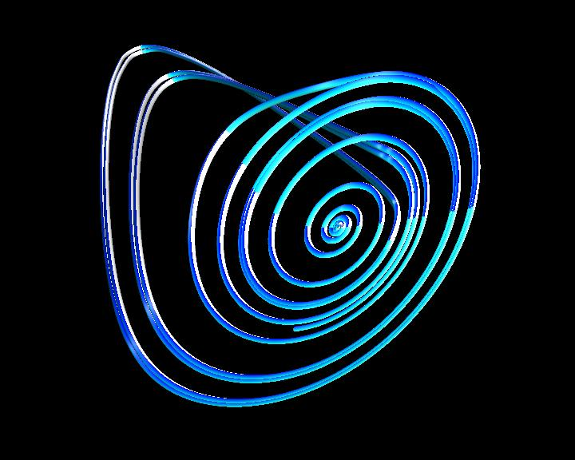
Figure 4. The Rossler attractor created in Maya.

These two attractors are incredibly interesting to look at. Combining the two or using multiples of them allows us to create an endless quantity of aesthetically pleasing images.

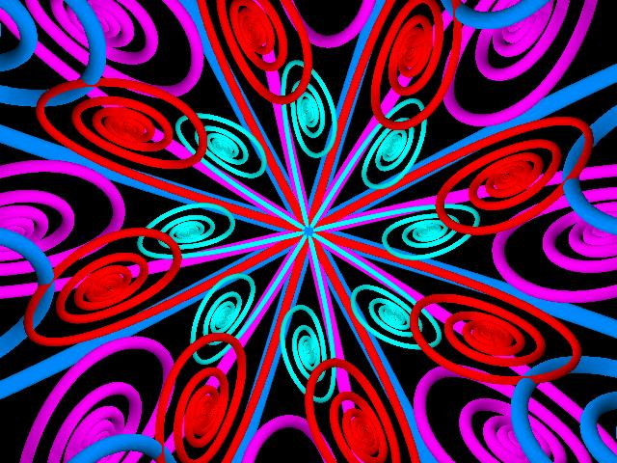
Figure 5. A pattern created using multiple attractors in Maya.
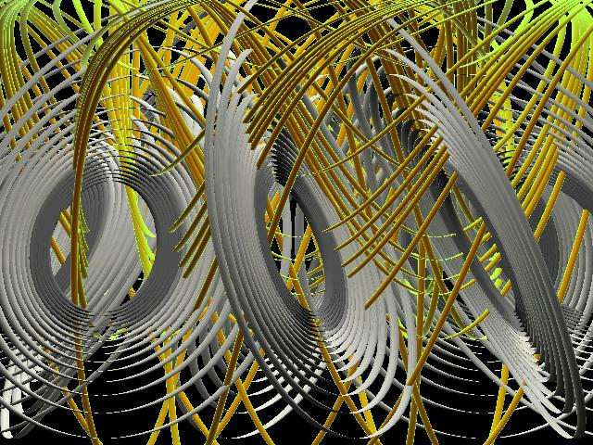

Figure 6. Another pattern created using multiple attractors in Maya.

Although these images look aesthetically pleasing they have no real practical use in computer graphics. The ability to create natural forms: trees, plants, clouds, mountains etc is much more advantageous within the realms of computer graphics and given that fractals are a popular and powerful way to replicate forms found in nature a natural progression for this project would be to investigate those uses further.

4 FRACTALS IN THE REAL WORLD

‘So, naturalists observe, a flea
Has smaller fleas that on him prey;
And these have smaller still to bite ’em;
And so proceed ad infinitum.’
[Swift 1733]

Geometric modeling of complex objects is a difficult process, especially with natural phenomena [Demko 1985]. Modeling with Euclidean geometry (planes, spheres, cones etc…) does not deal with the complexity of shapes found in nature. Objects like trees and rivers are complex at every scale and this detail is completely lost with Euclidean shapes. “Euclidean shapes are all locally flat: if you look at them closely enough, they become flat, planar, and boring” [Musgrave 1993]. However, this detail can be captured through the use of fractal geometry as it is complex at every scale, just like nature.

There are many shapes and patterns in nature that have the same self-similar properties as fractals. “Branches resemble trees, mountain tops have the same shape as mountain ranges, and small waves and clouds mirror larger ones.” [Oliver and Hoviss 1994]. Therefore it is not surprising that they can be replicated using fractals. Other examples of nature that can be imitated using fractals are: coastlines, rivers, lightning, flowers and seashells.

4.1 Iterated Function System (IFS)
Iterated Function Systems are a very commonly used type of fractal. They are composed of two parts: the initiator and the generator [Ibrahim and Krawczyk]. The initiator is defined by a set of contractive affine transformations (i.e. translations, rotations, vertical or horizontal shears that must reduce the distance between two points) [Edalat et al 1999]. Creating the fractal is simply a process of replacing every line of the initiator with the full generator for as many iterations that are required.
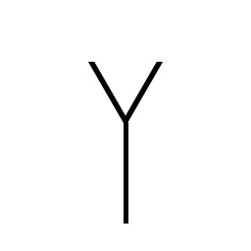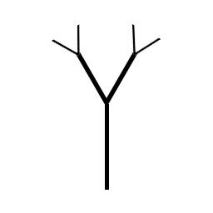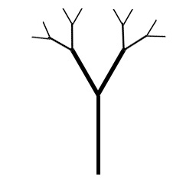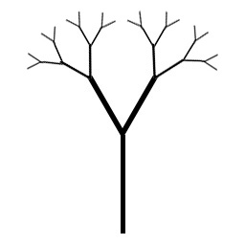
Figure 7. The beginnings of an IFS fractal tree.

4.12 IFS Fern Leaf
There are a number of IFS fractals, including Sierpinski’s triangle and the Von Koch Curve (used to generate snowflakes and coastlines), but probably the most well known IFS fractal is the fern leaf, also known as Barnsley’s fern as it was Michael Barnsley that first discovered it in his book Fractals Everywhere [Vetter 2003].

In the image (Figure 8) it is possible to see that the fern’s individual leaves are just miniature versions of the full-size fern. If you zoom in you would see that the smaller leaves have the same similarity.

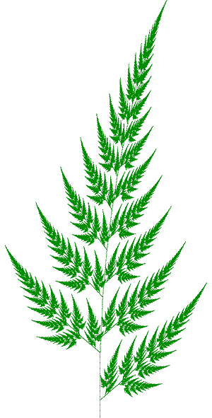
Figure 8. Barnsley’s fern
4.3 Fractal Clouds
The ability to simulate clouds is an incredibly useful tool. They are vital in flight simulations and can also be very effective in other applications, such as entertainment, advertising and art. Their creation once posed a serious problem to computer image generation techniques mainly because they do not have well-defined surfaces and boundaries [Gardner 1985] but we now know that fractals have the ability to overcome this problem.

Using the initiator and generator fractal method discussed above it is possible to simulate a variety of different clouds. There are three fundamental classes of clouds, these are: Cumulus clouds which have the classic puffy-white form, Cirrus clouds which are high and wispy and Stratus clouds which are the long layers that make up an overcast sky [Oliver and Hoviss 1994].

To create a cumulus cloud an initiator similar to the shape in figure 9 is required. This initiator is then replaced by the generator (figure 10) over numerous iterations.


Figure 9. Cloud initiator. Figure 10. Cumulus cloud generator.

The larger the number of iterations the greater the detail and realism of the cloud will be. Unfortunately, generating a large number of iterations is not ideal when using Maya. It can take the computer a long time to calculate all the objects that would be required in the scene. One option is to reduce the number of iterations and then attach one of Maya’s built in cloud paint effects to the objects created. The detail provided by the paint effect should compensate for the reduced detail in the geometry.

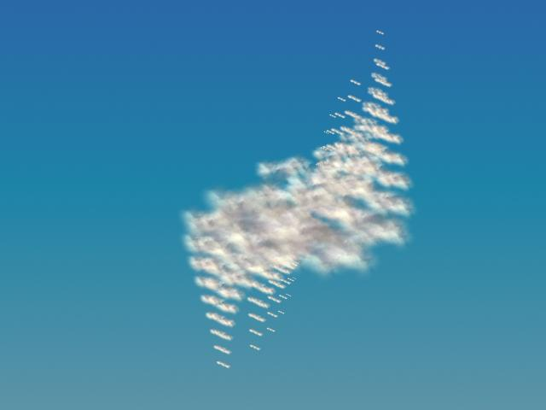
Figure 11. Fractal based cloud with paint effect.
Figure 11 shows an initial attempt to create a fractal cloud combined with a cloud paint effect. The MEL script used to create this cloud if fairly crude and would clearly need altering if it was needed to accurately represent the generator shown above (figure 10). However, this is just an experiment to check whether the level of detail is adequate to simulate a realistic cloud or not.

From this example (figure 11) it is clear to see that this method for the simulation of clouds has the potential to produce some very appealing outcomes. Although this could simply be a result of very convincing paint effects, which then asks the question: is it really necessary to generate all this complicated geometry if a simple sphere will suffice?

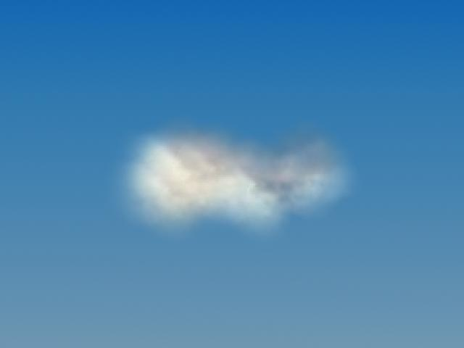
Figure 12. Cloud produced using Maya paint effects only.

Figure 12 shows a cloud created in Maya using only paint effects. The effects were drawn directly onto a sphere that had a translucent material attached to it. It was much simpler to construct than the MEL scripted cloud (figure 11) and far easier to work with. It is therefore evident that a realistic cloud does not necessarily require a large quantity of geometry to be produced within Maya.

Another approach to generating clouds is to use noise. “‘Noise’ means random information, like the static on a TV screen” [Stay 2003]. There are different types of noise but the most useful with regards to cloud simulation is called Perlin noise. The Perlin Noise function is created by adding noise to more noise with a range of different scales. Along with clouds, it can be very useful for recreating the patterns of waves in the sea or the outline of a mountain range [Elias 2003].

4.4 Fractal Landscapes/terrain
“One of the most common fractals we see in nature is the earth we walk on” [Musgrave 2001]. The ability to generate earth or terrain as it is more commonly referred to, is valuable for many areas within computer graphics, in particular computer games. “Terrain is the centerpiece of many games, an important backdrop in some, and just something to fill the space in others” [Lecky-Thompson 2000].

4.45 Midpoint Displacement
There are a wide variety of different algorithms available for the generation of fractal terrain. Probably the most common method is known as midpoint displacement, also known as the diamond-square algorithm when used in two dimensions [Shankel 2000]. Midpoint displacement in one dimension is constructed by taking the midpoint of a line segment and displacing it by a random value (figure 13). The midpoints of the two line segments generated from the initial displacement are then displaced, but by a smaller value. This process is repeated until a sufficient level of detail is reached.
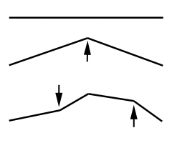
Figure 13. Midpoint displacement in one dimension.
(source: http://www.tursiops.cc/fm/#midpt)

The diamond-square algorithm is calculated on a rectangle. The first step is to displace the centre point of the rectangle. The value it gets displaced by is calculated by averaging the height values for the four corner points and then adding a random amount. This is known as the diamond step [Shankel 2000]. Next follows the square step. The midpoints between the four corners (the blue dots, Figure 14) are displaced by the average of the connected points plus a random amount [Fernandes 2005]. These two steps are then repeated until the level of detail is sufficient.
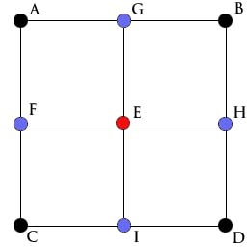
Figure 14. Diagram to demonstrate the first and second stages of the Diamond-Square algorithm.
(source: http://www.lighthouse3d.com/opengl/terrain/index.php3?mpd2)

To implement this algorithm in Maya a polygon plane with 2 subdivisions along the width and height needs to be created. At this stage the first diamond and square steps are fairly straight forward as there are few points (vertices) that need to be displaced and their heights are all zero. At present the plane is comprised of four faces. Once the first diamond and square step has been accomplished the four faces need selecting and subdividing. This creates the necessary points for the next steps of displacement.

In theory this algorithm should not be too complicated to script and, for the first few steps at least, it is not. However, after subdividing the faces a couple of times the number of points that need displacing grows incredibly quickly. Initially we considered creating a ‘for’ loop to select the required points for displacement but there were two main problems with this method. Firstly, when you subdivide the faces the numbers associated with the generated points have no obvious order. This makes selecting the required points virtually impossible with a simple ‘for’ loop. Secondly, even if it were possible to iterate through a ‘for’ loop to select the points, using a variable such as $i continually generated an error when used within the code:

setAttr "terrainShape.pnts[$i].pnty" $d;

In this example $i represents the point number for selection and $d represents the value to displace it by. Writing a MEL script that generates sufficient detail for a terrain using this method would involve a very long and laborious process of individually selecting a huge number of points and displacing them.

One possible solution considered was to create a new polygon plane for every step of the algorithm. The number of subdivisions along the width and height would correspond with the number of steps. This would solve the problem of having randomly numbered points because they would be in numerical order, starting at 1 in the bottom left hand corner and then working their way up to the top right hand corner. This would not solve the problem of not being able to substitute a variable into the MEL code that moves the point though.

Lengthy pieces of MEL code that individually displace hundreds of points are undesirable. Another solution was needed. The next attempt to solve this problem involved the algorithm for midpoint displacement in just one dimension. This can be implemented by creating a nurbs square and then deleting three sides, thus leaving a line for manipulation. We found that an adequate level of detail can be produced if the number of spans per side is set to 5 and the curve degree set to 3. Setting the curve degree to 3 allows a smooth curve to be generated.

Once this line is created the next step is to displace all the points by a random value. The end points get left untouched so there are a maximum of 6 points that can be displaced, a lot fewer than in the diamond-square algorithm. The points all need setting to a different height value so a random number needs to be created for each one (figure 15).

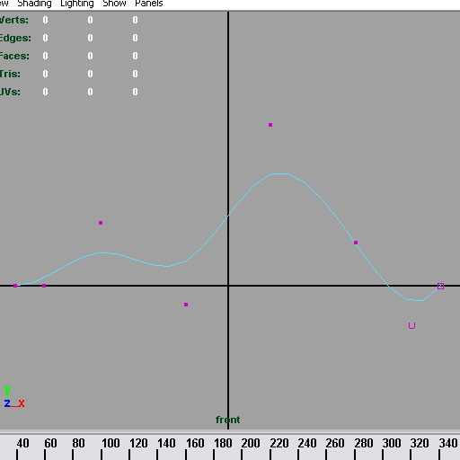
Figure 15. A side of a Nurbs square with its points all displaced to random values.
With the use of a ‘for’ loop an infinite number of these randomly displaced line segments can be created and translated. We used 4. At either end of these random lines an unaltered line segment is created (figure 16). This stops any undesirable point displacement around the edge of the terrain.

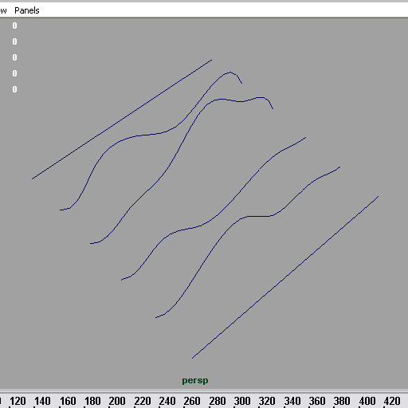
Figure 16. The required lines to generate a terrain.

These objects now need selecting and lofting together. This gives us our basic terrain shape (figure 17).

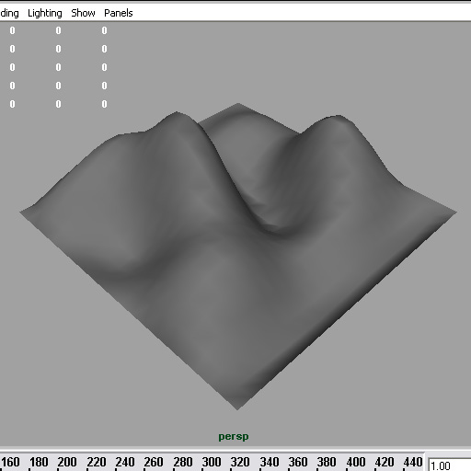
Figure 17. Lofted surface for terrain.

To add to the realism of this terrain textures are created and applied. Initially we created separate textures for the terrain (i.e. one for snow on the top of the terrain, one for sand at the bottom of the terrain and a green texture for the rest). The first terrain surface created was textured using a green perlin noise texture. This surface was then duplicated twice. One of the duplications was attached with the snow material and the other with the sand. We then slightly changed the scaling of these duplicated surfaces. This allowed the tips of the initial terrain to be covered up by the snowy surface, and the lower areas to be covered by the sandy surface (figure 18).

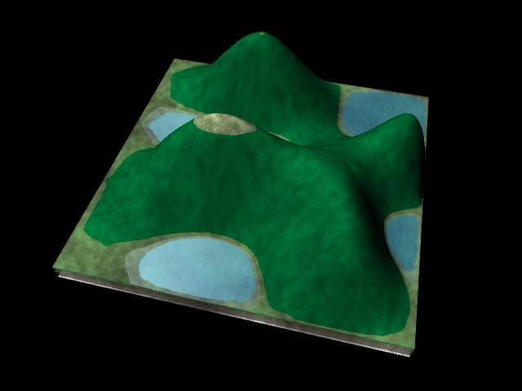
Figure 18. Terrain with the initial textures applied.

This approach failed to give a realistic appearance though as the different textures did not blend in with each other. This problem was overcome by using just one material with perlin noise whose colour is determined by a ramp. This ramp gradually varies the colour of the terrain depending on its height (figure 19). The lower areas are a sandy yellow colour and the high areas are a whitish colour to represent the snow. The rest is a dark green colour.

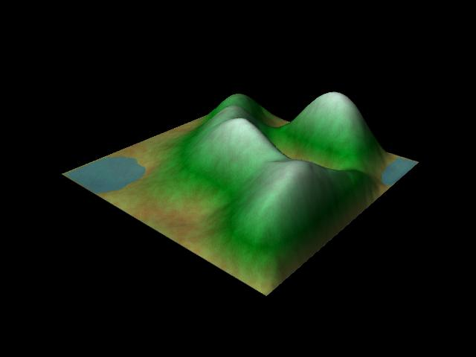
Figure 19. Terrain with its colours generated by a ramp.

The final addition to this terrain geometry is a simple polygon plane to simulate water. Its position never changes and it can only be scene in the areas where the height of the terrain goes below zero. An anisotropic, slightly transparent, blue colour is created for the water. Noise, of type wave, is also attached to this material.

Giving the user control over the creation of the terrain is important and at this stage they have very little. To increase their control we wrote a MEL script for a User Interface (UI) to accompany the terrain generating procedure, thus allowing any user to easily create a terrain. This UI is comprised of: three different sliders, a button to correct the colour ramp and a button to close the tool. The parameters controlled by the sliders give the user the ability to set the height (figure 20), width and depth of the terrain to their preference. A User Manual (appendix 4) has been written to fully explain this UI.

The colour ramp that is created when the MEL script is first ran needs altering otherwise the terrain will not be coloured correctly. This is why there is a need for the “Correct Colour Ramp” button. This button calls a procedure that changes the projection of the ramp to cylindrical and resizes it to fit the terrain. It also alters the colours to a more suitable terrain colour scheme. We had many attempts at rewriting the script so the correct colour ramp is created initially; therefore removing the need for the “Correct Colour ramp” button but this has not been achieved yet.

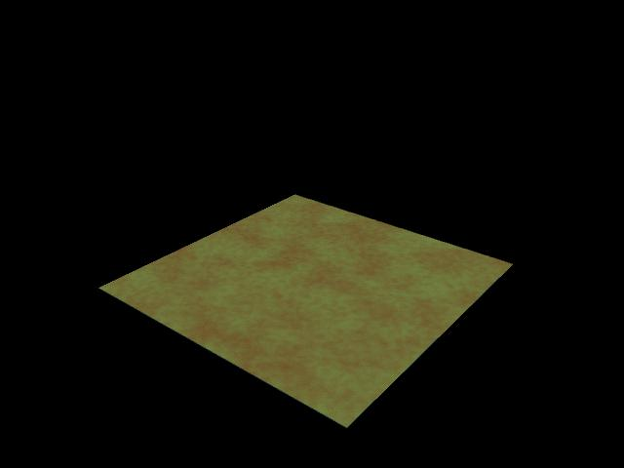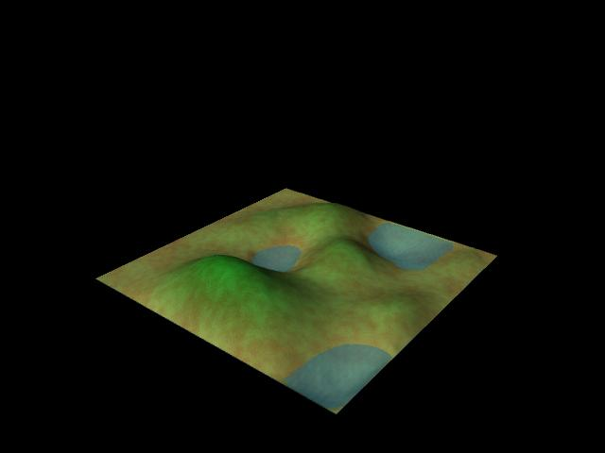
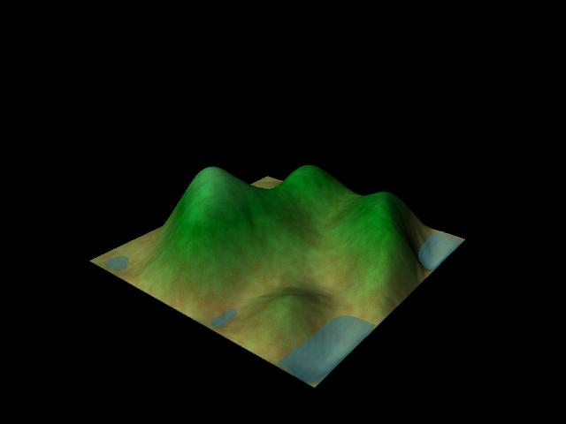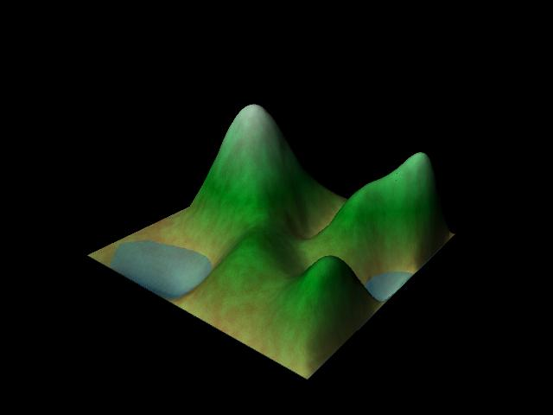
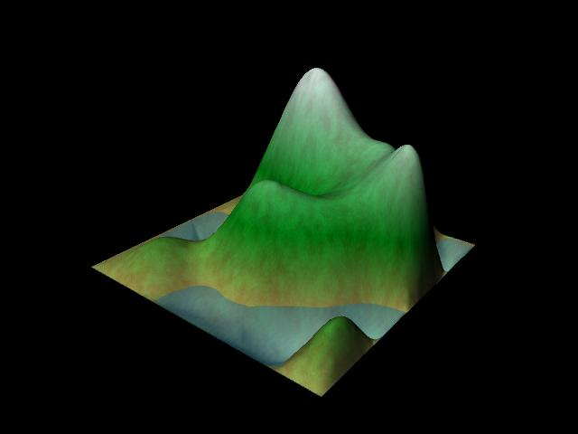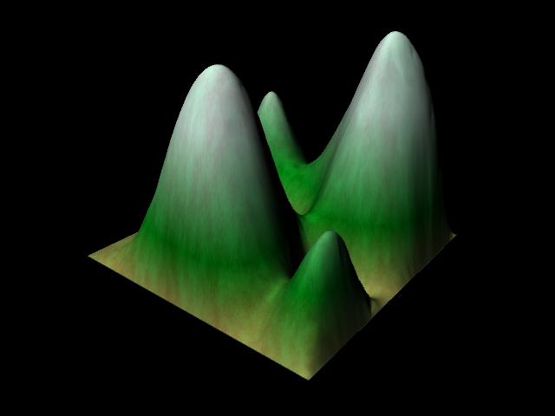
Figure 20. Renders of the terrain with heights varying from 0 to 5.

5. CONCLUSION
The concept of fractals and their uses was fairly new to us at the beginning of this project. A lot of research was required to equip us with the knowledge needed to complete this work. The information discovered was then discussed within this report. We defined what fractals are, the different types available and described their various uses within computer graphics. Several experiments using the mathematical algorithms required for specific fractals were then undertaken in Maya using MEL scripting. These resulted in a number of aesthetically pleasing works of fractal art showing an assortment of fractal attractors in varying positions and colours. We then discussed more practical uses of fractals. We underwent a comparison between Maya’s paint effects clouds and the clouds that can be created using IFS algorithms. Throughout this process a lot was learnt about the available paint effects in Maya and how they can be applied.

The final challenge was to extensively research fractal terrain generation and to write a MEL script that creates it in Maya. We were unable to accurately replicate the diamond-square algorithm using MEL due to continued troubles using variables in the command for displacing points. One possible solution was found using the algorithm in one dimension but given more time we would ideally like to be able to find a solution using the two dimensional algorithm.

This project has been a wonderful opportunity to learn a lot about fractals. However, we now realize just how vast the field of fractals is. It is a very broad subject. If this project were to be completed again narrowing the area for research down would probably benefit the final outcome as this would allow more time for specializing in that one particular area.

ACKNOWLEDGEMENTS
I would like to thank Phill Allen and Eike Anderson for their support and help through the development of this project.

APPENDIX 1.
This is the MEL script for the creation of the Mandelbrot set.
//-------------------------------------------------------------------------
//All the COLOURS used within the Mandelbrot set.
createAndAssignShader lambert "";
setAttr "lambert2.color" -type double3 0.0 0.0 1.0 ; //blue
createAndAssignShader lambert "";
setAttr "lambert3.color" -type double3 0.0 0.0 0.0 ; //black
createAndAssignShader lambert "";
setAttr "lambert4.color" -type double3 1.0 0.0 1.0 ; //pink
createAndAssignShader lambert "";
setAttr "lambert5.color" -type double3 1.0 1.0 1.0 ; //white
createAndAssignShader lambert "";
setAttr "lambert6.color" -type double3 1.0 1.0 0.0 ; //yellow
createAndAssignShader lambert "";
setAttr "lambert7.color" -type double3 0.0 1.0 0.0 ; //green
createAndAssignShader lambert "";
setAttr "lambert8.color" -type double3 0.0 1.0 1.0 ; //light blue

//---------------------------------------------------------------------
//Code to create Mandelbrot set.

int $iter;
int $SIZE = 100; //number of spheres to be generated in x and y
float $LEFT = -2.0; //constant determining the left most co-ordinate
float $RIGHT = 1.0; //constant determining the right most co-ordinate
float $TOP = 1.0; //constant determining the upper most co-ordinate
float $BOTTOM = -1.0; //constant determining the lower most co-ordinate

float $x, $y, $count;
float $zr, $zi, $cr, $ci;
float $rsquared, $isquared;

for ($y = 0; $y < $SIZE; $y++)
{
for ($x = 0; $x < $SIZE; $x++)
{
$zr = 0.0;
$zi = 0.0;
$cr = $LEFT + $x * ($RIGHT - $LEFT) / $SIZE;
$ci = $TOP + $y * ($BOTTOM - $TOP) / $SIZE;
$rsquared = $zr * $zr;
$isquared = $zi * $zi;

for ($count = 0; $rsquared + $isquared <= 4.0 && $count < 200; $count++)
{
$zi = $zr * $zi * 2;
$zi += $ci;

$zr = $rsquared - $isquared;
$zr += $cr;

$rsquared = $zr * $zr;
$isquared = $zi * $zi;

if ($rsquared + $isquared >= 4.0){
$iter = $count;
break; // the value is tending towards zero
}
}

if ($iter >= 0 && $iter <= 1){
sphere -p $x 0 $y -r 0.4;
sets -e -forceElement lambert8SG;
}

if ($iter > 1 && $iter <= 2){
sphere -p $x 0 $y -r 0.5;
sets -e -forceElement lambert7SG;
}

if ($iter > 2 && $iter <= 3){
sphere -p $x 0 $y -r 0.6;
sets -e -forceElement lambert6SG;
}

if ($iter > 3 && $iter <= 5){
sphere -p $x 0 $y -r 0.7;
sets -e -forceElement lambert5SG;
}

if ($iter > 5 && $iter <= 10){
sphere -p $x 0 $y -r 0.8;
sets -e -forceElement lambert4SG;
}

if ($iter > 10 && $iter < 200){
sphere -p $x 0 $y -r 0.8;
sets -e -forceElement lambert2SG;
}

if ($rsquared + $isquared <= 4.0 && $iter = 200){
sphere -p $x 0 $y -r 0.8;
sets -e -forceElement lambert3SG;
}
}
}

APPENDIX 2
This is the MEL script for the creation of the Lorenz attractor.

//Script for creating a Lorenz attractor.
//The initial C source code was taken from
//http://astronomy.swin.edu.au/~pbourke/fractals/lorenz/
//which I altered so it worked in MEL.
//---------------------------------------------------------------

int $i=0;
int $j=1;
int $max = 1000; //number of circles generated

float $myx0,$myy0,$myz0,$myx1,$myy1,$myz1;
float $myh = 0.01;
float $mya = 28; //a, b, and c are a set of commonly used
float $myb = 46.92; //constants to generate the Lorenz attractor.
float $myc = 4;

$myx0 = 0.1;
$myy0 = 0;
$myz0 = 0;

for ($i=0;$i<$max;$i++)
{
circle -c $myx0 $myy0 $myz0 -r 0.5;
//differential equations
$myx1 = $myx0 + $myh * $mya * ($myy0 - $myx0);
$myy1 = $myy0 + $myh * ($myx0 * ($myb - $myz0) - $myy0);
$myz1 = $myz0 + $myh * ($myx0 * $myy0 - $myc * $myz0);
$myx0 = $myx1;
$myy0 = $myy1;
$myz0 = $myz1;
}

select -allDagObjects;
scale -r 0.05 0.05 0.05 ;
loft -ch 1;

select -allDagObjects;
select -d loftedSurface1;
delete;

APPENDIX 3.
This is the MEL script for the creation of the Rossler attractor.

//Script for creating a Rossler attractor.
//---------------------------------------------------------------
int $i=0; int $j=1; int $max = 2000; //number of circles generated
float $myx0,$myy0,$myz0,$myx1,$myy1,$myz1;
float $myh = 0.04;
float $mya = 0.2;
float $myb = 0.2;
float $myc = 5.7;
$myx0 = 0.1;
$myy0 = 0;
$myz0 = 0;
for ($i=0;$i<$max;$i++)
{
circle -c $myx0 $myy0 $myz0 -r 0.1;
$myx1 = $myx0 - $myy0*$myh - $myz0*$myh;
$myy1 = $myy0 + $myx0*$myh + $mya*$myy0*$myh;
$myz1 = $myz0 + $myb*$myh + $myx0*$myz0*$myh - $myc*$myz0*$myh;
$myx0 = $myx1;
$myy0 = $myy1;
$myz0 = $myz1;
}
select -allDagObjects;
loft -ch 1;
select -allDagObjects;
select -d loftedSurface1;
delete;

APPENDIX 4. Fractal Terrain Generator
USER MANUAL
Fiona Mortimer
The National Centre for Computer Animation
Bournemouth University

This MEL script has been written for the generation of random fractal terrain (figure 1).
Figure 1. Random fractal terrain generated using this MEL script.

To run this script you need to open the ‘User_Fractal_Terrain.mel’ file in the Script Editor in Maya (or copy and paste it into the Script Editor) and then press return. Once it is entered the following GUI (figure 2) will be created on the screen. A colour ramp will also be generated.
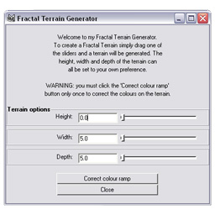
Figure 2. The GUI required for the generation of the fractal terrain.

The GUI includes three different sliders allowing you to choose the parameters used for the creation of the terrain. These are:
- Height
- Width
- Depth
All the points on the terrain get displaced by a number. This number is calculated by multiplying a random number between -0.05 and 0.1 by the value set by the “Height” slider. The “Height” slider varies from 0 to 5. Setting this slider to a large value like 5 does not necessarily mean the terrain will have a lot of height but it is much more probable than if the slider is set to a lower number. Obviously if the slider is set to 0 the terrain will have no height at all.

The “Width” slider sets the value for the width of the terrain. Unlike the height slider, the width of the terrain will be exactly the value specified by the “Width” slider. This slider varies from 5 to 20.

The “Depth” slider sets the value for the depth of the terrain. It works the same way as the width slider. The depth of the terrain will be exactly the value specified by the “Depth” slider. This slider varies from 5 to 20.

The colour ramp that is created when the MEL script is first ran needs altering otherwise the terrain will not be coloured correctly. The “Correct Colour Ramp” button changes the projection of the ramp to cylindrical and resizes it to fit the terrain. It also alters the colours to more suitable terrain colour scheme.

“Close” deletes everything in the scene, including the GUI.

Fractals
There are three other MEL scripts that have been written that generate other fractals. These fractals are:
- The Mandelbrot set (figure 3)
- The Lorenz Attractor (figure 4)
- The Rossler Attractor (figure 5)
To run any of these scripts you need to open their file (either Mandelbrot.mel, Lorenz.mel or Rossler.mel depending on which fractal you wish to create) in the Script Editor in Maya (or copy and paste it into the Script Editor) and then press return. The corresponding fractal will then be created.

Figure 3. Mandelbrot set created in Maya.
Figure 4. Lorenz attractor created in Maya. Figure 5. Rossler attractor created in Maya.

REFERENCES
Bourke, P (2001). “Fractals, Chaos”. http://astronomy.swin.edu.au/~pbourke/fractals/ [Accessed 27 Feb 2005]

Demko, S (1985). “Construction of Fractal Objects with Iterated Function Systems” Volume 19, Number 3, 1985.

Edalat et al (1999) “Bounding the Attractor of an IFS” http://www.doc.ic.ac.uk/research/technicalreports/1996/DTR96-5.pdf [Accessed 03 March 2005]

Elias, H (2003) “Perlin noise” http://freespace.virgin.net/hugo.elias/models/m_perlin.htm [Accessed 01 March 2005]

Gardner, G.Y (1985) “Visual Simulation of Clouds” Volume 19, Number 3, 1985.

Ibrahim and Krawczyk http://www.iit.edu/~krawczyk/mibrdg02.pdf [Accessed 02 March 2005]

Lecky-Thompson G.W (2000) “Real-Time Realistic Terrain Generation” Game Programming Gems. Jenifer Niles, USA. ISBN 1-58450-049-2

Mason, J.E (2003). “The Mandelbrot Set Crop Circle Formation”. http://www.greatdreams.com/crop/mndlbrt/mandlbrt.htm [Accessed 03 March 2005]

Musgrave, F. K (2001) “Fractal models of Natural Phenomena”
https://www.internal.pandromeda.com/engineering/musgrave/unsecure/S01_Course_Notes.htm [Accessed 01 March 2005]

Oliver and Hoviss (1994) “Fractal Graphics for Windows” Sams Publishing, USA
ISBN 0-672-30347-7 (Paperback)

Shankel, J (2000) “Fractal Terrain Generation- Midpoint Displacement” Game Programming Gems. Jenifer Niles, USA. ISBN 1-58450-049-2

Stay, D.S (2003) “Perlin Clouds” http://iat.ubalt.edu/summers/math/perlin.htm [Accessed 04 March 2005]

Swift, J (1733) “John Bartlett (1820–1905). Familiar Quotations, 10th ed. 1919.” http://www.bartleby.com/100/211.5.html [Accessed 02 March 2005]

Vetter, K (2003) “Fern Fractal” http://wiki.tcl.tk/10492 [Accessed 04 March 2005]

