Introduction.

“innovate”
v. in·no·vat·ed, in·no·vat·ing, in·no·vates
v. tr.

“To begin or introduce (something new) for or as if for the first time.”

What is Innovation? We had several lectures on the subject, which were held so as to help us decide in what way we wanted to 'innovate'. I found the whole concept of innovation hard to comprehend to begin with. I couldn't determine what it is to innovate...is it to 'begin or introduce' something new to an already established field, or can it mean to introduce something new to yourself on a personal level?
Take the field of music for example; If I wrote a song that was totally original to me would that be 'innovating'? There is a theory that all possible melodies and tunes have been explored and my song could be seen as just a modified version of a previous song, thus it wouldn't be seen as 'new'. But looking at it on a personal level, I would have indeed produced something 'new' for myself.
I feel that the main objective for this project is to do just that. To learn something new for yourself...and hopefully this knowledge will be of use for others.
But the next question I pondered was; in what direction did I want to take my quest to innovate? I saw two possible routes, the technical or the artistic. I have always been of the artistic inclination, this coupled with the fact that the technicalities of the subject Computer Animation seem to be always considered above the artistic made my decision final.
I decided to explore a process of my mind that I had always taken for granted. It was the process of 'interpretation'. What triggered the thought was seeing the trailer for 'Paycheck'. I was subjected to three minutes of footage that portrayed a distinctly average US blockbuster type film and I was surprised to see the phrase tact on the end:

“From the author that brought you 'Minority Report' and Blade Runner’:


Image taken from a poster advertising “Paycheck”

I knew the author well, Philip K. Dick. I had also enjoyed many of his short stories and consequently enjoyed many of the films that had arisen from adaptations of those stories, especially Ridley Scott's 'Blade Runner' originally Dick's “Do Androids Dream of Electric Sheep”. But a sense of annoyance took over when I saw the trailer for John Woo's latest action fest. I saw Ben Affleck, Uma Thurman and John Woo team up and I instantly felt like they were cashing in on a Philip K Dick idea. The reason for my annoyance I realised was down to the way John Woo had obviously decided to interpret Dick's text. I presumed that Dick's text was being used for an 'Affleck vehicle', an excuse to have Ben in a futuristic environment and ride motorcycles in a 'thrilling' way. This caused me to consider Hollywood’s incapability to bring original ideas to the screen, and their constant need to pilfer the ideas from respected authors. The interpretation of text is big business in 'tinsel town'. Some adaptations of novels, like 'Paycheck' feel like 'plundering' for ideas, yet some like Clint Eastwood's recent, 'Mystic River’ (based on the novel by Dennis Lehane) make genuinely decent films. Where as it feels like John Woo wanted an excuse for some motorcycle chases, Clint Eastwood I feel wanted to bring the book to the screen. But never the less both directors 'Interpreted' a text.
What made John Woo interpret Philip K Dick's text in the way he did? What made Clint Eastwood interpret Lehane's text the way he did? This type of questioning has led me to want to research the process.

Sign and Interpretation.

The subject of 'interpreting text' is sprawling to say the least. Many people are wary of interpreting literature. They see interpretation as arbitrary, arcane, and possibly fraudulent, as something teacher’s do to confuse students. But the truth is, we all interpret as we read. Interpretation is something a reader does in response to a text and is done on many different levels. There are many philosophers from different standpoints that dedicated their lives to exploring the many facets of interpreting text, many with very different beliefs. The last thing I expect to achieve is to uncover something 'new' in this area, but by comparing and contrasting a small amount of established philosophies from the last century, I hope to further my understanding of the concept of interpreting text.
There are two extreme theories of how we, as humans interpret text. These theories, and which one you believe to be 'true' depends on where you think the 'meaning' of the text to lie. Does the meaning of the text lie 'within' the text itself? Or does it lie in a combination of things such as with the reader or the author?
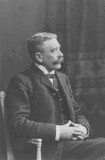
Ferdinand Saussure (1857-1913) a Swiss linguist believed the meaning of the text to lie in the text itself. He chose to look at language in a synchronic way, this means he studied the linguistic system in a particular state, without reference to time, like a snapshot. He was one of the founders of modern linguistics and he established the 'structural 'study of language. Saussure conceived that Language was a system made up of 'signs'. The sign is made up of the 'signifier' (the sound image) and the 'signified' (the concept or idea). He also believed that the relationship between the signifier and the signified was arbitrary, or random. For example, there is no reason why the word 'rabbit' should signify a small furry creature. Another word could serve the same function just as well. There is arbitrariness about the fit between signifier and signified. He proposed that meaning does not belong to words but that the meaning is determined by the difference between signs and not by the identity of them.

Ferdinand Saussure

Essentially Saussure headed up the argument that the formal properties of the text, the grammar, the language, the uses of image and so forth, contain and produce the meaning, so that any educated reader will inevitably come to essentially the same interpretation as any other.
I instantly found Saussure's structralist study of interpretation of text intriguing, yet flawed. He was looking at the text and nothing but the text. Studying within a vacuum. I felt he was ignoring some very important aspects. I imagined John Woo again reading the novel ‘Paycheck'. Surely he was considering more than just the difference between the words or the 'signifier' in his interpretation?
Post structuralism evolved in the late 1960s as a critique of structuralist theory. Post structuralist's beliefs spawn from the fact that they believe language to be inadequate. Jacques Derrida's theory of 'differance' proposed that meaning is inherently unstable due to the play of signs within language. This is because that within language, a signifier and a signified exist which provide the meaning of the word or phrase.
At its most basic level, the signifier may be the letters F-I-S-H, which provide the reader with the signified, the word FISH, which in turn provides a mental image of fish. However the reader's image of fish may vary from a live goldfish or shark to a freshly caught trout or rows of Salmon in a fishmonger's window. Thus the interpretation that the reader lends to the signifiers within the text is based upon the reader's experiences. These experiences may be derived from prior knowledge that the reader has previously attained whether it is from a book, film, television or general life experience. Thus intertextuality is viewed by the post structuralists as essential to the interpretation of the text, and as such exists as a strength rather than a weakness. Another example of this theory using John Woo again, for continuities sake: if he read the words; “a chase ensued” written by Dick it is likely that what he visualises a 'chase' to be would differ greatly from another directors interpretation. Woo, being an action heavy director would no doubt immediately conjure up an elaborate, high-speed chase with high-powered vehicles, maximising the adrenaline for the audience. Conversely, another director, with a less action style, may see the chase as being more stealth orientated and thus building suspense in the audience. Here we see the prior knowledge and previous experience of their own unique directing style affecting the initial interpretation of the source text.

Structure Vs. Post-structuralist

So we have the structuralist's point of view, where there is an assumption that there is a common agreement of the sign. As a result the interpretation of text shouldn't vary a huge amount from person to person. It is assumed that the 'educated' reader should pick up the meaning from the text, and nothing but the text.
Then conversely we have the post-structuralist point of view, where multiple interpretations of the same text is expected due to a large amount of factors specific to the individual, including culture and history.
I feel it is important to consider the actual style of the text itself in more detail. There are many different styles of writing and to generalize and categorize all of them under the one heading of 'text' seems shallow. To be able to compare texts and peoples interpretations of them some distinctions need to be made. To keep things simple I am going to categorize the text that I am concerned with into two groups:

    - Descriptive Text
&
    - Emotive Texts

An example of an author who used a descriptive style is J.R.R Tolkien, whose most notable of works was The Lord Of The Rings. In this novel he set about creating an entire world with the use of text. Every element in the extremely lengthy book, ranging from the environments to the characters are painstakingly detailed in their description.
Here is an excerpt from the book at a poignant stage in the story:

“The dark figure steaming with fire raced towards them.... The Balrog reached the bridge. Gandalf stood in the middle of the span, leaning of the staff in his left hand, but in his other hand Glamdring gleamed, cold and white. His enemy halted again, facing him, and the shadow about it reached out like two vast wings. It raised the whip, and the thongs whined and cracked. Fire came from its nostrils. But Gandalf stood firm.
“You cannot pass,” he said.
...The Balrog made no answer.... It stepped forward slowly on to the bridge, and suddenly drew itself up to a great height, and it's wings were spread from wall to wall; but Gandalf could be seen, glimmering in the gloom; he seemed small, and altogether alone: grey and bent, like a wizened tree before the onset of a storm.
...With a bound the Balrog leaped full upon the bridge. Its whip whirled and hissed.
At that moment Gandalf lifted his staff, and crying aloud he smote the bridge before him. The staff broke asunder and fell from his hand. A blinding sheet of white flame sprang up. The bridge cracked. Right at the Balrog's feet it broke, and the stone upon which it stoodcrashed into the gulf, while the rest remained, poised, quivering like a tongue of rock thrust out into the emptiness.
With a terrible cry the Balrog fell forward, and its shadow plunged down and vanished. But even as it fell it swung its whip, and the thongs lashed and curled about the wizard's knees, dragging him to the brink. He staggered and fell, grasped vainly at the stone, and slid into the abyss. 'Fly, you fools!' he cried, and he was gone.”

This section of text shows classic Tolkien. It is true to his very descriptive style. As with the majority of The Lord Of the Rings, any reader who reads the text is likely to interpret it in very similar ways. The nature of the style gives little room to interpret things differently.
For example, Tolkien describes each movement of both characters in this excerpt very thoroughly;

“...It stepped forward slowly on the bridge, and suddenly drew itself up to a great height....”.

Also the situation of the characters is detailed;

“...Gandalf....glimmering in the gloom; he seemed small, and altogether alone: grey and bent,....”.

The structuralist's could argue that Tolkien's style of writing backs up their philosophy of the interpretation of text. For large chunks of text in Tolkien's epic have the meaning self contained.
The interpretation of the text would not vary with the influences of society or culture. The actions that Gandalf performs in this extract, for instance, would be the interpreted the same by a person from a Far Eastern culture as it would to a person living in a Western culture. The personal learning’s that the individual has learnt in their respective culture could be seen has having no effect or bearing on the meaning that the reader extracts from the text.
Tolkien is specific. His text could be seen as using no 'Signs' that could mean apposing things in different cultures, and anything he does mention that could be perceived differently, he explains every facet so as to abolish any conflicting opinions the reader might have. He doesn't give the reader room to imbue their own thoughts and experiences onto the text, and thus restricts the possibility of multiple interpretations.
The Lord of the Rings begins with a lengthy prologue. Tolkien starts to lay the foundations of his story, by informing the reader of the history of the world he has created. He doesn't 'skim' over aspects though, quite the opposite is true. He goes to great length to make sure the reader knows everything he knows about the world. He spends pages and pages of the prologue detailing the history of the race of Hobbits, even including information on how the Hobbit's log things historically, named “The Shire-Reckoning”. But he not only establishes sweeping aspects of the Hobbit's history, he details the smaller things like the Hobbit past-time of smoking “Pipe-weed” at great length. No aspect, big or small goes un-noted by Tolkien. There are no gaps for the reader to fill in. As a result, Tolkien is essentially making himself obsolete. You could look at it this way; as soon as the text had been written by Tolkien the reader had everything they needed to interpret it. Tolkien, the author, was not required after the novel was published.

Looking at it this way Tolkien's work could be called 'Objectivist'. This is a word that encapsulates the idea of the meaning being situated entirely in text. Another way of putting this is to say the meaning is 'transmitted' from the text. I found out that such a model of communication is called 'transmissive': the meaning is seen as something that can be 'transmitted' from a 'sender' to a passive 'receiver'. The meaning must be 'extracted' by readers. Simply put, nothing matters beyond the text itself. This I feel embodies the base theory behind the structuralist's philosophy.

The fact that the range of interpretation in Tolkien's novel is so small is somewhat proved by looking at Peter Jackson's recent film adaptations of The Lord Of The Rings.

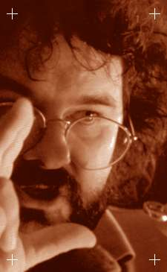
Peter Jackson

The films have been met, not only with critical acclaim (for many reasons including visual effects), but with love and respect from the most ardent of The Lord Of The Rings fans. Now for a book with so many avid fans this is no mean feat. But essentially the reason for the success is simple. It lies in the fact that Peter Jackson's interpretation of Tolkien's novel is very similar to everybody else's. He like the millions of others who read the book stayed within the confines of the small area of “Scope for Interpretation”, (as shown diagrammatically on the next page). As I have noted above, Tolkien covered 'every base' with his novel from describing the characters to the environments in such detail. It's as if Tolkien wanted desperately to convey the identical world that he visualised to the reader, with there being no risk of his vision being 'diluted' by discrepancies that could be caused by an manner of cultural or personal reasons, on the readers behalf.

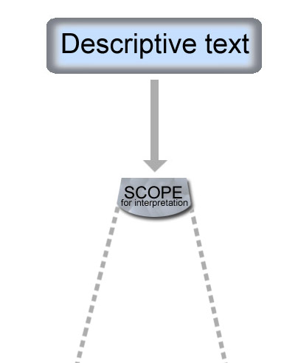

An image showing the small scope for interpretation that is offered from more descriptive texts.

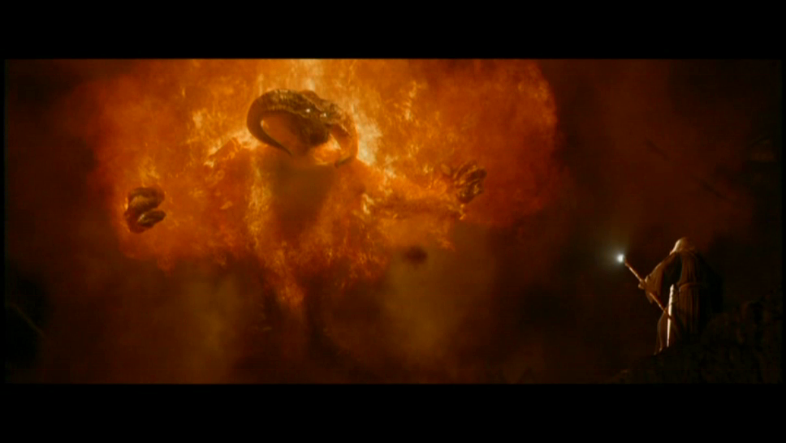
We can see the closeness of Peter Jackson's interpretation to that of Tolkien's original text by looking at the scene that I have quoted above from the novel and comparing it to some shots from the film adaptation.

Here we see Peter Jackson's visualization of the Balrog fight, more specifically, in the picture above we see the text being faithfully transferred to screen.

“...It stepped forward slowly on the bridge, and suddenly drew itself up to a great height....”.

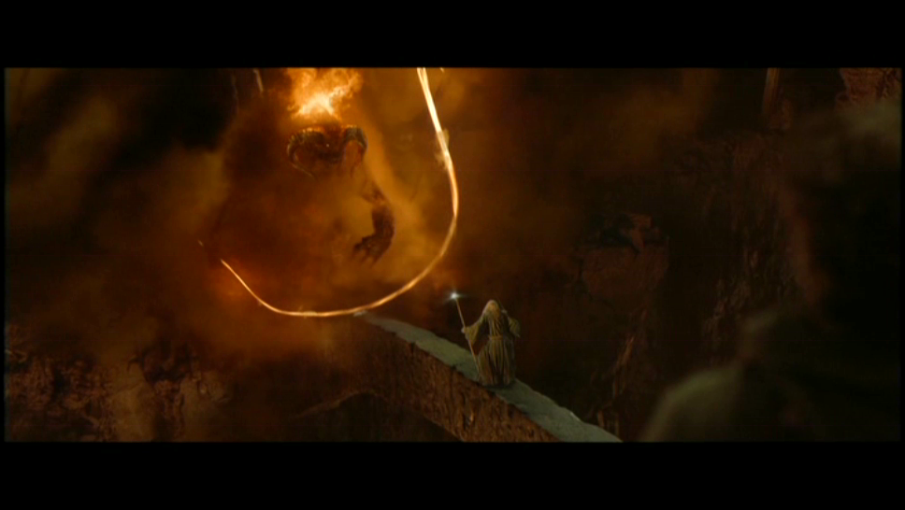
Another example from the same paragraph, can be compared to the image above:

“...With a bound the Balrog leaped full upon the bridge. Its whip whirled and hissed.”

This is a minor example of the point I am trying to convey, but the entire film is laden with faithful visual reproduction of Tolkien's text.
Structuralism tended to focus on isolated signs devoid of context, which meant that meaning was not necessarily viewed as something that might change depending on the identity of the user. They held the view that human subjects are caught up in the play of language, largely because the structure of culture was thought to be a product of the shape of the human mind. I feel that this is quite an ignorant way of thinking, and is choosing to discard many things.

A philosophy that chooses to incorporate all the aspects that Structuralism chose to ignore is the 'Post -structuralist' and 'Subjectivist' school of thought. Poststructuralist's like Benveniste and Lacan believed, like Derrida, that the connection between the signifier and the signified is far from arbitrary and seems more natural and should be stated as necessary. Benveniste paved the way for a vision of human subjectivity. This is where it is thought that the meaning of the text is entirely in its interpretation by readers. The text is seen to be 're-created' by the reader, with a huge amount of factors effecting that 're-creation'.
The French psychoanalyst, Jacques Lacan (1901-1981), believed that human experience was hugely important in regards to the interpretation of text. He divided human experience into a three-fold structure: the Imaginary, the Symbolic and the Real.

The Imaginary is specific to each person, a fantasy-image of our self as a coherent whole. Lacan associates the psychological development of our self-images with a "mirror stage" early in life.
The Symbolic is the collective fantasy of our culture as embodied in language. We become enmeshed in social roles, obligations and limits as we learn language and become aware of other people as distinct from ourselves.
The Real is simply electrical signals interpreted by your brain.
By incorporating the 'human experience' the notion that there will be multiple interpretations of the same section of text is held.
Take this random sample of text:

“She felt alone, desperate, sick and defiled. Something had been broken deep inside her and she didn’t know how to reach or mend it and for the next few moments she tried to push the horrible memory into the dark recesses of her heart. This was the only thing that gave her relief— numbness.”

Here we have a segment of text that is hugely emotive. It is descriptive, but mainly of the emotions this little girl is having. I feel that if a Structuralist standpoint is taken to interpret this text, and to assume that the meaning is wholly held in the difference between the words, is a view that may risk in fact losing vital elements of the 'meaning'. The fact is, there is plenty of room for the reader to imbue their own thoughts and experiences onto the text. The uses of emotive words like “alone”, “desperate”, and “numbness” all have a wide scope of interpretation and could mean varying things to different people.
For an extreme example consider this: if a teenager from a large family in England, who has many siblings was to read this text, his concept and interpretation of the word “alone” may be very different to that of a poor African orphan of the same age. For the English teenager, the experience of being 'alone' may not have featured very much in his young life. Surrounded by his brothers and sisters everyday, at school with friends etc. His only experience of being alone may be when he goes to bed at night in his safe suburban home. In this case the word 'alone' and it's 'meaning' to this teenager would be the polar opposite of what the same word meant to the African orphan. For his life may have consisted purely of being on his own, with no one to rely on or comfort him. Thus, the African orphan's interpretation of being “alone” is imbued with a lifetime of first hand feeling, totally differing from the English teenagers first hand experiences. Similar notions can be applied to every word that hints towards emotion, tally up the differences in interpretation of every word and in the end the entire meaning of the text could be utterly different.

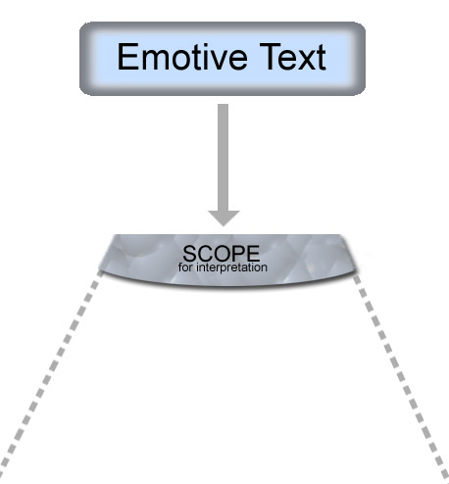

Simple diagram illustrating the fact an emotive style of text offer an increased room for interpretation

Both extreme points of views tend to shut one variable or another out. In the case of the objectivist the Text holds the key to the meaning. In the case of the subjectivist the Reader holds the key to the meaning. What about a point of view that combines these theories, a theory in itself that tries to encompass the reader, the text and the author? Wouldn't that make more sense?

This question became a vital aspect in determining how people interpret the works of the author Philip K. Dick.
Following on from my brief mention of Dick in the introduction I would like to embellish on the author. I had seen several of the many films based on Dick's novels before I had read any of his literature, including “Total Recall” and “Blade Runner” (based on the novel “Do Androids Dream Of Electric Sheep”). I had enjoyed them immensely and as soon as I realised they were based on a novelist's short stories I was eager to read some of his work. I proceeded to read several of the stories that were published in “Volume Four of Collected Stories”(show in the image below). I knew nothing of Dick as an author when I read the story “The Minority Report”. I was also not aware of what period of time he had written the stories contained within the collection.
The first thing that surprised me was the length of the stories. “The Minority Report” was a mere thirty pages long. Yet, for me, Philip K. Dick managed to create not only an interesting and engaging story, with equally engaging and rounded characters, but he set the whole thing in a future scape with a huge amount of integrity.
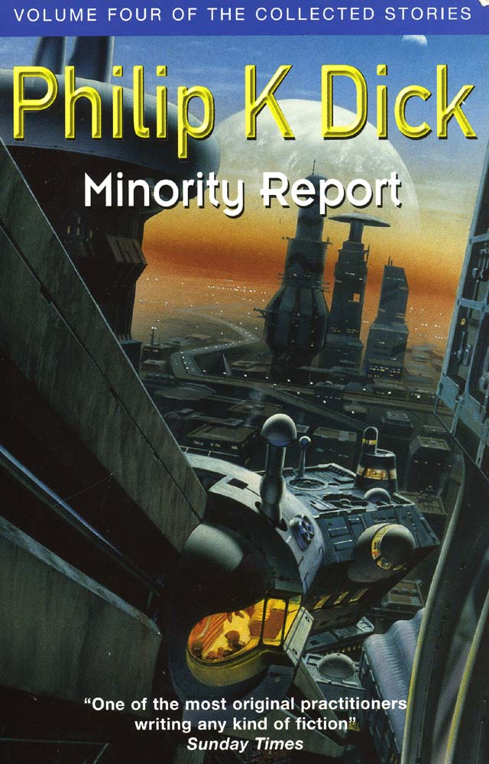

“His works were characterized by paranoid ramblings and speculations about alternative histories and the triumph of fascism in America. His stories frequently delved into heavy philosophical questions about the nature of reality and the meaning of individual identity, often resulting in trippy mind-bending zen-koan-style novels that leave some readers puzzled, others enlightened and still more deeply disturbed.”

Quote about Dick from http://www.rotten.com/

The success of his writing style, in my eyes, lay in his faith in not only the solidarity of his original core ideas but also in the faith in the reader. I discovered that with Dick's stories that it would be wrong to say that the full meaning of the text could be extracted from just the text itself, i.e. an 'objectivist' interpretation, neither could the reader alone imbue the meaning to the text, i.e. A 'subjectivist' interpretation. It would take a combination of the two to really get everything from Dick's text. A process of negotiation is required between the reader, the text, and the author. This, I discovered, could be seen as a 'constructivist' interpretation.
I see Dick's text as quite malleable. There is airiness, a sense of space in the text. At first glance it doesn't seem this way, with you being thrown into the story at a fast pace from the beginning (this is of course needed due to the short nature of the stories). For example “The Minority Report” starts with the paragraph:

“The first thought Anderton had when he saw the young man was: I'm getting bald. Bald and fat and old. But he didn't say it aloud. Instead, he pushed back his chair, got to his feet, and came resolutely around the side of his desk, his right hand rigidly extended. Smiling with forced amiability, he shook hands with the young man.”

But if you look at the novel as a whole, you realize that Dick has had to be sparing with the word count. Thirty pages doesn’t contain a lot of text to play with. So inevitably there will be 'blanks' that need to be filled in. Dick can't cover every aspect of the environments that appear in the story, like Tolkien did in The Lord of The Rings. Nor can he give each character an entire history. I discovered that this was mainly down to his need to write down his ideas as fast as possible and then move on. Trust needs to be placed in the reader to fill in the gaps that Dick leaves. Dick lays the foundations and covers all the major aspects that need to be covered to tell the story, he gives the people in his novels enough character to carry the story but allows the reader to expand those characters further via their interpretation. I feel that Dick's main intention with his novels was to portray a core idea, often of social significance, and let the reader ponder it. He would decorate the idea with a few elements that happened to be of the 'sci-fi' genre, but his main goal was to lay down his idea before he forgot it.
This can be shown with the recent film adaptation of “The Minority Report” by Steven Spielberg. The short nature of Dick's story meant heavy adaptation was required for the transfer to screen. And as I have mentioned above, like anybody, Steven Spielberg's mental interpretation of the Dick novel "The Minority Report" is likely to be quite far removed from anyone else’s. The novel being a mere thirty pages long, Spielberg has made it into a 2hour long feature film would require heavy interpretation and ensuing expansion.

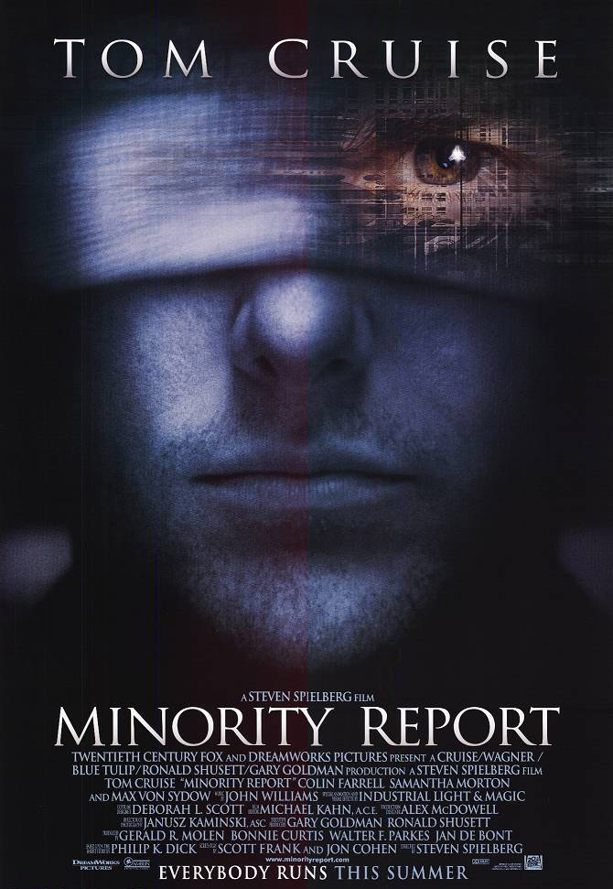
Poster for Spielberg’s 2002 film ‘Minority Report’

There are many elements in the film version of The Minority Report that are distinctly and obviously very faithful to Philip K. Dick's novel, i.e. Major aspects of the story remain. For instance the main themes are intact: The main character Detective John Anderton starts out on top of his game. A new, younger detective threatens his position. Anderton is accused of a murder by the very system that he helped create. He claims he is being framed. He sets about trying to prove his innocence.
But there are areas where we can see evidence of Spielberg extending certain aspects of the story with a personal flair. For instance, throughout the whole novel there is no mention of children, it is not implied in any way that Anderton has any offspring. But Spielberg, renowned for his use of children in many of his films centres the emotional state of the main character John Anderton on him having and lost a son. I feel there are reasons behind Spielberg's inclusion, and the themes don't seem out of context. It was the 'constructivist' philosophy that I had researched being shown. I would like to speculate that Spielberg doesn't do things by halves when it comes to film making. It would be safe to assume that he researches what he directs very thoroughly. I would guess that Spielberg is a fan of Philip K. Dick's writing, and much like Ridley Scott constantly conferred with Dick about his film adaptation of “Do Androids...” Spielberg took Dick's background and personal perspective into account when making his own film. I mention this, because it provides evidence that there is a 'repore' between the author of the text, the text itself and the reader/interpreter of the text. It is this three-way 'conversation' that is the key to the final interpretation that is extracted from the novel.

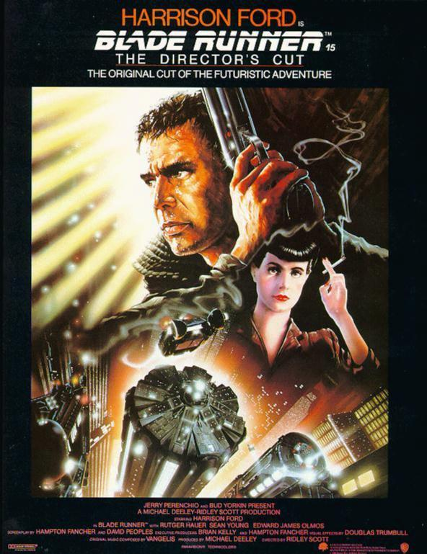
Poster for Ridley Scott’s adaptation of “Do Androids Dream of Electric Sheep?”

I believe that I can relate to this concept on a personal level. After I read “The Minority Report” for the first time, I decided to look into the life of Philip K. Dick. I found more than I expected. I found out that the mind of the man Philip K. Dick was very fragile. From the very start of his life he was haunted by the catastrophic loss of a twin, who died just a few days old. He battled with depression and other personal loss, amongst other things. Late on in his life, he even believed he had a personal visit from God. He was visited by a 'Pink beam', an experience that drove him to the edge of sanity and perhaps beyond. He became increasingly paranoid and his life imitated his art on a scary level. He was engulfed with paranoid delusions that the FBI and the KGB were monitoring his every move. I then proceeded to read the short novel again with my new discoveries of the man behind the book. My ensuing experience of the novel was altered from when I first read it. My perception of several elements in the book had changed and I saw concepts and ideas that Dick had put forward in a distinctly different light. I found my self-trying to view aspects from Dick's perspective when he wrote the novel in 1956. The car chase in the book took on a whole new look. I started to envisage a future scape from the perspective of living in the 50's, the cars that were involved had a less 'shiny' and glassy look as I had originally interpreted them as being, and became more metal and chrome, distinctly influenced by the styling of 1950's automobiles.
This is just one aspect out of many that changed in my second read of the story. But even with this small change, the evidence of the knowledge of Dick's background, which includes the era in which he wrote, the mental state he was in etc, directly influenced my interpretation.
Similarly, after reading about Dick I felt that the character of John Anderton and the paranoid situation he finds himself in “The Minority Report” mirrors Philip K Dick's life and feeling. I discovered that by writing his novel Dick was expressing the way he felt and was an attempt to make sense of his feelings, he found the process a good vent for his inner turmoil and helped alleviate the pressures he was feeling mentally.


Tom Cruise as paranoid John Anderton in Spielberg’s film adaptation & Spielberg’s visual interpretation of an automobile from Dick’s novel.

I feel I can relate this concept to Spielberg. Judging by the inclusion of children in many of Spielberg's previous films, i.e. E.T: The Extra Terrestrial and A.I: Artificial Intelligence (see images below),I believe that this is how Steven Spielberg has related and interpreted the themes of Loneliness and paranoia that Anderton feels in the novel to his own life. Being a family man, it isn't a farfetched notion to assume that Spielberg, like any parent has very protective feelings over his children. He may have interpreted Anderton's paranoia in the novel to his own fear and paranoia of losing his children. This may have resulted in Spielberg's additions to the story. More specifically, in Spielberg's film it is the loss of Anderton's child that is the integral basis of the story and starts a chain of events in the characters life that results in him being plunged into a state of paranoia and fear.

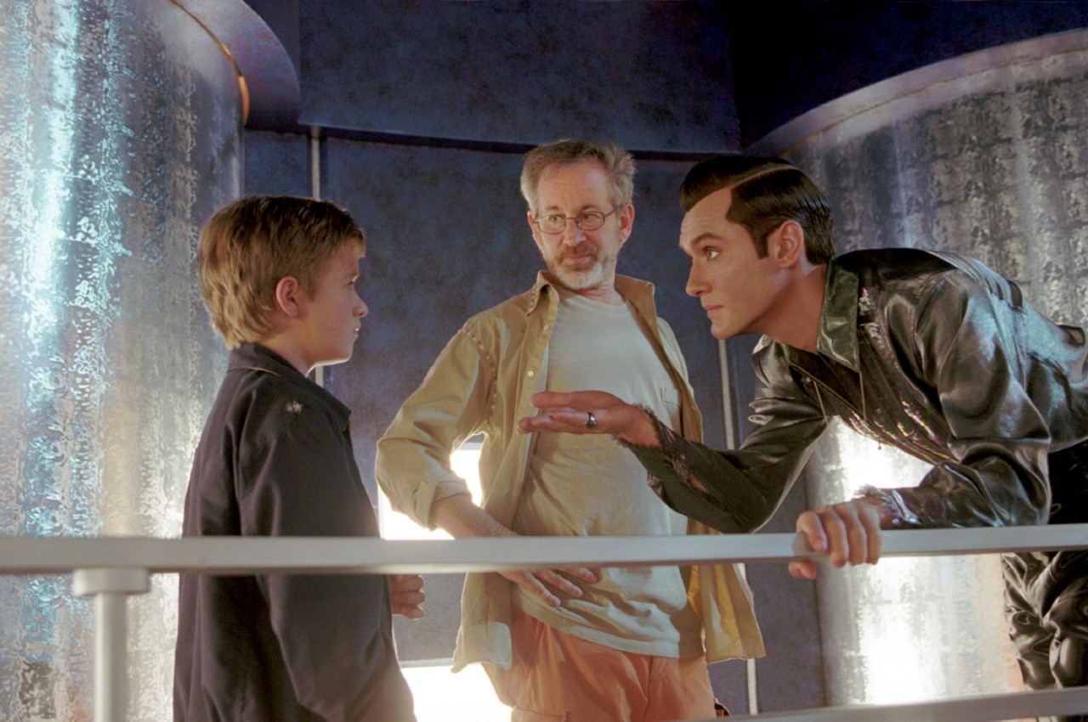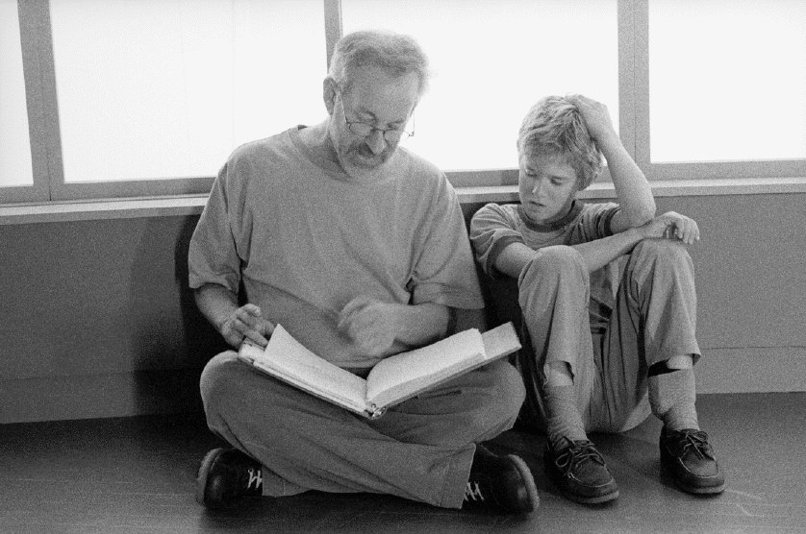
ET: The Extra Terrestrial, Spielberg on set of AI: Artificial Intelligence, Spielberg with child actor Hayley-Joel Osment

So here we see examples of two texts, The Lord of the Rings and The Minority Report that have been interpreted and adapted into films. If I had looked at The Lord of the Rings on it’s own I may have been convinced that the interpretation of text is a relatively simple act, seeing as how the film and so many interpretations, including my own were so faithful to the book. But much like how the structuralist’s went about their philosophies, it would have been like investigating something in a sterile environment to only consider that one text. And as soon as I did look at another text of a different style I realized that the subject I had involved myself with was immense and certainly wasn't easy to sum up.

Practical

During the course of my research I got the growing feeling that I had opened a large can, the contents of which was worms. As soon as you start to try and untangle the web of the human mind, it is very easy to get caught up in it, and in the end make it worse. I feel that, to a certain extent this is what has happened to many of the theorists and philosophers who have concerned themselves with the subject. It is so sprawling that with one point of view comes a counter point of view, and the theories end up going around in circles.
I could not hope to advance any theories of interpretation, or really ‘add’ anything of importance to the academic history of the subject that hasn’t already been discussed. Of course this was not my original intention anyway. What I wanted to achieve was to open my eyes to an aspect that I had not previously considered.

It’s all very well speculating about how others interpret text and to use examples of films that have portrayed their visions, but to understand the subject I have chosen to learn about more fully I feel I must investigate my very own process of interpretation. Although I have contemplated my own interpretations of certain texts during my research, I felt like I needed to go a small step further and see the process through from start to finish in a more practical sense. I decided that the whole practical would have to be condensed. It would be insane to think I could reproduce my own interpretation of an entire novel visually, in the short amount of time we have been allocated for this project. I needed to compromise. I decided that using just a small excerpt of text would be enough to explore the fundamentals of interpretation. I chose the following short piece of text to consider:

“Waiting…waiting…it was all in the waiting. His cold sweaty hands lay on the ivory pegs, twitching. The nervousness was all consuming, and the lingering made it build. What went through his mind was random, and the randomness was rapid. Whirling and bending, his thoughts were like an orchestra of voices singing wrong versions of the piece he was to play.”

The text is written by a friend, I took a paragraph extract from a short story. It is relatively obvious to say that by the very reading of this small excerpt, the text has been interpreted. I have discovered over the course of my research that this is true for any person with any degree of intellect. I have also discovered that the first stage that determines how that person interprets the text is the style of the text itself. As I have previously mentioned I have simplified things in my investigation, and split text into two categories, one of which is ‘emotive’. This piece is just that, it has a heavily emotive content. It consists of no real description of environment and is more descriptive of feelings. These factors, as I have discovered, lead to the possibility of many interpretations.
I wanted to explore my interpretation of it, and try and discover if what I have written about over the previous few thousand words is truly applicable to myself.
I want to be extra critical of the processes my brain was making. I realize that most of the processes that take place in the human brain that are related to interpretation are subconscious. For this reason I didn't want to labour the process and contemplate things to much to begin with. I wanted at least part of the process to happen naturally.
My interpretation started with the initial reading of the text. It did not take long to read. It also didn't take long to form a visual image in my head of what I read. The very fact that I had been concerned with the process my brain was dealing with at that moment made me hyperaware of what I was thinking. I feel that what I visualised from the text may be somewhat a caricature of what I would normally think, in a less 'forced' situation. Never the less it is definitely an interpretation and I decided to visualise my interpretation in a series of still images.
These are the images: (can be seen on a larger scale on the additional inserts)


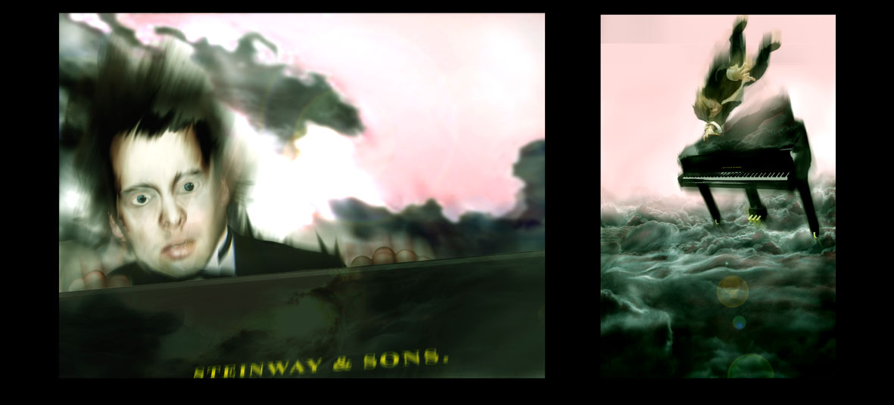
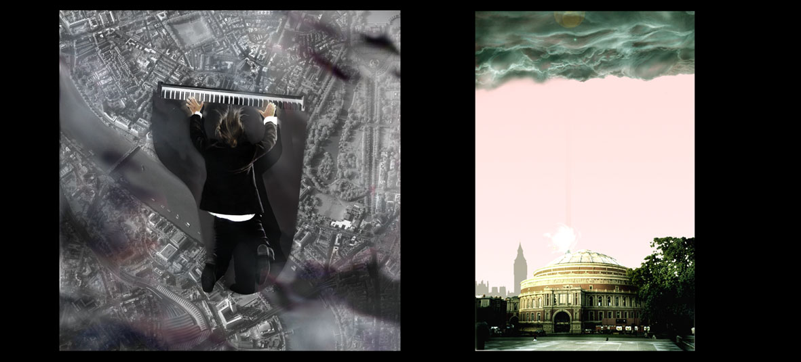

It occurred to me that as soon as I read the text I was linking the words that I was processing to images in my mind. This is exactly what Saussure theorised. I was indeed linking the 'signifier' to the 'signified' when interpreting the 'sign', in other words I was linking the sound image to the mental construct when interpreting the word. Everything so far was going just as a structuralist said it would. I was, for example, seeing an image of “cold, sweaty hands lay[ing] on the ivory pegs of the piano”, this could be very similar to another persons image, could it not be? Thus backing up the fact “that any educated reader will inevitably come to essentially the same interpretation as any other.” Which was essentially the claim of Derrida et all.
But I paused for a second...and considered more closely what I was visualising from the words I read. Starting with the setting. I had considered the text closely and extracted, from the emotive style, mainly a feeling of extreme anxiety. A feeling that I have close bonds with. In my late teens I started to suffer from anxiety, or ‘panic’ attacks. The experiences I had, and am still having related to this aspect of my life have brought a huge importance to the word ‘anxiety’.
Before I had to deal with the spiral of thought that occurs when you have a severe panic attack I had a totally different view of the word. When I was younger I associated anxiety with exams and tests. I would get butterflies before my grade 3-clarinet exam for example. Nothing too extreme and nothing that I couldn’t cope with. If I had visualized the same section of text at that age, I feel that my interpretation of the word anxiety would have been far less extreme. As it stands today I visualized a ‘concert pianist’ falling through the sky. The embodiment of the fear and ‘nervousness’ that the pianist is feeling straight from my heart. I have made the emotions that the character in the text is feeling personal to me. The last few years of panic attacks, seemingly totally irrational and utterly uncontrollable, is in my mind synonymous with the feeling of falling through the sky. The feelings of impending disaster and the complete lack of control are the keys to the association. It may seem over the top, but the text,

“What went through his mind was random, and the randomness was rapid. Whirling and bending, his thoughts were like an orchestra of voices singing wrong versions of the piece he was to play.”

really reminded me of how I felt when having a panic attack. The ‘randomness’, the ‘thoughts…like an orchestra of voices’, these are all words that hit a chord in my mind, unlocking a cupboard of feelings in my brain personal to me.
Moving on, my interpretation of smaller details like the object that is always inherently linked to “the ivory pegs” is even very specific to myself. I did not see a generic 'clip art' style image of a piano. I saw a boudoir grand piano, with many layers of lacquer that built up to create a mirror like reflection upon its surface. It looks very expensive and is made by “Steinway & Sons.”. I pondered why this mental construct was so very specific? I realized that in fact I had visualised the very piano my uncle owns. I had seen it at Christmas when my family had made our annual visit to see him in Wales. The reason I could picture it so clearly was because he had just had it refurbished when we visited and was taking great delight in showing it off. I would say that the mental construct that I have creating from just reading the word 'piano' is really quite specific, unique and personal. I wouldn't like to bet any money that many people had the exact same mental construct of the piano as me.
Looking more broadly at the subject, we can see my visual sequence starts with the pianist falling through the sky above the dark, ominous clouds, and then he is seen falling through them and out of the other side, and eventually crashing into the Albert hall. Much like Steven Spielberg did with Philip K Dick’s “The Minority Report”, I have extended the text slightly. I could have easily visualized this piece of text in one image. But I chose that to realize all that I was extracting visually in my mind, a series of images was more appropriate. It is interesting to look at my friend Leon’s interpretation of the text. I asked him to read the same extract and visualize it in any way he wanted. This is what he came up with:

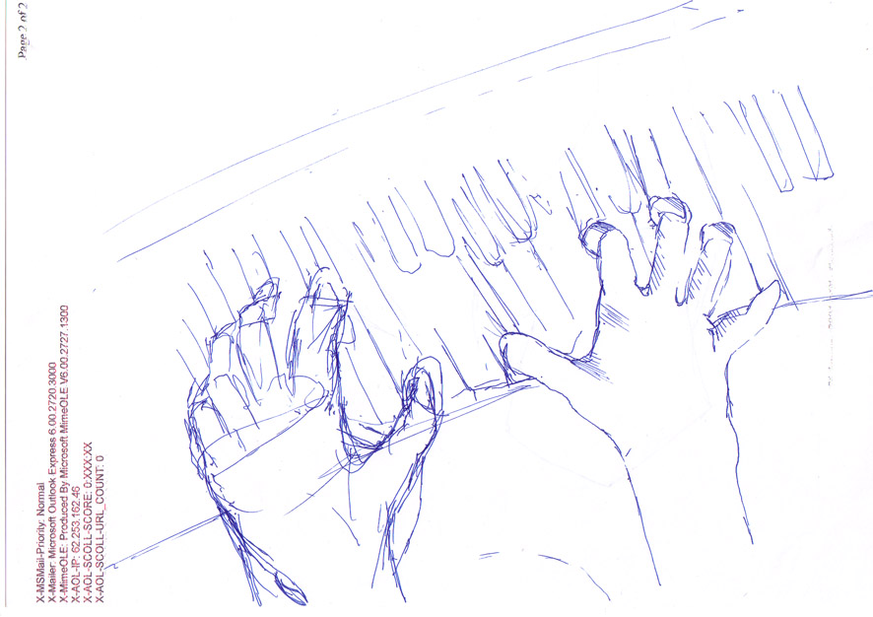

Leon’s visual interpretation of the text

Here we have one sketch, quite literal in its execution. Crude, due to time constraints, but just as valid an interpretation as my own. He has had a much more specific image in his mind of what the text is describing. He has not felt the need to embody the emotions in an elaborate way, but has opted to place himself and the ‘viewer’ of his interpretation directly in the place of the pianist. I asked him why he chose to visualize the text in the way he did. This is his response:

“Yeah, I sketched an image of the pianist’s hands. I imagined myself in the situation, which was easy because I have been a similar one loads of times at college, just before I play to an audience of tutors and other students. The words that were used in the text really took me to the bench at the piano and I basically drew what I saw in my mind.”

I also asked him for a specific detail. I asked what make of piano he was visualising himself play. He told me he was playing a “Bentley” piano “Like the one I practice on.” Quite different again from my glossy Steinway.

I should note that my visualization of the text was not shown to Leon, and consequently had no bearing on his interpretation. We can see why Leon has visualized it in the way that he has. He experiences the exact same situation very often, at his place of study; Guildhall music college in London. He does a Masters in Jazz piano and gigs around the city regularly.
So we have seen two interpretations of the same section of text that are entirely different. Mainly I feel down to the large scope of personal interpretation the ‘emotive’ text allows for. There are so many variables going through the mind that I just cannot document. But the main thing this small experiment has confirmed in my mind, is that people’s interpretations of an emotive piece of text can be truly sprawling in their variation from another persons and are highly personal. It really is the background, the culture, the films watched, the books read, the area and the era lived in…. the list goes on and on. It is hard to see how Saussure and other stucturalist’s could overlook such an important aspect of interpretation.
I feel I have made many discoveries during the research and practical execution of the topic of ‘interpreting text’. I was surprised to discover how recent in history the ‘Structuralist’ theory of interpretation of text was challenged. I feel a massive benefit from this small investigation in my own personal outlook. My understanding of the acts of ‘perceiving’ and ‘interpreting’ has changed somewhat, but has not fully developed. At the moment I am hyper aware of what I am associating mentally with any text I read. I remember in the 1st year of this degree, Phil Allen held ‘Film-Language’ lectures. He told the class that our enjoyment of films will, in the short-term decrease, but in the long-term increase. This was down to the fact that to begin with we would be analysing and scrutinizing the films very hard whilst we watched, but after a while you learn to soak up the ‘clues’ and meanings in the films and gain a greater understanding of what the film maker is trying to convey. This is similar to reading text, and novels. I feel my conscious thoughts of the very process of interpretation are in a way clouding some true ‘unconscious’ elements at the moment, and in a way making some of the text I read seem contrived. This I feel will pass, just as Phil Allen said about studying film.
What I will be left with, I hope, is a slightly increased understanding of what thoughts and images rush through my brain as I read.

This is a very small window into the process of interpretation for I have only scratched the surface of a sprawling topic. The process has, after all, been in existence ever since humans could communicate with the written word.

Source: The Oxford English Dictionary
Information gathered from: http://www.colorado.edu/English/ & “http://www.columbia.edu/itc/english/”
? Constructivism The term refers to the idea that learners construct knowledge for themselves---each learner individually (and socially) constructs meaning---as he or she learns. “http://www.exploratorium.edu/IFI/resources/constructivistlearning.html”
Sources: The Gnosis Archive: Gnostic Studies on the Web http://www.webcom.com/~gnosis/pkd.biography.html Philip K. Dick Official Web Site: http://www.philipkdick.com/ (set up by Dick’s own children)
Courtesy of Ewan Cameron. Extract taken from the short story entitled: “Laden”.

