Appendix A
Figure 1

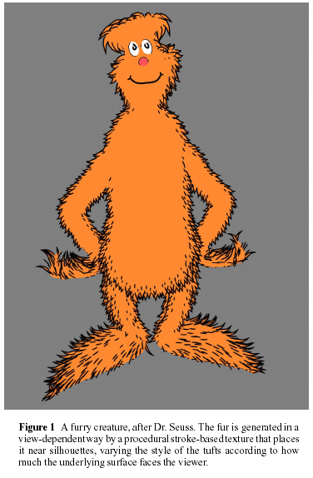

Figure 2

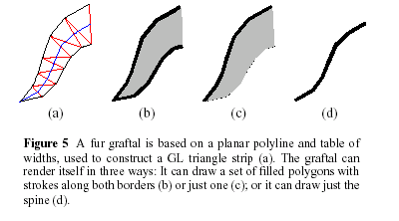

Appendix B

Figure 1

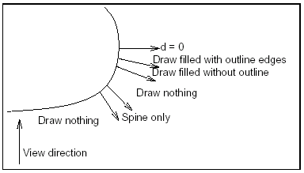

The dot product d of the view vector and surface normal determines a graftal’s drawing style. In Appendix A, figure 1 the “Draw filled without outline” region is empty: it was transitioned from “filled with outline” to “draw nothing”.

Figure 2

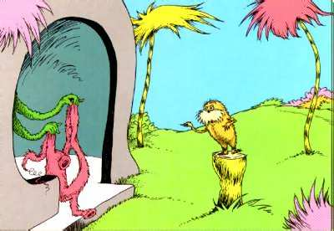

One of Dr. Seuss’s story images
Appendix C

Figure 1

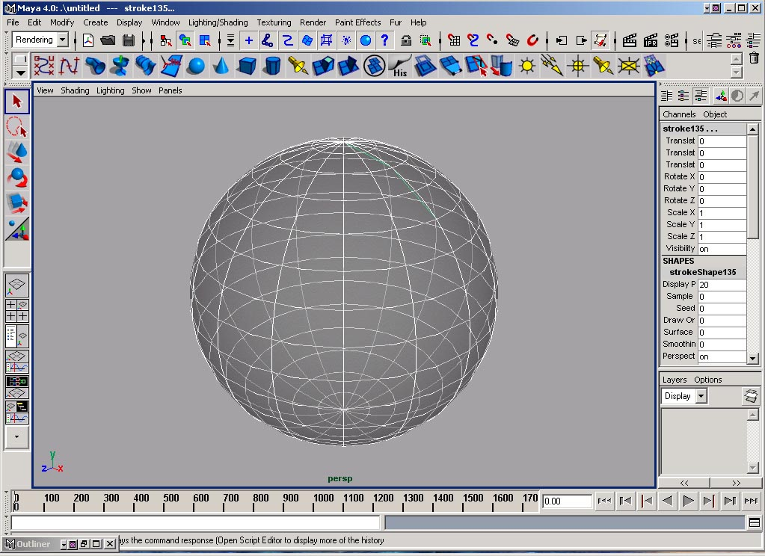

Figure 2

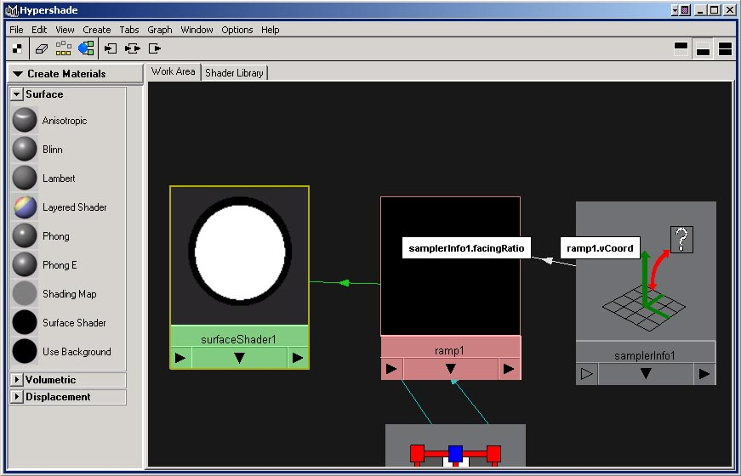
Appendix D

Figure 1
Geometry test Left is before, and Right is after the attachment of texture connected to a facing ratio.

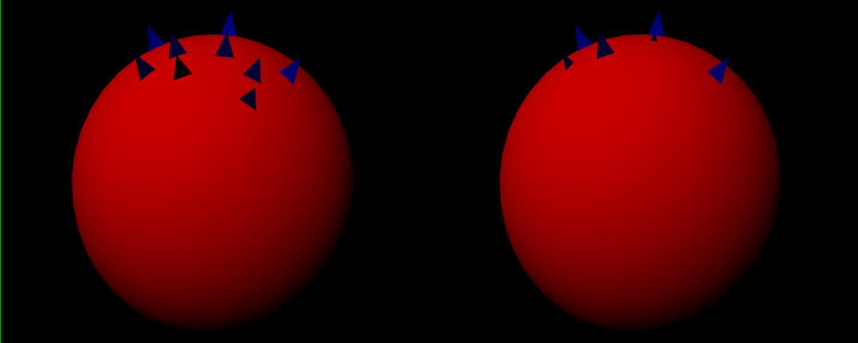

Figure 2
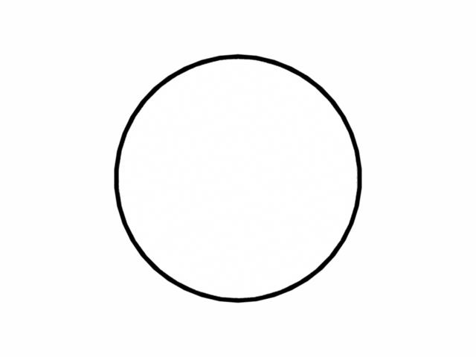
Fur baldness map

Figure 3
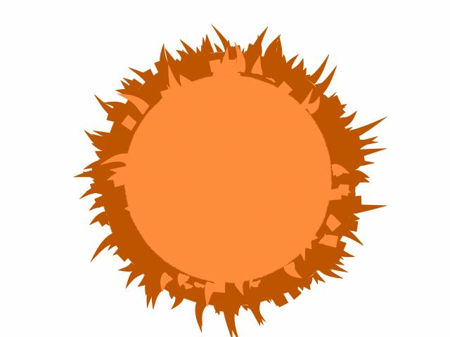
Two tone flat fur using an input from a facing ratio.

Appendix E

Figure 1
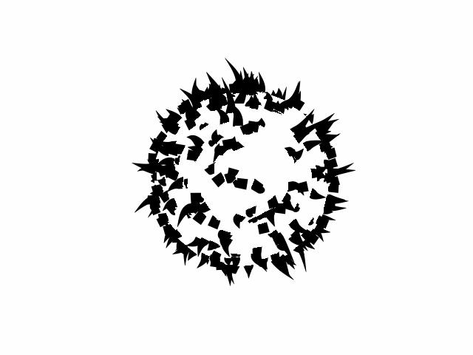
Black Fur render

Figure 2
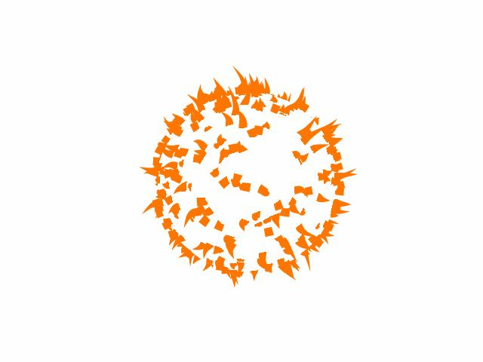
Brown Fur render
Figure 3
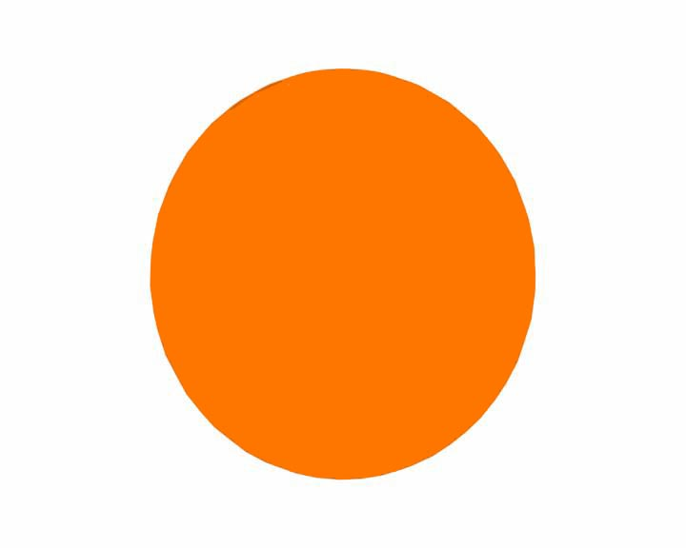

Orange sphere which fur is attached to.

Appendix F

Figure 1
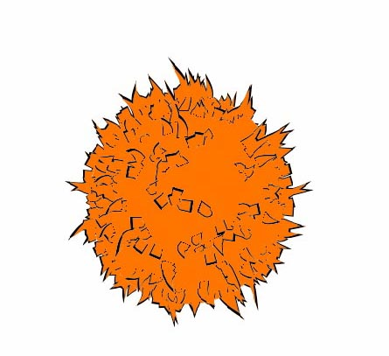
One tone fur effect

Figure 2
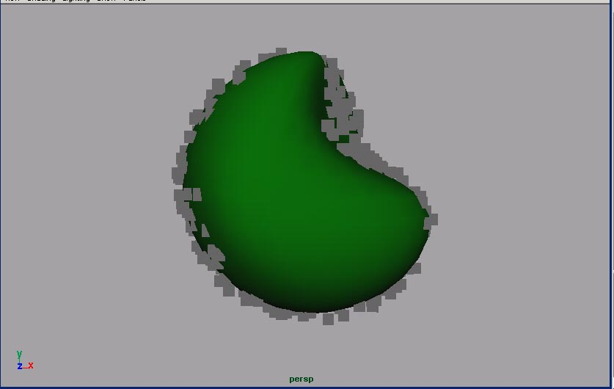
Particles working in world space.

Appendix G

Figure 1

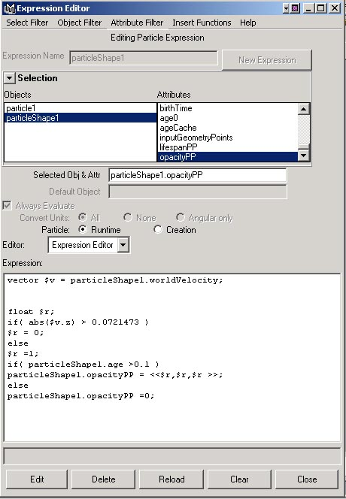

Figure 2

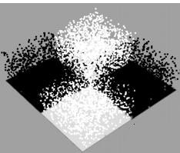
Particle emission dependent on a ramp (Maya Help Files)

Appendix H

Figure 1

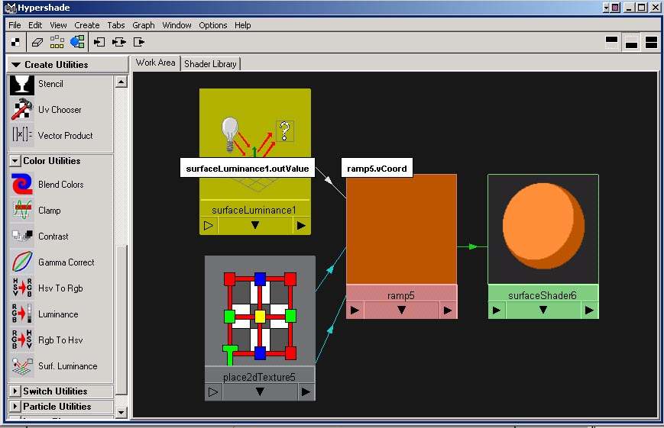Surface luminance texture ramp

Figure 2
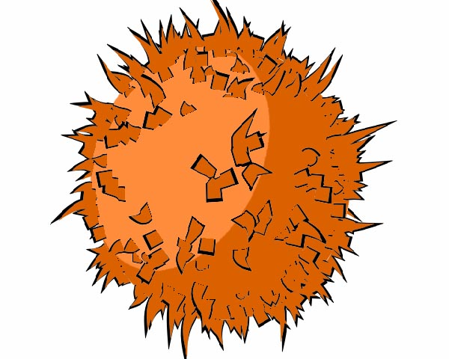
Two tone base colour with single colour fur.

Appendix I

Figure 1
Figure 2 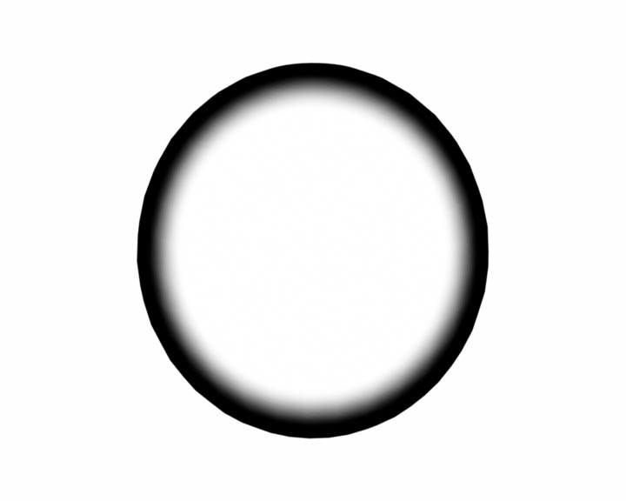
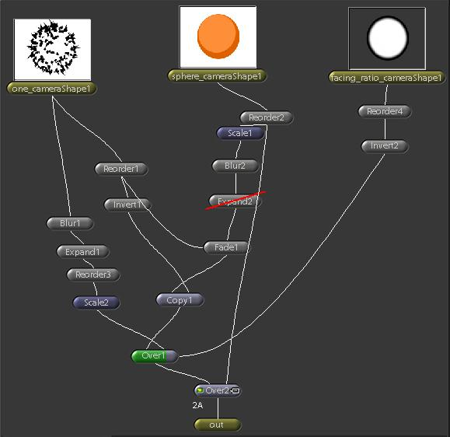
Shake layout for blended black fur mask effect.

