MORPHING OF POLYHEDRAL OBJECTS OF DIFFERENT TOPOLOGY

ABSTRACT

The technique to transform one object into another has been widely used in the entertainment industry as well as science. To graphically present ‘morphing’ the current technique is to transform between 2D images. This can be extended to transform between 3D objects, which has many advantages over the 2D approach. The problems with 3D morphing includes keeping a convincing form throughout the sequence due to the different topological arrangement of objects. This paper proposes a tool to morph between two 3D objects regardless of their topology and with controls in which the user can manipulate to define the morph.

1. INTRODUCTION

The term morphing comes from the word metamorphose and means ‘to change into a wholly different form or appearance’. Recent films to use the technique include Terminator 3:Rise of the machines and X-Men. The idea of transforming one object to another is not only used in special effects but is fundamental in even 2D animation when keyframing from one image to another, there needs to be an appropriate blend in order for the images to flow one from the other.

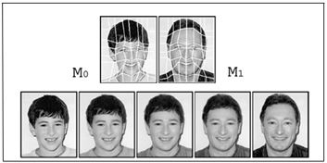Even though the use of 3D computer imagery has been widely used in current movies, the sequences where morphing is used is still largely done using 2D techniques. The simplest technique is to transition from one 2D image to another and this was seen first on screen by the in the movie Willow 1988.

Image taken from Image Metamophosis with scattered feature Constraints

The technique, created by Douglas Symthe of Industrial Light and Magic, involves using a two-mesh warping algorithm. The first mesh, M0, specifies the co-ordinates of control points or landmarks on the source image (image to be morphed). The second, M1, specifies their corresponding positions in the target image (final morphed image). M0 and M1 are then overlaid and animated from one to the other in order to produce the final sequence.

This warping algorithm is limited in that there is no real control over the transition of one object to another as the geometry of either objects are not altered. With this technique the two images have to be similar in order for it to give a convincing result – the eyes and mouth need to be in similar positions on a face, for example, or the objects need to have the same angle towards the camera.

The growing use of 3D computer generated objects means the technique can be moved from 2D. If a 3D technique was adopted the result would be a generation of intermediate 3D models which would overcome the shortcomings of a 2D morphing technique. It means that the objects could be morphed separate to the animation, as the intermediate objects generated would have their own solid geometric properties. With a 2D technique the animator is unable to correctly handle the following changes:
- Shadows and Highlights.
- Features not visible in the original 2D image.

With 3D morphing the morph is independent of the viewing angle and lighting conditions of the scene and once the morph sequence has been created the animator is free to experiment with various camera angles and lighting.

The advantages of a 3D technique should make it the more suitable choice when coming to show metamorphosis on screen. This paper looks at the ways in which morphing can be taken into the 3D animation environment and the process interactively controlled by the animator.

2.0 CURRENT ALGORITHMS

Over recent years there have been 3D morphing techniques that have been tried and tested. They fall into basically two types of algorithms, surfaced based and volume based. To describe these techniques the terms source and target are used to mean the state of the morphed object before and after transformation.

  - SURFACED BASED ALGORITHM

In surface based algorithm the surface patches of the source model are transformed into the surfaces patches of the target model.

The quality of this morphing technique is highly dependent on the source and target models’ geometric primitives and their topological properties. In order for the morph to be convincing the source and target model need to share similar properties.

The process of this method of morphing is divided into 3 steps by Parus [12]. These steps are:

- Finding a correspondence between the source and target object. The correspondence is between the vertices on each object. In the morph each vertex on the source object is moved to the corresponding vertex on the target object. In order for this to work for objects of different shape the position P1 on the source needs to be matched to P1 on the target.
Image taken from paper by Paru [12]

On a target object with less points than that of the source, extra points need to be added in order for the topology to match. In this case faces on the target object are triangulated to create the extra points.

To find which triangle corresponds with which on the object the two meshes are mapped to a common parameter domain. For genus 0 meshes (those being without holes.) Parus writes that it is a unit sphere. For star-shaped objects a spherical projection can also be used. After the parametization of each object, the position of a particular vertex on the source object can then be found on the target object. This is found by projecting points on the source object onto the sphere and then from the sphere to the target object.

- A construction of a super-mesh. The super-mesh represents both the source and target object and shares both objects topology so it can transform into either mesh.
To achieve this, edges of source object need to be inserted into target and vice verse. The intersections of an edge on the source object and the edge of the target object are found and then the new edge is inserted. Extra edges are then included to support the new points resulting in triangulation.

- Interpolation of corresponding vertices. This is the movement of the vertices from the source to the target. In most methods the interpolation is linear and there hasn’t been many suggestions to change this to support a more organic effect.

Other methods of surface morphing have been discussed. Chen et al,[3] presents a surface based method which transforms 2D linear contours which can then be extended to work on 3D lofted objects. Parent describes a solution of dividing the object into pairs of sheets of faces [13]. These are then recursively subdivided until the topology of each pair is identical. The method developed by Parent uses the same method as the 2D-morph method by Symthe. The regular grid created in the method provides a lattice (3-Dimensional grid) in which the vertices can be controlled and rearranging the position of points on the lattice in turn repositions the vertices. The problem with this method is that the approximation will not accurately capture the morph in highly non-linear regions unless a very fine grid is used.

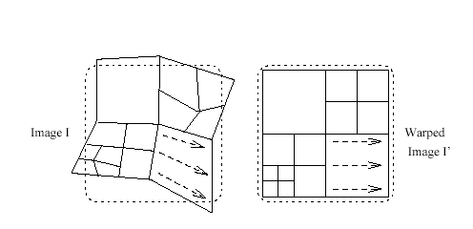

2.2 VOLUME BASED ALGORITHM

In volume-based algorithms the source and target 3D objects are represented as volumes and then these volumes are manipulated in order to make one object become the other.

The entire object is reconstructed into a more complex model based on cross-sections. Again the amount of vertex or surface patches needs to match in order for the morph to be convincing and most of these methods assume the cross-sections consist of closed polygonal contours.

The advantage of this type of algorithm over the geometric type of algorithm is that it can be applied to objects represented by either geometric primitives or volumes. The disadvantage is that the objects need to be first warped into a more complex model making it just as expensive to compute.

The technique with this algorithm is the use of voxel-based models rather than polygonal models. Voxel- based models captures not only the object itself but also the space surrounding the object. The first step with this algorithm is to classify the objects in 1D space into segments of object and non-object. The object segments are then mapped to the corresponding segments on the target object similar to that of the surface based method by the non-object segments squashing and stretching the object.

Chen [4] introduces a volume distortion algorithm which uses 2 sets of disk fields to control the transformation of one object to another. The disk fields are specified by its centre point, a normal vector and its radial vector in Euclidean space where the radial vector is perpendicular to the normal vector. The two disk fields build a cylindrical control field. This defines a co-ordinate mapping system and can be used to control distortion of from the source volume to the destination volume. The points are then reverted to their position in Euclidean space.
Image of effect of disk, taken from Chen, volume Distortion and Morphing using Disk fields

The disks can be scaled, translated and/or rotated to produce the destination volume. For more control of the morph, more disks can be added these in turn can be transformed separately to give the desired effect.

With both types of algorithms, unless written for two specified objects, the feature recognition and matching are automatic and there have been hardly any proposal to make the algorithm more flexible so the animator has control over the way in which the object morphs. Lerios warping method provides extra control into how the morph sequence transforms.

Lerios, [6], presents a method which is driven by volume warping and blending. Specifying collections of element pairs, to establish overall correspondence between both volumes controls warping. The element pairs (influence field) serve as magnets that influence the shape of the volumes. The two volumes have to be warped first and then the resulting warped volumes are blended to get a smooth transformation between the volumes. The warp of the objects uses the technique produced by Chen on areas between the elements added to the object.

The importance of user control is crucial, as the automatic feature of these algorithms cannot always give the desired effect. The quality of the morph could be easily improved by the control the user is entitled to.
The problem this presents is that not only does the designer have to create a technique that works efficiently but also one that permits fine user control and an accompanying user interface for the animator to use without having to know of the complex mathematically properties of the algorithm. Lerios writes that in order to be efficient the technique must have a high level of:

Realism- the resulting morphing object must have plausible 3D geometry and retain essential features of the original source and target model.

Smoothness- the final render of the morph must show a smooth transition.

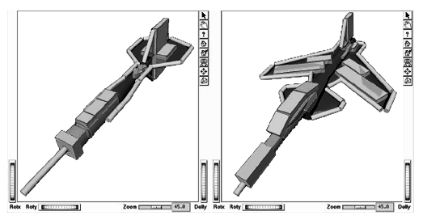The user interface presented by Lerios uses elements to establish correspondence between models. These elements are points, segments, rectangles and boxes. The x, y, z co-ordinates are shown when the user selects an element in order to change its attributes. This variety of elements allows the user to sculpt the morph.
Image of morph user interface taken from Lerios, Feature-based Volume Metamorphosis

The interface although intuitive does seem complex to use, and it would take the user a long time to refine the morph. It also is best used for objects of similar properties as it would be to hard to use on objects which had no resemblance. The tool in which this paper intends to propose is to incorporate a user-controlled element with an algorithm that is not too expensive to be used interactively as the animator refines the process.

3.0 CURRENT TOOLS

In 3D animation packages such as Maya there does exist tools to aid in morphing. In Maya this is the blendshape function. When used on NURBS objects the user is free to morph between objects of different topology. This works effectively until the user starts to use more complex objects in which the surface patch matching starts to become more of an issue. The problem comes when the user wishes to use polygonal objects, as the morph is only efficient if the objects share the same topology.

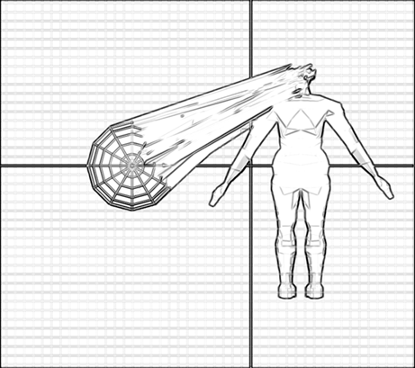

There is an option to morph objects of different topology but this does not morph the entire object. The reason being that the option to morph polygonal objects relies on a surface based algorithm where points/ vertices on the source object are mapped to vertices on the target object. With a point by point method if one object is larger than another, then some points will not be mapped.

For polygonal objects with matching number of points this still presents a problem as the function also relies on the ordering of the vertices. Each vertex is assigned a number on creation, when new vertices are added to an object Maya automatically assigns them a number. This can be a new number or one that is currently being used resulting in the current order being changed. The method of renumbering takes on no logical order so when morphing from one object to another the vertices are more than likely to cross over and intersect making the resulting object bear no resemblance to the target object. The overall morph sequence results in an object which collapses and folds into a twisted target object. An algorithm to be used in Maya would need to solve this problem if either of the mentioned algorithms are to be implemented.

  - RECENT TOOL DEVELOPMENT

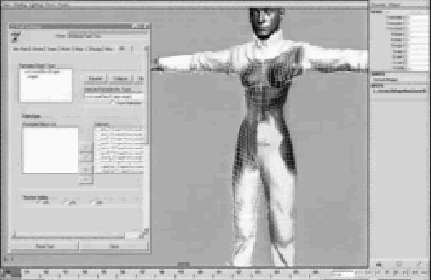Image of Maya modelling environment with plug-in and effects. Taken from Kleiser-Walczak

For the movie X-Men 2 the problem of user controlled morphing was attempted to be solved. A tool was created by Daniel Roisman of Kolektiv as a plug-in to Maya. One of the characters in the movie could transform into any shape or character of her choice. The solution to the way in which she morphed was to use an artisan tool to paint weights onto areas which in turn morphed to the target object.

This map of weights could then be used to also interpolate between textures on the character which would match the animation sequence perfectly. The problem with this tool is that it still doesn’t solve the problem associated with polygonal morphing. Although the models where modelled independently of each other the animator had to go over both models after converting them to NURBS. This was to make sure that both objects had the same number of surface patches, the same topological arrangement and the same parametization.

The ideal tool would allow efficient transformation of objects regardless of their geometric properties and being able to morph polygonal objects rather than having to converting them first. It should also like the Roisman tool allow the user to control the way in which the object transformed from the source to the target object.

4.0 MOVING THE ALGORITHM TO A FUNCTION IN MAYA

The tool proposed in this paper uses an algorithm which combines the benefits of both the surface based and volume based algorithm. This is less expensive to compute as there is no need to transform the source and target object into volume based objects which are topically more complex than their original form. It also means that when mapping points no points are left out of the equation.

  - Morph_v1

As the tool is to be used in Maya the first thing to do is organise the way in which the vertices are ordered. Before calculating the movement of each vertex on the object the algorithm needs to reorder them in a logically manner. The algorithm presented, in this first attempt of the tool, reads in the positioning of the vertex and then reorders the numbering in height order.

The algorithm in MEL uses a sort algorithm to do this. Problems in implementing the algorithm occurred as the algorithm needs to rearrange the ordering of points with x, y and z co-ordinates while only evaluating vertices on one axis. There is a sort command in MEL but this cannot be used as it only works on values of one-dimensional arrays. The sort needs to be efficient enough not to take too long to compute, as the program will crash if it does.

After the vertices are reordered, on the y-axis of each object the vertices can then be grouped and moved so that each vertex is moved resulting in a complete transformation. This approach assumes that both objects consists of closed polygonal contours and this is the approach which will be kept to throughout the paper in order to provide an efficient tool at its simplest level. The technique can then be later developed to overcome the problems of objects with irregular shape and objects with holes.

4.1.1 Result
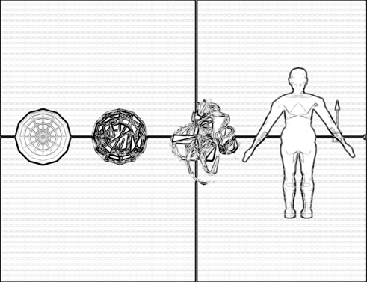

The result of using this tool means that the user can morph between polygon objects of different topology. This algorithm does not solve the problem of the resulting object not resembling the original target object as vertices still move over each other.

In order to produce a morph which is convincing the object needs to resemble both the source and target object.

4.1.2 Solution

The proposed projection method seen in research by Parent [1], could be used to rectify the problem. This approach involves the algorithm to know of the surface layout of the objects including information on the edges and faces, which would be too expensive to compute for a tool to be used in Maya. The algorithm can be developed to use the information gained from the original tool.

To solve this problem a technique, which is similar to the presented methods of using 2D contours and disk-controlling, can be used.

4.2 Morph_v2

This second algorithm divides the object into cross-sections/slices Each slice on the source object is then evaluated against the corresponding slice on the target object and a list of destination values are calculated for each vertex. By calculating a set of destination points before the transformation is as effective as creating a super-mesh as described in the Parus paper. This means the calculation of movement only needs to be calculated once and then the animation sequence of the morph is processed separately meaning the tool is more efficient interactively.

The slices are then matched using 2D morphing methods. The geometry is adjusted by adding points to the object with less vertices. Therefore the target object is the smaller object and the source object is the larger.

The following method is explained by using a cross-section of the source object consisting of 5 vertices and a cross-section of the target object consisting of 3 vertices

This is the simplest solution of mapping extra vertices. The points on the source object are mapped to the target object. Points, which fail to be matched, are overlapped onto the last point. This creates a complete closed morphing object with no points crossing over each other within the slice.

In the following example two different shapes are used with no subdivisions along the height of the object. In development, for the amount of slices the user would input the amount of slices they wish to create on the larger object but in this version of the tool the user is only given the option of two slices, which for the example is appropriate.

Although the original tool renumbered the vertices in height order, the arrangement is still inappropriate for the individual slices to be used. An extra algorithm is needed to arrange the vertices in the slice. Also P1 on slice1 needs to correspond with P1 on slice two in order for the object not to twist. The algorithm used to sort the slice finds the closest point on slice two to that of P1 on the slice before. The vertex is then made P1 on the above slice and the remaining vertices are arranged in order of closest to P1 on the x and z axes. This eliminates the problem of the slice of vertices being made up vertices in a star-shaped manner.

4.3 Morph_v3

This version of the tool allows the user to input the amount of slices they wish. The algorithm still at a simple stage allows the user to input up to 6 slice to help in the transformation of the source object . The way in which it is used best is for the user to input the amount of divisions along the y-axis on the source object.

The following image shows the result of using the tool on the same cylinder and cube as in the above figure. The difference is that the cylinder has an extra cross-section, to overcome the problem of this the tool settings can be changed to a higher slice value. The image shows the results of the setting being set to 2 and then again at 3 for a more accurate result.

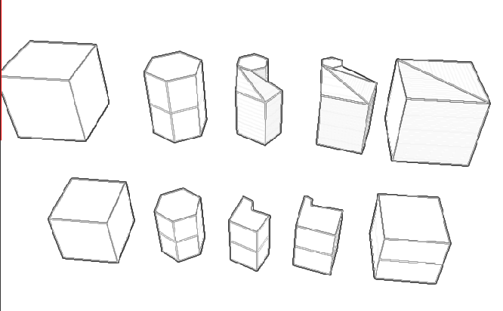

4.3.1 Implementation

The script is made up of eight procedures. On calling the script the user is presented with a user interface window in which the morph is initialised and controlled. To set up the objects for transforming the user has to select the largest object which will be the source object and the second smaller object which is to be the target object. The button ‘create Morph’ calls the procedure init() which sets up the morph.

global proc init()

The procedure first moves both objects to the origin and reads in the co-ordinates of the vertices from both objects in world space. The vertices co-ordinates are stored in two vector arrays, the term vector being as used in the Maya Mel scripting language a variable with x, y and z values. The two arrays, one for the source object and one for the target are then sorted using the SortVerts() procedure.

global proc SortVerts(vector $array[], string $Vertex[], int $end)

This procedure takes in three parameters that being the object co-ordinate array which is to be sorted, an array of the corresponding vertex name and the size of the array. A variable is set to the first y-co-ordinate value in the array. The procedure then finds the largest y value and moves it to the end of the array, the name of that vertex position is also moved. The process is repeated until all the vertices and names have been repositioned.

global proc CreateSlice()

This reads in the value of the sliceControl slider and sets the amount of slice divisions on the objects. It groups the vertices in order of which slice they fall into. The slices are determined through height ranges. The amount of vertices in each object slice are then passed to the procedure SortSlice() in order to be sorted appropriately. An array of destination values are then created within the slice and this builds the shared topology morphed object.

If the target object has no vertices in a given slice Sn the procedure looks to the above slice, Sn+1, for points. The destination co-ordinates are then obtained by the halfway points of the vertices in the slice below, Sn-1, and the slice above, Sn+1. If the source object has no vertices in the given slice the procedure will terminate with the message to the user to use a smaller slice range. This stops the program from working out unnecessary calculations if slice input is set too high.

global proc SortSlice(int $object, int $amount, int $limit,)

This takes in three parameters- which object slice being sorted, the last vertex co-ordinate and name in the slice and the first vertex in the slice. The procedure needs to know which object it is sorting as only the source object co-ordinates will be moved and need the corresponding names of the vertices to rearranged.

In the implementation of Morph_v2 the procedure then assigns the position of the first vertex on the object. The procedure then finds the nearest vertex on the x and z axis to this vertex and stores it. This means that the slice above will follow the same order of movement as the previous slice. The vertices are then arranged in order to how they are positioned to each other. This is done by a loop which finds the vertex closest to the first vertex, then the next vertex closest to the second and so on. Unfortunately this does not provide accurate results so for the third attempt to the tool a different approach to organising is set up.
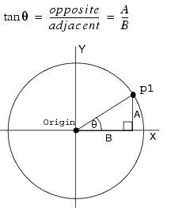

The procedure sorts the slice in order of where the point lies on rotation around a circular plane. It uses the tan command in Maya which finds the angle between the line formed from the vertex point P1 to the origin and the x axis. The angles are placed into an array and then the vertices are swapped according to where the tan angle lies in the temporary array.

global proc moveVerts(vector $morphObject1[], vector $morphObject2, string $VertexToMove[], int $amount)

The procedure which repositions the vertices on the source object to its corresponding position on the target object take in the following four parameters:
$morphObject[] The source object co-ordinate values,
$morphObject2 the array of final destination values,
$VertexToMove[] the string array of the source object vertices which are to be moved
and the amount of vertices which are to be calculated.
It reads in the position of the morph from the morph slider which has a value between 0 and 1. This in turn becomes the value of $t where the linear interpolation equation A = (1-$t)S + $t*T is used. Where S is the source object and T is the target object.

global proc reshape()
This procedure is called on moving the morph slider to update the value of $t and to reposition the vertices through the moveVerts procedure.

- RESULTS AND IMPROVEMENTS

The tool currently works on all objects with no vertices on the caps of the object. As the algorithm works from the bottom of the object up, the vertices in the slices above must contain the largest amount of vertices. Another problem with the method currently used in is the lost of faces, which wouldn’t be appropriate on more complex models, if the slices on either object had different amounts of vertices. If this were the case it would cause the faces on the resulting object to look twisted other methods of arranging the vertices in the slice need to be considered. These other methods are explained in the same manner as the method mentioned and implemented in the current tool example with a source object slice of 5 vertices and a target object slice of 3 vertices.

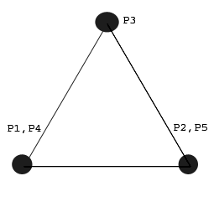

Method 1
The points on the source slice are matched to the target slice in either a clockwise or anti-clockwise order. This is repeated until all the points on the source slice are mapped, resulting in evenly overlapped vertices. This would give a more evenly spread result than the one currently used. The result on a 3D object means that the object would still twist on complex objects as it morphed.

Method 2
The amount of points on the source slice are divided by the amount on the slice of the target object. The points are then grouped and mapped to the target slice. This results in overlapping that doesn’t twist the 3D object. There is still a lost of faces in this method but this can be developed to spread the vertices out .

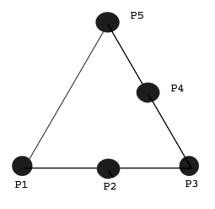

Method 3
An extension to the previous method provides the most efficient method in matching the vertices on the source object to the corresponding slice on the target object. The amount of faces on the object would not be reduced if this method were implemented and it would solve the problem of twisting.

The program also needs to recognise that a slice on either object will not have the same number of vertex as either the slice above or below. It also needs to work for objects such a spheres that have vertices that aren’t arranged in a single loop. To solve this problem a procedure similar to that of the Chen algorithm can be implemented. The procedure would create a control disk for the top of the object and the bottom of the object.

The outer size of the disk would be the size of the distance between the furthest vertex and the origin. The vertices in the top and bottom slice would then be arranged on where they lie on the disk going from the outer rim to the centre in the same way that the overall object is divided by slices. These circles on the source object are then mapped to the corresponding circles on the target object.

It would not be necessary to produce these disks for the middle of the object as the objects tend to be hollow. A similar technique for the middle of the object could be written to morph objects with holes.

To control the morph better on complex objects the user could specify the slices of the object through use of other objects. This idea is first presented in the Lerios research [6]. As an extension to the current tool NURBS circles could be used to identify the positions of the slices on each object. This in turn would be read in to the algorithm and the appropriate calculations made.

The alignment of the morph could also be specified. The current tool still tends to work on objects which are morphed at angle but it could be improved by allowing the user to specify the orientation of the object with out having to rotate the object prior to the morph initialisation. Locators could be set and the user would in turn rotate theses into the appropriate positions.

The way in which the morph is performed could also be improved. A technique similar to the tool created by Kleiser-Walczak could be adopted to give a free-hand morph control. In the current tool presented here options to change the interpolation equation could be implemented as automatic changes. Different methods of interpolation could be selected, causing the morph to ripple for example. This would mean creating a variable in the MoveVerts() procedure to chose which interpolation technique to use. Also the way in which the tool updates can be changed to having the morph interactively update or to only update at intervals. This option would allow the user to see still see the morph on objects which take up to much of the CPU when updated interactively.

These extra elements to the tool would provide exceptional control at an easy-to-manipulate level for animators. It would produce a fully interactive 3D Morphing tool which would be placed in the 3D working environment.

6.0 TEST MORPH

RESULT 1

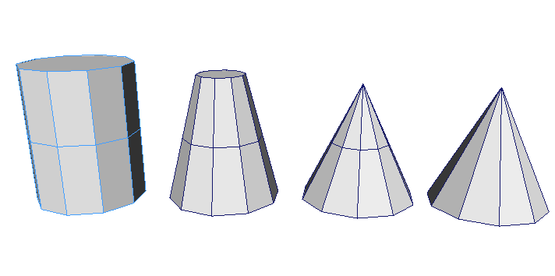

CYLINDER
Radius = 4
Height = 10
Subdivisions Axis = 12
Subdivisions Height = 3 Subdivisions Cap = 0

CONE
Radius = 4
Height = 8
Subdivisions Axis = 10
Subdivisions Height = 1
Subdivisions Cap = 0

MORPH
Slice = 3

RESULT 2

CYLINDER
Radius = 4
Height = 10
Subdivisions Axis = 12
Subdivisions Height = 3 Subdivisions Cap = 0

CONE
Radius = 4
Height = 8
Subdivisions Axis = 10
Subdivisions Height = 1
Subdivisions Cap = 0

MORPH
Slice = 4

RESULT 3

CONE
Radius = 4
Height = 8
Subdivisions Axis = 10
Subdivisions Height = 3 Subdivisions Cap = 0

CUBE
Width = 10
Height = 10
Depth = 10
Subdivisions Axis = 1
Subdivisions Height = 1
Subdivisions Depth = 1

MORPH
Slice = 3

RESULT 4

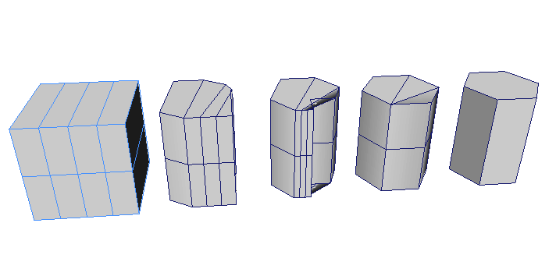
CUBE
Width = 10
Height = 10
Depth = 10
Subdivisions Height = 2 Subdivisions Width = 4

CYLINDER
Radius = 4
Height = 10
Subdivisions Axis = 6
Subdivisions Height = 2
Subdivisions Cap = 0

MORPH
Slice = 3

RESULT 5

CYLINDER
Radius = 4
Height = 10
Subdivisions Axis = 6
Subdivisions Height = 4 Subdivisions Cap = 0

CUBE
Width = 10
Height = 10
Depth = 10
Subdivisions Height = 2
Subdivisions Width = 1

MORPH
Slice = 5

BIBLIOGRAPHY

- Kent, J., Carlson, W. and Parent, R. Shape Transformation for Polyhedral Objects. Department of Computer and Information Sciences, Ohio. (July 1992)

- Breen, D., Mauch, S., Whitaker, R. and Mao, J. 3D Metamorphosis between Different Types of Geometric Models. Computer Graphics Group, California Institute of Technology and SCI Institute, School of Computing. (2001)

- Chen, E, and Parent, R. Shape Averaging and its applications to Industrial Design. IEEE Computer Graphics and Applications 9,1(January 1989)

- Chen, M, Jones, W., and Townsend, P. Volume distortion and morphing using disk fields. Department of Computer Science, University of Wales Swansea. (January 1999)

- Cominos, P. 2D Computer Assisted Animation. NCCA Bournemouth University. 1997

- Lerios, A., Garfinkle, C., Levoy, M. Feature-Based Volume Metamorphosis. Computer Science Department, Stanford University.

- Payne, B. and Toga, A. Distance Field Manipulation of Surface Models. IEEE Computer Graphics and Applications 12,1 (January 1992)

- Surazhsky, V. and Gotsman, C. Guaranteed intersection-free polygon morphing. Israel Institute of Technology, Israel.(2001)

- Renteria, J., Polyhedral Morphing. University of California, Santa Cruz.

- He, T., Wang, S. and Kaufman, A. Wavelet-Based Volume Morphing. Department of Computer Science, State University of New York at Stoney Brook. (October 1994)

- Cohen-Or, D., Levin, D. and Solomovici, A. Three-Dimensional Distance Field Metamorphosis. School of Mathematical Sciences, Israel.

- Parus,J., Mesh Morphing Dept. of Computer Science & Engineering

- Parent R., Shape Transformation by Boundary Representation Interpolation: A recusive Approach to Establishing Face Correspondences. Computer and information Sciences Research Center (1991)

- Lee, S., Wolberg, G., Chwa, K., Shiu S. Image Metamorphosis with Scattered Feature Constraints (December 1996)

- Images from X-Men tool taken from http://www.kwcc.com/works/ff/xmen.html

- Maya Plug-in STROIKA ANIMATION from Koletiv

